Modeling the Personality & Cognition of Leaders
February 2005
Barry G. Silverman, PhD., and Gnana K. Bharathy
Ackoff Center for the Advancement of Systems Approaches (ACASA), University of Pennsylvania,
Towne Bldg, Philadelphia, PA 19104-6315
barryg@seas.upenn.edu
Keywords:
Personality modeling, knowledge engineering, human behavior modeling, leader modeling
ABSTRACT: This paper summarizes efforts at adapting a personality profiling framework to model behavior and choices of political and military leaders. This is part of a larger project to create a role-playing, decision-making game to allow you to play out scenarios of interest against other leaders. In this modeling exercise we implement the Hermann leader personality profile tool to create historic leaders (Saladin, Richard I, etc.). We then attempt to validate the leader agents against scenarios of the 3rd Crusade.

- Introduction
Agent-based simulation of political leaders is a newly evolving field, motivated by the need to better understand how leaders behave, what motivates them, and how they could be influenced to cooperate in projects that might benefit the overall good. There is a sense that creating plausible models of leaders can help to explain what makes them tick, and can explain their possible intentions, thereby helping others to see more clearly how to influence them and elicit their cooperation. It is a human tendency to project our own value systems upon others and presume they want the same things we want (the mirror bias). Once we form such hypotheses, we tend to look only for confirming evidence and ignore disconfirming facts (the confirmation bias). Heuer (1999) points out that it is vital to break through these and related biases, and that methodical approaches such as realistic simulations, if well done, might help to elucidate and explore alternative competing hypotheses of other leaders’ motivations and intentions. Thus generation of new ideas is a second potential benefit of simulations. For either benefit (explanation or idea generation), agent based simulation will be more valuable the more it can be imbued with realistic leader behaviors.
An assumption of this research based on evidence from video- and multi-player online-games, is that if the leader agents have sufficient realism, then players should be engaged and motivated to play against them in role playing games or online interactive scenarios in a manner that permits them to experience three learning and discovery objectives: (1) enhance their understanding of the situations real leaders live with, (2) test alternative competing hypotheses, and (3) draw new insights about what influences specific individuals in those leader roles.
Such goals suggest it is time to bring to bear new mechanisms that can enhance the realism of agent models and of our ability to use them to explain leader behavior and to generate new ideas on how to influence leaders. What is known in diverse fields such as autonomous agents, game theory and political science, psychological and cognitive modeling, and leader personality profiling that might help one to construct more realistic models of leaders? We completed a review of such literatures (see Sect.2), after which Section 3 examines the leader-agent framework we have assembled. In Section 4, diverse leader agent prototypes are run and results of their behaviors are presented, including attempted recreation of select historical leaders. Finally, Section 5 discusses the results, what has been learned, and a research agenda for improving the field of agent based leader modeling and simulation.
- Personality Models
There are several theories describing personality (Ewen, 1998), including Five Factor model or Big Five, Eysenck’s PEN, Cattell’s model of personality and Myers-Briggs Type Indicator (MBTI), although in the above models, personality traits do not necessarily translate into behaviors (actions) that an agent would execute. Some domain specific theories, which relate personality to low level behaviors, are also available.
Various unobtrusive, remote personality-profiling techniques have been applied in the political leadership domain, including adjective checklists (Piedmont et.al., 1991), Q-sort procedures (Kowert 1996), and content analysis (Hermann, 1999). Having surveyed the landscape of leadership theories (Chemers, 1997) and personality profiling techniques, we have chosen to adopt and test out the value of the Hermann framework as a starting point.
Unlike a number of other leadership frameworks that are normative, prescriptive and pertaining to overall measures of leader greatness (Chemers, 1997), Hermann’s work exploits the stable patterns or personality traits to describe the leader behavior.
After two decades of studying over 122 national leaders including presidents, prime minister, kings, and dictators, Hermann has uncovered a set of leadership styles that appear to influence how leaders interact with constituents, advisers, or other leaders. Knowledge about how leaders react to constraints, process information, and are motivated to deal with their political environment provides us with data on their leadership style. Hermann determined that the seven traits shown in the left column of Table 1 are particularly useful in assessing leadership style.
In Hermann’s profiling method, each trait is assessed through content analysis of leaders’ public statements as well as or other secondary sources of information. While both prepared speeches and statements from interviews are considered, the latter is given preference for its spontaneity. The data is collected from 50 or so interviews, analyzed or content coded, and then a profile is developed. These are then compared with the baseline scores developed for the database of leader scores. Hermann has developed mean scores on each of the seven traits. A leader is considered to have high score on a trait, if he or she is one standard deviation above the average score for all leaders.
In our LeaderSim personality model, we adopt Hermann’s traits (Table 1) with the following changes:
- We simplified traits 3 and 4 by using Openness-to-Information directly rather than as a combination of conceptual complexity and self confidence.
- After discussions with Sticha et al. (2001), we added one further trait, namely Protocol Focus vs. Substance Focus as a continuum to describe the leader’s penchant for protocols (e.g., state visits or speech acts such as religious blessings) as opposed to taking any concrete actions.
Using the Hermann framework one could populate a simulation with real leader profiles. Thus, for example, one could determine which leaders tend to be deceitful vs. honest. Specifically, the leader with low belief in control (trait 1) but high need for power (trait 2) tends toward deceit, while the leader with high trait 1 and high trait 2 tends toward accountability and high credibility. Likewise, the same could be done for the other traits (and our new trait of protocol vs. substance), as we will demonstrate in Section 4 for a historical re-creation scenario.
Table 1 – The Seven Traits of the Hermann Leadership Style Profile
Trait | Comment
Belief that one can influence or control what happens, | Combination of the two attributes (1) and (2) determines whether the leader will challenge or respect the constraints.
Need for power and influence,
Conceptual complexity (a form of IQ), | Combination of the two attributes (3) and (4) determines how open a leader will be to information.
Self-confidence,
Task Vs Relationship Focus: The tendency to prefer problem-solving functions to those involving group maintenance and relationship fostering, dealing with others' ideas and sensitivities. | Hermann expresses the two distinct leadership functions as a continuum between two poles:  - Moving the group toward completion of a task (solving problems) and  - Maintaining group spirit and morale (building relationships).
An individual's general distrust or suspiciousness of others | The extent of their in-group bias and general distrust of others provides evidence concerning a leader’s motivation, particularly whether the leader is driven by:  - perceived threats or problems in the world, or  - perceived opportunities to form cooperative relationships.  The leader’s outlook about the world and the problems largely determines the confrontational attitude of the country, likelihood of taking initiatives and engaging in sanctions.
The intensity with which a person holds an in-group bias.
- Modeling Cognition & Personality
In this section, we describe how one might structure leaders’ personality profiles into value trees to reflect their goals, standards, and preferences – what we refer to as GSP trees. Elsewhere we review how an affective reasoning agent can use GSP trees to construe emotions about world events and to summarize those into an overall subjective expected utility in order to compare alternative action choices and make decisions: e.g., see Silverman et al. (2002, 2004, 2005). Hence we do not repeat that math here except to summarize that a software called PMFserv takes world events and a given agent’s GSP trees and uses them to compute: (1) that agent’s construal of the events and (2) next choice of action based on expected utility of what that action will accrue relative to that agent’s GSP tree values and weights. In Section 5, the reader can see screen shots that show the construals of events of historic case study leaders, as well as the decisions their GSP trees (and PMFserv) lead them to take as a next step. Thus the GSP trees determine a leader’s values and getting them tuned determines if a simulated leader makes the choices similar to the actual leader’s behavior. We thus focus this article on the derivation of the GSP trees and the study of whether or not the agents using those GSP trees are able to faithfully replicate historical scenarios.
In the ensuing sections, we explore how the GSP trees are derived and calibrated. Specifically, each leader is modeled with his/her personality traits represented through Goals, Standards and Preferences (GSP) tree nodes with Bayesian importance weights. A Preference Tree is one’s long term desires for world situations and relations (e.g., no weapons of mass destruction, stop global warming, etc.) that may or may not be achieved in the scope of a scenario. In leader agents this translates into a weighted hierarchy of territories and constituencies (e.g., no soldiers of leader X territory Z) that the leader wants.
The Standards Tree defines the methods a leader is willing to take to attain his/her preferences. Following from the previous section of this article, the Standard tree nodes are mostly Hermann traits governing personal and cultural norms, plus the additions of protocol vs. substance, and top level guidelines related to Economic and Military Doctrine. Personal, cultural, and social conventions render inappropriate the purely Machiavellian action choices (“One shouldn’t hesitate to destroy a useless ally simply because they are currently weak”). It is within these sets of guidelines where many of the pitfalls associated with shortsighted AI can be sidestepped. Standards (and preferences) allow for the expression of strategic mindsets. Thus, our framework allows our agents to be saved from their shortsighted instincts in much the same way as humans often are.
Finally, the Goal Tree covers short-term needs and motivations that implement progress toward preferences. In the Machiavellian and Hermann-profiled world of leaders, we believe the goal tree reduces to a duality of growing vs. protecting the resources in one’s constituency. Expressing goals in terms of power and vulnerability provide a high-fidelity means of evaluating the short term consequences of actions.
With GSP Trees thus structured, we believe it is possible to Bayesian weight them so that they will reflect the portfolio and strategy choices that a given leader will tend to find attractive. As a precursor to that demonstration and to further illustrate how GSP trees represent the modified Hermann profiles, Figure 1 shows the weighted GSP tree of Richard the Lionheart.
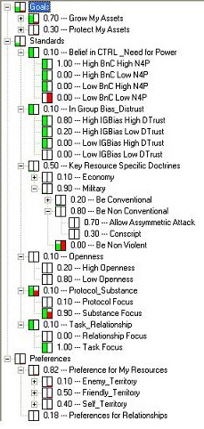
Figure 1: Richard the Lionheart’s GSP Tree
It is worth noting how the G-tree covers the power vs. protect trait. Beneath each subnode there are further subnodes, but under the G-tree (and P-tree) there are just long sets of constituency resources with importance-valuated weights. The standards or S-tree holds most of the other Hermann traits and their important combinations, such as traits 1 and 2 that combine to make the four subnodes covering all possibilities of Belief in Control (BnC) vs. Need for Power (N4C). Likewise, there are subnodes for the intersection of In Group Bias (IGBias) vs. Degree of Distrust (Dtrust). Openness, as mentioned earlier, is a direct replacement for two other traits, while task vs. relationship focus is also supported. The modifications to Hermann show up as the protocol vs. substance subnodes and the key resource specific doctrines of importance to that leader. In Richard's case, the G-tree weights show he leans heavily toward power and growth, which is also consistent with his P-tree weights on his own resources. His standards reveal him to be Hi BnC - Hi N4C, Hi IGBias - Hi Dtrust, Low Openness, substance- and task-focused, and favoring asymmetric or non-conventional attacks (he did slaughter thousands of unarmed townsfolk for effect).
- Methodology
The central model building process of concern here is to construct the GSP tree nodes and weights in a principled fashion. Given the lack of public statements for these long dead leaders, Hermann’s formal approach to content analysis could not be used for populating and weighting the Hermann traits on the GSP tree branches. Instead, we had to construct our own approach to content analysis for organization of literature on these leaders. That approach includes steps such as evidence table construction, differential diagnosis for making sure that alternatives hypotheses of trait levels are considered in the tables, pair-wise comparison process for weight assessment, and other steps including assessment of uncertainty, verification and validation, and sensitivity analysis. Details on these steps exist in (Bharathy, 2005) and we review but a few of them here due to space restrictions.
Before reviewing some of the content analysis and model construction steps, we would like to point out that the independence of training and testing data sets was ensured by separating the empirical evidence into two distinct periods in the history. One part is used for constructing and verifying the model as described in this section. The other part was reserved for validation and correspondence testing (Section 5). Specifically, the events and scenarios in the town of Acre were set aside for validation. The remaining evidence, particularly those related to the early phase, beginning with the Pope’s speech that set off the crusades, was used to instantiate the models of the leaders (training data). Records from the time when Richard descends on Acre were reserved for validation.
As we have seen earlier, the higher-level nodes of the goal tree are structured based on the short-term goals pertaining to the resources, and those of the standard tree are based on Hermann’s traits plus a few additional ones. Instantiating these trees for a model of a leader (say Richard the Lionheart) involves determining the weights of all the nodes and linking them to lower level nodes relating behaviors and personality. This can be achieved in two stages. Firstly, hypotheses about individual behavior are tested against available evidence, and then in stage two, the weights are determined for these behaviors.
Organizing Evidence Tables: For the Third Crusade, the data was available as empirical, narrative materials consisting of a body or corpus of many statements of biographical information, and historic accounts (Maalouf, 1985; Reston, Jr., 2002; CLIO). These empirical materials were organized into evidence tables through a modified content analysis process by breaking statements into simpler units with one theme (replicating statements when necessary), adding additional fields, namely reliability and relevance, and then sorting. For illustration, the following is an excerpt from the evidence table pertaining to the behavior of Richard, the Lionheart.
Table 2: Sample Evidence Table
Theme | Evidence | Reliability | Relevance
M1 | Amasses wealth in battles | V. High | …
M2 | Conquers territory 1, etc. | V. High | …
Considering Alternate Hypotheses (Differential Diagnosis): The best approach when interpreting evidence is to hypothesize alternative explanations and to seek evidence that confirms and disconfirms each hypothesis. Attempting to disconfirm the hypotheses against existing evidence embraces the scientific process and minimizes the confirming bias (Kahneman et. al., 1982). The approach we suggest is to take all competing hypotheses that explain a set of evidence and then pit them against these evidences.
Specifically, let us assume that the evidence (E_{i}) with a reliability Re_{i}, rejects (or supports) a hypothesis (H_{j}) with a strength (C_{ij}), where C_{ij} ∈ (-1, +1). C_{ij} value of +1 implies full support, while –1 implies complete rejection, as assessed by the expert or knowledge engineer. We find it best to work with a confirmation index that weighs disconfirming evidence about an order of magnitude higher than confirming evidence. Let us call this process of estimation based on disconfirming evidence as differential diagnosis, a term found in medical decision-making. This results in:
CI_{Avg}(H_{j}) = $1n×\sum{K×C_{\text{ij}}×{\text{Re}}_{i}}$ (1)
where K = { w₁ when C_{ij} >=0, and w₂ when C_{ij} <0 }. Essentially, K is used to assign a higher weight (say an order of magnitude) to disconfirming evidence (w₂ >> w₁). We have used w₁ value of 1 and w₂ value of 20.
The competing hypothesis that has the highest positive confidence wins only if the hypotheses are mutually exclusive, the difference in CI is significant (ΔCI_{Avg} > 1.0), and the variance is small. For hypotheses, which are not mutually exclusive, ordinal ranking might be obtained. When mutually exclusive hypotheses can not be clearly distinguished by their confidence score, multiple competing hypotheses might have to be entertained during the course of the sensitivity analysis.
Let us consider the following stylized case to illustrate this technique. Note that simplifications have been made due to length limits. Is Richard’s inclination to grow any of the following resources (expanding the empire, wealth, religious blessings or military prowess) more influential than others in explaining his behavior in his life? Could his inclination be ranked?
Figure 2: Segment of Goal Tree
Grow Assets
Authority
Economy
Religious Blessings
Military Prowess
Goals Tree
Protect Assets
Differential diagnosis allows one to consider all relevant evidence at once and also gives higher weight to disconfirming evidence as described above. It allows one to find out whether these hypotheses could be ranked in the context of all available evidence.
Let us formulate the above questions into the following competing hypotheses: Growth and expansion of the empire (Authority: H1), wealth (Economy: H2), religion (Religion: H3), or whether he loves warfare for its own sake (Military prowess: H4). Then, we construct the table (Table 3) as below and pit all of these hypotheses against the available set of evidences.
Table 3: Diagnosis for Goal: Protect Assets
Evidence | Re. | H1: Auth. | H2: Econ. | H3: Relg: | H4: Mil.
Amassed wealth in battles | 1.0 |  | 0.9 | -0.5
Conquered several territories. | 1.0 | 0.9 | 0.8 |  | 0.9
Sold territory conquered | 1.0 | -0.8 | 1
Seldom governed the lands he had authority over. | 1.0 | -0.8
Spent excessively on battles. | 1.0 | 0.5 | -0.5 | -0.5 | 0.9
Known to have said: “If I could find a buyer, I would mortgage London to raise money for battles” | 0.7 | -0.9 | -0.5 |  | 0.9
Spent most of his 9 year rein outside England on Crusade | 1.0 | 0.3 |  | 0.7 | 0.8
Had not obeyed other religious laws | 0.9 |  |  | -0.8
Fought against his father, and then a host of other rules. | 1.0 | 0.6 |  | -0.5 | 0.8
Died fighting over a treasure | 0.8 |  | 0.9 | -0.5
Confidence Index |  | -4.2 | -1.4 | -5.2 | 0.4
As one can see in Table 3, a number of rows of evidence disconfirm Richard’s religious inclination, while there is little that contradicts Richard’s inclination to grow military assets. It should not surprise the reader that Richard seems most inclined to growing military prowess, following by growing wealth, governing, in that order.
Determining the Weights: For such nodes as Task versus Relationship, or Grow versus Protect, determining weights is easy. There are only two nodes, and Richards is nearly a pure type. However, when the number of nodes to be compared increases, then assessment of weights is difficult without an appropriate technique.
Table 4: Questionnaire for Pair wise Comparison

What would Richard prefer, or find important, between:
Authority |  |  | & | Economy |  | Not sure

How much more would Richard prefer that? [Or How much more important would this be to Richard?]
Equally | Slightly | Strongly | Very Strongly | Extremely
1 | 3 | 5 | 7 | 9

Table 5: Weight Estimation
 | Authority | Economy | Religious Blessings | Military Prowess | Geometric Average | Weight
Authority | 1 | 1 | 5 | 1/2 | 1.26 | 0.25
Economy | 1 | 1 | 5 | 1/2 | 1.26 | 0.25
Religious Blessings | 1/5 | 1/5 | 1 | 1/6 | 0.29 | 0.06
Military Prowess | 2 | 2 | 6 | 1 | 2.21 | 0.44

Such a weight assessment process is subjective, however, it is improved by pair-wise comparison using the Analytical Hierarchy Process (AHP) based scoring scheme (Saaty, 1982). Incorporation of an AHP-like pairwise comparison caters to the fact that at a given time, the human mind can comfortably and reliably compare only two attributes. This also helps eliminate inconsistent ranking within the same groups, provides more systematic processes for assessment of weights, and leaves an audit trail in the process. The pairwise comparison assessment also takes into account the knowledge from differential diagnosis, using the ordinal rankings to crosscheck against the weights estimated.
Once again, let us look at the weight estimation for the stylized case considered in the previous section (see Figure 2). This process makes use of a format such as illustrated for two GSP tree nodes in Table 4.
Following this type of process, all relevant pairs of sibling nodes at a given level of the tree are compared and the weights for the GSP trees are enumerated. For example, in Table 5, Authority is compared against Authority, which yields equal importance giving a score of 1. When Authority is compared against Religious Blessings, the former was found to be strongly more important, giving a score of 5. If the order of comparison were to be reversed, it would be the reciprocal. The geometric mean along each row, when normalized gives the weights.
The last column in Table 5 shows the finalized weights for the stylized Goal Tree of Figure 2. In the same manner, the weights for all the GSP tree nodes were assessed for each leader.
- Simulation
  - Validation
The validation employs the portion of the crusade story hitherto unused in the evidence tables and model construction. Specifically, it describes the story of Richard on his way to Jerusalem, laying siege to the city of Acre, being offered ransom from the Emir, his initial acceptance of ransom offer and the subsequent takeover of the city of Acre by Richard, failure in meeting the negotiated settlement, and finally the tragic massacre of all citizens of Acre carried out by Richard in retribution (Muhlberger, 2004). This scenario has been put through the face validation, and has performed satisfactorily in most parts.
Figure 3 describes the states (ovals) and paths (arrows) in the mini-Crusade story. The thick-bordered ovals and arrows indicate the actual history. The lighter ovals and arrows are counterfactuals, the outcomes that could have happened but did not occur (note that a historical event is just one of the possible outcomes). The likelihood of witnessing a given event in the simulation, given the same starting conditions, has been denoted in parenthesis by an ordinal scale of Very High [VH], High [H], Medium [M], Low [L] and Very Low [VL].
For simplicity sake, the focus of the discussion here is on Richard, ignoring the remaining players, except the ruler of Acre, personified as a single Emir. Based on the literature evidence, the Emir of Acre at that time has been portrayed as a man who does not believe that he is in control of the world, nor does he have significant need for power. Accordingly, the GSP tree model of Emir has been constructed as an average, weak and meek leader.
Figure 3 – Possible Outcomes, Paths, and History
The emotional reactions of the synthetic leaders (Richard, Emir), along with the decisions they chose to carry out, are shown below in Figures 4 to 8.
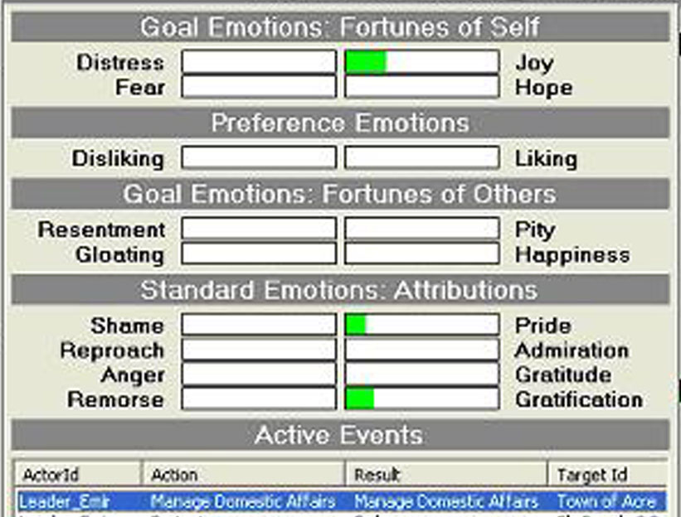 | Unaware of Richard’s imminent arrival, Emir of Acre is managing the domestic affairs, an action that satisfies his goals and standards, in the absence of any other issues.
Figure 4 – Emir’s Emotions when Richard Arrives

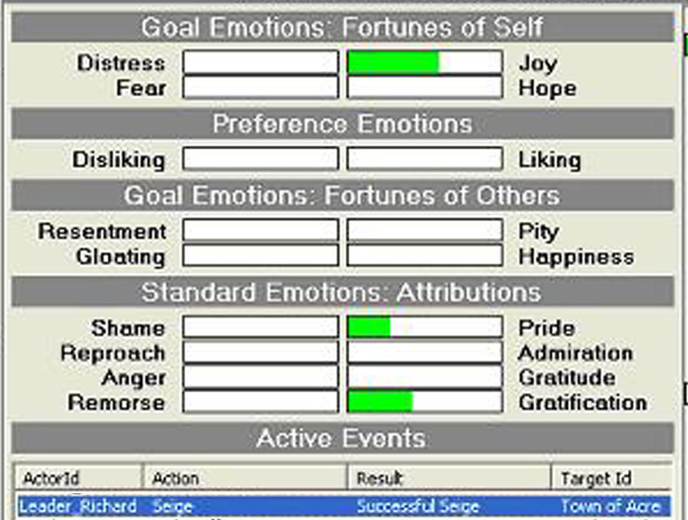 | At the same time, Richard has selected Acre as the target, a weak enemy city, located along the way to Jerusalem.
Figure 5 – Richard on seeing Acre (an easy target)

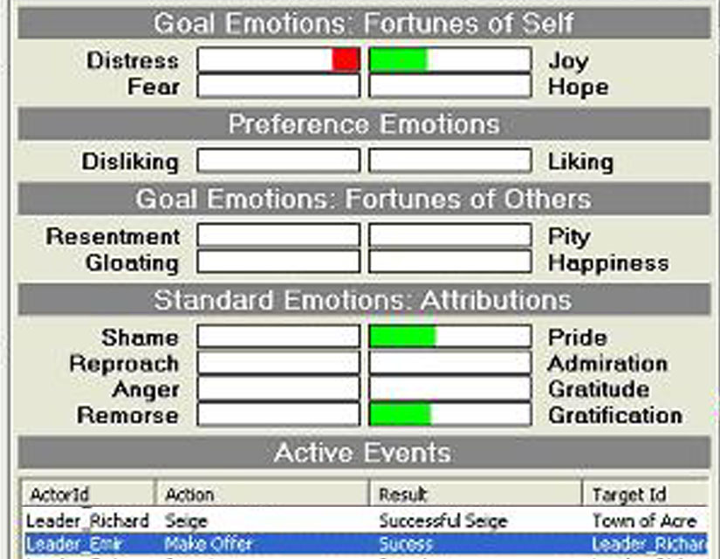 | Richard agrees to Emir’s ransom offer, and Emir is able to protect his life, people and military.
Figure 6 – Emir’s Emotion after concluding Negotiations to get Richard agree to Ransom

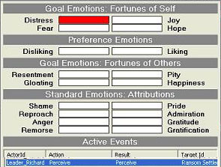 | Richard receives the ransom settlement, only to find that it falls short of the agreement, and feels deceived.
Figure 7 – Richard’s Emotion on being disappointed with Ransom Settlement

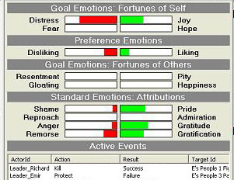 | In one of the futures (in this case, the actual history), Richard executes the people.
Figure 8 – Richard’s Emotion Panel as he orders Execution of Prisoners
In this sequence, the simulation repeats the historical account, thereby satisfying our correspondence test. However, the decision space is stochastic, this history is only a single path in a complex space, and other counterfactuals (alternative histories) might emerge with small perturbations to the GSP trees and their weights.
  - Illustration of the Sensitivity Consideration
The weights on the GSP Tree are estimates, and are associated with uncertainty estimates, the details of which have been omitted here. The implication is that one must be interested in the behavior in the neighborhood of the existing weights, with sensitivity analysis. While we plan to carry out a detailed and systematic sensitivity analysis through such techniques as Morris walk, Monte Carlo filtering, and design of experiments, currently, at present we have carried out a limited investigation of the sensitivity surrounding the gruesome massacre of civilians in Acre.
Richard ordered the massacre of the civilians when the ransom payment failed to comply with the agreement. It is suspected that one set of nodes dealing with In-Group Bias and Distrust could have played a significant influence on Richard’s decision. However, there was limited pre-crusade evidence regarding Richard’s In-Group Bias and Distrust. Therefore, given the importance of this event and the limitation of the model building information, this is an ideal candidate for further investigation.
The specific question we ask is: what change in the weight of the given nodes of Richard would have allowed Richard to spare the people, given the identical circumstances? Accordingly, we tracked the likelihood of two events (described using an ordinal scale of small, medium and large), namely Richard ordering execution or siege (E), and Richard making less hostile action such as releasing the civilian prisoners, leaving Acre, or visiting Acre instead of just executing the civilians (F).
In-Group Bias Weight → | High | P(E) = High  P(F) = Low | P(E) = High  P(F) = Low | P(E) = High  P(F) = Low
In-Group Bias Weight → | Medium | P(E) = Low  P(F) = Medium | P(E) = Medium  P(F) = Low | P(E) = Medium  P(F) = Low
In-Group Bias Weight → | Low | P(E) = V. Low  P(F) = Medium | P(E) = Low  P(F) = Medium | P(E) = Medium  P(F) = Low
In-Group Bias Weight → |  | Low | Medium | High
 |  | Distrust Weight →
Figure 9 – Sensitivity of the Events to Weights of In-Group Bias and Distrust
As one would expect, lowering the weights for In-Group Bias as well as Distrust reduces the likelihood of execution being ordered by Richard. On the other hand, small perturbations of distrust also result in Richard exhibiting more friendly behaviors such as visiting Acre, instead of laying siege. The visits, however, make Richard more vulnerable to capture by Emir, a radically different historical outcome indeed.
Systematic analysis is vital, before the results, especially the interaction between other parameters, can be confirmed. Likewise, correspondence tests play an equally vital role. Such sensitivity studies amplify how important proper model building and competing hypothesis evaluations are upon the end behavior of the simulated agents.
- Conclusions & Recommendations
We have illustrated how one could proceed with constructing cognitively detailed models of the leader agents. It must be noted that what is being modeled is limited to cognitive and personality structure. In the research attempted here, emergent leader behavior has been observed through the use of value trees of the motivations and influences that drive the leaders. At critical decision points or selected snapshots, one can examine the agent GSP tree values, its emotive construals and calculated utilities, and the impact of other leader actions and utterances upon its choice of decisions. The agent can also be examined to detect its emotional state and activations in terms of specific relationships and events.
In addition to on-going validation and sensitivity analysis of the leaders, PMFserv is being enhanced to implement several game-theoretic constructs relevant to leader studies. At present, the leader agents demonstrated in this paper are capable of making their own independent micro-decisions. However, they can process their values and action options for only a single ply into the future. Our next version, currently in prototype, includes perception enhancements, multi-ply lookahead, nested intentionality where each agent constructs a model of the other agents to assess their likely motivations, and the ability to manage communiqués, relationships and reputation via a socio-cognitive model of trust. We believe that such capabilities, combined with the personality profiling described in this article will result in powerful, game-theoretic adversaries who tend to emulate choices of the actual leaders they mimic. Testing that idea will be our next challenge.
- Acknowledgements
The authors would like to acknowledge the financial support of the US Government, of IDA Task E2-2334, and the Beck Fellowship Fund.
- References
Bharathy, G. (2005). Modeling the Behavior of Synthetic Human Agents in Virtual Worlds. A Systems Methodology for carrying out Knowledge Engineering & Modeling of Cognitively Detailed Agents (Doctoral dissertation, University of Pennsylvania, 2005).
Chemers, M. M. (1997). An Integrative Theory of Leadership. Mahwah, NJ: Lawrence Erlbaum Associates.
Ewen, R. B. (1998). Personality: A Topical Approach, Lawrence Erlbaum Associates, London
Hermann, M. G. (1999). Assessing leadership style: A trait analysis. Hilliard, OH: Social Science Automation, Inc.
Kahneman, D., Slovic, P., & Tversky, A. (1982). Judgment under uncertainty: Heuristics and biases. Cambridge, UK: Cambridge University Press.
Kowert, P.A. (1996). Where does the buck Stop?: Assessing the impact of presidential personality. Political Psychology, 17, 421-452.
Muhlberger, S. (2004). Retrieved on April 10, 04. URL: http://www.theorb.net/textbooks/muhlberger/lionheart.html
Piedmont, R., McCrea, R., & Costa, P. (1991). Adjective checklist scales and the five-factor model. Journal of Personality and Social Psychology, 60, 630-637.
Saaty T. L. (1982) Decision Making for Leaders. New York: Van Nostrand Reinhold.
Silverman, B.G., Johns, M., and G. Bharathy (2004). Agent Based Modeling Leaders. Technical report, Philadelphia: University of Pennsylvania/ACASA.
Silverman, B.G., Johns, M., O’Brien, K., Weaver, R., & Cornwell, J. (2002). Constructing virtual asymmetric opponents from data and models in the literature: Case of crowd rioting. Proceedings of the 11th Conference on Computer Generated Forces and Behavioral Representation, Orlando, Florida, 97-106.
Silverman, et al (2005). Human performance simulation. In J.Ness, D.Ritzer, & V.Tepe (Eds.), The Science and Simulation of Human Performance (Chapter 9). New York: Elsevier.
Sticha, P. J., Handy, K. and D. M. Kowal. (2001). Predicting Policy Decisions: Literature Review

