Criticism Based Knowledge Acquisition (CBKA) as Organizational
Support Systems
Position Paper
AAAI Spring Symposium
November 199 1

Barry G. Silverman
Institute for Artificial Intelligence
George Washington University
2021 K St. NW, Suite 7 10
Washington D.C. 20006

1) Introduction

There seem to be two views (at least) of the role of knowledge acquisition in organizations. (1) A traditional view is that knowledge acquisition is to cull the rules of super-experts and place them into knowledge bases that can help improve the performance of less experienced employees. An alternative view, and the one explored here, is that (2) knowledge acquisition is to improve the performance of the organization by improving the rules and knowledge of its expert practitioners. In the later view, any system that acquires knowledge from practitioners is a knowledge acquisition system (e.g., a CAD program that acquires designs, a word processor that acquires documents, or a spreadsheet that acquires forecasts and budgets).
The presumption made here is that practitioners are fallible in general and, in particular, they succumb to biases introduced both by cognitive limits of the human mind and by organizational pressures. For example, the major accidents of our times (e.g., Three Mile Island, Bhopal, Exxon Valdez, the Vincennes’ downing of an Iranian Airliner, etc.) are all due to rules and knowledge used by an organization-wide chain of certified experts. That is, none of these incidents are due either to a novice operator or to a single accidental decision of one experienced operator. They are due to organization-wide errors that left the experienced operators or decisionmakers in a vulnerable position to begin with. These organization-wide errors persist because of systematic biases in human cognition combined with group-think mentalities and information masking behaviors that organizations trigger in their members.
For these, and other reasons, knowledge acquisition must strive for the higher level goal of improving, not just transferring, knowledge. In order for knowledge acquisition to improve the knowledge of the organization, it is useful for the knowledge acquisition system to be capable of critiquing that knowledge. This is Criticism Based Knowledge Acquisition (CBKA) and it takes the form of critics embedded in the relevant acquisition package (spreadsheet, word processor, CAD program, etc.). Criticism is not a negative condemnation, but a constructive and mutual search for improvement and higher truths. CBKA is a grab-bag full of approaches, methods, techniques, and knowledge for stimulating practitioners and whole organizations to higher levels of capability. To be effective, CBKA must be deployed on a wide scale throughout the organization of interest. If this is done, it can act as a humane, error forgiving and correcting technology that will support and improve the entire organization’s communications and performance.
Organization-wide CBKAs are large undertakings with many unknowns. For example, there are only a few, poorly documented models of organizational behavior and error; the biases of expert cognition are many, but equally poorly understood; and the models of normative ideals, to which organizations and experts should strive, are potentially complex, controversial, and difficult to communicate. Despite such challenges, the potential for CBKA to do some good is amplified by the large number of unexploited opportunities found at most organizations. This paper reports a few of our results and lessons learned to date.
2) Expert Practitioners Are Fallible and Biased
We begin by examining a model of human error processes that is useful for CBKA system construction purposes. While novice error is widely studied in the computer assisted instructional sciences, there are few, if any, readily available models of expert error for helping CBKA.
The model used here is rooted in the half century old tradition of psychological study of expert performance. Many examples of psychological models have a beneficial impact upon AI/ES programs. The AI/ES programs do not implement the full detail of the psychological models. Rather, they capture the spirit and several key notions of those theories. The same is true here. The areas of psychology tapped here are Social Judgment Theory (e.g., Brunswik, 1955), Human Information Processing (e.g., Newell and Simon, 1972), Subjective Decision Theory (e.g., Kahneman and Tversky, 1982), and slips/lapses theory (e.g., Norman, 1982). These are each altered and adapted to be useful and implementable in the critiquing sense.
Specifically, the adaptation is a synthesis that takes the form of a model or diagnostic graph of human error consisting of three layers and several levels shown in Figure 1. Shortly, we will discuss each of the levels of Figure 1 in depth. For now, we will just point out that the outermost layer gives the CBKA system engineer a method to account for the external manifestations of errors in human behavior. It involves a cue usage model. The middle layer causes the CBKA system engineer to determine what causes lead to the erroneous behaviors identified in the outer layer. Finally, the last layer (shown as the bottom two levels of Figure 1) leads the CBKA system engineer to investigate the innermost cognitive reasons causing the error, the specific processes and operations that went awry .
The layers of the model make CBKA system engineering a more flexible activity .The more layers the CBKA system engineer can diagnose, the more effective his CBKA system will be in performing its functions. Yet, an engineer who only completes a one-layer-deep CBKA system will still wind up with a usable program. How many layers of the error component a CBKA system engineer develops will be determined by factors such as, but not limited to, project goals, available budget, schedule deadlines, difficulty of modeling the domain of interest, and availability of reusable models of error processes for similar domains.
The error model used here accounts for the major causes of errors. The model
specifically omits treatment of errors due to extreme crisis or panic. Temporal urgency and stress are clear factors in many of the types of human errors of this book's model. Yet, very different cognitive operations occur in the extreme crisis state. We only focus here on errors that arise prior to reaching the state of panic. Finally, the model handles multiple, simultaneous errors. Yet, it handles them in a rather simplistic (fixed decision network) fashion. Future researchers may suggest more elegant models that capture dynamic priority assignment of simultaneous errors, better sequence concepts for "chains" of errors, nondeterministics for error suspiscions, and so on.

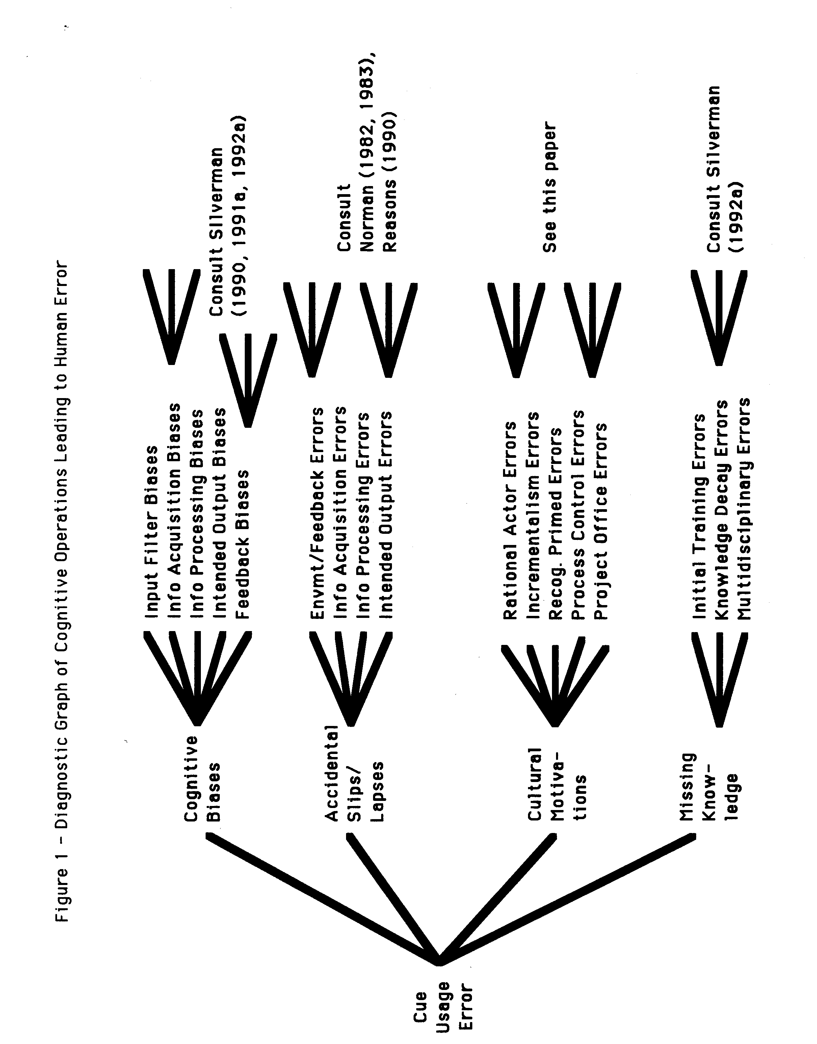

2.1 ) The Cue Usage Layer
Cues are the points of reference or touchstones that need to be followed to reach a correct task outcome. For example, if off-the-cuff you had to predict the height of Benjamin Franklin, you would do so by comparing his height to those of other people (points of reference) in paintings and drawings you remember from that era. You also factor in the cue that people generally were shorter back then .
In well-defined tasks, there will often be a normative set of cues to apply in order to reach the correct outcome. Errors in these tasks can be identified by noting the cues not used by the expert. In less well-defined tasks, there can be many cue paths to a productive outcome. Errors here can often be identified by tracking and identifying cues the expert should avoid. Also, if a robust collection of alternative "normative behaviors" exist, potential errors can be flagged if the expert deviates from the envelope of known normative behaviors.
Sometimes cue usage errors are relative. That is, an error to one person, or from that person's perspective, may not be an error to another person. For example, to a hard line communist, the Gang of Eight probably did the right thing in trying to oust Gorbachev and Yeltsin. In general, however, we can fix the perspectives that are permitted and avoid such difficulties. If we want, we even can have CBKA systems from each of several perspectives that we turn on or off depending on our cue usage preferences.
One way to categorize cue usage errors is in terms of two major uses of CBKA systems. (1) In the realm of Knowledge. critics inform the user with knowledge and constraints, or criticize the knowledge the user has offered. (2) In the realm of Skills and Judgement, they criticize the user's reasoning, judgment, and decision processes. These two categories correspond to the difference between "knowledge base" and "inference engine" used in the expert systems field. The knowledge base holds the domain insight. The inference engine performs domain-independent reasoning and manipulates the knowledge to solve problems.
Other, more detailed schemes for categorizing cue usage errors exist (e.g., Silverman 1992a, Hollnagel 1991 ). Researching and extending these are vital to a more complete model of expert error processes. However, we will forego treatment of these topics in order to preserve space for discussion of the organizational biases theme of this paper.
2.2) The Middle Layer: Causation
At the second layer, the taxonomy/graph of the previous section branches into four causes of cue usage errors. Table 1 depicts these classes of error causes along with a sample of illustrative subcauses. We now, briefly, discuss each of the four in turn.
Cognitive biases are tendencies the practitioner is likely to repeat. They are judgment heuristics that humans routinely use to replace formal logic and reasoning with in order to save problem solving time and reduce complexity. Humans often use these heuristics (e.g., availability, representativeness, or confirmation) without error. Unfortunately, these heuristics are highly prone to misuse. Three common biases are availability, representativeness, and confirmation heuristics. As an example, an actual doctor described in Silverman(1992a) only recommends procedures he has used before (the availability bias). He uses simple versions of trait matching to conclude a patient appears to fit his model of a hypochondriac (representativeness bias). Finally and paradoxically, he suffers no loss of confidence in his approach due either to its over-simplicity or to loss of patients who aren't hypochondriacs from his practice (confirmation bias). Silverman (1985) reports an actual design case at NASA, where almost this exact sequence of biases arises repeatedly in spacecraft system design processes as well.

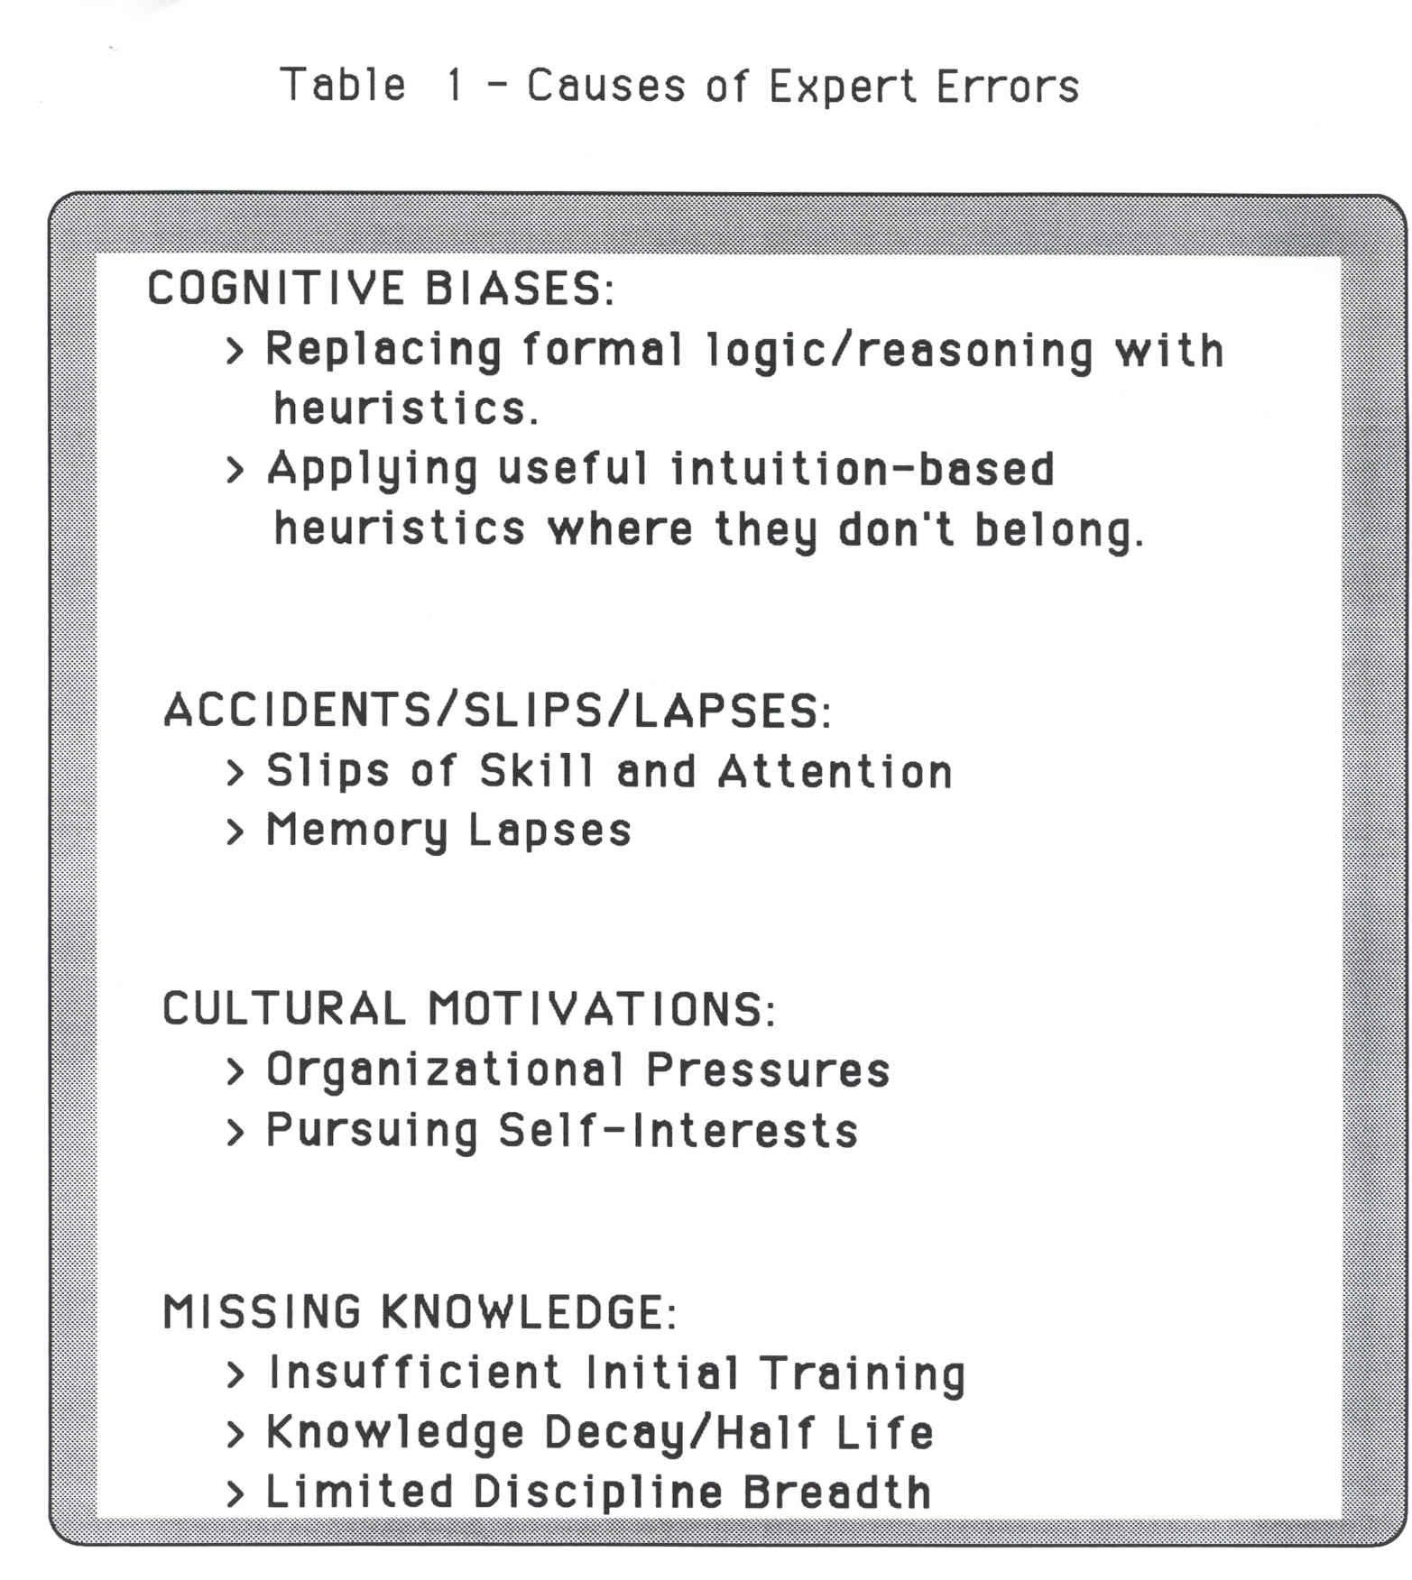

Automaticity errors are attentional slips or memory lapses that, unlike cognitive biases, tend to be non-repetitive but get by the practitioner "this time" or on this execution of a "schema." Schemas are the sequences of normative cues and steps to follow to properly perform a task and reach a goal. Slips are often random errors of schemas we intended to follow, but due to habit we slip back into our old pattern of using a more familiar schema. For an attentional slip example, a doctor who routinely lets the nurse take all patients' temperatures, intends to do it himself on a day the nurse is absent. She does so on the first patient and then forgets to repeat the task on the next several patients. Memory lapses include, among other errors, skipping of steps in a well-known schema. A memory lapse example might be, a doctor begins to write a prescription, but is interrupted by a nurse. By the time she returns to the prescription writing task, she forgets that she has not specified the frequency of the dose. Slips and lapses occur in numerous fashions and are an important source of practitioner errors.
The third cause of errors, like cognitive biases, tend to be repetitive. Unlike cognitive biases, they mayor may not be subconscious. Specifically, cultural motivations tend to be goals and values the practitioner picks up from his organization or environment and internalizes into his mental model of the task. Japanese car designers are not biologically better suited at designing quality features into their automobiles. These differences are due to environmental forces such as societal values, corporate "culture", and so on. Cultural motivations help the designer to conform, fit in, and belong. They also can cause the proficient practitioner to commit errors when he is expected to shift mental models. For example, a Japanese car designer will tend to design relatively unsafe cars by American standards. Likewise a proficient FORTRAN programmer's LISP code often looks (unsurprisingly) like FORTRAN. In large project offices, the motivational biases imposed by management often are to always complete the project on time and at budget, even at the expense of creating tools and databases that will make the next project quicker, cheaper, and better.
The last major class of errors in Table 1.1 are the missing concept related ones. Modern professions are such multi-disciplinary and broad endeavors, that there are no individuals who know them fully. Experts will always have edges to their expertise beyond which they are
fallible or a nonexpert. Teams of practitioners, each member of which has a different specialty, must cooperate to complete many tasks. This means that the team manager, case administrator, etc. doesn't truly know if the solution is robust. Instead he often develops a sense of trust in his specialists' decisions based on whether their advice passes whatever testing is attempted and whether their advice appears to work in the field conditions encountered to date. Add to this the
5 year half-life of most scientific and engineering knowledge, and the potential grows quite high that solutions will be reached that are out of date and ill conceived. The loss of sailors' lives on the USS Stark, which burned for 18 to 20 hours after being struck by 2 Iraqi Exocet missiles, was compounded by the Navy's continued use of lightweight aluminum and Kevlar armor. This despite the design lesson learned from the British Falklands experience (several years earlier) that Frigates should be built with more survivable, all steel superstructures.
This completes my description of the graph in Figure 1. I have described most of the lowest level of Figure 1 at length elsewhere: e.g., see Silverman (1990, 1991 a, 1992), Bailley(1991 ). These other sources also include100s of lower level rules of the Figure 1 graph and explain how CBKA can exploit and be guided by them. What is new, and what I would like to focus on more fully here, is the lower levels of Figure 1 having to do with cultural motivation, in general, and with organizational culture, in particular.

3) Organizations Magnify Certain Cognitive Biases
Culture includes family, organizational, societal, and other environmental entities that affect an individual's performance on a task. Often, errors are not so much due to one individual's actions as to the sum of the actions of an entire network of forces (i.e., Which snowflake causes the avalanche?). For example, who is to blame for the homeless, the ghetto gangs, or the drug problems that claim the streets of the United States and other countries?
Cultural motivations is too large a topic to tackle in toto. Yet, in work settings it is becoming increasingly obvious that, at the very least, organizational culture leads to many of
the errors. These were the findings in accidents such as Challenger, Bhopal, Three Mile Island, Chernobyl, and so on. Further, the focus on organizations constrains the study of human error to just those biases and slips/lapses relevant to the organization of interest.
Unfortunately, even the narrower subject of organizational biases leads to a vast, and still only poorly understood topic. The goal cannot be to develop a complete rule base of organizational errors that a machine using CBKA could access. Instead, we can only accumulate a case base --a file of lessons learned about the nature of organizations, the kinds of errors different types of organizations tend to commit, and the critics that help or hinder such organizations. We begin this case base by describing four models of organizations, the errors they are prone to, and the CBKA systems needed.
(1) At one extreme is the reliance upon the "rational actor" model of an organization. Here, decisions are assumed to be based on perfect information of all the long range alternatives, probabilities, outcomes, etc. The rational approach is highly quantitative and supposedly comprehensive in relation to problem dimensions and maximization of goals. Yet, it often
ignores the subjective intuitions of experts, world views and preferences of decision makers, and socio-political constraints. Consequently, supposedly "rational" solutions are often unacceptable or impossible to implement. An example of a rational organization is the Combat Development entity of the US Army cited later in this paper. This is the technical side of the Army that often comes up with highly rational technologies for countering known threats. Yet, their solutions are non-implementable because they neglect to consider operational factors and how the new technologies can be supported, used, and integrated by the soldier in the field.
(2) At the other extreme, decisions are reached through incrementalism, the bureaucratic aggroach, or muddlin' through (Lindblom, 1959). This is often referred to as the "gut feel" approach. Advances are made in small steps (disjointed marginal adjustments) and there is
rarely any drastic change. Decisions are implementable since they are reached by a politically pluralistic process. Muddlin' disregards irrationalities, tolerates ambiguities, and is sensitive to power struggles. It is the "art of the possible" and it assumes that errors in short term decisions are readily compensated for. Unfortunately, this approach rarely links decisions to long term objectives. It has little hope of solving the underlying "disease," but concentrates instead on eliminating the symptoms. CBKA for bureaucratic, muddlin' organizations should strive to push them toward longer range and more widely accepted forms of problem solving.
The next section holds an example of a task for which the otherwise rational Army users exhibit an organization-wide incrementalism tendency.
(3) Yet another model of organizational behavior is suggested by Klein(1989) for organizations making decisions, particularly under time pressure. Klein's studied 150 decision makers and found that experienced "decision makers ususally recognize ways that situations are typical, including typical responses. Very few decisions are made using analytical processes such as generating a variety of options and contrasting their strengths and weaknesses." He called this "recognition grimed decisions" and described it as a form of analogical recall of both the nature
of the problem and the manner in which to solve it. This approach gives decision makers great decisionmaking speed and clarity of purpose, properties that are desirable in time constrained situations. Klein also points out, though, that the problem with recognition primed
decision makers is that if their initial recognition is flawed, they tend to pursue it until they are relieved of command. That is their initial recognition primed decisions are susceptible to "availability biases" (using only past experience data that is personally known or vividly described). Further, once they make their decision, they are impervious to disconfirming evidence and they only cognitively focus on facts and evidence that supports their viewpoint. This is the confirmation bias. Thus firefighters, platoon leaders, police chiefs, and other emergency situation decisionmakers often are summarily dismissed and/or replaced after they exhibit inflexibilities in the face of what looks like overwhelmingly disconfirming evidence. An emergency response CBKA system that alleviated many of the availability and confirmation biases before they took root, could be of great value to time critical decisionmaking organizations. It could be deployed in squad cars, in field portable "laptop" PCs, and so on.
(4) Organizations in supervisory process control and vehicle/plant operation are also under time pressure. In addition their interactions with the environment and the controlled system often are constrained to reading sensor data and setting controls on a panel. Reasons (1988) characterizes these organizations and the operating personnel who "gamble in favour of the most frequent past outcome. This frequency-gambling heuristic, together with similarity-matching (relating cues to stored events on the basis of shared features), constitute the primitives of the cognitive system. Add to these the powerful and pervasive confirmation bias, and we are in a position to predict the qualitative forms of most human errors." (p. 13) .This implies the errors that lead to many technological accidents (e.g., train crashes, airplane collisions, and plant spillages) may be largely due to only three cognitive causes. If so, it is certainly worth investing in critics of these human errors. More on this shortly.
(5) Proiect Management and Systems Engineering Offices have been studied by (Silverman, 1983, 1985a,b). Empirical results collected from 29 project managers at two organizations (NASA and the Military) suggest entire organizations appear to exhibit consistent sets of biases and errors. Specifically, in the effort to reach deadlines at cost and on time, managers in these offices sacrifice cross-project progress and fail to reward subordinates' contributions that will make it cheaper or easier to finish the next project. As a result practitioners (subordinates) in these organizations tend to perform each project much as the last one --the corporation has no institutional memory and it can't learn or adapt to the lessons discovered in a single project office. Due to these organizational biases, Silverman's studies show the practitioners commit availability biases (e.g., designing new systems based on easily retrieved prior designs) and use overly simplistic decision rules (e.g., adjusting the prior project's budget linearly to forecast the new project's budget). Due to cognitive biases, these practitioners commit these errors without loss of confidence in the quality of their results, another form of the confirmation bias. There are other biases that are characteristic of project/systems management offices that aren't discussed here (e.g., see Silverman, 1991 c).
In summary recent results do show that humans in real decision making and problem solving environments succumb to several of the most important cognitive biases. They often do so because of motivations of the organizations and environments they work in.

4) A Model of Computer Supported Collaboration to Reduce Organizational Error/lmgrove Performance
We are interested in constructing of a model that includes not only man-machine communication factors but also explicitly intrapersonal (cognitive, affective, physical factors), intracomputer (computer system architecture), organizational factors (task, structure, reward, personnel, resources, knowledge, and decision processes), and the organization's environment. It must recognize that interactions take place between these factors which effect the performance of both the user of a knowledge based system and the collaborators of the using group.
This perspective is important when the system is integrated into the larger organization. To be effective, the collaborative system must fit well into the larger organization. To do this, the system designer and/or implementor must be able to customize the system so that the
system can help achieve the goals of the organization. To do this the designer or organizational design maker needs to know what factors he can effect to produce a system that will aid the organization in achieving its goals.
This perspective still recognizes the importance of man-machine communication. In the literature on organization excellence you get excellent performance through people by motivating them, by continual improvement in their skills, and by ensuring that they understand what are the goals of the organization. Communication is important to this process. But it is not the only factor. There can be good human-computer communication yet the
person's judgment or the machine's "judgment" may be faulty or biased. This biased judgment can result in less than optimal performance.
There are both near- and long-term goals of this research. The near-term goals are to (1) conduct studies on a set of judgment affecting factors which are modifiable by the system designer to produce a collaborative system exhibiting sound judgment, (2) develop some initial design guidelines for ensuring sound judgment in collaborative systems. The long-term goals of this research are to (1) develop a collaboration model which incorporates high payoff
attributes like sound judgment, (2) validate the model, and (3) provide guidelines for the design and implementation of collaborative systems.
Figure 2 shows the collaborative system is affected by a "practitioner-CBKA system" in which a given user interacts with the computer on an "equal basis" to enhance performance.
That is, the human expert is not simply transferring knowledge to a computerized "student," but also being critiqued by CBKA. That interaction is shown as the inner-most box of Figure 2 since that interaction and the factors listed therein are the principal area proposed for initial investigation. Before explaining those factors, however, the reader should realize that what underlies this research is an attempt to use a deep understanding of judgment theory to enhance human collaborator performance. The goal is to study how knowledge based human-computer collaboration theory can be improved through lessons learned by behavioral and decision
process psychologists over the past four decades of experiments and theorizing about the nature of heuristics used in judgment: e.g., see Section 3. The factors listed in the inner-most box of Figure 2 indicate several dimensions of human-computer interaction can have an impact upon joint judgment processes.
Whereas most people recognize that nonsense fed into a computer will result in nonsensical output ("garbage in-garbage out"), they are unable or reluctant to apply that
dictum to an acknowledged domain expert's knowledge transferances. In part the difficulty lies
in finding someone (i.e., "super" knowledge worker) qualified to determine that a given expert's transferred knowledge is conceptually incomplete or biased. However, part of the issue to be
faced is whether the intuitive processes that have gotten the expert to where he or she is, are actually adequate for the machine to use.
By this it is meant that the machine should not simply rely upon shallow heuristics that some knowledge engineer culled from a domain expert but that the machine should exploit a deeper knowledge of common place human processes of judgment forming and of widespread sources of bias: e.g., as related to availability, representativeness, vividness, gambler's
fallacy, confirmation, and the like. The machine should also be expected to somehow exploit deep knowledge also drawn from judgment theory of how to debias errant human collaborator judgment.

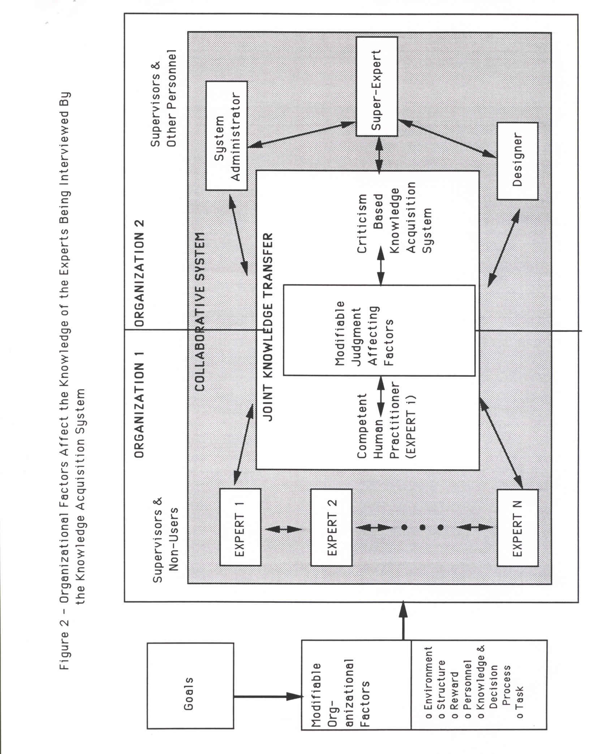

As a matter of semantics, we say the machine has knowledge and judgment. Clearly this knowledge/judgment was given to it by human designers/experts/etc. (organization #2 in
Figure 2) and hence it may be fallible. Part of the attention in this research will thus also be devoted to validating that knowledge and hence of validating the role of judgment theory in the design of knowledge based systems. This does not imply, however, that the results to be
collected in each of the factors apply only to the role of judgment theory in knowledge based system design. The results should be applicable to a general theory of how knowledge based systems can collaborate with humans.
This approach immediately raises a host of research questions, such as but not limited
to, how does the machine obtain a deep model of judgment forming and debiasing; who gives it the criteria to decide the human collaborator has erred; upon what basis can a given corrective procedure be claimed effective; and what does a successful or failed collaboration say about the validity of judgment theory? This research is the beginnings of an attempt to explore such questions. It will also examine the effect various alternatives for each of the factors in the inner-most box of Figure 2 have upon both the overall outcome of the collaboration as well as upon the success of various interactions that transpire when individual judgment knowledge is transferred in either direction.
This section presents the inportant factors of the process of collaboration between the practitioner and the CBKA system. Before introducing the factors, it is worth pointing out, as do Trist(1977) and Houston(1979), that there is a shortage of research on collaboration and no accepted theory has yet been developed. More recently, Grosz & Sidner(1990),
Fischer(1990), and Kraut, Galegher, & Egido(1988) repeat the same point. Failures in collaboration often arise due to problems such as but not strictly limited to: (1) unequal
balance between work performed, work agreed upon, and credit publicly claimed; (2) personal "chemistry" differences such as unwillingness to yield control, share intentions, or tone down lectures (deep knowledge) to the degree desired by the other party; and (3) lack of experience in collaborating, improper cognitive orientation, and/or lack of resources considered
worthwhile by the other collaborator. In a human-computer collaboration, the first of these failure sources is irrelevant, while the second and third are the principal focus of this
research. Getting machines to be intelligent enough to eliminate these sources of failure in collaborative work is an important first step in moving toward "practitioner-CBKA systems".
The collection of environmental, organizational, task, interpersonal, and
collaborative factors that may affect the usefulness of a collaborative relationship is too vast to examine in the scope of anyone study. For the sake of the present paper, factors modifiable in our (COPE) testbed will be examined as listed in the next section.

4.1 ) Overview of Criticism Based Knowledge Acquisition
Up to this point, I have only vaguely defined CBKA and the computer side of the equation. Let me be a little more precise. Specifically, CBKA systems are a class of knowledge acquisition programs that accept as input the statement of the problem and the user-proposed solution (problem-solution pairs are the unit of knowledge of interest in rules, analogs, object lattices, and so on) and that produce as output a critique of the user's judgment and knowledge in terms of what the program thinks is wrong with the user-proposed solution. These programs critique human generated solutions from the perspective of missing knowledge viewpoints as well as for recurring judgment errors. In addition to the syntax and/or logic checking levels of many existing knowledge acquisition systems, CBKA requires the machine include a higher level of criticism. This higher level is to examine the domain normative model and cues underlying the user's solution (via a "differential analyzer") and to attempt to stimulate him or her to improve his own performance (via a dialog generator and screen interface).
At this level, CBKA should know how to cue the domain expert. In this paradigm the machine need not know how to solve the entire domain problem but must excel at helping the human to do so. Thus as the spell/grammar critics are unable to author a memo so too are the more sophisticated medical critics unable to fully interview and diagnose a patient. Both types of critics are, however, useful adjutants to help experts improve their performance on a minimal interference basis.
To help the CBKA system successfully accomplish its task there are a number of "design parameters" that a CBKA system engineer can and must learn how to properly tune: (1) timing of the criticism can be before, during, or after the expertise transfer; (2) the criticism
process can run incrementally or all at once in batch mode; (3) the mode of critic startup can
be passive (user invoked) or active (self-invoked); (4) the CBKA system's message can convey shallow or deep knowledge; (5) the CBKA system's algorithms can be heuristic, algorithmic, or model-based; (6) the human-CBKA system interface can be textual, command driven, or iconic; (7) the CBKA system's strategy may be a positive appeal, a negative condemnation, or procedural; and (8) the strategy type may involve querying, hinting, suggesting defaults or analogs, repetition, persuasion, repair, and others.
The above represents a large space of design alternatives and, to simplify it somewhat, three reasonable cateaories of CBKA systems have been labeled in Silverman (1990, 1991 a,b) as:
(1) "influencers" which work before, or possibly during a specific subtask, in incremental mode, with heuristic reasoning, and as a positive appeal to the users' intelligence before they commit a common error;
(2) "debiasers" which self-activate incrementally (i.e., right after after each
subtask) to see if the user has committed an error and if so to provide negative feedback -- since it is telling user they erred, it is inherently negative feedback; and
(3) "directors" that are step by step procedures that walk users through the use of a cue, rather than appealing positively or negatively to their intelligence for using that cue.
A cue critic generally includes only a few rules and thus is narrow and quite limited in scope. However, "decision networks" of critics can be deployed in a CBKA system to compensate for this weakness. A decision network is a cluster of critics that uses several influencing strategies (e.g., hint, show defaults and analogs, tutor, etc.) followed by debiasers and directors that only are triggered if the before-task critiquing failed to cause a given cue to
be used. It is a decision network because there are multiple critics for a given major type of error and the machine must decide which critics to invoke when from the network. The decision rules that affect the choice of critic to "fire" in a given situation are typically a precompiled sequence based on the "generative theory of bugs" (see below) and on what seems to work. Example decision networks appear in each of the next two sections.
In addition to including one or more strategies, a decision network of critics should also exploit clarifiers. Clarifiers are techniques which incorporate insight about human perception and understanding in order to improve the delivery of a strategy. Thus for example, when a strategy calls for presenting textual information to a user, a clarifier might include organizing that information hierarchically or via "hypertext" to hide what isn't initially needed but which might be probed after the initial criticism is absorbed. Another example would include the use of visualization aids such as screen icons, direct work item manipulation, and/or colorization to make the intended point of the strategy with even less textual material. The use of these and other clarifiers will improve the usability of the critics and the human factors of the strategies.
Finally, a decision network can make good use of reinforcers for those cases where the point of a given critic strategy is missed by the user. Reinforcers give a network a degree of "endurance" and perserverance that can be useful in instances where the first several strategies tried fail to remove a given bias or error from the user's behavior. Three common reinforcers are: (1) Repitition in which the same criticism is re-stated in a different way one or more times so as to help reach distracted or differently oriented users. (2) Persuasion including cajoling by "carrot and stick" methods can help change a recalcitrant user's perspective. Often this can be accomplished by presenting cause of an error to motivate understanding of the criticism, followed by .e1f.e..c.1 to show the user the" stick" he'll encounter if an error goes unchanged. And, (3) view argumentation in the form of textual explanations on why a given criticism is important. Often the argumentation takes the form of presenting alternative viewpoints of the same problem.
In most of the CBKA systems the author has designed, both the single critic approach and batch mode have been avoided. It was felt at the outset that the error or missed cue should first be prevented by an influencer. If that fails, it next should be addressed by a debiaser as soon as possible and while the subtask is still fresh in the user's mind. Directors are reserved for helping the user get through overly complicated cue usage sequences. Through use of various combinations of influencers, debiasers, and directors one can always reach a reasonable knowledge transfer from the expert. This is formalized as:
PRINCIPLE 1: The CBKA system should have a library of functions that serve as error identification triggers and influencer, debiaser, and director strategies.
5) Results To Date of CBKA as Oraanizatianal SuQQQrt S~stems
Principle 1.1 helps guide the design of alternative styles of human-critic interaction so CBKA systems can include multiple styles of interaction such as, among other examples: active, during task debiasers and pre-task, incremental influencers. The goal of this section is to let the reader see that the principle has practical value based on lessons learned in actual applications and experiments.

It would be useful for Section 5.1 to present the details of each CBKA application and experiment, yet, space will not permit this. Instead references to the relevant studies are provided. Section 5.2 then discusses the lessons learned from an organizational support system perspective.
5.1 ) Overview of Selected CBKA System Results To Date
This section summarizes about 3 dozen critic engineers' attempts to use CBKA in six distinct domains. The six efforts and their various authors correspond to the six rows of Table 2. The first two columns of Table 2 summarize the application task and normative cues, while the third column indicates common cue usage errors. The last two columns of Table 2 indicate the experiments conducted and the lessons learned about critics. The next several paragraphs discuss the entries in the body of the table. In this discussion, the reader should note that the
first three rows correspond to real applications. The last three concern experiments intended to learn more about human error, critic engineering, or Principle 1.
The first row of Table 2 summarizes the largest CBKA application we have constructed to date. It supports decision paper writing in the U.S. Army. Specifically, the critic supports Army personnel at 17 sites nationwide who must write 100s of decision papers per year, one for each new piece of materiel the Army buys. For each paper, there are two principal tasks: (1) to forecast the worst mission the piece of materiel must survive, and (2) to structure the issues and criteria the piece of materiel must satisfy with respect to that worst mission. If the piece of materiel can satisfy those issues and criteria, it will be effective in the battlefield. Unfortunately, experiments show the Army personnel, with the best of intentions, tend to
overly focus on technical gadgetry to the exclusion of cues about operational effectiveness and suitability .That is, the personnel focus on concrete experience they have with engineering and overlook abstract (handbook, training, and intelligence) information about operation, use, and support of the materiel in the field. Following Principle 1 and critic engineering methodology, the author built a critic with 1,500 rules, 1 ,500 objects, 2,000 notecards, and 300-odd analogs to attempt to influence, debias, tutor, and direct the Army personnel to write more well-balanced decision papers. Aside from a successful implementation, several experiments were performed on both professional personnel and students. The lessons learned support Principle 1 .
The second row of Table 2 summarizes a prototype of a critic for an engineering design task. Specifically, a critic with about 3 to 4 dozen rules was embedded behind a ship computer aided design (CAD) package. The critic evaluates designs to help with the placement of antennas to avoid electromagnetic interference effects. Critic engineering showed the users suffered primarily from missing concept, rather than misconception, errors. Also, this was one of the first critics we built. It follows conventional critic design advice (e.g., as recommended by
Miller, 1983, Langlotz & Shortliffe, 1983 or as used in grammar critics) in that it uses only batch after-task debiasing. This violates Principle 1 and experiments revealed that Principle 1 is more correct than the conventional design advice. This conclusion is based on the reactions of four supervisors of designers when they used the system. The lesson learned was that incremental, before and during task critiquing (through multiple media) is necessary to avoid frustrating users who are competent in the general task but who are missing concepts in a specific subtask. We are now building engineering critics for the Navy that benefit from these lessons.
The third row of Table 2 summarizes the second largest CBKA application we have constructed to date. During 1983 and 1984, when it was used, it supported spacecraft systems planning and design at the Goddard Space Flight Center. Specifically, this was a Lotus spreadsheet based case base, called Simplified Cost Analogy Technique (SCAT), intended to minimize availability biases afflicting system planners in the design of new spacecraft ground sytem facilities. The NASA planners tended to generate budgets, plans, and designs from analogies to past successful analogs, yet their memory of these analogs was constrained to systems they had personal experience with. SCAT contained 4 megabytes of analogs to influence them; a normative model of how to do analogical reasoning; and an optional plan generate mode. It also, non-dynamically, collected new analogs in a prescribed format and absorbed them into the case base. SCAT was built prior to case based reasoning and didn't have the benefit of a dynamic memory , it was human maintained. SCA T also was built prior to the derivation of Principle 1 and it suffered from (1) being too passive of an influencer, (2) omitting any debiasers, and (3) missing out on the currently available clarifier technology. For all these reasons, when its original sponsor departed NASA, SCAT fell into disuse, but not before it had saved the Space Telescope project $12 million in plan error elimination.
The fourth row of Table 2 summarizes a series of experiments two semesters of graduate students performed in a probabilistic reasoning domain. The domain consisted of situation descriptions that seemed like they could be solved via common sense heuristics but which really required the use of formal models of probability and statistics. The students followed critic engineering methodology to identify which cues the subjects would be likely to focus on/ignore. They then used this as an "error theory" to tailor critics to alter the subjects' mental schema for solving the task. Six teams of students adopted different error theories that lead them to implement different critic strategies. Each team then ran a control group and an experiment group consisting of between 15 and 49 subjects ranging in skill from intermediate to expert. Comparing across experiments and adjusting for skill differences of the users reveals that expert statisticians use fewer before and during task influencers. Regardless of skill level, after task

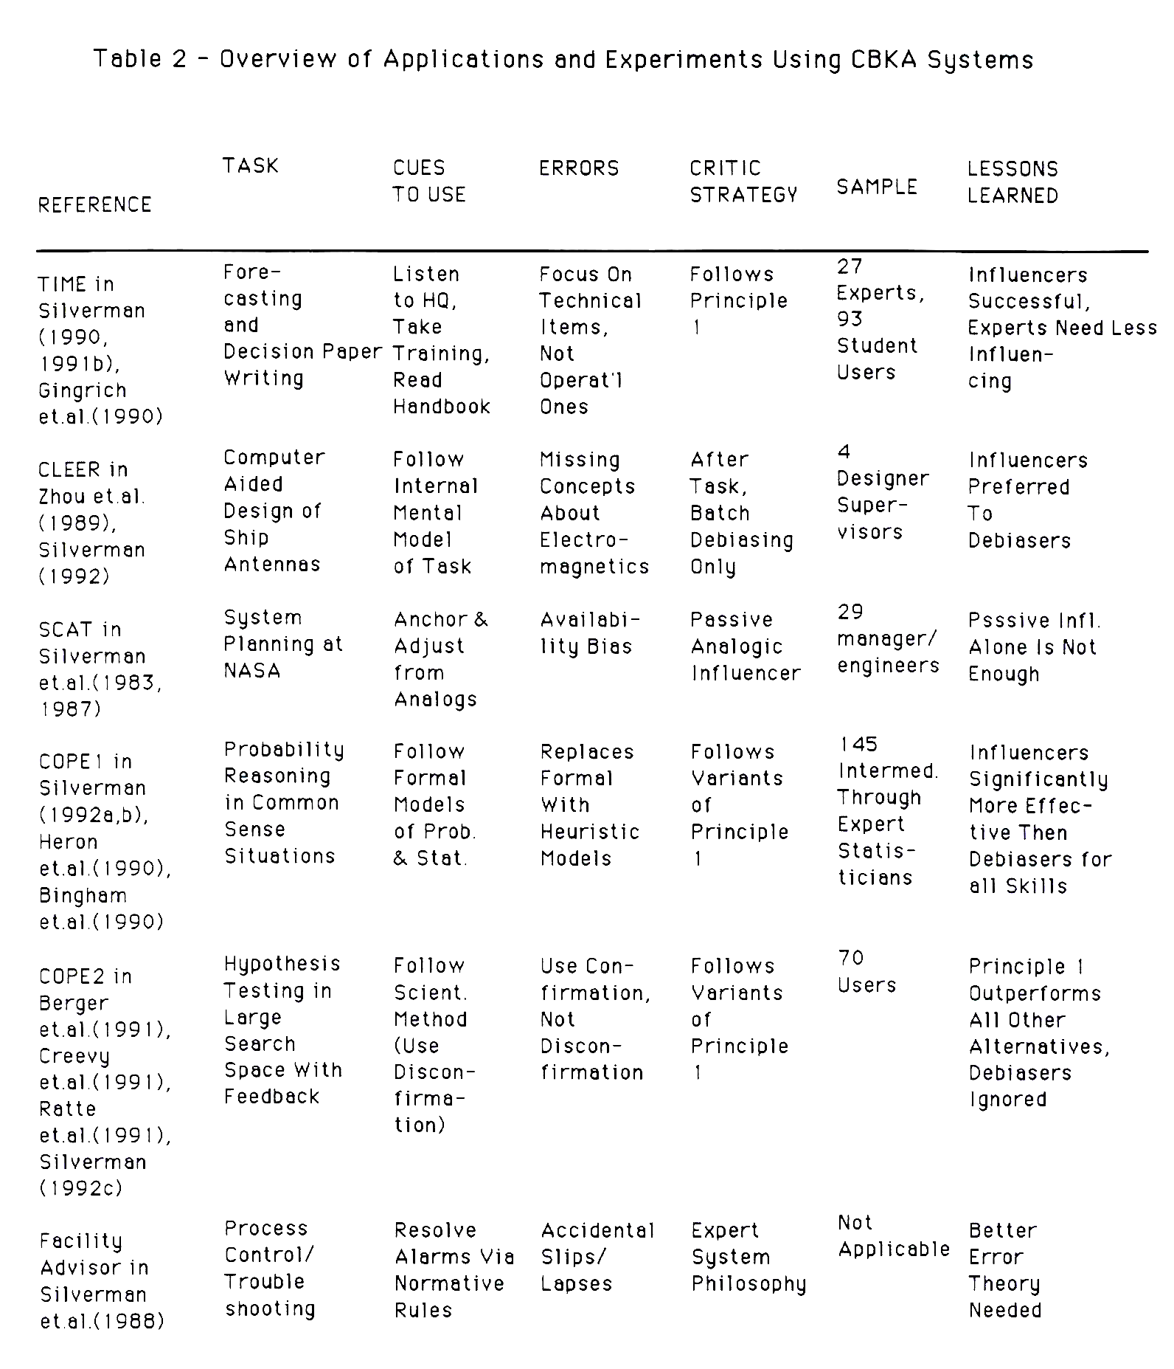

debiasing is almost always unsuitable as a sole strategy. It was found, however, that after task debiasers become more useful as task difficulty increases. This is due to the inability of the influencers to capture the subjects' attention. From the explainability viewpoint, another lesson is that the media and wording of the criticism appears to have significant impact as well.
The fifth row of Table 2 summarizes three more experiments from graduate student
critic engineers in a third semester's project. This time they chose a task of hypothesis testing in a large search space with feedback. The domain was guessing a string of numbers to induce a rule about numbers (the so-called Wason's 2 4 6 problem). The only normative cue of interest here is whether the subjects use number strings that disconfirm their hypothesis for the rule. There is a human tendency to use the confirmation heuristic, despite training in the scientific method which teaches the value of critical thinking and disconfirmation (trying to disprove a hypothesis). Individuals who use disconfirmation heuristics solve the problem. Confirmation leads to extended search and failure to reach the correct hypothesis in the time limit. The
lessons learned here repeat some of those of the previous paragraph. That is, subjects given before task influencing, and incremental during task critiquing far outperform subjects with alternative styles of criticism. Also, there was no evidence that after task debiasing helped any subject at all.
The last row of Table 2 summarizes a prototype expert advisory system built for spacecraft control and troubleshooting at a NASA control center. This prototype was largely a failure as an implementation. It violated Principle 1 in every regard. It was not a critic, but instead tried to impose expert systems philosophy (i.e., ignore the users'
solutions/transferances and suggest the correct answer independently) on the operators. We knew the expert operators were prone to errors, but the expert advisory systems philosophy was inappropriate to correcting them. For one thing, it had no knowledge of their transferances or of the errors contained in them. It is hard to advise operators without seeing what their current efforts and intentions look like. Further, we lacked a robust theory of errors such as
Norman (1983)'s slips/lapses theory or Reason (1990)'s frequency gambling/feature matching/confirmation bias theory .Thus, even if we had seen their transferances, we had no systematic approach to drive them toward a normative model. In summary , we did not view the process control task as a CBKA application. In retrospect, we could have applied the relevant theories of organizational and individual error; Principle 1 ; and the CBKA approach to operator improvement. It is possible to argue that Pilot's Associate's success to date is in pursuing my retrospective approach. We hope to examine this idea more fully in future studies.
5.2) Implications for Organizational Support Systems
The results to date are still too slim to support strong statements about how to design CBKA systems for many types of organizations. For the sake of the workshop discussion, however, I will venture some "forecasts" that our results to date suggest. The reader must realize these are highly tentative and are likely to change as more results are collected.
Specifically, Table 3 and the discussion that follows summarize my forecasts for the use of CBKA in various organizational support system roles. At some level, these forecasts will seem obvious and don't need much support to be believed. At another level, the forecasts are either counter-intuitive or controversial. I will attempt to point out some of the controversies as a guide to focus future research effort.
Across the top of Table 3 are the various organizational models. The rows of the table indicate some factors affecting the success of CBKA systems. For example, the first three rows
of the table relate directly to Principle 1. It is clear from our results to date, that not only task differences, but also organizational differences can be used by CBKA designers to scale their expectations about what to include in the decision network. Thus "rational actor" organizations can be expected to spend long times in collecting data and making decisions. They tend to digest influencers as some of our Army (TIME) and Navy (CLEER) results suggest. On the other hand, the incrementalists and time pressured organizations (last three columns of the table) often have little time or patience for interruptions of influencers. Still, practitioners in these organizations commit errors and need some mechanism for the knowledge acquisition system to help them. Our experience with the Army forecasters plus intuition about incrementalists in general suggests they are too busy, biased, and/or task involved to respond to anything but a director. The same applies to recognition primed decisionmakers. Process controllers, however , are acclimated to computer warnings and there is some evidence that they may react favorably to debiasers (e.g., see Rouse et.al., 1987, Hollnagel, 1991). A point of controversy, however, is that operators also resent any piece of software intended to oversee their work, and they are notorious for finding ways to circumvent it.
The fourth row of Table 3 concerns whether users can benefit from the machine remembering previous knowledge bases and retrieving them as analogs for reuse in the current context. This is a style of influencing or before-task critiquing since it is intended to anchor the user in a productive mindset before any erroneous behavior has a chance to take sway. That is, the user sees and uses the prior successful knowledge base and its implied normative cues as an anchor from which to make adjustments in the knowledge base currently being created. Our results to date (plus intuitions) suggest that rational actor organizations, project offices, and recognition primed decisionmakers can benefit from analogical influencers and case based memories. However, incrementalists and process operators work in too large a space of
differing problems to benefit from analogs. Similar problems recur infrequently in those domains.

The fifth row of Table 3 concerns how to get CBKA systems adopted and used. My direct experience with TIME and SCAT both involve a high level manager refusing to accept work products (knowledge bases) unless they had been created inside, and were still modifiable
within, the relevant CBKA system. There are many alternative style of adoption and insertion possible, however, my intuition is that incrementalist and time pressured organizations will tend to require some form of top down imposition of a CBKA system, at least until its use becomes institutionalized. This is due to the inertia to overcome the initial learning curve and behavior adjustment obstacles. This conclusion probably holds regardless of how intuitive and clarified is the use of CBKA system.
6) Conclusions and Research Agenda
The central thesis of this paper is threefold: (1) Knowledge acquisition systems should attempt to improve the performance, knowledge, and task outcomes of the expert practitioners who use them. (2) By doing (1 ), knowledge acquisition systems become CBKA systems that, in turn, act as organizational support systems. And, (3) different types or models of organizations exist that reveal characteristic bias tendencies that CBKA systems can and should help
overcome. This paper explores some of the characteristics of five types of organizations:
rational actors, incrementalists, recognition primed decisionmakers, process operators, and project offices.
This paper also traces some of the lessons learned and research still needed for fitting organizational support systems, CBKA systems, to these types of organizations.
Specifically, an argument is made that CBKA systems are best designed with an a priori theory of errors that accounts for fallibility tendencies of both expert cognition and organizational approach. That theory is only partially understood and many single-organizational-model- focused studies will be needed to derive a better theory of organizational (and indiviual) errors suitable for predicting how to best design CBKA systems. Nevertheless, to ignore what is already known may lead CBKA system designers to repeat past mistakes and to needlessly create sub- optimal knowledge acquisition systems.

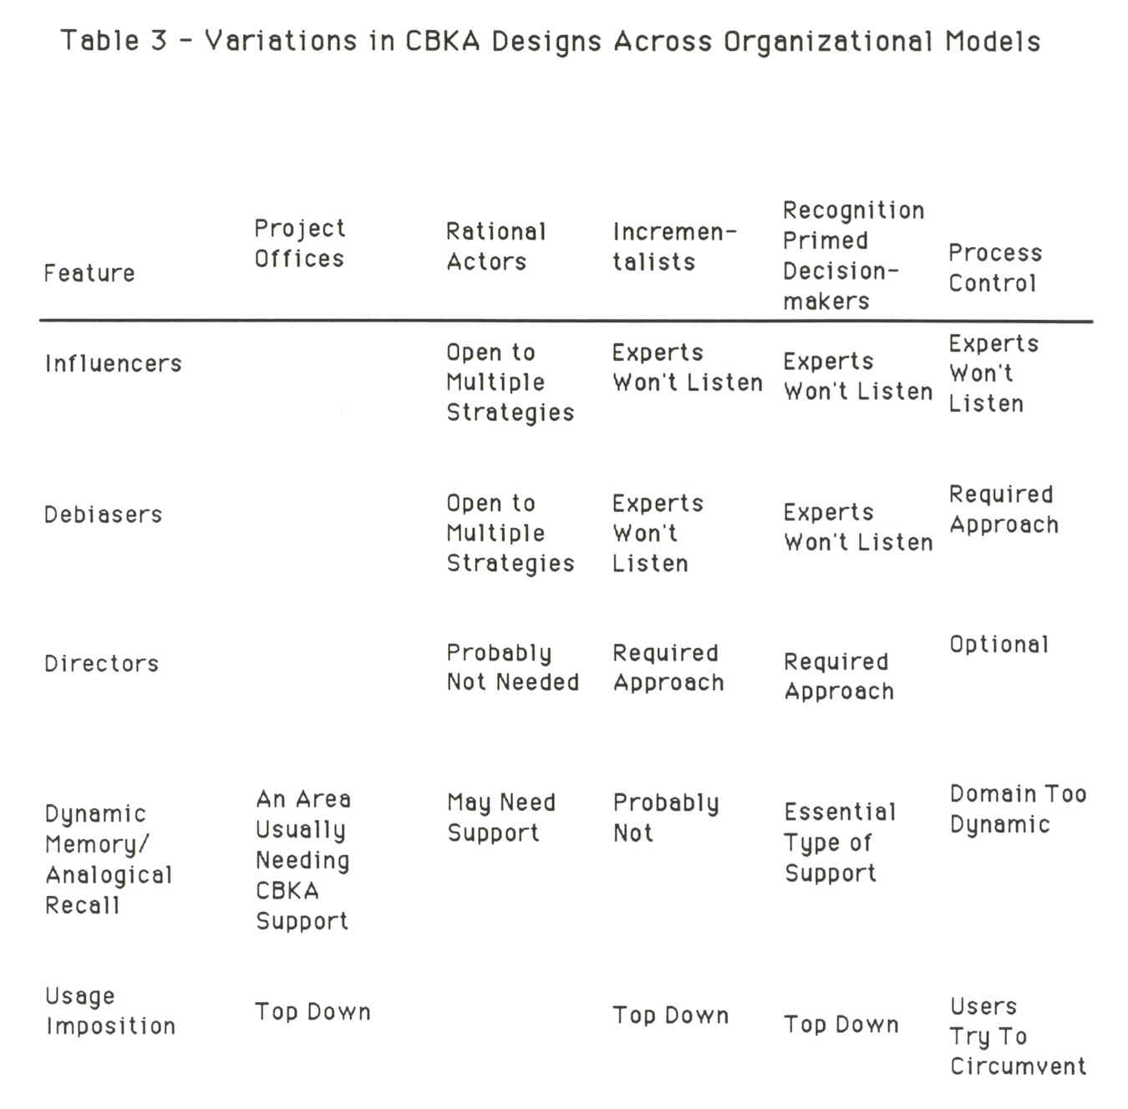

REFERENCES
Bailley, D., Developing a Rule Base for Identifying Human Judgment Bias in Information AcQuisition Tasks, Washington D.C.: George Washington Univ. Masters Thesis, Apri11991.
Berger, M., Coleman, L., Muilenburg, B., Rohrer, R., "Influencer Effects on Confirmation
Bias", Experiment Report, avail. from the Institute for Artificial Intelligence, Washington D.C.: Geo. Washington Univ ., April 1991.
Bingham, W.P., Datko,L., Jackson, G., Oh,S-H, "Establishing and Approving Quality Critical Operational Issues: An Application Using the COPE Shell", Experiment Report, avail. from the Institute for Artificial Intelligence, Washington D.C.:Geo.Washington Univ., April 1990
Brunswick, E., Conceptual Framework of Psychology, Chicago, IL: University of Chicago Press, 1952.

Creevy, l., Neal, R., Reichard, E., Turrentine, B., "Comparison of a Dynamic Critic to a Static Critic Using the Wason's 2 4 6 Problem", Experiment Report, avail. from the Institute for Artificial Intelligence, Washington D.C.: Geo.Washington Univ., April 1991.
Gingrich,S., lehner,G.,lepich,C.,Powell,D., Vautier,J.,"The Mission: A Group One Final Report", Experiment Report, avail. from Inst. for Artificial Intelligence, Washington D.C.: Geo. Washington Univ. April 1990.
Grosz, B., Sidner, C., "Plans to Support Communication and Collaboration Among Agents," Knowledge Based Human Computer Communication Symposium Notes, AMI: Menlo Park, 1990, pp. 40-43.
Herron, T .,Mackoy ,R., Mohan, et.al., "Critics for Expert Statisticians", Experiment Report, avail. from Inst. for Artificial Intelligence, Washington D.C.: Geo.Washington Univ. Dec. 1990.
Hollnagel, E., "The Phenotypes of Erroneous Actions," in G.R.Weir and J.l. Alty (eds.), Human- Computer Interaction and Complex Systems, London: Academic Press, 1991.
Houston, W.R., "Collaboration," in G.E. Hall, S.M., Hord, G. Brown (Eds.), Exploring Issues in Teacher Education: Questions for Future Research, Austin, University of Texas, 1979.
Kahneman, D., Slovic, P. Tversky, A., Judgment Under Uncertainty: Heuristics and Biases, Cambridge: Cambridge University Press, 1982.
Klein,G., "Recognition Primed Decisions," Advances in Man-Machine Sys. Research, 5, 1989, pp.47-92.
Kraut, R., Galegher, J., Egido, C., "Relationships and Tasks in Scientific Research
Collaborations", in Greif, I. (editor), Computer Supported Cooperative Work: A Book of Readings, San Mateo: Morgan Kaufman, 1988, pp.741-69.
Langlotz, C.P ., Shortliffe, E.H., "Adapting A Consultation System To Critique User Plans," 1!l1 J.. Man-Machine Studies, v. 19, 1983, pp. 479-96.
Lindblom, C.E., "The Science of Muddlin' Through," Public Administration Review, v. 19, 1959, pp. 79-99.
Miller, P.l., "ATTENDING: Critiquing A Physician's Management Plan," IEEE Trans. On PAMI, PAMI-5, n. 5, September 1983, pp. 449-61.
Norman, D.A., "Categorization of Action Slips," Psycholoaical Review, v.88, n.1, January 1988, pp. 1-15.
___________ "Design Rules Based on Analyses of Human Error," CACM, v.26, n.4, April 1983, pp. 254-8.
Newell,A., Simon,H., Human Problem Solving, Englewood Cliffs: Prentice Hall, 1972.
Ratte, D., Crowe, C., Skarpness, P., Allen, T., "Wason's 2 4 6 Confirmation Bias", Experiment Report, avail. from the Institute for Artificial Intelligence, Washington D.C.: Geo. Washington Univ., April 1991.

Reason, J., Human Error, New York: Cambridge University Press, 1990.
Rouse, W.B., Geddes, N.D., Curry, R.E., "An Architecture for Intelligent Interfaces: Outline of An Approach To Supporting Operators of Complex Systems," Human-Comguter Interaction, v. 3, May 1988, pp. 87-122.
Silverman, B.G.,"Software Cost and Productivity Improvements: An Analogical View,", Comguter Magazine, v .18, n.5, May 1985, pp. 86-96. Reprinted in Software Issue for the 1980s. T .L. Jones, IEEE/CS Press, 1986.
__________ "Critiquing Expert Judgment Via Knowledge Acquisition Systems," AI Maoazine, v.11,n.3, Fall 1990b, pp.60-79.
, "Expert Critics: Operationalizing the Judgment/Decisionmaking Literature as a Theory of "Bugs" and Repair Strategies," Knowledge Acquisition, v.3,n.2, June 1991 a, pp.175-214.
___________ "Criticism Based Knowledge Acquisition for Document Generation", Innovative Applications of Artificial Intelligence, AAAI Press, July 1991 b, pp. 291-319.
, "Expert Error and Critiquing Theory for Computer Aided Software Engineering", Washington D.C.: Inst. for AI Tech. Report, 1991c.
__________,_ Critiquing Human Error: A Knowledge Based Human-Computer Collaboration Approach, London: Academic Press book manuscript (pending publication), 1992a.
___________ "Human Computer Collaboration", Human Computer Interaction Journal, accepted for publication, 1992b.
___________ "Modeling and Critiquing the Confirmation Bias in Human Reasoning," l.E.E..E Trans. SMC, submitted for publication, 1992c.
Silverman,B.G., Hexmoor,H.H., Rastogi,R., "Facility Advisor; A Distributed Expert System Testbed for Spacecraft Operations Control", in J. Liebowitz, Telecommunications Applications of Al, J. Wiley, 1988.
Silverman, B.G., Moustakis, V.S., "The INNOVATOR Expert System: Heuristics and Representations," B.G., Silverman, (Ed.), Expert Systems For Business, Reading: Addison- Wesley, 1987 (ch. 16).
Silverman, B.G., Moustakis, V., Liebowitz,J., Bokhari, I., Tsolakis,I., "Resource Planning by Analogy: The SCA T Support System" in Micrcomputers: Tools or Toys? , ACM/NBS, June 1983.
Trist, E. (1977), "Collaboration in Work Settings: A Personal Perspective," The Journal of Applied Behavioral Science, v. 13, n. 3, pp. 268-78.
Zhou,H., Simkol,J., Silverman,B.G., "Configuration Assessment Logics for Electromagnetic Effects Reduction (CLEER) of Equipment on Naval Ships", Naval Engineers Journal, v. 101 ,n.3, May 1989, pp.127-37.

