Design, Construction and Analysis of

60 Hz Notch Filters

Group M1
Rob Jenkins
Rob Ledger
Minhthe Luu
Dan Pincus

Submitted December 10, 1998

BE 309 Laboratory, Department of Bioengineering,
University of Pennsylvania, Philadelphia 19104

Abstract
This experiment accomplished two goals: construction of Twin Tee and Wien Bridge 60Hz notch filters and evaluation of their response to frequency sweeps and EKG signals. Bode plots show a maximum attenuation of 35dB at 62.4Hz for the Twin Tee and 42.7dB attenuation at 55.6Hz for the Wien Bridge when fed a 10V_{P-P} frequency sweep. The data show that the Wien Bridge had comparable performance to the Twin Tee in attenuation of 60Hz noise from an EKG signal + 10% 60Hz noise, with 17.5dB and 18.1dB attenuations respectively. A noise to signal attenuation ratio demonstrates that the Wien Bridge and Twin Tee were comparable for an EKG + 10% 60Hz noise with a ratio of 4.7 and 4.66 respectively, but the Twin Tee outperformed the Wien circuit for an EKG + 100% 60Hz noise signal with 3.75 and 2.80 ratios respectively. A 2nd order digital Butterworth filter consistently attenuated 60Hz noise more than 1st order for both 10% and 100% 60Hz noise content in EKG signals.

Background
Household current in the United States alternates polarity 60 cycles/sec, or 60Hz. This alternation of current creates a changing magnetic field that, through induction, allows the 60Hz frequency to infiltrate nearby currents and create new alternating currents within them. The changing electric field produced by the alternating current interferes by causing alternating current to flow to ground through the system.
The human body’s nervous system employs neurons’ changing electric fields to transmit information from one part of the body to another. It is possible to detect, externally, gross neuronal activity, particularly in regions where many neurons activate at once to create a single event. Detection and interpretation of these signals can indicate whether a body is healthy or not, and if not, diagnosis may be possible. Because the bio-signals are very weak, great amplification is needed to view the signal waveform. 60Hz noise pervades the waveform because of magnetic induction in wires, displacement currents in the electrode leads, displacement currents in the body, and equipment interconnection and imperfection. This interference distorts the data, and obscures the behavior of the body. (2)
Analog filters, such as the Wien and Twin Tee, and digital filters, such as the Bessel, Chebyshev and Butterworth, can be used to suppress certain frequencies of a signal. Specifically, these filters can attenuate a 60Hz frequency and largely retain the power of all other frequencies. The attenuation of a signal frequency is given by the relationship:
dB Attenuation = -20 log (V_{out}/V_{in}) Equation 1

Filters do not only attenuate a desired frequency, but attenuate adjacent frequencies as well. An ideal notch filter will completely attenuate the desired frequencies and attenuate no others. Practically, strong attenuation and moderately sharp drop-offs are possible. In theory, the number of poles (order) that a notch filter has determines the drop-off rate; the higher the order the greater the rate. (4)
The number of active elements in the circuit determines the order of an AC filter. The active elements used in this project were capacitors. Specifically, the Twin Tee filter was a 3rd order filter because it had three capacitors, and the Wien Bridge filter was 2nd order because it had two capacitors.
The order of the filter can be further analyzed by looking at the Laplace transform of the system response of the filter. Each active element in the circuit contributes an
s-variable upon Laplacian transformation; thus a circuit with two capacitors has the general form of a quadratic over a quadratic (see Equation 2). Furthermore, because the Laplacian variable s = j$\begin{aligned}H(s)=\frac{{\text{As}}^{2}+\text{Bs}+C}{{\text{Ds}}^{2}+\text{Es}+F} \\ |H(s)|=\frac{|(s−z_{1})(s−z_{2})|}{|(s−p_{1})(s−p_{2})|}\end{aligned}$ω, the magnitude of the transfer function (of a 2nd order filter) can be represented as the quotient of the magnitudes of the roots of each quadratic (see Equation 3).
Equation 2

Equation 3

In Equation 2, the constants are dependent on the resistor and capacitor values of the circuit, and determine the z and p values of Equation 3 (which are the zeroes and the poles of the circuit, respectively). In an ideal notch filter, the transfer function will have one zero at the notch frequency (z₁ = ω_{n} * j), and one zero off the positive imaginary axis (z₂ = ω*j – k or z₂ = -ω*j), so that a frequency sweep will only yield an attenuation to zero at the notch frequency (ω_{n}). The transfer function will also have poles that are shifted slightly off the zeros (p₁ = z₁ – m ; m << 1), so that the quotient of the magnitude of the zero and its respective pole is as close to one as possible. If the quotient of every zero over its pole is close to one, the frequency response of the transfer function will be very sharp (i.e. the magnitude of the transfer function will equal one for every frequency except when ω = ω_{n}, where it will equal zero). (4)

Methods

Analog 60Hz Notch Filters
Both an analog Twin Tee and a Wien Bridge 60Hz notch filter were constructed using standard resistors, capacitors and LM741 Operational Amplifiers, each with 5% deviance (Figure 1, 2). A 10V_{p-p} frequency sweep of 5 to 550Hz generated with a Virtual Instruments Function Generator was passed through each filter; the output voltage versus the input voltage was measured using a Virtual Instruments Oscilloscope, and bode plots of the filters were created. PSpice was also used to virtually construct both the Twin Tee and Wien Bridge on a Pentium133 computer. Analyzing the filters in PSpice with a frequency sweep produced expected bode plots of the filters.

A standard 1V_{p-p} EKG signal generated by Virtual Instruments Arbitrary Function Generator was fed through each analog filter, and the attenuation of the EKG signal was measured to determine the filter’s ability to maintain signal integrity. To determine each filter’s effectiveness in reducing 60Hz noise in a heart signal, EKG signals mixed with 10% 60Hz noise and 100% 60Hz noise were passed through each filter. LabView was then used to examine the FFTs of the input and output signals and characterize each filter’s effectiveness in attenuating 60Hz noise.

Electroencephalograph Machine (EEG)
In order to characterize only the effects of the 60Hz notch filter of the EEG machine the built-in low and high-pass filters were set on their highest and lowest settings, respectively. As with the aforementioned Twin Tee and Wien Bridge filters, a frequency sweep of 5 to 550Hz was passed through the EEG machines, as well as EKG signals with 0%, 10% and 100% 60Hz noise. FFTs and V_{out} vs. V_{in} were created and analyzed to determine the characteristics of the EEG machine’s 60Hz notch filter.

Digital 60Hz Notch Filters
Digital bandstop filters were setup in LabView to emulate the analog filters. Because, in LabView, the cutoff frequencies correspond to where the digital filter attenuates the signal by 3 dB, corresponding cutoff frequencies were determined from the Bode plots of the analog filters. The low and high frequency cutoffs for both the digital Wien Bridge and Twin Tee filters were chosen to be (20Hz , 175Hz) and (16Hz , 250Hz), respectively. As above, a frequency sweep, clean EKG, and EKG plus 100% 60Hz noise signal were fed through the digital Chebyshev, Bessel, and Butterworth filters. The effectiveness of the digital filters was determined by comparing the power of the 60Hz frequency before and after filtering using FFTs.

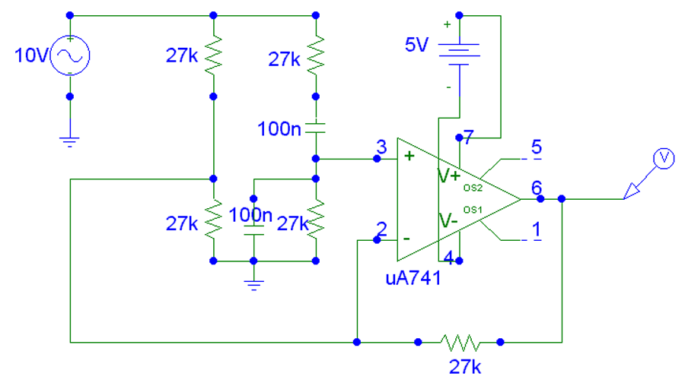
Figure 1. Wien Bridge

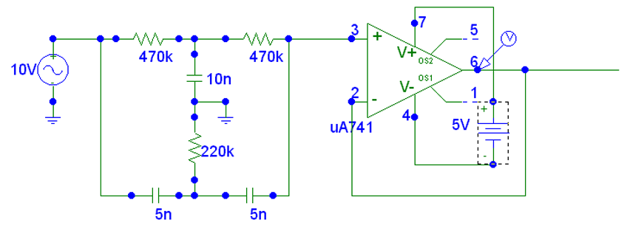
Figure 2. Twin Tee Filter

Equipment
- LM 741 Operational Amplifier
- Capacitors, Inductors, Resistors
- Bread boards
- Power Supply
- Signal Generator
- Oscilloscope

Virtual Bench, LabView

Results
Bode plot was constructed from varying the input frequency from 5Hz to 800Hz and measuring the output voltage. Input voltage was set to 10Vp-p in both cases. Using an oscilloscope, frequency at which the greatest attenuation was achieved was 60.2Hz for the Twin Tee filter and 55.6Hz for the Wien Bridge.
Figure 2. Bode plot of 60Hz Twin Tee and Wien Bridge notch filters.
Note the greater attenuation rate of the Wien Bridge indicative of less signal distortion.

Data summarized in Table 1 show the actual dB attenuation from each notch filter for both the signal and noise components. Since both filters affected the signal in addition to attenuating the noise, the efficiency of the filter is defined to be the ratio of the noise attenuation divided by the signal attenuation in dB.

Table 1. dB Attenuation
Attenuation of a EKG + 10% 60Hz signal |  |  |  | Attenuation of a EKG + 100% 60Hz signal
 | Wien | Twin Tee |  |  | Wien | Twin Tee
Noise(dB) | 17.5 | 18.1 |  | Noise(dB) | 19.7 | 27.4
Signal(dB) | 3.72 | 3.9 |  | Signal(dB) | 7 | 7.3
Summary of dB attenuation of the actual signal and noise components by the notch filters.

Figure 4 shows the two notch filters to be comparable for filtering 10% 60Hz noise, but the Twin Tee outperforms the Wien Bridge for 100% 60Hz noise.

Figure 4. Efficiency of Wien and Twin Tee Filters
Summary of the overall efficiency of Wien Bridge and Twin Tee for both 10% and 100% 60Hz noise.

The 60Hz notch filters were modeled by a 1st order and 2nd order digital filter. In both
cases, whether with 10% or 100% 60Hz noise, the 2nd order digital filter doubled the noise attenuation compared to the 1st degree filter as summarized in Figure 5.

Figure 5. EKG Noise Attenuation in Digital Butterworth Filters

A 2nd order filter consistently outperformed the 1st order filter in both 10% and 100% 60Hz noise.
Table 2. Phase Shift of Wave Complex in Seconds
Time Delay (seconds)
Wave Complex | P-Q | Q-R | R-S | S-T
2T (EKG) | 0.012 | -0.004 | -0.004 | 0.009
2T (100%) | 0 | 0 | -0.011 | 0
Wien (EKG) | 0 | 0 | 0 | 0
Wien (100%) | 0.01 | 0 | 0 | 0
No significant time delay is noticeable in signals.

The phase shift was calculated by measuring the delay in peaks of each wave complex of the original signal to the filtered signal.

Discussion
The tabulated results show that the Twin Tee and Wien Bridge analog notch filters are both effective in reducing noise in a standard EKG signal. In terms of efficiency (noise attenuation / signal attenuation), the two are comparable in filtering an EKG + 10% noise signal. However, the Twin Tee is more efficient at filtering the
EKG + 100% noise signal; that is, in terms of dB, the Twin Tee attenuated the noise about 3.8 times as much as it attenuated the signal, while the Wien Bridge attenuated the noise about 2.8 times as much as the signal. It is important to note that this difference in efficiency is not due to a decrease in attenuation of the signal; both filters in the
EKG + 100% noise case attenuated the signal by 7.0 dB. The difference was due to the fact that the Twin Tee attenuated the 100% noise by 27 dB, while the Wien Bridge only attenuated the noise by 19 dB. Therefore, the difference in efficiency was due solely to the increased ability of the Twin Tee over the Wien Bridge to attenuate 60Hz noise. Further analysis of the Bode plots of these filters supports this conclusion: at 60Hz, the Twin Tee has its maximum attenuation of 35 dB, while the Wien Bridge attenuates by 25 dB. The noise attenuation data was originally calculated by measuring the peak-to-peak voltage of the noise in the region between the PQRST wave. The signal attenuation data was measured as the voltage change between the R peak and the S peak. This data was supported by a frequency analysis, where the power at the 60Hz frequency in an FFT was measured from a unfiltered and filtered signal. The signal attenuation could not be measured in this way, because the EKG signal was composed of a range of frequencies.
Analysis of the EEG proprietary 60Hz notch filter led the experimenters to the conclusion that the EEG machine is unacceptable in filtering EKG signals. In addition to a 60Hz notch filter, the EEG machine has low-pass and high-pass filters that are impossible to disable. Even with the cutoff frequency set at the highest setting for the low-pass filter (75 kHz) and the cutoff frequency set at the lowest setting for the high-pass filter (0.1 Hz), the filters attenuated an EKG signal to the point that it was unrecognizable. Because the effect of these filters could not be eliminated, there was no way to accurately test the effectiveness of the 60Hz filter. The conclusion is that the EEG is ineffective at monitoring EKG signals, mainly because the important content of the EKG signal is at 1 Hz. Most EEG signals are at much higher frequencies, so the EEG machine was not made with the intention of monitoring a 1 Hz signal.
Analysis of the digital counterparts of the analog filters was tainted by poor experimental procedure. The digital filters were designed to model the analog filters; however, the original analog Twin Tee filter had a design flaw that radically reduced its maximum attenuation and its attenuation rate. Therefore, the digital model of the Twin Tee filter was based on a flawed Bode plot, and was a first order filter. When it became apparent that the Twin Tee filter was not a first order filter, but rather inaccurately designed, there was no longer time to test a digital filter based on the new Twin Tee Bode plot. If there had been time, the digital model of the Twin Tee filter would have been a 3rd order filter with cutoff frequencies at 16Hz and 250Hz.
The data taken of the digital filters is a good characterization of 1st and 2nd order filters, and the second order filter does approximate the analog Wien Bridge filter. The second order digital filter attenuated the noise by about 8 dB more than the Wien Bridge. Furthermore, both digital filters’ attenuation showed less dependence than the analog filters’ on the noise content of the input signal. That is, the maximum difference between the dB attenuation of the noise in a digital filter from the EKG + 10% to the EKG + 100% signal was 8% (in the 2nd order filter). However, the minimum difference in an analog filter was 12% (in the Wien Bridge) and the maximum was 50% (in the Twin Tee). The digital filters showed a greater and more consistent attenuation of noise than their analog counterparts.
An interesting question to analyze is why the digital filters’ attenuation was more dependent on the order of the filter than the analog filters’ attenuation. For example, the difference in attenuation of 100% noise between a 2nd order and a 3rd order analog filter (Wien Bridge vs. Twin Tee) was about 7.7 dB. However, the difference in attenuation of noise in the same signal between a 1st order and a 2nd order digital filter was about 13.6 dB. There are two obvious possible explanations for this phenomenon. The first is that attenuation dependence not linear; that is, the change from a 1st to a 2nd order filter is much greater than the change from a 2nd to a 3rd order filter. The other possible explanation is that the digital bandstop filter is really a linear combination of low- and high-pass filters. Ideal low- and high-pass filters’ attenuation rates are strongly order dependent. Thus, the digital bandstop filter would show the same dependence if it were composed of these filters. The analog filters would not show the same dependence, because they are not algebraic combinations of low- and high-pass filters.
EKG data, in clinical situations, is analyzed in a very subjective manner; that is, doctors make preliminary diagnoses of a patient’s condition based on the shape and look of their EKG wave. Thus, the most important factor to look at when considering the usefulness of filters is how the filter changes the shape of the EKG wave. Notch filters can change the shape of the wave because the sharp changes in the PQRST wave occur at higher frequencies (around 30-50Hz). If the filter attenuates a significant amount of power of these frequencies, the peak will lose its sharpness. In this study, the shape of the EKG wave was characterized by the time between the peaks of the PQRST wave. These times were measured in a ‘normal’ EKG, the same signal run through the two analog filters, and the EKG + 100% 60Hz noise run through the two analog filters. The times were measured by examining the graphs of the EKG waves, determining the number of seconds per pixel, and calculating the time between peaks based on the number of pixels between them. This process used MS Paint™ in zoom, so that the error in any given calculation is estimated to be a maximum of 2 pixels. After determining the time between the peaks in a normal EKG wave, and the times for the filtered waves, the difference was calculated in time and then in pixels. The filters had a remarkably little effect on the times between the PQRST peaks in all situations. When the time shifts shown in Table 2 are expressed in terms of pixels, the magnitudes range from 0.38 to 2.1. Obviously any values below 1 pixel are under the resolution of the computer monitor and therefore a function of error. It is estimated that the greatest shift, 2.1, is also within the error of the experimental method. Thus, via this method, the filters had no significant effect on the shape of the EKG wave.
However, the filters affected the EKG wave in ways that were subjectively noticeable but completely ignored by the previous method. For instance, the Wien Bridge flipped the EKG signal upside-down. While this is easily remedied, it is certainly an aspect of filtering the signal that needs to be taken into account. Furthermore, the filters could change the shape of the signal without changing the time between the peaks. As is evident in Appendix Figures 1 and 2, the complex between the S and T peaks of the unfiltered signal is very different from the complex in the filtered signal. This change does not show up in the time between the S and T peaks, and thus is left out in the method used above.
In conclusion, this study supports the contention that the Wien Bridge and Twin Tee analog 60Hz notch filters, as constructed, are effective at removing the noise from an EKG signal. Digital models of the analog filters proved to be more effective, in terms of decibels, at removing the noise. Thus, a real-life system of an EKG machine with a proprietary analog filter that then sends the signal for digital processing would most likely yield the signal of greatest clinical use. Further studies would need to analyze the digital filters’ effects on the shape and time between peaks of the PQRST wave. They should also involve an experienced cardiologist who could verify if the filters (both analog and digital) were maintaining the integrity of the signal. Finally, they should include an analysis of how the filters respond to irregular heartbeats; because these EKG waves have different frequency content, the filters might distort them more than the normal EKG.

References
1) Berbari, Edward J. Principles of Electrocardiography. Biomedical Engineering Handbook. 1995. CRC Press, Hartford CT.

2) Huhta, James C., Webster, John G. 60-Hz Interference in Electrocardiography. IEEE Transactions on Biomedical Engineering, Vol BME-20, No2 March, 1973.

3) Mims III, Forest M. Engineer’s Mini-Notebook, Second Edition. 1985, RadioShack,
USA.

4) Dr. Kenneth Foster. Professor of Bioengineering, University of Pennsylvania.

5) Morrison, Ralph. Noise and Other Interfering Signals. 1992, John Wiley & Sons, Inc., New York.

6) Tompkins, W, Webster, J. Design of Microcomputer Based Medical Instrumentation. 1981. Prentice Hall Inc. Englewood Cliffs, NJ.

7) Webster, John G. ed. Medical Instrumentation—Application and Design, 2nd ed. 1992, Houghton Mifflin Company, Boston.

8) Webster, John G. et al. Sensors and Signal Conditioning. 1991, John Wiley & Sons, Inc., New York.

9) Winter, Bruce B., Webster, John G. Driven-Right-Leg Circuit Design. IEEE Transactions on Biomedical Engineering, Vol BME-30 No 1. Jan 1983.
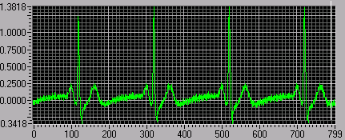Appendix A

Figure A.1 Sample input signal of EKG + 10% of 60Hz noise

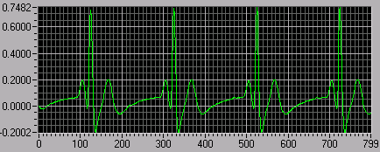Figure A.2 Filtered signal after an analog Twin Tee filter

Figure A.3 FFT of EKG + 10% 60Hz signal
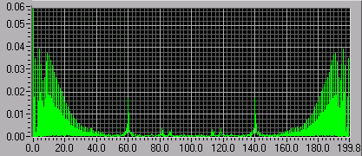

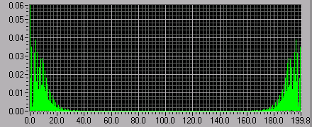Figure A.4 FFT spectrum of signal after Twin Tee filtering

Appendix B

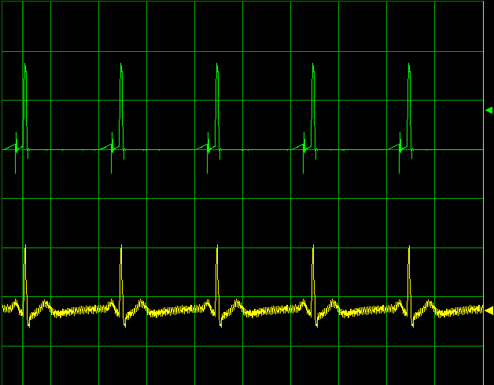Figure B.1 EEG 60 Hz filter with 10% 60Hz noise content

Figure B.2 Output signal after feeding in 10% 60Hz noise through first order digital filter
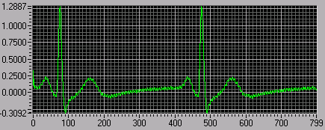

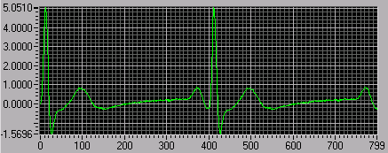Figure B.3 Output signal after feeding in 10%60Hz noise through second order digital filter

