Measuring Polypropylene and Nylon Suture Displacement During Uniaxial Tension

April 25, 2007

Gina Cheng
3901 Locust Walk
Box 701
Philadelphia, PA 19104
(240) 277-2230

Background

In clinical practice, surgeons use sutures to keep wounds closed as the tissue heals. Thus, the sutures must be able to withstand a fair amount of force without deforming and allowing the wound to open. Assuming α=0.05, previous research has shown that under the same force, 6 sutures per 2 cm wound length exhibits significantly less strain than when using 3 sutures per 2 cm; all sutures tested were running locked and 100% nylon thread.¹ This conclusion suggests that a greater number of stitches used per unit of distance will allow the sutured material to show less strain, and thus more sutures will better prevent wound separation under load. Though surgeons could theoretically simply use more sutures to securely close a wound, they would have to spend additional time in the operating room.
To expand on the existing experiment, 6 running locked polypropylene sutures per 2 cm will be tested under the same conditions as the original nylon sutures. Both nylon and polypropylene sutures are nonabsorbable, so they would typically be used to close similar types of tissues during surgery. Since 6 nylon sutures have already been shown to have less strain relative to the 3 nylon suture samples, 6 polypropylene sutures per 2 cm will be tested in the proposed project. The sample set that exhibits less strain, either the polypropylene or the nylon thread, will determine which suture material better maintains a closed wound site; the same number of sutures using the identified material will permit less displacement between the two pieces of sutured material, thus making it more efficient to use during surgery.

Hypothesis/Objective and Aims

The proposed project will determine whether the suture material affects the amount of strain of a sample, assuming the testing conditions are the same: suturing technique (running locked), number of sutures per unit of length (6 sutures per 2 cm), suture diameter (0.1 mm), and load applied (static, 1-kg weight). It is hypothesized that the strain of the samples sutured with 100% polypropylene thread will be significantly different from that of the samples sutured with 100% nylon thread. The new polypropylene thread data set will be compared to the original nylon thread data set in order to test this hypothesis.

Equipment

Major Equipment
- A CCD Camera (640x480 pixels) will record digital images of the samples in order to assess the deformation of the sutures. (Since the deformation is expected to be relatively small, a digital image offers more accuracy in calculating the deformation length than a direct measurement using a ruler.)

Lab equipment
- A ruler will be used to spatially calibrate the camera, allowing the conversion from the number of pixels in a digital image into traditional units of length. The ruler will also be used to measure the desired dimensions of the felt sample material.
- A 1-kg weight will serve as the source of static load applied on the sutures.
- 2 clamps will hold both ends of the felt material. (The upper clamp will be fixed on a stand. The lower clamp will be attached to the bottom edge of the felt and also attach the 1-kg weight.)
- 2 stands will be needed as stationary supports – one to fix the upper clamp and the other to fix the CCD Camera.
- LabView 8.0 and BMPReader software will be used to record and analyze the digital images.

Supplies
- Stiffened Eazy Felt (UPC 0831101806) will serve as the sample material that will be sutured.
- A sewing needle will be used to suture the felt material with polypropylene thread.
- Scissors will be needed to cut the sutures and felt material according to the specified dimensions.
- A marker pen will be used to outline, on the felt, the dimensions according to which the material will be cut. The pen may also be used to mark the felt where the sutures must be placed for each sample.

Newly Purchased equipment
- 100% polypropylene thread, of size 5-0, will serve as the suture material being tested. (The original nylon thread has a diameter of 0.1±0.05 mm, and the size 5-0 polypropylene thread corresponds to this same diameter.)

Proposed Methods & Analysis

Five samples of the polypropylene sutures will be tested under the same loading conditions as the five original nylon suture samples, and the same method of digital imaging will be used to measure the gap-width of the loaded samples (Appendix Figure 2). The following protocol, which has been adapted from the original experiment using nylon sutures¹, details the newly proposed experiment:

Procedure Step | Estimated Time for Completion
- Use 6 evenly spaced, running locked sutures (with 100% polypropylene thread) to sew two pieces of 2.00 cm by 3.00 cm felt together along the 2.00-cm edge, as shown in Figure 1 of the Appendix. This constitutes one sample. Create 5 samples total. | 60 min  (12 min/sample)
- Calibrate the Sharp CCD Camera by taking 5 pictures of a ruler that is loaded on the clamps in the exact orientation in which the samples will be (same distance from the camera and same angle). | 10 min
- Using the digital images in the BMPReader window, determine the average number of pixels in one centimeter according to the ruler. This is the pixel to actual deformation conversion factor. Calculate the 95% confidence interval to assess the amount of measurement error. | 20 min
- Load each sample vertically in the clamps. Attach a 1-kg mass on the bottom clamp. After 1 minute, take a digital image of the sample. | 25 min  (5 min/sample)
- Using the horizontal cursor bars in BMPReader, determine the gap-width in pixel units between the two halves of felt material for each sample. Use the conversion factor to calculate the actual deformation of the sutures. | 10 min
- Use the deformation values to calculate the suture strain of each sample (deformation divided by original length), with a gauge length of 2.00 cm. | 5 min
- If the variance of the calculated polypropylene strain values is less than 5% of the sample set mean, use a two-sample t-test assuming equal variances to compare the strain of the polypropylene sutures and that of the nylon sutures (Appendix Table 1). Otherwise, use a t-test assuming unequal variances. Based on the two-tailed p-value, determine if the polypropylene suture sample exhibits a significantly different strain. | 5 min

Potential Pitfalls & Alternative Methods/Analysis

There is inherent error in the accuracy of the results since both deformation and strain values are derived from the raw pixel data. This error, however, can be quantified during the calibration of the camera with the ruler. The procedure specifies that 5 images of the calibration ruler should be taken. The experimenter must then average the number of pixels between two 1-cm ruler markings, and then proceed to calculate the 95% confidence interval as an indicator of error. In the previous nylon suture experiment, a calculation of 95% confidence for the pixel-to-actual-deformation conversion factor produced an interval of ±3.2%.¹
The 640x480 pixel resolution of the CCD Camera also limits the accuracy of the results. The edges of the felt pieces along the gap may be difficult to see depending on the lab room lighting. To minimize this possible source of error, the contrast of the images may be adjusted on LabView. Also, as in the nylon suture experiment, a dark background may be placed behind the white felt material when recording digital images. This would enhance the clarity of the gap edges, making the measurement of the gap-width more accurate.
In the original nylon suture experiment, the loaded samples were assumed to be flat when loaded. During the actual testing, however, the actual samples bent slightly when the static force was applied. The sample bending should not affect the data since only the gap-width was measured; the suture material within this gap should have experienced a negligible amount of bending, and thus, can be considered as flat. Even so, one must be aware of this potential source of error when comparing the data. To eliminate the error, the experimenter could use longer felt samples for testing the polypropylene sutures. A longer sample piece would only show slight bending at the bottom end due to the lower clamp, and there would be no observable bending near the sutures.

Budget

Purchase | Supplier | Specifications | Unit Cost | Quantity | Total
100% polypropylene thread | Mountainside Medical Equipment, Inc. | Size 5-0 | $ 39.50²  (per box of 12-18” threads) | 9  (5 threads for each of the twenty BE-210 groups) | $ 355.50

References

¹ Gina Cheng, Sameer Kirtane, Albert Kong, and Lauren Pietruszynski. Imaging Techniques for Measuring Suture Displacement During Uniaxial Tension. Department of Bioengineering, University of Pennsylvania. Philadelphia: University of Pennsylvania, 2007.

² "Sutures." Mountainside Medical Equipment, Inc. 2005. 24 Apr. 2007 <http://www.mountainside-medical.com/products_display.cfm?productID=119FE9BB-D7DC-9124-8F078C52100965CA>.

Appendix

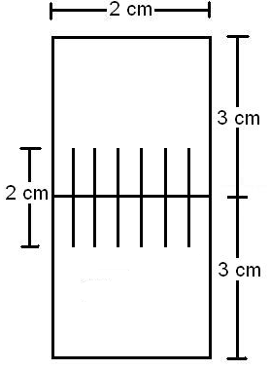
Figure 1: Diagram of polypropylene 6-suture sample.

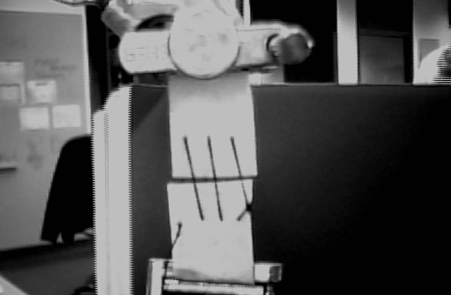
Gap-width
Figure 2: Gap-width of a loaded sample. The digital image shown here is of a deformed nylon 3-suture felt sample, taken with a camera having a 640x480 pixel resolution; the samples for the proposed project will be polypropylene 6-suture felt samples. ¹

Sample | Strain (mm/mm)
1 | 0.027328897
2 | 0.036537548
3 | 0.036537548
4 | 0.027328897
5 | 0.027328897
Average | 0.031012357
Standard Deviation | 0.004511299

Table 1: Strain of each nylon 6-suture felt sample with gauge length of 2.00±0.05 cm.¹

