Supplementary Information for Computational Delineation of the Catalytic Step of a High Fidelity DNA Polymerase by Ravindra Venkatramani and Ravi Radhakrishnan

Contents
Supplementary Methods: S1.1-S1.4
Supplementary Tables: S1-S3
Supplementary Figures: S1, S2
References

Supplementary Methods
S1.1 System Preparation: A ternary complex of BF/DNA/dNTP (explicitly solvated) with correct dCTP opposite guanine G (or G:dCTP) was constructed as reported in our prior studies ^{1,2}. Hydrogen atoms are added to the model using the HBUILD utility in CHARMM ³. The protonation states of histidine (HIS) residues are chosen according to recommendations from the WHATIF web interface (http://swift.cmbi.kun.nl/WIWWWI). Protonation states for all other groups except those at the catalytic site are chosen based on their individual pKa values in aqueous solution at a pH 7.0 ⁴. The model complexes are then solvated in a cubic box of water molecules and neutralized by placing Na⁺ and Cl⁻ ions around the complexes at an ionic strength of 75 mM using the program Solvate 1.0 ⁵. All Na⁺ and Cl⁻ ions are placed at least 8 Å away from any protein atoms and from each other. The ions are positioned at points of electrostatic extrema using a Debye-Huckel potential (corresponding to a temperature of 300K) calculated within Solvate. 5 ns classical molecular dynamics production trajectories are obtained for this system after standard equilibration protocols.

S1.2 pKa Calculation: In order to assess the effect of the protonation states of the conserved catalytic site aspartic acid residues, we employed a Poisson-Boltzmann approach ⁶⁻⁸ to evaluate the relative stabilities of the ground state (ternary complex in the closed state) in several models. Our implementation of this approach considers a protein with a particular titratable site (labeled i) and compares its pKa (denoted pKa_{i}^{int} for intrinsic pKa of residue i) to that of an the corresponding isolated amino acid (A) in solution (denoted pKa_{i}⁰) using the relationship ⁶: pKa^{int}=pKa_{i}⁰ - y(i)ΔΔG_{i}^{env}/2.3k_{B}T. Here, ΔΔG_{i}^{env} is the change in the electrostatic energy of the ionizing the group in the protein environment relative to solution and y(i) = -1 or 1 for an acidic or basic group, respectively. Using a thermodynamic cycle ⁶⁻⁸, ΔΔG_{i}^{env} is given by: ΔΔG_{i}^{env} = -y(i)* [ΔG_{i}^{env}(A)- ΔG_{i}^{env}(AH)], where ΔG_{i}^{env}(A) is the difference in the free energy of interaction of A (in the unprotonated state) with its protein environment relative to the reference state in solution. ΔG_{i}^{env}(AH) is the corresponding term for the protonated state. The contribution to ΔG_{i}^{env} is broken up into two contributions: ΔG_{i}^{env} = ΔG_{i}^{RF}+ ΔG_{i}^{PERM}, where ΔG_{i}^{RF} is the difference in reaction field energy in the isolated state and in the protein, and ΔG_{i}^{PERM} is the contribution of the permanent charges. The reaction field term is computed using the Poisson-Boltzmann (PB) solver in CHARMM, i.e. determined from the difference in the reaction field potential Δφ^{RF} at a charged atom in an isolated amino acid side chain, which is assumed to have the same structure as the corresponding side chain in the protein: ΔG_{i}^{RF} = q_{i}* Δφ^{RF} /2. ΔG_{i}^{PERM} is the free energy term arising from interactions between a particular ionizable amino acid and the potential Δφ^{PERM} due to partially charged atoms in the rest of the protein: ΔG_{i}^{PERM} = Σ_{j} q_{j}*Δφ^{PERM}, where the summation over j includes all charged sites in the side chain of the ionizable group. We explored the protonation states of four titratable residues in the active-site as depicted in table below:

Residue | ΔF [Kcal/mol] | pKa^{int}
D653 | -3.4 | 2.5
D830 | -10.6 | 7.7
D865 | -6.2 | 4.5
O3' (DNA terminus) | -13 | 9.5

Here, ΔF=y(i)ΔΔG_{i}^{env}-2.3*k_{B}T*pKa_{i}⁰. Based on the trend (Table above), D830 leads to a maximal lowering of free energy among the three catalytic aspartic acid residues. Our calculations also reveal that for the pH range of operation between 4.5 and 9.5, the primer terminus of DNA (namely the O3' atom) likely remains protonated and that the protonation of D653 and D865 increases the free energy relative to the unprotonated system. Hence, we constructed different model systems for different protonation states of the aspartic acid residues; Model 1: all three unprotonated; Model II: D653 protonated; Model III: D830 protonated; and Model IV: D865 protonated.

S1.3 Umbrella Sampling: During our umbrella sampling simulations we apply a harmonic restraint to each reaction coordinate d_{i} which adds a new potential bias 0.5*K_{i}*(d_{i}-d_{i}⁰)² to the QMMM Hamiltonian. Here K_{i} is the force constant of the coordinate d_{i} and d_{i}⁰ is the reference value around which the coordinate d_{i} is restrained. By varying the offset of the restrained potential in steps of 0.1-0.5 Å chosen to obtain overlapping windows, we effected the transition of the system from reactant to the product. At each window, we performed 100 steps of energy minimization using the steepest-descent (SD) method followed by Langevin dynamics (with friction coefficient γ = 10 ps⁻¹) at 300 K with a 1 fs timestep for 300 steps and subject to d_{i}⁰ and a forcing restraint of 1000 kcal/mol/Å². Note that this large K_{i} was employed to bring the system to the desired constraint values and data from this segment of the trajectory was not utilized in any free energy calculation. This was followed by a second round of Langevin dynamics (which provides the actual data for umbrella sampling) at 300 K of 1000 steps (1 ps) for model I and 500 steps ( 0.5 ps) for model III, per window, subject to d_{i}⁰ and to a lower value of the forcing restraint K_{i} as described below.
Model I: we employed five reaction coordinates based on distance between two select atoms: terminal primer adenine O3′-dCTP P_{α} (d_{a}); terminal primer adenine O3′-Catalytic Mg²⁺ (d_{b}); proton H3T-dCTP:O1_{α} (d_{c}); proton H3T-dCTP:O2_{β} (d_{d}); and dCTP:O3_{α}-dCTP P_{α} (d_{e}). The specifications of the various constraints in terms of K_{i} and d_{i}⁰ are: we first performed umbrella sampling simulations by reducing d_{a}⁰ from 3.00 Å to 1.25 Å in steps of 0.5-0.1 Å. For d_{a}⁰= 3.0 to 1.5 Å, we set K_{i}=50 kcal/mol/Å². For d_{a}⁰=1.50 Å, windows were further sampled at restraints of K_{i}=50, 70, 90, 110, 130, 150 kcal/mol/Å², respectively. We performed umbrella sampling by reducing d_{c} from 3.00 Å to 1.00 Å in steps of 0.5-0.25 Å and K_{i}=20 kcal/mol/Å². We performed 2d umbrella sampling along d_{d} (reducing d_{d}⁰ from 3.5 Å to 1 Å with K_{i}=20 kcal/mol/Å²) and d_{a}⁰=1.50 Å at K_{i}=150 kcal/mol/Å². We performed 2d umbrella sampling along d_{e} (increasing d_{e}⁰ from 1.7 Å to 2.7 Å with K_{i}=50 kcal/mol/Å²) and d_{a}⁰=1.50 Å at K_{i}=150 kcal/mol/Å².
Model III: we employed five distance-based reaction coordinates: terminal primer adenine O3′-dCTP P_{α} (d_{a}); O3′-catalytic Mg²⁺ (d_{b}); proton D830:H2_{δ} - dCTP:O2_{β} (d_{c}); O3′-proton H3T (d_{d}); and dCTP:O3_{α}-dCTP P_{α} (d_{e}). The specifications of the various constraints in terms of K_{i} and d_{i}⁰ are: we first performed umbrella sampling simulations by reducing d_{a}⁰ from 3.00 Å to 2.00 Å (steps of 0.25 Å) and K_{i}=50 kcal/mol/Å². Next a 2-dimensional umbrella sampling was performed along d_{a}, and d_{c,} reducing d_{a}⁰ from 2.00 Å to 1.10 Å (steps of 0.3-0.1 Å), and reducing d_{c}⁰ from 2.5 Å to 1.00 Å (steps of 0.5-0.1 Å) and subject to a forcing restraint of K_{i}=20 kcal/mol/ Å² along both d_{a} and d_{c}. We then performed umbrella sampling increasing d_{d}⁰ from 1.0 to 2.3 Å with K_{i}=20 kcal/mol/ Å². Finally, we performed umbrella sampling increasing d_{e}⁰ from 1.8 to 2.6 Å with K_{i}=20 kcal/mol/ Å².

S1.4 Umbrella Sampling along the Principal Components (PCs): For the m^{th} PC the eigenvector ξ_{m} represents unit displacement along that mode. If R(0) represents the geometry of the active site for a_{m}=0 then R(a_{m})=R(0)+ a_{m}*ξ_{m} represents the geometry for a displacement of a_{m} units along the m^{th} PC. Our goal is to find the free energy change as the amplitude a_{m} of the mode changes by Δa_{m} such that it reduces d_{a} by Δd_{a}; since our previous work ¹ has shown that the reduction in d_{b} is correlated to that in d_{a} it is sufficient to track only d_{a}. Starting with an active site reference geometry R(0), for each PC the amplitude was scanned in steps of unit displacements to reduce d_{a} from 3.5 Å to 3.0 Å (concomitantly, d_{b} reduces from 2.7 Å to 2.0 Å) and snapshots R(a_{m}) were recorded for each step. The initial values of the reaction coordinates (d_{a}=3.5 Å, d_{b} =2.7 Å) correspond to average values from 5 ns classical MD simulations reported earlier ¹. Constrained classical MD simulations were carried out for the subsystem used in the QMMM simulations, starting from the same reference geometry R(0) for the active site used earlier. For each unit displacement along the m^{th} PC we perform two rounds of SD minimization followed by Langevin dynamics (γ=10 ps⁻¹) at 300 K with a 1 fs timestep. A positional harmonic restraint was applied to the heavy atoms of the active site to force it to the geometry of the corresponding snapshot R(a_{m}) during the simulations. The first round is performed with a high value of forcing restraints (2000 kcal/mol/Å²) applied to atoms of the active site and consists of 50 steps of SD minimization followed by 500 steps of ABNR minimization and 1000 step Langevin dynamics. The second round is performed with a lower value of the forcing restraint (200 kcal/mol/Å²) and consists of 50 step SD minimization followed by 500 steps of ABNR minimization and 10000 steps (10 ps) of Langevin dynamics per window. Coordinates were saved every 20 steps during the dynamics run of the second round (total 500 snapshots) for free energy computations.
For each unit displacement window along the PC corresponding to amplitude a_{m}, the WHAM algorithm mentioned earlier was applied to the snapshots from the constrained simulations to obtain the unbiased probability distribution and the free energy as a function of root mean square deviation (RMSD) with respect to geometry R(a_{m}). We emphasize that the WHAM was applied to each window independently as the reference geometry R(a_{m}) around which the system is constrained changes from window to window. The free energy at a displacement of a_{m} units along the m^{th} PC is given by the free energy at root-mean-squared deviation RMSD=0 Å from the corresponding displacement window. Thus constructed a 1-d free energy landscape as a function of amplitude a_{m} along the m^{th} PC. However since in practice the RMSD could not be reduced to exactly zero we choose the free energy at a small value of RMSD (for e.g. RMSD=0.0177 Å for ξ₁) from each window to represent the free energy for the corresponding amplitude. This small value was chosen as the RMSD at which the free energy is a minimum for the window corresponding to a_{m}=0 units.
Supplementary Tables

Structural parameters  Distances Atom1—Atom2 | MM  Å | QM-MM  Å | Crystal structure  Å
G:C1'—dCTP:C1' ^{(IS)} | 10.57 (0.15) | 10.53 (0.12) | ^{(a)}10.56 ^{(b)}10.3 (0.2)
T:C1'—A:C1' ^{(PIS)} | 11.11 (0.23) | 11.10 (0.20) | ^{(a)}10.10 ^{(b)}10.3 (0.2)
dCTP:P_{α}— A:O3′ | 3.51 (0.26) | 3.00 (0.10) | -
Catalytic Mg²⁺—A:O3′ | 2.66 (0.56) | 2.14 (0.09) | ^{(c)} ~2.0*
Catalytic Mg²⁺—dCTP:O2_{α} | 2.43 (0.35) | 2.26 (0.12) | ^{(a)}2.66 ^{(c)} 2.4
Catalytic Mg²⁺—D831:O1_{δ} | 1.81 (0.04) | 2.03 (0.07) | ^{(a)}2.66 ^{(c)} 2.4
Catalytic Mg²⁺—D653:O2_{δ} | 1.80 (0.04) | 2.09 (0.07) | ^{(a)}2.93 ^{(c)} 2.4
Catalytic Mg²⁺— Nucleotide Mg²⁺ | 3.62 (0.18) | 3.67 (0.10) | ^{(a)}3.54** ^{(c)} 3.6
Catalytic Mg²⁺—WATER1:O | 1.94 (0.06) | 2.06 (0.06) | ^{(c)} 2.6
Catalytic Mg²⁺—WATER2:O | 1.93 (0.05) | 2.08 (0.08) | ^{(c)} 2.5
D830:O1_{δ}—D653:O2_{δ} | 2.70 (0.10) | 2.98 (0.13) | ^{(a)}3.82
A:H3T—D830:O1_{δ} | 3.02 (0.24) | 2.83 (0.22) | -
A:H3T—dCTP:O1_{α} | 3.20 (0.33) | 3.16 (0.27) | -

* Modeled

** Mn replaces Mg in the crystal structure

IS insertion site (From ref ⁹: the site occupied by the incoming nucleotide and its basepair n)

PIS post insertion site (from ref ⁹ : the n -1st base pair)

(a) Crystal structure of BF ternary complex (PDB id: 1LV5)

(b) From Johnson and Beese ¹⁰
(c) From Doublie et. al. ¹¹

Table S1: Comparison of structural data for the BF/DNA/dCTP system (template G opposite incoming dCTP) obtained from classical MM trajectories (last 5 ns) and QMMM trajectories (last 5 ps) MD simulations with crystal structure values for BF and T7 DNA pol.

Model | D653 | D830 | D865 | Free Energy kcal/mol  (QMMM/PB)
I | Unprotonated | Unprotonated | Unprotonated | -23475.2
II | Protonated | Unprotonated | Unprotonated | -23368.7
III | Unprotonated | Protonated | Unprotonated | -23555.1
IV | Unprotonated | Unprotonated | Protonated | -22830.3

Table S2: Free Energy Change for Protonation computed using the QMMM Poisson-Boltzmann Method. Removing the proton on A:O3′ from models I and III leads to models II and IV, respectively, which are energetically less favorable compared to the respective original states from which they were derived. Another model (Model V, not shown) was included to test whether the proton on A:O3′ can be transferred to D830 in the ground state for model I; the calculation showed that the proton on D830: O1_{δ} is unstable and transfers back to A:O3′ during geometry optimization leading to a state which is close to model I.

Sub-domains/fragments | G:dCTP
O Helix [20-172] and dNTP [529-540]. | 0.33 (0.79,-0.07)
O1 Helix [185-260] and dNTP [529-540] | 0.08 (0.32,-0.11)
O Helix [20-172] and template T_{n} [409-430] | 0.20 (0.56, -0.09)
O1 Helix [185-260] and template T_{n} [409-430] | 0.29 (0.81, -0.10)
O Helix [20-172] and primer [288-371] | 0.06 (0.54,-0.33)
O1 Helix [185-260] and primer [288-371] | 0.01 (0.37,-0.29)
O Helix [20-172] and template [372-510] | 0.07 (0.56,-0.29)
O1 Helix [185-260] and template [372-510] | 0.17 (0.81,-0.23)
O Helix [20-172] and O1 Helix [185-260] | 0.12 (0.60,-0.22)
dNTP [513-540] and Primer P_{n-1} [351-371] | 0.38 (0.70,0.06)
Primers P_{n-1} [351-371] and P_{n-2} [329-350] | 0.45 (0.93,-0.13)
Primers P_{n-2} [329-350] and P_{n-3} [310-328] | 0.45 (0.94, 0.07)
Primers P_{n-3} [310-328] and P_{n-4} [288-309] | 0.46 (0.93,0.01)
Template T_{n} [409-430] and T_{n-1} [431-450] | 0.49 (0.89,0.15)
Template T_{n-1} [431-450] and T_{n-2} [451-469] | 0.52 (0.94,0.25)
Template T_{n-2} [451-469] and T_{n-3} [470-491] | 0.47 (0.89,0.16)
Template T_{n -3} [470-491] and T_{n-4} [492-510] | 0.49 (0.92,0.13)
Template T_{n} [409-430] and dNTP [513-540] | 0.28 (0.56,-0.05)
Template T_{n-1} [431-450] and Primer P_{n-1} [351-371] | 0.41 (0.73,0.07)
Template T_{n-2} [451-469] and Primer P_{n-2} [329-350] | 0.43 (0.74,0.15)
Template T_{n-3} [470-491] and Primer P_{n-3} [310-328] | 0.3 (0.63,-0.02)
Template T_{n-4} [492-510] and Primer P_{n-4} [288-309] | 0.22 (0.70,-0.31)
R615 [1-11] and dNTP [513-540] | 0.25 (0.47,0.03)
R615 [1-11] and Primer P_{n-1} [351-371] | 0.30 (0.59,0.03)
H829 [270-279] and Primer P_{n-1} [351-371] | 0.35 (0.55,0.04)
H829 [270-279] and Primer P_{n-2} [329-350] | 0.19 (0.44,-0.01)
Y714 [161-172] and Template T_{n} [409-430] | 0.25 (0.48,-0.04)
Q797 [261-269] and Template T_{n-1} [431-450] | 0.34 (0.47,0.17)
Terminal primer P_{n+1} (A) O3′ [371] and P_{α} [529] of dNTP | 0.69

Table S3: Coupling in the catalytic-site region. We present values of the correlation coefficient (η) between various sets of atoms in the active site region. Since multiple atoms are present in each subset (except for the last row where we give the correlation between two specific atoms) we give the average values of η as well as the maximum and minimum values in parenthesis. The data was extracted from variance-covariance matrices constructed during PCA of the active site and is presented in figure 5. The index numbers which locate a particular subset/fragment in the correlation plots are given in square parenthesis.

Supplementary Figures

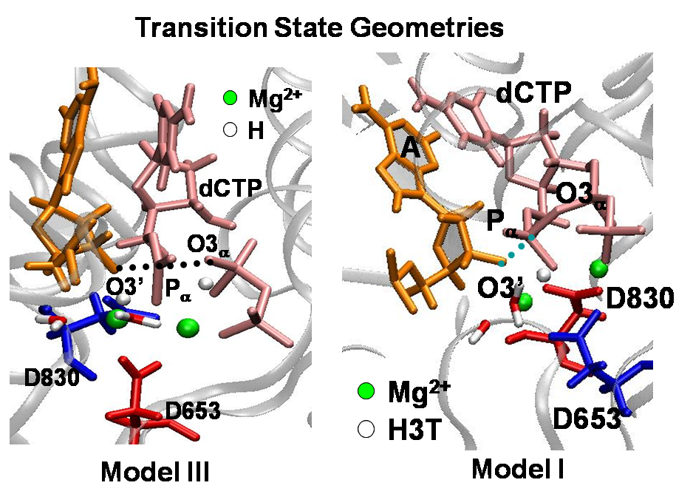

Figure S1: Snapshots of transition state geometries for Models III and I. The O3’-P_{α} and P_{α}-O3_{α} distances at the transition state in both models are in the range 1.9-2.1 Ǻ. Based on these values, we classify the mechanism to be associative in character.

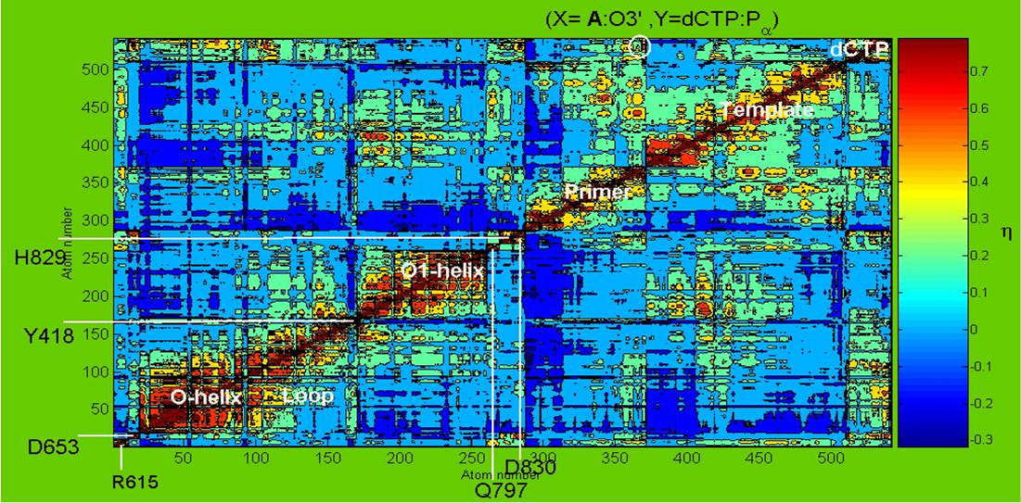

Figure S2: Correlations between vector displacements (r - ⟨r⟩) of atoms in the active site region for the G:dCTP system. Here r is a vector drawn from the origin to the atom of interest with average value ⟨r⟩.

References

1. Venkatramani R, Radhakrishnan R. The effect of oxidative damage on active site pre-organization during nucleotide incorporation in DNA by a high fidelity polymerase from Bacillus stearothermophilus. Proteins: Structure, Function, Bioinformatics 2008;71:1360-1372.
2. Venkatramani R, Radhakrishnan R. A computational study of the force dependence of phosphoryl transfer during DNA synthesis by a high fidelity polymerase. Phys Rev Lett 2008;100:088102.
3. Brooks BR, Bruccoleri RE, Olafson BD, States DJ, Swaminathan S, Karplus M. Charmm - a Program for Macromolecular Energy, Minimization, and Dynamics Calculations. Journal of Computational Chemistry 1983;4(2):187-217.
4. Radhakrishnan R, Schlick T. Orchestration of cooperative events in DNA synthesis and repair mechanism unraveled by transition path sampling of DNA polymerase beta's closing. Proceedings of the National Academy of Sciences of the United States of America 2004;101(16):5970-5975.
5. Grubmuller H, Heymann B, Tavan P. Ligand binding: molecular mechanics calculation of the streptavidin-biotin rupture force. Science 1996;271(5251):997-9.
6. Yang AS, Gunner MR, Sampogna R, Sharp K, Honig B. On the calculation of pKas in proteins. Proteins 1993;15(3):252-65.
7. Georgescu RE, Alexov EG, Gunner MR. Combining conformational flexibility and continuum electrostatics for calculating pK(a)s in proteins. Biophys J 2002;83(4):1731-48.
8. Alexov EG, Gunner MR. Incorporating protein conformational flexibility into the calculation of pH-dependent protein properties. Biophys J 1997;72(5):2075-93.
9. Johnson SJ, Taylor JS, Beese LS. Processive DNA synthesis observed in a polymerase crystal suggests a mechanism for the prevention of frameshift mutations. Proceedings of the National Academy of Sciences of the United States of America 2003;100(7):3895-3900.
10. Johnson SJ, Beese LS. Structures of mismatch replication errors observed in a DNA polymerase. Cell 2004;116(6):803-816.
11. Doublie S, Tabor S, Long AM, Richardson CC, Ellenberger T. Crystal structure of a bacteriophage T7 DNA replication complex at 2.2 angstrom resolution. Nature 1998;391(6664):251-258.

