Athena’s Prism—A Diplomatic Strategy Role Playing Simulation
for Generating Ideas and Exploring Alternatives

Barry G. Silverman, Ph.D.¹, Richard L. Rees, Ph.D.², Jozsef A. Toth, Ph.D.³,
Jason Cornwell¹, Kevin O’Brien¹, Michael Johns¹, Marty Caplan³
¹Electrical & Systems Engineering, University of Pennsylvania (UPenn) (barryg@seas.upenn.edu)
² Great Falls, VA
³Institute for Defense Analyses (IDA), Alexandria, VA

ABSTRACT
This paper presents a role playing simulation tool intended to support analysts with idea-generation and alternative competing hypotheses so as to influence world situations and leaders. Section 1 explains these goals. Section 2 surveys the current state of the practice and explains why a new game-based simulation tool is needed. The result, Athena’s Prism, can be readily configured for analyzing real world diplomacy and conflict situations, compels the player to view problems as system-wide concerns, engages 3 to 7 players, and reaches useful conclusions within two to three hours (Section 3). Athena’s Prism was initially designed in 2003 as a tabletop simulation, and in 2004 rendered as a collaborative computer-based architecture. Section 4 reviews this process and lessons-learned from playtest sessions as the tool evolved into its current form. Section 5 closes by presenting next steps.

1) The Problem and Challenge
Intelligence analysts must clear at least three hurdles to get good product out the door: cognitive biases, social biases and self-imposed organizational impediments. Others (e.g., Gilovich, et al. [1], Heuer [2], and Kahneman and Tversky [3]), explain the cognitive processes that can help or trip humans on our march to analytic outcomes. A less well mapped set of dangers arises in the social dynamics of communicating tasking, working with other analysts, editing and customer interaction. These include questions (yes-no or vague questions, those that elicit policy prescription, or reflect misunderstanding of essential issues) from customers, which require analysts to reformulate the tasking while trying to stay on track with customer needs. In addition, a bias arises in the undue weight assumed or given to the analyst with seniority or who waves the biggest fistful of or most recent intel reports or who represents analytic assertions with the imprimatur of senior management. Finally, the mere fact of a unit’s published record creates analytic inertia—an argument at rest tends to stay at rest and one in motion (i.e., ambiguous or uncertain) tends to stay in motion. (A variation of this includes groupthink.)
Organizational impediments come in many forms. The way we work—e.g., short cycle times and some business processes—can compel analysts to simplify concepts, minimize collection or rely on previously published material, all of which tend to impede alternative hypothesis-seeking. Reluctance to change positions in the face of contrary data—with loss of face for both producers and consumers—creates a disincentive to propose alternative hypotheses. The youth bulge in the government-wide analytic corps can be a demographic impediment. It’s not uncommon for many analysts to be relatively new to their accounts or to the discipline of intelligence analysis. To supplement overworked senior mentors and supervisors, training and analytic tools for this army of newbies will remain in demand for the foreseeable future as the intelligence community continues to hire. Athena’s Prism was conceived to address to some degree all three of these obstacles.
Athena’s Prism aims to simulate the personality, problem-solving styles, values, goals and environments of individual leaders. The software is intended to aid hypothesis generation—breaking through biases to present new, unexpected or less likely but critical outcomes from a given set of conditions. The target user community comprises leadership and terrorism analysts and others who need to anticipate a decision-maker’s actions. It is not a game—we call it a simulation tool—but leverages young analysts’ familiarity with video and computer games and role playing against either other players or the computer.
Borrowing from commercial software development practices, Athena’s Prism aims to meet the following criteria:
- engaging so analysts will want to use it
- collaborative to take advantage of a variety of experts
- user-centric to include aspects of the analysts’ methodology and knowledge
- realistic to simulate enough of the leader’s character, culture, thinking, situations and policy options to make it believable
- production-centric to conform to production protocols, e.g., citing sources, and to integrate with an analyst’s desktop environment and completed in reasonable time (two hours).
In comparison to current analytic practice, the software should produce more, or more varied, alternative hypotheses and less evidence of both cognitive and social biases.

2) State of the Practice
2.1) Problems with Existing Computer Tools
Many computer-based analytic tools exhibit the following problems:
- Visual presentation or activities required of users don’t reflect the skills or thinking styles of the target users. Tools are designed by engineers and quantitative methodologists, but are intended for analysts who majored in social sciences, international relations or liberal arts, i.e., qualitative thinkers discomfited by numbers and underlying theories that are the bases of many good tools;
- Other than geospatial and link analysis tools, few tools support analysts trying to understand the intentions and thereby predict the actions of people—especially real people—such as counterterrorism targets, criminal figures, espionage assets or national leaders. It is easier to represent people in general, a canonical cell leader, crowds, enemy units—but harder to work on the thinking of the real opposing general.
- Applications do not integrate well with the analysts’ workflow or procedures—instead create discontinuity in analytic activity and take too much time in a compressed production cycle. Tools are designed generally without regard to the workflow or production platforms of the users—“integration” amounts to placing an icon on the desktop so the application can launch. A tool that melds into the actual activities of an analyst, say, feeds knowledge or analytic results directly into the MS Word template in use would be much more useful than disparate applications enabling only copy-and-paste.

2.2) Gaming Theory—not Game Theory
Athena’s Prism was based, in part, on earlier work between UPenn and IDA funded by the Defense Modeling and Simulation Office (DMSO) [4]. Following DoD’s longstanding involvement in modeling, simulation, and human behavior representation (HBR), many small- to large-scale exercises are routinely depicted as game-like, implying competition, engagement, immersion, and even the suspension of disbelief. One of the maxims of adult education—analogous to use of knowledge-discovery tools—is that learning occurs by doing, not just through passive auditory or visual input (lecture or reading). Game-like simulations observe this maxim.

2.3) Pros and Cons of Available Game Technology
The computerized game industry offers many options, but none are of direct use to Athena’s Prism. The relevant game genre is the diplomatic strategy role-playing game (RPG): e.g., Civilization, Empire Earth, and Rise of Nations. The player controls a country or constituency within a given historical era or fantasy world and is a system-wide manager straddling Diplomatic, Information, Military, Economic, and Socio-cultural (DIMES) actions. However, (1) these games depict fictional or historical contexts and generalized or fantasy AI-based agents—they do not simulate real people in real current contexts and do not provide the ability to do so; (2) players can’t negotiate meaningfully in these games—they are best for macro-moves and only the basics of DIMES and system-wide management; and (3) real-time graphics and scenery generation tax development and CPU resources—Will Wright [5], developer of The Sims, warned against the trap of over-investing in graphics, which add immersive but not analytic value .
A related genre exists in Massively Multi-Player (MMP) Online Strategy RPGs, such as SimCountry.com and Superpower2.com. The player must also deal with system-management issues but hundreds of players are needed to populate MMP-RPGs, while unfilled roles are relegated to the AIs, which are not rendered with any psychologically realism.
Tabletop cousins of strategy RPGs also offer a rich source of practices. An example is ManTech’s InfoChess which, through a modified chess game, successfully compels teams to practice the subtleties of information denial, deception, and intelligence collection. But this game is limited to military command and control capabilities. The National Security Decision Making Game (NSDMG.com), is an example that expands the focus to much of DIMES, however, it requires eight hours to play and 40 to 80 players to fill political and other roles.
As a result of our market survey, we realized the need to create a game from the ground up and tailored to analysts’ needs. We also saw a need to invest in opponent AI that implements realistic and user-calibrated human behavior models (personality, stress, emotion, speech acts, intentionality, deception, etc.). The AI version of Athena’s Prism is soon to be delivered and its design is the topic of a separate paper [6]. This paper focuses only on the human-to-human (role playing) version of Athena’s Prism.

3) Configuration and Use of Athena’s Prism
Athena’s Prism can be readily configured for any real world leaders and conflict situation, compels players to deal with system-wide management concerns, requires only three to seven players, and reaches useful outcomes within two to three hours. Developed in the Python language, the tool is implemented as a collaborative client-server architecture where players sit at their own client screens. Figure 1 illustrates a basic client screen. We explain the tool and game configuration using our “5P” approach (plot, people, place, properties, process) to rapidly assembling scenarios.
Plot—The plot for a given game session is centered on ‘The Question’ to be answered. Typically, an analyst is presented with a question from a policy maker or operational unit. It may be specific, such as, Will financial sanctions force Country Z to stop sponsoring terrorism? Or How will cell “X” respond to “Y” kind of intervention? Or, it may be general, such as What alternatives will best influence Leader X and what might be unanticipated side-effects? Figure 1 illustrates a scenario answering a hypothetical question regarding Roadmapfour countries, each of which is role-played by a user-analyst. The Figure shows Leader A’s screen.
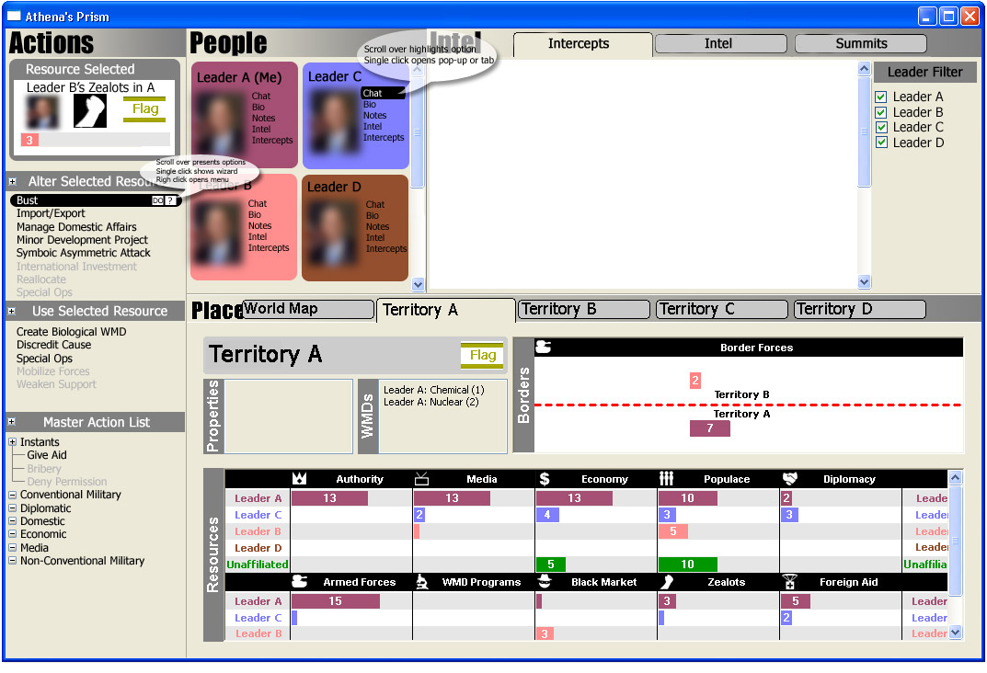Figure 1. Main Screen of Athena’s Prism and the many folders and activities possible under the People, Places, and Actions sub screens.
People—The next step is to define the critical set of leaders who have roles in the question at issue—roles assumed by the game players. The tool can accommodate with ease a wide variety of simulated players depending on the analyst’s interpretation of the question being asked. The top area of Figure 1 shows the personae in the scenario. Four photos are visible in the scroll box. Next to each photo are buttons that bring up background profiles for that leader, any notes the player wishes to add, instant message chat with that player, intelligence, and intercepts of other players’ communications. Chat occurs through a popup window that is a private link between two players. Intercepts are viewable in the tab to the right as chat messages describing espionage actions (see Process below) have won the player the right to see them. Some are fully visible, others are hidden, where the player knows who is chatting with whom, and yet still others are completely hidden.
Place—Because conflicts are invariably linked to control of resources (broadly defined), a total systems perspective dictates a model of resources arrayed in their respective territories under the control of specific leaders. Leaders/players own different amounts of resources in their own and other leaders’ territories; rules of play allow resources in others’ territories to be used—and sometimes captured—under certain circumstances, which mimics for instance the option/risk of seizing or having seized one’s assets. Resources include people, economy, media, authority, mass communication channels, emissaries, military, WMDs, and so forth. Resource levels are represented by bar charts at the bottom of the screen (in Figure 1); the rules dictate the costs of each action one wishes to perform in the world and the payoff rates for competitions (e.g., wars, attacks, labor strikes) won or lost. Color coding of places, histograms, and leaders helps analyst-players to stay oriented throughout a session.
Properties—Resource amounts, locations, and control (Authority) greatly constrain what a given player may or may not do during game play. In addition, there are a number of political and cultural realities that further factor into a leader’s decision making. These are entered into the Properties box to the left of WMDs in Figure 1 (none shown here) for each constituency, which are marked up according to political and cultural features and properties of the leader’s constituency. Some examples are classes of actions or leaders that the constituency favors or opposes. There are automatically generated rewards and penalties for complying with or going against these properties, respectively. In this manner, the constituency’s wishes and cultural norms tend to have an influence on the player over time. Treaties, cultural attributes, policies and ad hoc agreements constrain payoffs, costs and/or availability of actions.
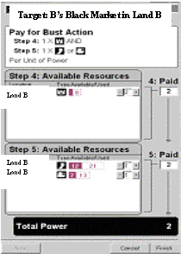
Process (Actions)—In general, players adopt a portfolio of strategies that they tend to pursue asynchronously and in parallel, where a strategy is a high-level goal (e.g., remove all WMDs in the world) that might be implemented by any of a number of alternative actions. In all, there are nearly 100 possible actions in the current version, each of which has rules which identify action applicability, costs, and constraints. The rules govern the spending and replenishment of resources (i.e., zero-sum game), how to grow assets, how one can pursue the particular goals derived from the analytic or operational question in play, how actions affect other players, ways to defend against attacks, what may be said during communiqués or summits, how espionage works, the carrots or benefits one leader can offer other leaders, and so on. Wizards and popup help messages assist the analyst-player to plan strategies, make choices, budget resources, and to correct disallowed choices from the menus. Communicative actions might range from specific threats against individuals, to media attacks and negative publicity intended to isolate a group, to leaflets with persuasive messages, as a few examples. Physical actions can range from air strikes and suicide bombings, to non-violent resistance and donating aid or development projects, among many others.
Despite only 100 possible actions, the choice set rapidly explodes when one considers the array of possible targets, multiple ways one can pay for any given action, the various levels of severity or dimension at which one can choose to act, and the conditions placed on actions taken or foregone articulated in the messaging window,. Thus, the "optimal" path through a game or scenario is unknown a priori or even after a single playing. Ideally, an analyst would discover unexpected or previously discounted outcomes, as well as the events and decisions that lead to them.
In the session that generated Figure 1, Leader A noticed Leader B’s Black Market tokens were nearly at a level where he (Leader B) could purchase WMDs. Rather than wait to see if Leader B pursued that action, Leader A had a number of communiqués with Leader B about this matter, but to no satisfying result. Consequently, he began exploring military action against Leader B. In the top left corner of Figure 1, the Action Wizard shows that he toggled Leader B’s zealots in Leader A’s country, while the Action List below that in Figure 1, identifies the various actions he might pursue. Figure 2 shows a shred of the Wizard sequence where Leader A could fund a Bust Action against Leader B’s Black Market resources in his country. This wizard screen shows the rule for paying for that action, and then presents Leader A with rocker switches to choose the options for making the payment from his currently untapped resources.

Figure 2 - Portion of Action Wizard for a Bust that Leader A Attempts against Leader B.
Once the payment is made and Leader B goes through a similar process to select a defense, the Athena simulation engine will hold a playoff to see who wins the bust attempt. Behind the interface is a model similar to colored Petri Nets. Leaders’ actions to attack and/or defend resources invoke probabilistic firings from the engine. These lead to non-deterministic outcomes, and winnings and losses that the respective leaders then allocate to the resource boxes.

4) Some Results to Date
Athena’s Prism was initially designed in 2003 as a paper-based tabletop game. The design process included numerous sessions of testing and refinement in the usual manner of game mechanics/rule tuning. Once the game was fully tuned and sessions were satisfying from a usability standpoint, we froze the rules and mechanics and began a computer implementation. During development, a number of feedback sessions were held with leadership analysts to evaluate the user interface, mechanics, simulation actions, and usefulness of the evolving simulation tool.
In order to give the reader a deeper sense of the Athena game, the following section summarizes some of the patterns of play that have emerged from testing sessions—samples of idea-generation the game was intended to stimulate. The players were a mix of junior and senior analysts, retired analysts and senior management brought in for expertise in scenario development, and contractors filling in when needed.
Unforeseen Hazards—Asymmetric attacks, traditional military moves, economic wars, and other “heavy stick” strategies tended to appeal to younger analysts. One effective player learned to wait towards the end of the session, when everyone was weakened, to make the more costly and effective moves.
WMD and Suicide Bombing Patterns—In all games, with all player types, the most desperate and dreaded measures occurred when a leader was nearing the end of his resources and saw no real options.
Alternative Methods for Influencing Outcomes—Many alternative action strategies were pursued in repetitions of the same scenarios. Many of the more seasoned analysts paid diplomatic visits, undertook gestures of friendship, and produced voluminous amounts of open and secret message traffic, media campaigns, and summit requests. Deception tended to occur when the statements were kept vague.
Hidden Opportunities—During one session a western leader thought she was moving toward her goals, but the region was growing more unstable as the groups of terrorists and nationalists were stockpiling, anticipating aggressive action. Interestingly, in the after-action debrief, the western leader thought the rival leader had belligerent intent, while the latter confessed to wishing he could be a western ally, but had little recourse to cope with the resource distributions and stances of the other players.
Innovative Thinking—On occasion, a player explored radical departures from conventional policy – e.g., blind altruism, bombastic treatment of stubborn allies, etc. In most such cases, a single-minded policy worked in the short run only, confirming the game theory dictum - ‘mixed strategies’ are optimal.

5) Conclusions and Next Steps
Role play or AI-driven simulation tools, like Athena’s Prism, are useful analytic tools insofar as they address some of the cognitive and social biases and organizational impediments noted above. For example, Athena’s Prism provides:
- a mechanism and a procedure to delineate assumptions explicitly (even more formalized when setting the parameters of the AI agents);
- a level playing field among analysts (enabling them to interact behind the camouflage of role playing or, later, AI;
- a neutral, no-loss-of-face way—through role playing or, later, AI—to learn that one’s certainty of outcome was wrong or at least not exclusively right—it’s easier to admit to a machine than to one’s colleagues, rivals or bosses;
- a rich and systematic means by which to entertain new ideas and hypotheses, to save these with an audit trail to study how we ended up at any particular outcome, and to identify some ways that we could be surprised.
Athena’s Prism has borne out part of its promise in preliminary evaluation. Results of user testing of the tabletop and computerized (but without the AI) versions have been favorable. Analysts find them believable, engaging and productive of novel ideas. The structure, process and content of the simulation tool seem to neutralize or steer clear of some of the cognitive and social hurdles noted above. Whether and how the tool improves hypothesis generation over the current practice—especially after AI is added—is an empirical question we hope to answer in further testing and evaluation.
We will evaluate whether and how Athena’s Prism affects organizational factors, such as the ease with which it enables new hypotheses to challenge conventional wisdom in the analytic process, and how well it integrates with production regimens. By a similar token, we intend to assess the comparative value of using the tool in both modes, role play and AI. Finally, we hope to deploy the tool within and across agencies to assess its performance in fostering collaboration. We seek partners from the community toward these ends.
Beyond the benefits of a single tool, we consider the impact on the analytic corps of the advances in information and analytic tool development. Among our user-testers is a new generation of analysts facile with RPGs, AI-driven simulations, graphical user interfaces, and multitasked presentations. At the same time, a large portion of the analytic corps is discomfited by analytic and explicitly quantitative tools.
Real differences in information processing and thinking styles of those who are more or less conceptual, quantitative, graphical, numeric, linguistic, conceptual, and visual or auditory processors can affect analytic performance. Advances in neuropsychological sciences enable us to identify these proclivities and differential effects on learning, thinking and the use of tools. Optimal matching of tool design with cognitive strengths could maximize individual performance. Moreover, as tools become more sophisticated, they will change analysis itself. Over time, we will need to adapt all aspects of intelligence work to optimize this interaction.
To leverage parallel advances in people and technology, we will need to evolve advanced workflow schemes, organization design, selection, training and management. The future could be bright for actively integrating engineering, psychosocial systems and work design. Advanced analytic tools are just one of three—but alone insufficient—vectors for change. MS Word™, PowerPoint™, hierarchical organizations, tightly controlled approvals, serial production and Seven Habits of Highly Effective People won’t cut it for long.
.
References
[1] Gilovich, T., Griffin, D., Kahneman, D., eds. (2002). Heuristics and Biases: The Psychology of Intuitive Judgment. New York: Cambridge University Press.
[2] Heuer, R.J., Jr. (1999). Psychology of Intelligence Analysis. Washington, DC: Center for the Study of Intelligence, Central Intelligence Agency.
[3] Kahneman, D., Tversky, A., eds. (2000). Choices, Values and Frames. New York: Cambridge University Press and the Russell Sage Foundation.
[4] Silverman, B.G., Johns, M., et al. (2002, May). “Constructing Virtual Asymmetric Opponents from Data and Models in the Literature." 11th BRIMS, SISO, www.seas.upenn.edu/~barryg/HBMR.html
[5] Wright, W. (2003). Personal communication to second author.
[6] Silverman, B.G., Johns, M., Bharathy, G. (2004, August). “Agent-Based Simulation of Leaders.” ACASA/UPenn, Tech Report, (available from lead author).

ACKNOWLEDGEMENT
The authors gratefully acknowledge the US Government for providing the funding for this effort and for contract support via IDA task EE-2-2334 and GH Engineering, Vienna, VA. We also are indebted to about three dozen current and former intelligence analysts and contractors who generously devoted their time and comments throughout. Finally, any opinions, claims and/or errors in this document are the authors’ alone, and do not represent official government statements.

