Prepared for the Course:
SYS 508 Knowledge-based Systems & Int. Agents: Assignment

 |  | Physiology – Tank Model Report
Prepared For: | Dr B. Silverman
 | Professor of Systems Eng
Prepared By: | G. K. Bharathy |  |  | E-Mails: | bharathy@seas.upenn.edu
 |  |  |  | Date: | 15 May 2003
 |  |  |  | Status: | Draft

Contents
1 Introduction 1
1.1 Background 1
1.2 Scope 1
2 Methodology 1
2.1 Requirements Analysis & Design 1
2.2 Implementation & Testing 2
2.3 Validation 2
2.4 Post-Implementation Monitoring 2
2.5 Reporting 2
3 Reservoir Model 2
3.1 Cognitive Performance 3
3.2 Motive Performance 4
3.3 Reservoir Model 4
3.4 Further Revision to above Physiology Model 6
4 Revised Physiology Model 7
5 Parameter Selection 7
5.1 Energy Utilization & Exhaustion 7
5.2 Sleep 11
5.3 Stimulant 11
5.4 Environmental Effects 13
5.5 Injury 13
6 Rules/ Look Up Table 15
7 Conclusions & Recommendations 16
8 References 16

Introduction

Background
Professor Silverman and his team are developing storyworlds for rapid story generation-in this case, about crowd behavior - that should provide learning opportunities (discovery, feedback, rehearsal) about crowd control. This particular project is attempting to fill a gap in the development process.

Scope
The objective is to develop a simplified model of the physiology of the agents.

Methodology
The project work involves the following phases:

Requirements Analysis & Design
The approach used by Prof Silverman’s team consist of developing representation of the system and its components by describing, their properties and constraints in an abstract fashion. Given the nature of use for the model, the model itself does not have to have any one-to-one correspondence to physiology, but is required to capture the essential behaviors of the human.
The model addresses, or accounts for, the following issues:
- Experience exertion on carrying out tasks;
- Appropriately affected by sleep loss, intake of stimulants, food;
- Respond to environmental stimuli such as temperature;
- Depict the effects of injury through O2 depletion and cranial pressure;
- Allow for impacts depending on up to 5 weapon types (club/rock, knife, rubber bullet, small caliber, large caliber bullet) hitting in one of 3 areas of the body (head, body, limbs);
The physiology model would provide two outputs, namely:
- Overall Motive Capacity for kinesthetic
- Stress level for decision-making
The development of the model is iterative process. Different types of models have been explored in the past. Particularly, the model using coupled network of reservoirs has been favored because of its ability to depict the time variation of the physiological limitations, and due to the ‘tradition’ using reservoirs in the game development industry.

Implementation & Testing
The team has modeled the physiology using a coupled network of reservoirs a series of physiological reservoirs that maintain the level of stress the agent is experiencing as a result of its physical environment and the state of its body.
The reservoirs parameters are based on valid Performance Moderator Functions (PMF). Alternative approaches are considered within this framework.
The physiology reservoirs were calibrated to literature for sleep deprivation, nutrition (caloric digestion), and exertion based on the military website on forced marches at various temps, and impact of light/noise for flashbangs. The idea of the bladder is also being considered, but has yet to be incorporated.

Validation
The validation was primarily carried out by assessing the type of output produced against commonsense, social norms and expectations. The model has also been validated against a different literature data (if available) and reduced/ simplified cases.

Post-Implementation Monitoring
Not covered by the scope of this work.

Reporting
The project has culminated in a report with formal design of the new objects and methods, and discussing the implementation of the modeling results. The recommendations for further work have also been outlined in this section.

Reservoir Model
The purpose of the physiology model is to primarily output two measures of the condition of the agent, as listed below:
- Input to Cognitive Ability
- Input to Motive Capacity
The agent’s physical state may undergo changes between decision cycles and this change is reflected at the very beginning of the new cycle. “If the agent is dead, unconscious, or in shock, this will clearly have an affect on its cognitive as well as motive ability. Less extreme physical states are important as well, however, as they help to determine the agent’s overall arousal”.

Cognitive Performance
The levels of cognitive capacity are measured by coping style, which is related to Integrated Stress. The Integrated Stress, which is a composite stress, is generated by integrating the three distinct forms:
- Event Stress
- Time Pressure
- Effective Fatigue
The IS affects the cognitive ability, and hence determines the coping style. The Integrated Stress value is used to derive the agent’s coping style, or Ω level as shown in the Figure 3.1. All stress levels are expressed in comparable units and the integrated stress is estimated by linear addition. Note that these three stressors are combined into an Integrated Stress value between 0 and 1, where .5 denotes peak arousal.
Figure 3.1- The Classic Performance Moderator Function is an Inverted-U (Silverman et.al., 2003a)
The details regarding cognitive capacity are described in Silverman et.al. (2003a), a summary of which is given below:
Gillis and Hursh (1999) conducted an exhaustive literature review of stress and arousal. Their research is some of the most valid in the field, and therefore, is adapted here with some modifications to account for how these three stress forms are derived.
In particular, Event Stress, the emotional arousal derived from the actions that the agent has taken and witnessed recently, is derived by summing the magnitude of all of the emotions that the agent felt during the previous decision/action cycle.
Time pressure is based on time-dependent action that the agent may have elected to pursue in previous ticks.
Effective Fatigue is derived from the level of the agent’s energy tank.

Motive Performance
We identified 5 levels of motive capacity, namely:
- Healthy,
- Slowed and Dazed
- Limping Badly
- Incapacitated
- Dead
Some of these lead over time in the reservoir to others (e.g., incapacitated will lead to bleeding out and then death) while others might have a natural recovery interval (e.g., dazed and slowed fades over time).

Reservoir Model
The agent’s physiology is based around an energy reservoir, or tank. As the agent’s desired arousal and magnitude of physical exertion change, the agent opens and closes a valve at the bottom of the tank that releases the energy to be used for those tanks. The agent is bound by the flow of energy out of the tank. For example, if the supply of energy in the tank is quite low, the flow out of the tank may not be sufficient to support a particular energy intensive task.
The reservoirs currently in use are:
- Exertion
- Nourishment
- Injury
- Sleep
- Environmental Conditions (such as Temperature, Noise, Light and Humidity)
A virtual stomach refills the energy tank based on the agent’s rate of digestion. When the agent’s sleep falls below a critical threshold, a second valve in the tank of energy is opened.
Figure 1: Physiology Module (Silverman et.al. 2003)
This preliminary model is elegant and simple, but does not have any correspondence with the physiology in the component level.
This model is being refined to reflect the reality more closely. There is always a trade off between the level of detail and the resemblance to reality. One such attempt is given below. This model attempts to capture different environmental conditions and injury types to different parts of the body. The model also allows for separate reservoirs for capturing O2 depletion, intracranial pressure and cardiac output, and allows for at least two three types of injury.
It also allows for stimulations such as khat, which promotes amphetamine-like stimulatory effects resulting in increased rate of energy expenditure and increased alertness (PMF Addendum). In the above model, stimulant modulates the Actual Expenditure valve of the Energy Store. Other negative effects modulate the wasteful expenditure valve of the energy reservoir.
However, the difficulty with this model is that it is difficult to calibrate and predict the performance; especially given that the pieces are calibrated in parts. The calibration of the model as a system is beyond the scope of the work.

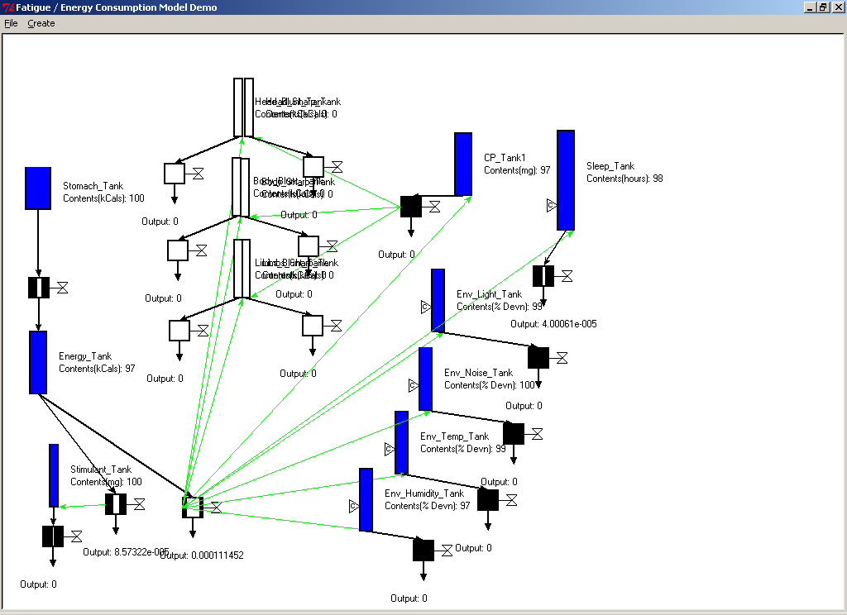
Figure 2: Physiology Module Iteration 2

Further Revision to above Physiology Model
Development of a model is an interactive process. Due to the complexity of the above model, we propose to revise the above model as follows:
We propose to strike a balance by including the necessary components in the aggregated form, but providing the differing parameters through a look up table. The abstract tank model still plays the central role, but multiple separate tanks may not be necessary to represent injury, environmental effects etc. These effects and the parameters are controlled by the list of parameters to look up and use for the simplified aggregated model. The following injury model illustrates this. Therefore, we propose to strike a balance by including the necessary components in the aggregated form, but providing the differing parameters through a look up table. The abstract tank model still plays the central role, but multiple separate tanks may not be necessary to represent injury, environmental effects etc. These effects and the parameters are controlled by the list of parameters to look up and use for the simplified aggregated model. The following physiology model illustrates this.

Revised Physiology Model

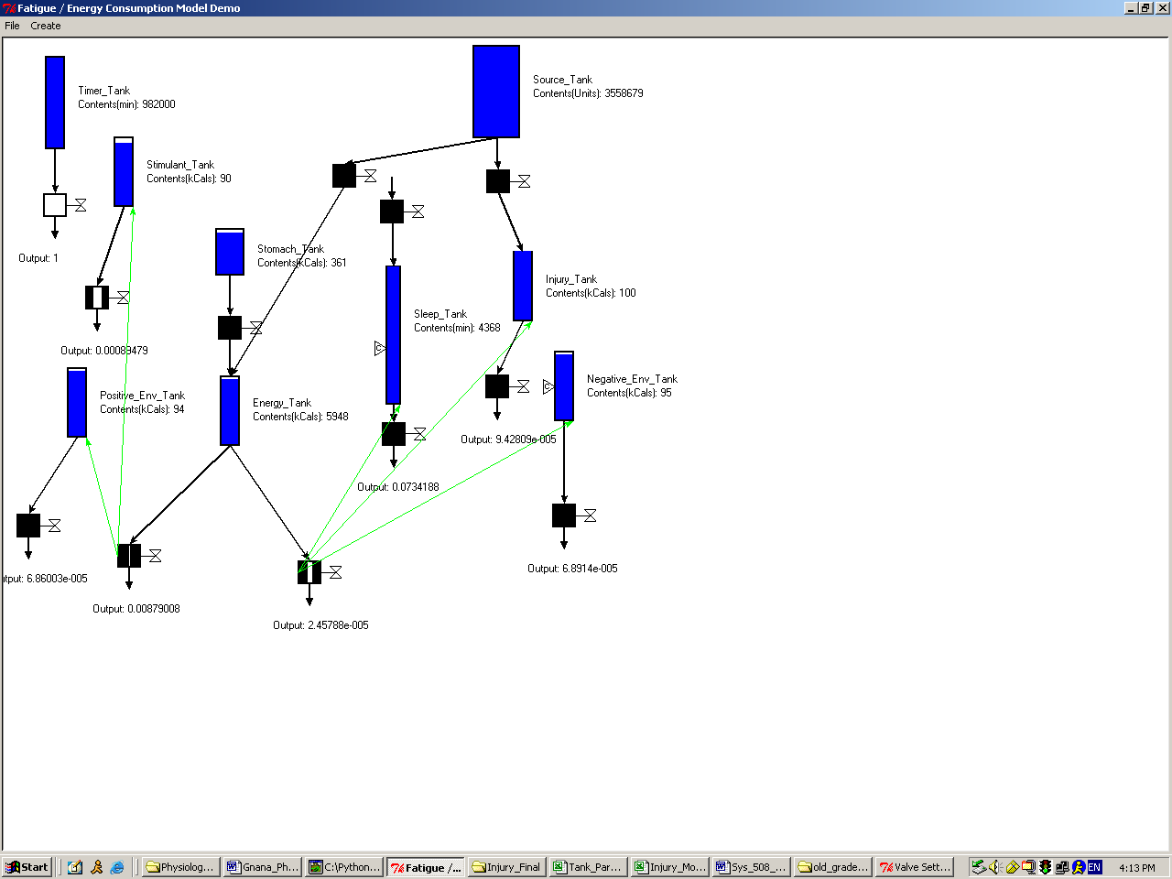

Salient Features
- Minimal number of tanks
- As many tanks as there are # of parallel effects required to be represented
- Source Tank for replenishing tanks during recovery phases.
Tank | Purpose
Energy Tank | Central tank modeling the activity or energy in the agent. Models the ability function. It is more than the reservoir of energy (calorific value).
Injury, Sleep, Environmental Tanks | Controls respective functions
Stomach | Models energy from digestive system. Can be used to refill the energy tank.
Source Tank | Can be used for refilling.
Time | Just to indicate time

Parameter Selection

Energy Utilization & Exhaustion
The energy valves are sized to reflect the utilization of energy and exhaustion experienced with performing tasks.

Work Type | Energy Expended  (from PMF) | Approximate Eqn  (Coefficients Rounded Off) | Valve Resistance or Flow
Very, Very Hard (VVH) – Burst Energy | 900 kCal/ hr for 0.25 hrs | (h/h0) = 1 – 0.20t | Const Flow  Rate = 0.20 kCal/min
Very Hard (VH) – Very Hard Work | 500 kCal/ hr for 2 hrs | (h/h0) = 1 – 0.05t | Const Flow  Rate = 0.05 kCal/min
Hard (H) – Hard Work | 400 kCal/ hr for 4.5 hrs | (h/h0) = 1 – 0.02t | Const Flow  Rate = 0.02 kCal/min
Medium (M) | 400 kCal/ hr for 10 hrs | (h/h0) = exp(-t/200) | RA = 200 min  R = 16 min/kCal^(2/3)
Light (L) – Sustainable, Minimum Activity (Close to BMR) | 400 kCal/ hr until other mechanism pose limitation (starvation, sleep etc., not work exhaustion) | (h/h0) = exp(-t/1000) | RA = 1000 min  R = 80 min/kCal^(2/3)

Sleep
Assumptions
Long-term effects of sleep loss such as depression are ignored
Circadian effect is, more important. However, circadian cyclical effect, sleep inertia etc are ignored for simplicity
Given an initial sleep reservoir size of 3 days and the critical value sets in after two days of lack of sleep. Literature does not specify an exact duration, but says that sleep effect catches on after two days (SAFTE model).
Event | Approximate Eqn  (Coefficients Rounded Off) | Valve Resistance or Flow
Sleep | (h/h0) = exp(-t/2500) | RA = 2500 min  R = 200 min/sleep unit^(2/3)

Stimulant
This needs to capture the fact that as long as stimulant is available, the energy tank useful output valve is opened more (without adding more tanks and complicating further).
We use the persistence stimulant. For example, keep the valve open for the duration of the persistence of the stimulant. The stimulant particularly studied was Khat, and the data corresponds to Khat. However, the model might be applicable to most Amphetamine like stimulatory drugs that promote increased rate of energy expenditure (further opens energy reservoir valve). Other types of drugs have not been modeled.

Stimulant Type | Persistence | Approximate Eqn.  (Coefficients Rounded Off) | Valve Resistance or Flow
Short | t1/2 = 0.5 hr | (h/h0) = exp(-t/43) | RA = 43 min  R = 3.4 min/mg^(2/3)
Med | t1/2 = 2 hr | (h/h0) = exp(-t/173) | RA = 173 min  R = 14 min/mg^(2/3)
Long | t1/2 = 4 hr | (h/h0) = exp(-t/346) | RA = 346 min  R = 27 min/mg^(2/3)

Environmental Effects
Two tanks regulate environmental effects, namely positive and negative tanks. Tanks have yet to be calibrated to include these influences. The relationships to be used are available only for temperature variations and humidity, both negative environmental influences.

Injury
In order to model recovery, we have recommended an inexhaustible (perpetually full) tank, which could open to fill in the injury tank.
Note, the summary results in the Table XYZ are obtained from Injury Modeling study (Bharathy, et.al., 2003).
Figure XYZ: Overall Scores & Classification
AIS Score Class | Severity Description | Resulting Motive Capacity | Score Range (SI0)
AIS Score Class | Severity Description | Resulting Motive Capacity | From | To
0 | None | Healthy | 0 | 0
1 | Minor | Minor, but ignorable | 0 ≤ | < 20000
2 | Moderate | Slowed and Dazed | 20000 ≤ | < 40000
3 | Serious | Limping Badly | 40000 ≤ | < 60000
4 | Severe | Incapacitated | 60000 ≤ | < 80000
5 | Critical | Incapacitated, Dying | 80000 ≤ | < 100000
6 | Un-survivable | Dead | 100000 ≤ | ≤ 120000

While injury levels were modeled very carefully, the time to recovery has yet to be modeled in detail. Therefore, the tank model for injury is yet to be complete. The following is only an illustration based on Golden Hour Score.
Opening the injury valve would drain the energy valve.
AIS Score Class | Severity Description | Reservoir Action Description | Valve Resistance
0 | None | Do nothing
1 | Minor, Improving | Open Injury Tank Valve slightly, close that valve and refill after event duration. That is for each injury event, some loss of energy occurs, unless several minor injuries follow one another, the agent is live and kicking.  The reaction is instantaneous that this could also be modeled by simply decreasing the amount of energy in the energy tank by a fixed quantity (say 300 kCal). | On injury, the valve resistance of injury tank should be changed to 1000 min/injury tank units^(2/3)  But this resistance will vary with time as:  (R) = 1- exp(-t/500)
2 | Moderate, Improving | Open Injury Tank Valve slightly, close that valve and refill after event duration. With a single injury, the agent is live but not physically active.  If the time effects are not important, the reaction could be modeled by simply decreasing the amount of energy in the energy tank by a fixed quantity (1000 kCal). | On injury, the valve resistance of injury tank should be changed to 600 min/injury tank units^(2/3)  But this resistance will vary with time as:  (R) = 1- exp(-t/500)
 | Moderate, Deteriorating | Open Injury Tank Valve as prescribed. Injury will continue to get worse. Medical treatment is not modeled. | On injury, the valve resistance of injury tank should be changed to 600 min/injury tank units^(2/3)  (h/h0) = exp(-t/300)
3 | Serious, Deteriorating | Open Injury Tank Valve as prescribed. Injury will continue to get worse. Medical treatment is not modeled. | On injury, the valve resistance of injury tank should be changed to 550 min/injury tank units^(2/3)
4 | Severe, Deteriorating | Open Injury Tank Valve as prescribed. Injury will continue to get worse. Medical treatment is not modeled. | On injury, the valve resistance of injury tank should be changed to 300 min/injury tank units^(2/3)
5 | Critical, Deteriorating | Open Injury Tank Valve slightly, close that valve and refill after event duration. Medical treatment is not modeled. | On injury, the valve resistance of injury tank should be changed to 150 min/injury tank units^(2/3)
6 | Un-survivable | Open Valve Fully | On injury, the valve resistance of injury tank should be changed to 50 min/injury tank units^(2/3)

Rules/ Look Up Table
Wasteful Energy Output Valve (WEOV)
Useful Energy Output Valve (UEOV)
Injury Tank Output Valve (IV)
Sleep Tank Output Vale (SV)

Causative Event | Effect | Look Up Table Entry
Normal, Awake | BMR + Min activity | UEOV Light Work  All other valves same as before
Work | Activity, Draining in Energy through UEOV | Open UEOV to appropriate level
Take Stimulant | Ensure Stimulant tank is filled to appropriate level  Energy through UEOV  Stimulant Level Falling (Decaying) | Open UEOV  Open Stimulant Valve
Injury | Managed through controlling injury tank valve (IV) | Open Injury Tank Valve to appropriate level specified. Then vary the resistance itself as specified.
Sleep | Managed through controlling sleep tank valve (SV) | Open sleep tank valve to appropriate level specified. Then vary the resistance itself as specified.
-Ve Environmental Factors (Extreme Temp) | Managed through controlling –ve Env tank valve (-EV) | Idea is the same, but have not been modeled yet. Open –E/Tank Valve to appropriate level specified. Then vary the resistance itself as specified.
+Ve Environmental Factors (Extreme Temp) | Managed through controlling +ve Env tank valve (+EV) | Idea is the same, but have not been modeled yet. Open +E/Tank Valve to appropriate level specified. Then vary the resistance itself as specified.

All emptied tanks are refilled using the mother of all tanks, Source Tanks. For example, sleep alleviates exhaustion due to lack of sleep.

Conclusions & Recommendations
A basic calibration of physiology model has been carried out. Some suggestions for controlling the physiology have also been given. However, the computer implementation has yet to incorporate the look up table feature.
Implementation of the look up table feature is recommended as the next step. Currently, the calibration is limited to fixing the tank parameters and dependencies.

References
Please treat this report as an addendum to previous report on Injury model.

