Building a 120Hz
Bandstop Filter

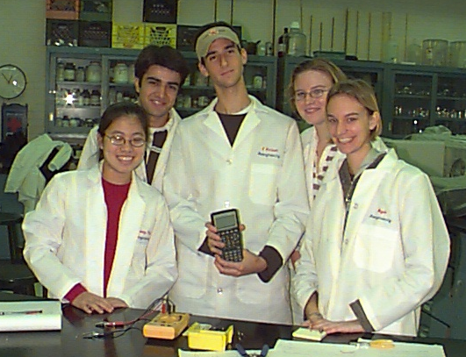

Group R5:
Scott Barbash
Meoghan MacPherson
Magdalena Jonikas
Justin Reddy
Melody Tsui

BE 209
Fall 2002
Dr. Meaney

Building a Bandstop Filter

Introduction

The purpose of this experiment was to build a bandstop filter to block 120Hz AC noise from the output of the power supply. Such a filter could be modified to block other frequencies depending on its intended use and the noise present. One possible use would be in an electronic eye, to be able to analyze frequency data while ignoring the background noise frequency. Another use is in filtering FM signals from frequencies received by wideband antennas. Because the FM signals are so powerful, they cause massive intermodulation problems. The proposed bandstop filters address this problem.
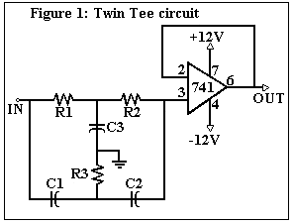
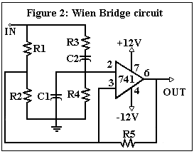
A Twin Tee and a Wien Bridge Notch Filters were chosen to accomplish this goal of blocking 120Hz noise. The Twin Tee circuit, shown in Figure 1, combines a lowpass and highpass filter to block a frequency f₀ according to the equation (1)$f_{0}=1/(2π\text{RC})$ where $R=R_{1}=R_{2}=2R_{3}$ and$C=C_{1}=C_{2}={C_{3}}/2$. A 741 Op-Amp chip is included to isolate the filter, should it be integrated with another circuit. The Wien Bridge circuit, shown in Figure 2, filters out a frequency by altering gain with respect to frequency, and having a minimum gain at the given frequency . The filtered frequency is determined by the equation (2) $f_{0}=1/(2π\text{RC})$ where R = R₁ = R₂ = R₃ = R₄ = R₅ and C = C₁ =C₂. Although the reference resistance (R_{ref}) is constant in this circuit, a change in frequency varies the impedance of the capacitors, which in turn changes the input resistance to the chip (R_{in}). Since gain = R_{ref}/R_{in}, the resistor and capacitor values are designed in such a way that R_{in}=R_{ref} at the frequency to be blocked, and R_{in}>R_{ref} at any other frequency. Thus a minimum gain of 1 occurs at the desired frequency, minimizing the response with respect to those at other frequencies. Although the goal of this project was to block 120Hz noise, the actual frequency of the AC noise from the output of the power supply was measured in order to make sure that this is an appropriate goal. This was accomplished with a phototransistor in a voltage divider as shown in Figure 3. Once the proper frequency to be blocked was determined, appropriate capacitor and resistor values were determined for both filter circuits. The bandstop filters were also used in combination with the voltage divider circuit to demonstrate the usefulness of the filters.

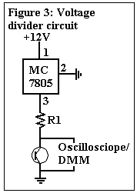
Methods

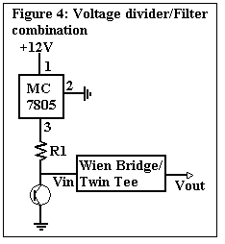
The AC noise frequency from the output of the power source was measured using the voltage divider circuit in Figure 3. As voltage is passed over the divider, voltage drop over the phototransistor varies with wavelength of the light absorbed. The virtual bench digital multi-meter was used to measure voltage drop across the phototransistor, and the oscilloscope was used to measure the frequency of the light absorbed by the phototransistor. The virtual bench Fast Fourier Transform instrument (FFT) was used to produce a magnitude-versus-frequency graph which showed the composition of the light signal over a one second interval. Once the frequency of the noise was confirmed to be 120Hz, appropriate resistor and capacitor values for the Twin Tee and Wien Bridge circuits were selected according to the equations (1) and (2). A 10V (peak to peak) sine wave was applied to each filter with a signal generator, scanning frequencies from 10HZ to 600Hz with 10Hz intervals between 10Hz and 100Hz, 5Hz intervals between 100Hz and 150Hz, 10Hz intervals between 150Hz and 300Hz, and 20Hz intervals between 300Hz and 600Hz. Since the expected frequency to be blocked out is 120Hz, sharp changes in response slope are expected in that region, and 5Hz intervals between 100Hz and 150Hz are appropriate in order to minimize error. For frequencies below 100Hz and between 150Hz and 300Hz, intervals of 10Hz were used since the slope of the response was expected to change less rapidly. Frequencies between 300Hz and 600Hz we scanned to check for unusual behavior far from the frequency of interest, and 20Hz intervals were deemed sufficient for that purpose. The output voltage was measured twice using the virtual bench digital multi-meter, and the average response was graphed against frequency in a Bode Plot using the equation dB = 20log (V_{out}/V_{in}). The Bode Plots were used to determine whether the Twin Tee and Wien Bridge circuits blocked the expected theoretical frequency of 120Hz. The blocked frequency was determined to be the frequency with the minimum response and compared to the desired frequency of 120Hz. For errors greater than 0% resistor and capacitor values were altered to bring the blocked frequency closer to that of 120Hz.
To demonstrate the usefulness of the 120Hz bandstop filters, the Twin Tee and the Wien Bridge were both combined with the voltage divider circuit as in Figure 4. Frequencies present entering and leaving each filter circuit were measured and displayed using a Fast Fourier Transform plot to show the effectiveness of each filter.

Results

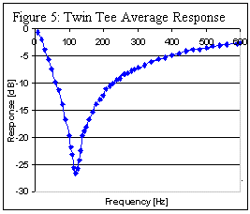
The noise frequency of 120Hz was confirmed using the votage divider circuit in Figure 3 with a 100kΩ resistor in position R1. Based on this frequency, the Twin Tee circuit was constructed using two resistors in series of values 464kΩ and 5.1kΩ totaling 469.1kΩ in positions R1 and R2 and three resistors of values 101.2kΩ, 46.9kΩ and 9.9kΩ totaling 158kΩ in position R3. Capacitors used in positions C1 and C2 had values of 0.0028μF and the capacitor in position C3 had a value of 0.04μF. The theoretical frequency value with minimum response was calculated to be 121Hz using equation (1) where R= 469.1 kΩ and C=0.0028μF.
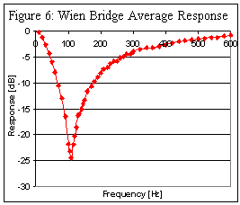
The Wien Bridge circuit was built using 33kΩ resistors in positions R1, R2, R3, R4 and R5, and capacitors of values 0.04μF in positions C1 and C2. The theoretical frequency of interest was calculated to be 120Hz using equation (1) where R=33kΩ and C=0.04μF.
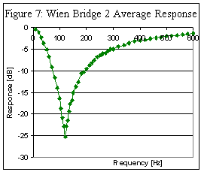
For both circuits a 10V peak-to-peak sine wave was applied scanning frequencies from 10HZ to 600Hz with 10Hz intervals between 10Hz and 100Hz, 5Hz intervals between 100Hz and 150Hz, 10Hz intervals between 150Hz and 300Hz, and 20Hz intervals between 300Hz and 600Hz. Output voltage was measured twice for each circuit to test reproducibility and the average response in decibels was plotted against frequency in Figures 5 and 6 for the Twin Tee and Wien Bridge filters respectively. The minimum response was measured at frequencies of 120Hz and 110Hz, resulting in errors of 0% and 8.33% with respect to the desired frequency of 120Hz for the Twin Tee and Wien Bridge respectively.
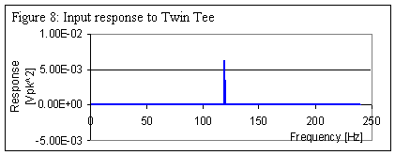
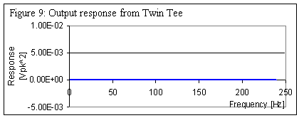
The resistor values for the Wien Bridge circuit were then altered to make up for the 10Hz difference between the theoretical and actual blocked frequency (this circuit is referred to as Wien Bridge 2 from here on). Resistors at positions R1, R2, R3, R4 and R5 were changed to two 15kΩ resistors in series, totaling 30kΩ. The capacitor values were not altered. According to equation (1) where R=30kΩ and C=0.04μF, the theoretical frequency of interest was calculated to be 133Hz. The same range of frequencies was scanned as for the other two circuits with a 10V peak-to-peak sine wave and output voltage was measured twice. The average response in decibels in graphed against frequency in Figure 7. The minimum response was measured at a frequency of 120Hz, resulting in an error 0% compared to the desired frequency of 120Hz.
The Twin Tee and Wien Bridge 2 circuits were tested by connecting them to the phototransistor circuit as in Figure 4. FFT plots showing dominant frequencies entering and leaving each filter circuit are shown in Figures 8 through 11. Figures 8 and 10 show the dominant 120Hz frequencies entering the Twin Tee and Wien Bridge filters respectively. Figures 9 and 11 show the lack of 120Hz noise leaving the Twin Tee and Wien Bridge circuits respectively.

Discussion

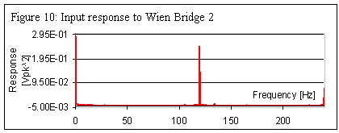
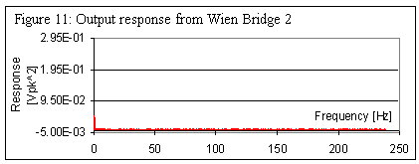
In this experiment, it was found that both the Twin Tee and Wien Bridge circuits are effective in blocking an AC noise frequency from the output of the power source. The Twin Tee filter blocked the expected theoretical frequency based on capacitor and resistor values used in the circuit. The Wien Bridge blocked a frequency 10Hz below the expected theoretical frequency of 120Hz. However, once resistor and capacitor values were adjusted for the error and set to the theoretical blocked frequency value of 130Hz, the desired 120Hz were blocked. The pairs of figures 8,9 and 10,11 show the efficacy of both circuits in removing the 120Hz noise coming into each filter.
Precision in determining the blocked frequency was limited by the scanning intervals used in the range between 100Hz and 150Hz. Since the interval chosen was 5Hz, a measured blocked frequency of 120Hz is actually 120 ± 2.5Hz, as the minimum response could have occurred at any frequency greater than 115Hz and smaller than 125Hz not inclusive. This results in a 4.2% error in the observed blocked frequency. A smaller interval would have been difficult to accomplish due to the nature of the available signal generator, which was not able to consistently provide frequencies with intervals smaller than 5Hz. In addition, the theoretical blocked frequency was limited by the available capacitor and resistor values and the possible combinations. For the Twin Tee circuit, there were no possible combinations that would result in a 120Hz theoretical frequency, instead, capacitors and resistors were used to block the frequency 121Hz. This did not influence the observed results, as the 1Hz difference was well within the 5Hz intervals used in scanning frequencies.
Since the circuits were only tested to block 120Hz noise, it is not certain that they would function similarly if capacitor and resistor values were designed to block a different frequency. Due to this limitation, is it not clear whether the offset in observed blocked frequency found when testing the Wien Bridge circuit corresponds to an 8.3% or a 10Hz decrease. This could be determined by designing the circuits so it blocks a frequency that is different enough from 120Hz such that 8.3% and 10Hz are clearly distinguishable. Testing both circuits with a variety of theoretical blocked frequencies would also bring out any problems or differences in performance that could not be observed with only one frequency.
Since both the filters are able to successfully block 120Hz noise, they could be used in combination with experiments requiring measurements free of interference from the noise, such as, the electronic eye experiment. In such cases the filter’s output would be connected to the input of the circuit used.

