Building the Electric Thermometer
W2: Lauren Boyer, Ana Crespo, Shaunak Patel, Jay Sy, Robert Yu
Abstract
In this project an electronic temperature monitor was designed. This device was tested for accuracy, precision and reliability. In addition to benchmarking the device, specific characteristics of human body temperature were studied. The major findings of this lab were a) core body temperature can be measured accurately from both oral and axillary locations (T_{oral}=0.812< T_{axillary}=0.998< t_{0.1,8}=1.397); b) the device is accurate in measuring body temperature from both oral and axillary locations (T=0.077< t_{0.1,8}=1.397); c) in general, it took females longer (4.56±1.65 sec) to heat the thermistor by 2°C than males (2.93±1.78 sec); d) the thermistor cannot be used to accurately measure body temperatures at open skin surfaces; e) there is no significant correlation between core and surface temperatures for a given subject; f) drift in the circuit was inconclusive.

Introduction
The design of our temperature monitoring device results from the need to observe a patient’s temperature over time. Specifically, our device is intended for use with infants, who cannot verbalize when they don’t feel well or have a fever and are more susceptible to damage due to body temperature fluctuations. The objective of this device is to monitor a patient’s body temperature and trigger an alarm when fever temperature is reached.

The device should meet several design criteria to be considered effective: it must be accurate (so it can measure body temperature correctly); it must have negligible drift, since it must be used for a prolonged period of time; it must have a resolution on the order of a tenth or hundredth of a degree, it should detect changes in temperature to the order of a tenth of a degree; the measuring probe should be able to function under a variety of conditions, such as a jostling patient; lastly, it should not be prone to false alarms or fail to give an alarm when fever temperature is reached.

In the first experiment of the course, we found that the thermistor was a good device for measuring temperatures in a half-bridge configuration. However, making the assumption that its resistance was linear with temperature outside of our calibration range was not accurate. In experiment three of the course, we used a LM741C operational amplifier and an LED array to visually signal when a certain measurement exceeded a threshold. This alarm set up utilizes the LM741C operational amplifier as a voltage comparator. The basis behind our temperature monitoring device is a combination of these two circuits.

The first stage of our experiment deals with the placement of the sensor. In most clinical situations, thermometers are used to measure body temperature in three locations: rectally, orally, and under the armpit (the axillary location). For practicality’s sake in the lab, the experiment is limited to the latter two locations. The first stage of the experiment addresses the question of how placing the probe at different locations affects the readings.

A second experiment was conducted to compare the rates of heating of the thermistor between the two genders. This experiment yielded data that supported our steady state response times and the physiological differences between genders.
An additional experiment, designed to test device reliability and the differences in circulation between genders after simulated hypothermic conditions, was attempted and deemed impractical in the lab. However, information about several device limitations, such as placement and reliability, was gained from our failed tests.

These experiments focus on testing the accuracy and precision of the thermistor and the alarm’s effectiveness in being triggered at a certain temperature, without any false alarms. We consider these criteria to be the most important for this device because they deal with the device’s basic function of correctly detecting changes in body temperature and alerting when temperature is at an unhealthy level.

Materials and Methods
Component Testing:
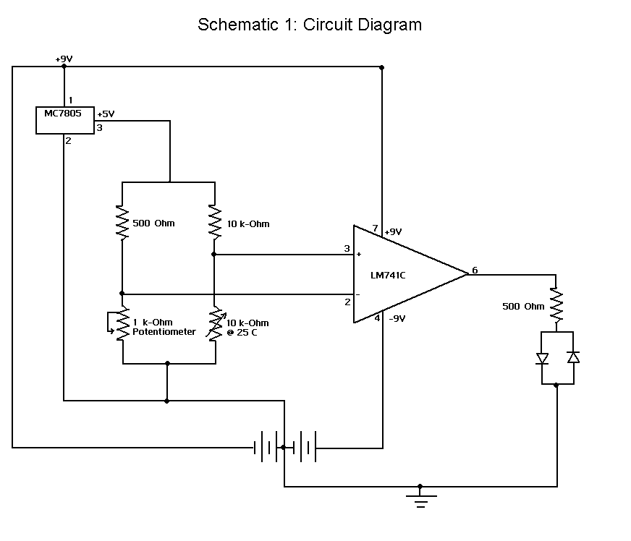
The component testing can be broken up into several parts. For the first part, the circuit must be verified to work correctly. A value of 37°C was set as the reference temperature, which has a corresponding voltage of approximately 2 V. Assuming a current of 1mA, a resistor of 500Ω can be used to cause the potential difference at the reference voltage node. A resistor of 10 kΩ is included before a 1 kΩ potentiometer, in order to give the precise resistance needed to generate the corresponding voltage for 37°C. A 10 kΩ resistor is used in order to minimize the potential difference across the thermistor. For the second part, the thermistor is put into the circuit, and must be calibrated. In order to calibrate, the thermistor is coupled to a thermometer and put into a water bath with varying temperatures. Voltage values were taken at temperatures between 35°C - 40°C and a calibration curve was established. This curve was established so that it will be accurate over an interval of 5°C. Once the exact voltage is found for 37°C, then the potentiometer can be adjusted so that V_{ref} will correspond to the exact voltage for normal body temperature. In addition, drift must be determined by placing the themistor in a beaker of water at room temperature for 10 minutes.

Experiment 1
Experimental protocol:
Initially, the subject was asked to sit down. A thermistor coupled with a thermometer (both wrapped in a rubber glove finger) was inserted into the oral cavity, underneath the tongue. A recording was made when the voltage measured by the DMM had stabilized, but not before 2 minutes had passed. Once this stabilization, or “steady-state,” was reached, the corresponding temperature reading of a thermistor was taken. The corresponding thermometer reading was then noted. Afterward, the thermistor and thermometer were removed from the mouth and sterilized using rubbing alcohol. The thermometer was shaken to settle the mercury. The thermistor/thermometer combination was then placed under the subject’s left armpit. Measurements were taken when “steady state” was reached, but not before 2 and a half minutes had passed. The thermistor-thermometer couple was then removed and sterilized. The above procedure was repeated 3 times for each subject and was conducted on 5 subjects.

Techniques:
The above protocol allows us to examine two main issues: the difference between temperatures at different parts of the body and the difference between the thermistor readings and thermometer readings. While the rubber membrane between the body and the thermometer-thermistor couple was detrimental to the speed at which we could take readings (it took time for heat to conduct through the rubber and air), hygiene is a crucial issue for clinical devices. Temperatures were taken from alternating locations. This helped minimize the differences from natural body temperature changes. A clinical thermometer was preferred over an alcohol one for increased resolution and ease of reading temperature values, since the mercury stays at the highest value reached until shaken.

Data analysis:
The protocol yields sufficent data for three T-tests: clinical thermomoter versus thermistor readings at each location and thermistor readings between axillary and oral locations. The first T-test establishes the accuracy of the thermistor; this is based on the assumption that the clinical themometer is a calibrated and accurate device. Once the accuracy of the thermistor was established, a T-test between axillary and oral locations where the device can be used to properly monitor body temperature.

Experiment 2
Experimental protocol:
The virtual DMM was turned on, the trendviewer was opened, and the data points were logged. The subject held the thermistor between his/her right thumb and forefinger until the voltage dropped to 2.25 V (the subject watched the trendviewer to know when the threshold was reached), and then the subject released the thermistor until the temperature dropped to the corresponding 2.35 V value (~2ºC). Ten continuous cycles of warming-up and cooling-down of the thermistor were recorded. The procedure was repeated for four subjects (two males and two females) with one run each. These voltage values correspond to 30.5°C and 28.4°C.

Techniques:
The virtual DMM originally measured room temperature, which determines the upper voltage value used in the experiment. Since room temperature is approximately ~10ºC lower than body temperature, it was inferred that the thermistor could be quickly warmed 2ºC if held in a subject’s hand. A change of 2ºC is roughly equivalent to a change of a tenth of a volt as measured by the DMM. The average time to complete one warm-up cycle was in the order of seconds, so multiple subjects were tested in a relatively short periods of time.

Data analysis:
Using the Voltage vs. Time graph, the time for each warming cycle was calculated. Each subject had roughly ten time periods, which were subsequently averaged by gender. A T-test was then used to determine if the average time for warming was statistically equal for the two genders.

Intended Experiment
Experimental protocol:
An ice bath is prepared to be at a constant temperature of 5ºC. A resting subject is asked to roll up his/her right sleeve and hold the thermistor probe between his/her right middle finger and palm. The voltage comparator is then set to the voltage at which the lit LED switches from red to green (the subject’s skin temperature at that time). The subject then put his/her right hand in the prepared ice bath for 30 seconds, at which point the green LED should be lit. The exact time at which the hand leaves the water should be recorded, then the LEDs should be observed and the time at which the red LED lights should be recorded. The above procedure is repeated once per subject for a total of 10 males and 10 females.

Techniques:
The primary goal of this experiment is to test the reliability of our device in a “real-world” application, i.e., actually using it on the human body where factors such as sweating and contact of the device with the skin introduce uncertainty in the temperature readings.

Preliminary Research
The average normal oral temperature for persons over the age of four is 37°C. This temperature can fluctuate in the morning and evening hours between 36.3°C and 37.56°C. Increase in body temperature can be caused by exercise, wearing excess clothing, high external temperatures, eating or emotional excitement. An oral temperature of 37.8°C signifies the presence of a fever. The body’s cooling mechanisms are evaporation (due to sweating) when the body temperature is greater then 37.22°C, radiation or conduction. There is variation in temperature at different sites of acquisition. Temperatures taken rectally are the most accurate, whereas those taken in the ear are the least accurate. Correlation between oral, rectal, tympanic and axillary temperature measurements is as follows:
-An oral temperature is 0.28°C to 0.56°C lower than a rectal or tympanic temperature.
-An axillary temperature is, on average, slightly lower 0.28°C to 0.56°C lower than the corresponding oral temperature.

The mean body temperature for men and women differ by 0.17°C (36.89°C and 36.72°F, respectively). Differences in thermoregulation between genders are due to Bergmann’s rule , which states that a subject with a greater body mass will have a greater amount of metabolizing tissue, resulting in a greater internal heat gain. In addition, as body mass increases, surface area to mass ratio decreases, thereby increasing the rate of heat dissipation through the skin. Females generally have lower skin temperature than males due to the presence of adipose tissue and lower basal metabolic rates. Females, who are very lean, have the lowest skin temperatures due to the body’s attempt to conserve heat. Other factors that compound thermoregulation are those which have effects on heart rate and vasodilatation /vasoconstriction.^{ii} Temperature positively correlates with heart rate and vasodilatation. Thus, with increased heart rate (due to exercise, stresses, or stimulants) or increase vessel diameter (due to vasodilators or use of muscle) will increase body temperature.

Results
The first stage of experimentation determined the normal oral body temperature range. The mean body temperature was found to be 37.7°C (normalized after cross calibration) with a standard deviation of 0.26°C.
Figure 1 shows that the data drifts with a slope of 2E-5 V/s. the regression fit the data with an r² value is 0.912.

Figure 2 shows the time periods needed for the device to stabilize in a given temperature medium. In a hot water bath (32°C) the thermistor had a stabilization time of 5 seconds and the cold water bath (10°C) stabilized in approximately 6 seconds. A third reading was taken with the thermistor covered in a rubber glove and placed in the mouth (37°C). Steady state response in this case was reached at 10 seconds.

Figure 3 shows both calibration curves. The regression equation for the first session was y (V) = -0.0471(V/°C) x (°C) + 3.6667(V) with an r-squared value of 0.9989, and for the second session, the regression equation was y (V) = -0.0476(V/°C) x (°C) + 3.7018(V), with an r² value of 0.9992.
Resolution of sensitivity is less than 0.01 V. This was found by connecting the voltage comparator to two potentiometers and changing the resistance of one potentiometer until the output voltage changed. The two readings on the digital multimeter read the same value to two decimal places.

The thermistor was calibrated in a 40ºC water bath with a decreasing temperature. Temperatures were recorded at half degree intervals. A linear regression was fit to the curve, voltage (V) = -0.0476(V/°C) x (°C) + 3.7018(V) with an r² value of 0.9992.
Preliminary investigation showed that the clinical thermometer was inaccurate. Thus, a cross-calibration was done with two other alcohol thermometers. Results showed that the clinical thermometer was an average of 1.1 º C lower that the alcohol ones. This average was found by taking 5 measurements between 37°C and 41°C at 1°C intervals. Two alcohol thermometers were used as reference readings.

The results of the first experiment show that there is no statistical difference between the measurements taken by the thermistor and the clinical thermometer. At an 80% confidence interval (D₀=0, t_{0.1,8}=1.397) comparison between the two devices at the axillary location yielded T=0.998, and at the oral location, T=0.812. Calculated T values were less than the t statistic (0.812<0.998<1.397), showing that the temperatures are equivalent. A difference of ~0.42-0.47 ºC between the temperature measurements of the devices is illustrated by Figure 4.

A comparison between temperatures at different body locations was made using the data collected from experiment one. Testing the data at an 80% confidence interval (t_{0.1,8}=1.397) the temperatures measured by the thermistor at the axillary and oral locations was compared. Statistical analysis yielded a T value of 0.0770. Similar statistical data was yielded by the measurements taken by the thermometer. Under the same constraints, a T-value of 0.111 was produced, which is less than 1.397. T-testing shows that measurements for both locations were the same for each device.

The second phase of experimentation showed that, on average, males were able to warm the thermistor 2˚C faster than females. Males warmed the thermistor in 2.92 ± 1.78 seconds (80% CI). Females warmed the thermistor in 4.5692 ± 1.65 seconds (80% CI). Figure 5 show the warming cycle trend of one male and one female subject. The positive slope portions of the graph, corresponding to the heating of the thermistor, are much shorter in for Subject C than for Subject A is a female. In previous testing, body temperatures of the two subjects differed only by 0.3°C (subject A=36.5°C, subject B=36.8°C)

Another observation to note was that three female subjects did not produce any data as their skin temperatures were not warm enough to realize a temperature change of two degrees Celsius (with respect to the lower voltage threshold). In all three cases, the subject’s skin would not warm up to the threshold temperature.

This difficulty in selecting subjects prevented us from testing the amount of time it took for skin temperature to restabilize after a hand was submersed in 5˚C water for 30 seconds. Figure 6 shows a sample trial. As evident on the graph, the overall trend showed that the hand did warm, but the large deviations from the trend line properly triggered the alarm, but were not accurate readings of the body temperature.

Discussion
The major findings of this experiment were: a) body temperature can be accurately measured from both oral and axillary locations; b) in general, it took females longer to heat the thermistor by 2°C than males; c) the thermistor cannot be used to accurately measure temperatures at surface locations; d) there is no significant correlation between core and surface temperatures for a given subject; e) drift in the circuit was inconclusive.

The aim of this experiment was to determine the accuracy of our device through the correlation of oral and axillary temperatures, measured with both the device and a clinical thermometer. Three t-tests were conducted, two comparing temperature measurements using the two devices (clinical thermometer and thermistor) at each location, and one comparing the thermistor readings at the two locations. Results show that the thermistor can accurately measure temperature, and that core body temperature can be measured from oral or axillary locations. These results bolster the viability of the device design. T-tests showed that oral and axial temperatures were statistically equivalent, which means that the probe can be placed in the more convenient armpit location. Trying to keep the probe in the mouth to get an accurate representation of the body temperature would severely hurt the devices usability.

The aim of the second experiment was to determine the differences in skin temperature between genders. From the data, averages of the time taken to heat the thermistor by 2°C were determined. Results showed that the average time taken was longer for females compared to males. This experiment was limited by the small number of subjects, and thus any generalizations are difficult to extrapolate from the data. One point to note is that data could not be collected for three female subjects, because their skin temperatures were too low to reach the set threshold value. This is agrees with our preliminary research that females have lower skin temperatures, and lower basal metabolic rates.

The proposed second experiment was designed to test the reliability of our device by using it to determine the time required for the temperature of the hand to return to its original one after immersion in a 5°C ice-water bath. The main obstacles in this experiment were maintaining a set reference voltage, the differences in original body temperature, and the differences and fluctuation in rate of warming. The initial procedure called for setting the reference voltage just below that of the corresponding original hand temperature, placing the subject’s hand in ice-water for 30 seconds, and then noting time taken for the alarm to go off, i.e. once the original hand temperature was reached. The major hindrance in this procedure was the time constraint, as recovery time was over 5 minutes. As an alternative, the potentiometer was set at a constant reference voltage. This did not work due to the significant differences in hand temperatures between the subjects. The initial procedure was tried again, but this time with the subject exercising his/her arm after removal from the ice-water. Exercise was used to increase heart rate and blood circulation to the arms, which in turn should have increased the rate of recovery for the hand. However, no conclusive data was obtained from this procedure either. Furthermore, the thermistor was placed in two different positions- the first was placed between the middle finger and the palm, and the second was placed between the middle finger and the thumb. The rationale for the secondary position was that the circulation would be better in the thumb, due to the presence of an artery; however, results did not show the expected trend. While no concrete numeric data was collected, observations showed that the device was functional, since the LED’s did switch color at the correct voltages.

Error due to the circuit was found to be negligible. Drift analysis showed a 0.01V increase in voltage, which corresponds to a 0.2°C decrease in temperature, when measured over seven minutes. Drift was measured by placing the thermistor in a water bath at room temperature. This apparatus, however, was still prone to some errors, since fluctuations in room temperature, or a difference in room and water-bath temperatures could be attributed to the determined drift. This data is inconclusive since the temperature could not be kept constant to a tenth of a degree. Also, if the determined drift were correct, that would correspond to an approximately 10°C decrease in a 6 hour span (the length of the lab period). However, since our device worked accurately for the entire lab period, it can be concluded that the experimentally determined drift was due to external factors. For any clinical monitoring application, the drift in the device must be zero, as the device would be used over long periods of time, and temperature changes measured would be small.

There are several improvements that can be made to the device. The biggest problem in the working of the device was keeping a constant reference voltage. The potentiometer is extremely sensitive, and needed constant re-adjustment. This device could be improved by increasing resistor values in the reference leg of the bridge, or by using a smaller potentiometer. This would correspond with a smaller voltage drop across the potentiometer, thus minimizing the magnitude of the fluctuations. Another improvement that can be made is to enhance the interface between the thermistor and the body. In our experiments, fingers of a rubber glove were used for protection and insulation from shock. The glove and air between the glove and the thermistor however, formed an extra layer of insulation which increased steady state response time.

References ? Mackowiak, P. A., Wasserman, S. S., and Levine, M. M. (1992), "A Critical Appraisal of 98.6 Degrees F, the Upper Limit of the Normal Body Temperature, and Other Legacies of Carl Reinhold August Wunderlich," Journal of the American Medical Association, 268, 1578-1580.
http://www.as.ua.edu/ant/bindon/ant475/heatcold/thermo.htm
Glickman-Weiss EL, Nelson AG, Hearon CM, Prisby R, Caine N Aviat Space Environ Med 1999; 70:284-8
K.C. Parsons, The effects of gender, acclimation state, the opportunity to adjust clothing and physical disability on requirements for thermal comfort, Energy and Buildings 34 (6) (2002) pp. 593-599.

