PROJECT FINAL REPORT COVER PAGE

GROUP NUMBER: W3

PROJECT TITLE: Improvements to Acid-Base Titrations

DATE: April 29, 2002

ROLE ASSIGNMENTS FOR OVERALL PROJECT

ROLE GROUP MEMBER

FACILITATOR: Jonathan Kahn

TIME & TASK KEEPER: Ania Oldakowska

SCRIBE: Shanaz Rauff

PRESENTER: Adnan Aziz

SUMMARY
One of the main objectives of this project was to improve the standardization methods involved in acid and base titrations. In the first phase of the experiment, sodium hydroxide (NaOH), a strong base, was titrated against potassium acid phthalate, the primary standard. The titrations were repeated twenty times to determine the concentration of NaOH to an accuracy of 0.5% and a to precision of ± 0.005 M as specified by the manufacturer: 1.000 ± 0.005 M. Hydrochloric acid (HCl), a strong acid, was then titrated against the standardized NaOH solution to determine its concentration. The titrations were repeated twenty times to determine the concentration of HCl to an accuracy of 0.5% and to a precision of ± 0.005 M as specified by the manufacturer: 0.995 – 1.005 M. Burets accurate to ± 0.05 mL were used in conjunction with the indicator phenolphthalein to determine an endpoint of the titrations. A separate mass-balance method, in which the masses of pre-titration and post-titration samples were taken and converted to volumes via density calculations, was also explored. The mass-balance method was determined to be more accurate than the volume method and produced the following results: NaOH concentration was 1.000 ± 0.003 M and the HCl concentration was 1.000 ± 0.001 M. The buret volume method gave the following results: NaOH concentration was 1.005 ± 0.005 M and HCl concentration was 0.998 ± 0.002 M. Even though the mass-density method was more accurate, both methods of calculation gave results that were within the range of the specific aims. In the second phase of the experiment, a mixed indicator was created using phenolphthalein and bromocresol green. A universal buffer was used to create solutions ranging from pH 2-12 in one pH-unit increments. The optimal mixed concentration in buffer contained 2.854 × 10⁻⁵ mol/L for bromocresol green and 7.233 × 10⁻⁹ mol/L for phenolphthalein. The molar extinction coefficients of bromocresol green were (5 ± 0.8) × 10⁶ L/(mol·cm) at 442 nm and (1.43 ± 0.3) × 10⁷ L/(mol·cm) at 616 nm, and that of phenolphthalein was (1 ± 0.8) × 10⁸ L/(mol·cm) at 553 nm. The indicator's viability was tested in a titration of HCl against sodium carbonate (Na₂CO₃) to determine the molar weight of Na₂CO₃ to an accuracy of 1%, which was found to be 106.7 ± 0.7 g.

SPECIFIC AIMS
- The concentration of NaOH solution will be determined by titration against potassium acid phthalate (KHP) to an accuracy of 0.5% of the manufacturer’s specifications and to a precision of ± 0.005 M as specified by the manufacturer: 1.000 ± 0.005 M.
- The concentration of HCl solution will be determined by titration against the standardized NaOH solution to an accuracy of 0.5% of the manufacturer’s specifications and a precision of ± 0.005 M as specified by the manufacturer: 0.995 – 1.005 M.
- A mixed indicator will be created with phenolphthalein and bromocresol green that has a distinct endpoint in the pH 4-6 range and another in the pH 8-10 range.
- The mixed indicator will be tested in a titration of HCl against Na2CO3; the molar weight of Na2CO3 will be determined to an accuracy of 1% by the titration endpoints.

HYPOTHESES
- NaOH concentration will be 1.000 ± 0.005 M
- HCl concentration will be 1.000 ± 0.005 M.
- Molar weight of Na2CO3 will be 105.989 ± 1.060 g.

BACKGROUND
The main purpose of this project was to improve the accuracy and precision of strong-acid, weak-base and strong-acid, strong-base titrations in the laboratory. NaOH was titrated against a primary standard, KHP, which gave a more accurate and precise standardization of NaOH and HCl solutions. Also, a mixed indicator was prepared to create an optimal color change in the pH 4-6 and pH 8-10 range.

Potassium Phthalate, KH(C₈H₄O₄)
Potassium phthalate (KHP) is a weak organic acid soluble to 25 g in 100 mL cold water. Relative to inorganic acids and bases, KHP has a high molecular weight of 204.2 g/mol which reduces weighing errors and makes it a suitable candidate as a primary standard. Also, KHP is very stable to light and heat in the environment. It is non-hygroscopic, and does not absorb water after being dried, permitting exact amounts of the primary standard to be weighed. Acid standards are also more stable than base standards since CO₂ dissolves in basic solutions to form bicarbonate which alters the pH. The reaction of KHP with a strong base, NaOH, proceeds as follows:
NaOH (aq) + KHC₈H₄O₄ (aq) → KNaC₈H₄O₄ (aq) + H₂O (l)
KHP is a moderately weak, monoprotic acid with a pH of 4.0 at 0.05 M concentration (20ºC). At equivalence point, when only phthalate ion is present, the same solution registers a pH of about 9.0.

Spectrophotometry
Visible light is constitutes a small part of the electromagnetic spectrum. When wavelengths in this range are absorbed, the remaining reflected wavelengths constitute the color of the reflector. Wavelengths from 400-700 nm can be detected by the human eye, but at low levels of sensitivity. Spectrophotometric procedures provide a more sensitive and objective measurement, creating a widely used and versatile bioanalytical tool. It is usually nondestructive and each chemical has its own characteristic spectrum, allowing particular compounds in a mixture to be singled out for observation. Most importantly, the measurements are of high accuracy and can be made rapidly.

Indicators
Phenolphthalein changes color from colorless (acid) to pink (base) at pH 8-10. An indicator changing color in a more acidic part of the range (pH 4-7) would provide the most distinct intermediate pH range of color; a mixture of phenolphthalein with this indicator would produce a mixed indicator with two endpoints. Consequently, bromocresol green was selected, as it turns from yellow (acid) to blue (base) at pH 4-5.5. An acidic solution of the mixed indicator is thus yellow, turning blue at pH 4-5.5, then purple at pH 8-10.

MATERIALS AND APPARATUS

Standardization
- 50 ml burets
- Anhydrous pure KHP
- Commercial HCl standard solution, (0.995 – 1.005) M
- Commercial NaOH standard solution, (1.000 ± 0.005) M
- Mettler H72 electronic mass balance (0 to 160 grams ± 0.0001 grams)
- Mettler PB303 electronic mass balance (50 to 300 grams ± 0.01 grams)
- Phenolphthalein (1% in isopropanol)
- Assorted glassware and plasticware

Mixed Indicator
- Micropipets (1000, 200, 20 μL) and pipets (10 mL)
- Components of the universal buffer solution as shown in the online manual
- Commercial HCl standard solution, (0.995 – 1.005) M
- Commercial NaOH standard solution, (1.000 ± 0.005) M
- Na₂CO₃, laboratory grade
- Fisher Scientific Accumet Model 625 pH meter
- pH buffer standards (4, 7, 10)
- Mettler H72 electronic mass balance (0 to 160 grams +/- 0.0001 grams)
- Bromocresol green (0.1% in aqueous solution) and phenolphthalein (1% in isopropanol) indicators
- Spectronic Genesys 5 Spectrophotometer
- Assorted glassware and plasticware

PROCEDURE

Part 1: Titration Experiment

Day 1 Parallel Task
- Weigh about 8.2g KHP into a 250mL flask. Dissolve in approximately 100 mL of deionized water. Add two drops of phenolphthalein. Record mass of flask and KHP solution. (10 min)
- Carefully add NaOH from the buret to the flask. Record the volume NaOH used. (20 min)
- Weigh the flask containing the KHP and the NaOH and record the final mass.
- Repeat the titration procedure twenty times. (180 min)
- Calculate the moles of KHP used, the corresponding moles of NaOH titrated, and hence, the mean concentration of the standard NaOH and its associated error using both the volume and mass-density method of calculation (discussed in Analysis). (10 min).

Day 1 Parallel Task
- Weigh a 250 ml beaker precisely on the Mettler H72 electronic mass balance.
- Using a buret transfer approximately 45 mL of 1.0 M standard HCl solution to the flask. Record the exact volume used. Weigh flask again and record mass (10 min).
- Add two drops of phenolphthalein and the magnetic stirrer into this flask. Weigh again (2 min).
- Carefully add the NaOH solution from the buret to the flask containing HCl. Record the volume NaOH used to reach the endpoint (pink color). Weigh flask again to record final mass (60 min)
- Repeat the procedure twenty more times. (180 min)
- Using the data as well as the standardized concentration of NaOH, calculate mean concentration of the standard HCl and its error with both the volume and mass-balance methods.

Part 2: Extinction Coefficient

Day 1 Parallel Task
- Weigh out universal buffer components as specified in online manual, place into a 1 L volumetric flask and dilute to make a final volume of 1L. NOTE: sodium tetraborate is harmful and tris is an irritant; handle with care. (50 min)

Day 2
  - Calibrate the pH meter with the pH 4, 7, 10 solutions. (Parallel task) (10 min)
  - Calibrate a P1000 and P200 micropipet with a mass balance and deionized water. (Parallel task)
  - Divide the universal buffer solution among nine clean beakers with a graduated cylinder. Label each beaker with pH 3-11, in unit increments. To the first beaker, add the 0.4 M HCl and NaOH solutions and dilute as directed by the manual to prepare a solution of pH 3. Continue with the remaining beakers in unit pH increments. (20 min)
  - Test each solution with the pH meter and relabel with the exact pH. (Parallel task) (10 min)
  - Pipet 7 mL of pH 3 buffer into each of three test tubes; repeat with new test tubes for each unit buffer pH, using a new pipet for each buffer pH. (10 min)
  - Using a P20 micropipet, transfer bromocresol green incrementally to two of the test tubes containing the buffers to create averagely intense blue and yellow solutions at the same volume added; record this volume (optimal concentration) and transfer to each of the seven other buffers. Repeat with phenolphthalein at pH 11 to create a pink solution of equal intensity as the blue and yellow solutions; record the volume used and add likewise to a new set of buffers.
  - Observe the colors of the individual solutions and check for consistency of color change and color intensity, photographing the test tubes as a record.
  - Pipet 3 mL of each bromocresol green solution into cuvettes and scan over 350-700 nm. Record peak absorbances, wavelength, and calculate the molar extinction coefficient of each indicator in each pH at peak absorbance wavelength. Repeat with phenolphthalein and the mixed indicator.

Day 3 Parallel Task
- Weigh about 5g of Na₂CO₃ into an Erlenmeyer flask. Dissolve in approximately 50 mL deionized water with magnetic stirrer until dissolved. Add mixed indicator in the determined ratio. (10 min)
- Add NaOH solution from the buret to the flask of Na₂CO₃. When approaching the endpoints (ie. color change from yellow to blue and later blue to purple), proceed carefully. Record the volume NaOH used at each endpoint. (20 min)
- Repeat the procedure five times. (180 min)
- Use the data to calculate the molar mass of Na₂CO₃.

RESULTS

Standardization
The acid-base standardization methods used by the manufacturer were reproduced in the first part of the project to determine the concentrations of commercial NaOH and HCl solutions. NaOH was titrated against the primary standard, KHP, to determine NaOH concentration. This standardized NaOH was then titrated against HCl to determine HCl concentration. Twenty titrations were repeated for each set of standardizations so that a total of forty titrations were performed.
Two methods were used in the standardizations to calculate the concentrations of NaOH and HCl. The volume method involved reading titrated volumes of NaOH from the markings on the buret. The mass-density method involved massing the titrant both before and after the titration. The net mass of NaOH used was then converted to a volume via an assumed density. The volume of NaOH titrated was then used, in each method, to calculate the moles titrated and thus the standardized concentration of either NaOH or HCl. The results for NaOH and HCl standardization are summarized in Table 1 below where average concentrations are given:
Solution | Mass-Density Method | Volume Method | Manufacturer Specifications
NaOH | 1.000 ± 0.003 M | 1.005 ± 0.005 M | 1.000 ± 0.005 M
HCl | 1.000 ± 0.001 M | 0.998 ± 0.002 M | 0.995 – 1.005 M
Table 1: Summary of results for standardization section indicating the concentrations of NaOH and HCl for two different calculation methods as well as the given manufacturer specifications.
The results show a slight difference between the concentrations of NaOH and HCl for the volume method and the mass-density method. Note that all results fall within the range of the manufacturer’s specifications. These topics will be further discussed in the analysis.

Mixed Indicator
Ten buffer solutions from pH 2-12 were prepared with a wide-range universal buffer for UV spectrophotometry. The exact pHs obtained were 2.544, 4.121, 4.962, 5.959, 6.805, 7.773, 8.540, 9.135, 9.638, and 10.882.
Bromocresol green was added dropwise with a P20 micropipet to an array of ten test-tubes, each holding 7 mL of a different buffer. The optimal concentration of bromocresol green in buffer was 2.854 × 10⁻⁵ mol/L, producing a yellow solution at pH 2.544, green at pH 4.121 and blue from pH 4.962 to pH 10.882. The resulting spectrum is shown in Figure 1. The procedure was then repeated with phenolphthalein. The optimal concentration of phenolphthalein in buffer was 7.233 × 10⁻⁹ mol/L, producing a colourless solution from pH 2.544 to 8.540 and pink from pH 9.135 to 10.882. The resulting spectrum is shown in Figure 2.
The mixed indicator was then created by adding the optimal concentrations of bromocresol green and phenolphthalein to each of a new array of ten buffer solutions. The resulting spectrum is shown in Figure 3. The solutions were yellow at pH 2.544, green at pH 4.121, blue from pH 4.962 to pH 8.540, and purple from pH 9.135 to 10.882.
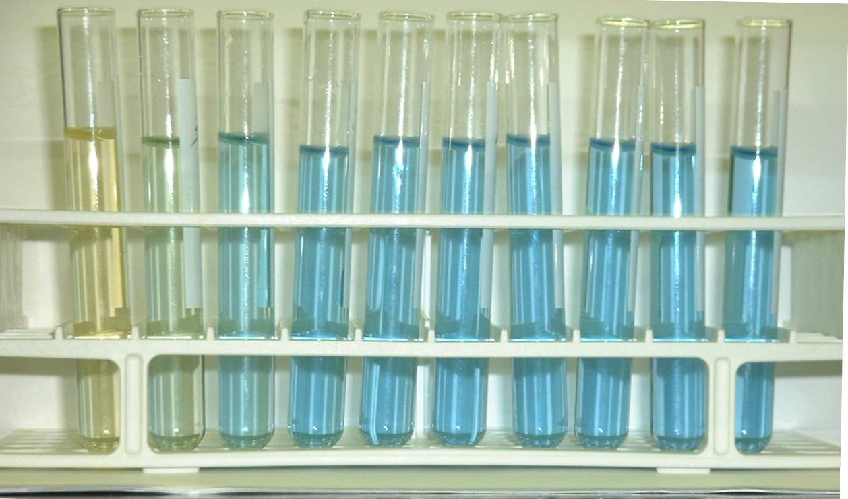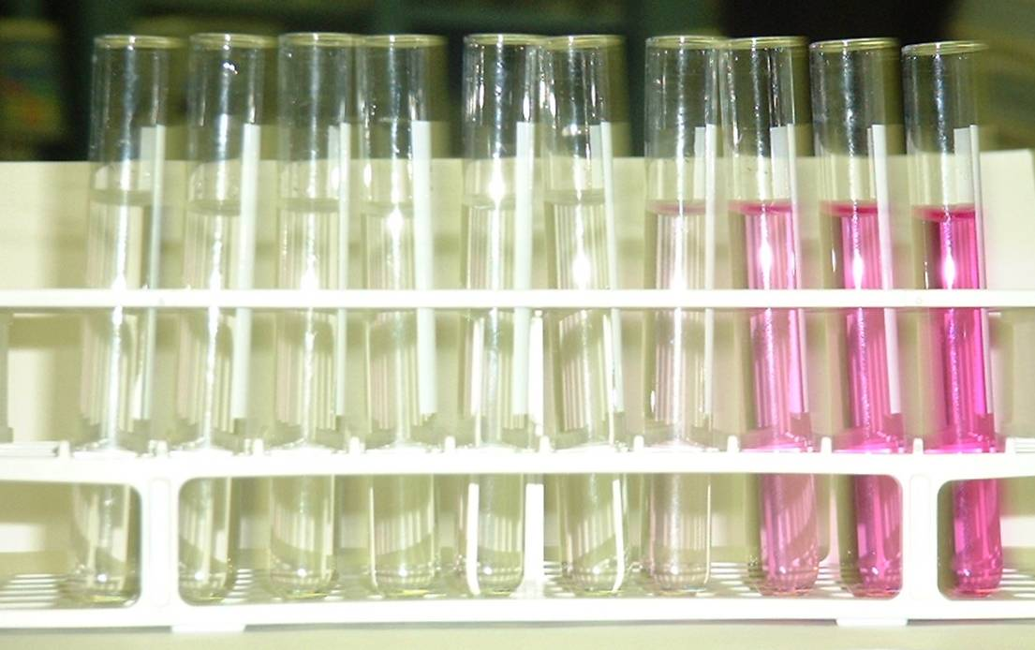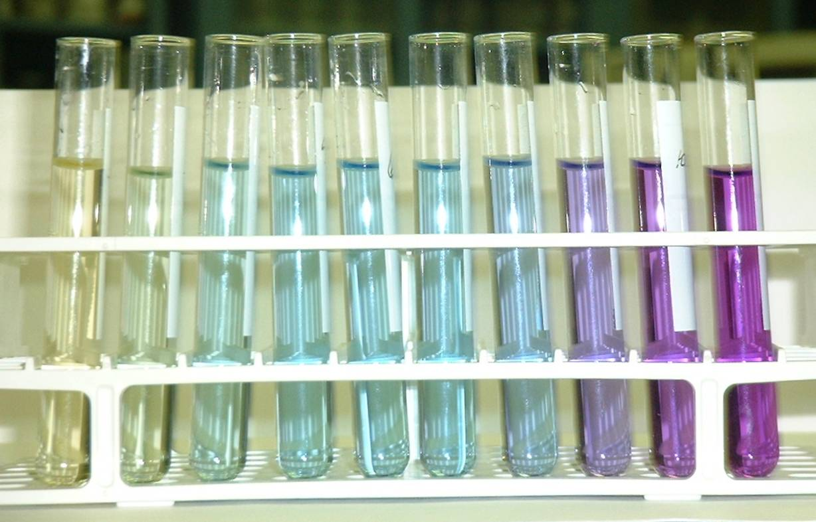
Figure 1: 2.854 × 10⁻⁵ mol/L bromocresol green in pH 2.544 - 10.882.
Figure 2: 7.233 × 10⁻⁹ mol/L phenolphthalein in pH 2.544 - 10.882.
Figure 3: 7.233 × 10⁻⁹ mol/L phenolphthalein and 2.584 × 10⁻⁵ mol/L bromocresol green in pH 2.544 - 10.882.

3 mL solution was withdrawn from each test-tube and placed in a cuvette for scanning in the 350 - 700 nm range. Absorbance against wavelength for the optimal concentration of each indicator at each pH were then plotted for bromocresol green, phenolphthalein and the mixed indicator in Figures 4, 5 and 6 respectively.
From Figure 4, the peaks for the bromocresol green were identified to be at 398 nm, 442 nm and 616 nm, representing maximum absorbencies in UV, indigo, and orange ranges of the visible light spectrum respectively. This implies in turn that the species causing maximum absorbance in these ranges were non-visible, yellow and blue respectively.
Figure 4: Absorbance of bromocresol green against wavelength for each buffer solution.
The average molar extinction coefficient for bromocresol green was (5 ± 0.8) × 10⁶ L/(mol·cm) at 442 nm (yellow absorbed), and (1.43 ± 0.3) × 10⁷ L/(mol·cm) at 616 nm (blue absorbed).
From Figure 5, the peaks for phenolphthalein were 376 nm and 553 nm, representing maximum absorbencies in UV and yellow ranges, and implying the species causing maximum absorbance in these ranges are non-visible and purple-pink respectively.
Figure 5: Absorbance of phenolphthalein against wavelength for each buffer solution. Solutions below pH 7.773 were not tested as they would register less than or as much absorbance as pH 7.773 solution, which was zero over the 350-700 nm range.
The average molar extinction coefficient for the phenolphthalein was (1 ± 0.8) × 10⁸ L/(mol·cm) at 553 nm (pink-purple absorbed).
From Figure 6, the peaks for the mixed indicator were 398 nm, 443 nm, 554 nm and 615 nm, representing maximum absorbencies in UV, indigo, yellow and orange ranges of the visible light spectrum respectively, and implying the species causing maximum absorbance in these ranges were non-visible, yellow, purple-pink and blue respectively.
Figure 6: Absorbance of mixed indicator against wavelength for each buffer solution.
Molar extinction coefficients could not be calculated for the mixed indicator as it was a mixture of two substances and no meaningful concentration could be derived. Instead, as a form of comparison, the individual bromocresol green and phenolphthalein curves were added together to produce Figure 7. The peaks were nearly identical to those found for the mixed indicator graph in Figure 6.
Figure 7: Absorbance of bromocresol green and phenolphtahlein indicator sum against wavelength for each buffer solution.
Finally, HCl was titrated against Na₂CO₃ using the mixed indicator to determine the two endpoints of the neutralization. The indicator turned from purple to blue at the basic endpoint and from blue to yellow at the acidic endpoint. The molar mass of Na₂CO₃ was found to be (106.7 ± 0.7) g.

ANALYSIS

Standardization
One of the main objectives of this project involved improving standardization procedures in the lab by a reduction of error in acid-base titrations. Several sources of error were of particular concern.
The main uncertainty in the experiment was accurately determining how much NaOH was titrated in each standardization. The burets used had a calculated accuracy of ± 0.05 mL. If the titrations were performed by the volume method, the amount of NaOH used in each titration would be the difference of the initial and final volumes read off the buret. The limited accuracy of the buret markings produced an equipment uncertainty of ± 0.0011 M for the standardized concentration of NaOH. The mass-density method reduced this error by avoiding the use of the buret markings to determine volume NaOH titrated, taking the difference of the initial and final masses of titrant solution (either KHP or HCl) to determine the mass of NaOH titrated. The volume of NaOH could then be determined by a density conversion, where the density was assumed to be 1.040 g/mL from the Handbook of Chemistry and Physics. This method reduced overall equipment uncertainty by 63.6% to ± 0.0004 M since the mass balance used had a weighing error of only ± 0.01 g. In each case, the volume of NaOH titrated was then used to calculate the standardized concentration of NaOH and HCl via mole conversions.
Thus, the mass-density method of standardizing acid-base solutions reduced the error and improved the accuracy of acid-base titrations. Both the volume and mass-density methods exceeded the experimental aims of 1% accuracy and ± 0.005 M precision from the manufacturer’s specifications. Although the exact method by which the standard solutions’ precision and accuracy are established is uncertain, cost-efficiency reasons are likely to be the driving factor underlying the wider band than can actually be determined.
Two other errors played minor roles in the standardization procedures. First, the density of NaOH had to be assumed at 1.040 g/mL for a concentration of 1.000 M. This assumption was validated by the resulting concentration of NaOH being only 0.03% different from the assumed concentration. Second, systemic error inherent to any experiment initially had a major effect by giving results with less precision and accuracy than desired. This was overcome by performing twenty titrations for each standardization procedure and averaging the data.

Mixed Indicator
Visual inspection of the mixed indicator showed that, proceeding from acidic to basic solution, the mixed indicator turned from yellow to blue and finally to purple. This was hypothesized to be the result of the colours of the individual indicators overlaying to produce a resultant colour. Phenolphthalein turns from colourless to purple-pink at pH 8-10, and bromocresol green from yellow to blue at pH 4-5.5. The indicator colour was thus identical to bromocresol green’s until pH 9.135, when the phenolphthalein affected overall colour by turning purple-pink. As the bromocresol green maintained a steady intensity of blue from pH 5.959 to pH 10.882, the increasingly intense purple produced must have been entirely due to the addition of increasingly intense purple-pink phenolphthalein.
To investigate this hypothesis further, the mixed indicator curve was compared to that of the theoretical mixed indicator curve obtained by adding the individual bromocresol green and phenolphthalein curves. The coincidence of the peaks of both the graphs confirmed that the colour changes were due to the same species in both the independent indicators and in the mixed indicator. In other words, no new compounds were produced by the interaction of the phenolphthalein and bromocresol green.
Interestingly, the visual determination of an optimal indicator – one in which the intensity of the phenolphthalein’s purple-pink equals that of the bromocresol’s yellow and blue – produced a mixed indicator registering much higher absorbances of purple-pink than blue, and in turn higher absorbances for blue than yellow. Although the second observation may be explained by the impossibility of adjusting the yellow intensity without altering that of the blue, the first observation suggests that the more purple-pink is required to produce the same apparent intensity level as for blue or yellow. Accordingly, human sight may be more sensitive to blue or yellow than purple-pink.
The mixed indicator was tested by titrating Na₂CO₃ against HCl, a reaction with two endpoints, one in each of the indicator’s effective ranges. The result was determined with 0.71% error, which was below the aim of 1%.
A principal source of error were the pH buffers, which were on average 12.8% off the value given in the handbook. Although the wide range of the buffer and the small amount of indicator added may have reduced large jumps in pH, the discrepancies call the stabilizing function of the buffer into question.
Another source of error was the minimum volume delivered by the P20 micropipet. Although the manufacturer’s specifications indicated a minimum of 2 μL, micropipet calibration with deionized water and a mass balance showed a minimum volume of 5 μL. As 5 μL of indicator produces a visible change in colour, the human error was transferred partially to the micropipet. Furthermore, due to its organic nature and the small volume pipeted, the phenolphthalein was observed to adhere to the micropipet walls, occasionally resulting in incomplete transferral of the indicator to the solution. This increases the uncertainty of the molar extinction coefficient for phenolphthalein and in creating the optimal indicator.
Lastly, as the HCl concentration used in the Na₂CO₃ titration was that determined in the first half of the experiment, the error in the value was carried over to the determination of the molar mass.

CONCLUSIONS AND RECOMMENDATIONS
- NaOH was standardized to a concentration of 1.000 ± 0.003 M for the mass-density method and 1.005 ± 0.005 M for the volume method.
- HCl was standardized to a concentration of 1.000 ± 0.001 M for the mass-density method and 0.998 ± 0.002 M for the volume method.
- Standardization via mass-density calculations, although more time intensive than the volume method, reduced equipment error in standardization by 63.6%.
- Laboratory standardizations, if performed carefully, can exceed the accuracy and precision specifications given by the manufacturer for NaOH and HCl concentration.
- To further increase the accuracy and precision of standardizations in themass-balance method of calculations by a factor of ten, have a mass balance accurate to +/- 0.001 g.
- To reduce the variability of the buffer, a wide-range buffer with components specifically buffering the most relevant pH ranges (4-6, 8-10) may be selected instead.
- To reduce the effects of indicator adhesion to the micropipet walls, dilute the indicators and pipet larger volumes. However, the diluting effect on the buffer capacities of the larger volume of indicator added must also be taken into consideration.

REFERENCES
- Castellan, GW, 1983. Physical Chemistry, 3rd Ed. Reading, Massachusetts, Addison-Wesley Publishing Company, Chapter 24.
- Available Volumetric Equipment under Course Documents on https://courseweb.upenn.edu/courses/BE210-2002A/, retrieved January 24, 2002.
- http://www.udel.edu/dhevans/C120LAB1-2002.pdf
- http://campus.murraystate.edu/academic/faculty/judy.ratliff/UV-Vis1.htm
- CRC Handbook of Chemistry and Physics, 73rd Edition. Ed. David R. Lide.CRC Press. Boca Raton, Florida. 1992

APPENDIX

NaOH Density Calculations
NaOH
mol/L | relative density |  | SUMMARY OUTPUT
0.51 | 1.0207 |  | Regression Statistics
0.641 | 1.0262 |  | Multiple R | 0.999933
0.774 | 1.0318 |  | R Square | 0.999866
0.907 | 1.0373 |  | Adjusted R Square | 0.999843
1.043 | 1.0428 |  | Standard Error | 0.000169
1.179 | 1.0483 |  | Observations | 8
1.317 | 1.0538
1.456 | 1.0593
 |  |  |  | Coefficients
1 | 1.0409 |  | Intercept | 1.000112
 |  |  | X Variable 1 | 0.040795

Micropipet Calibration
two-twenty
Volume (µL) | Mass (g) |  |  | mean | calculated volume |  | SUMMARY OUTPUT
0.002 | 0.0046 | 0.0051 | 0.0053 | 0.0050 | 0.005015 |  | Regression Statistics
0.004 | 0.0059 | 0.0064 |  | 0.0062 | 0.006168 |  | Multiple R | 0.987471
0.006 | 0.0078 | 0.0090 | 0.0098 | 0.0089 | 0.008893 |  | R Square | 0.975099
0.008 | 0.0118 | 0.0120 | 0.0111 | 0.0116 | 0.011668 |  | Adjusted R Square | 0.971986
0.010 | 0.0113 | 0.0113 | 0.0126 | 0.0117 | 0.011768 |  | Standard Error | 0.001024
0.012 | 0.0161 | 0.0140 |  | 0.0151 | 0.015094 |  | Observations | 10
0.014 | 0.0182 | 0.0182 |  | 0.0182 | 0.018253
0.016 | 0.0188 | 0.0148 |  | 0.0168 | 0.016849 |  |  | Coefficients |  | Std Error
0.018 | 0.0223 | 0.0209 | 0.0197 | 0.0210 | 0.021028 |  | Intercept | 0.002802 |  | 0.0007
0.020 | 0.0223 | 0.0244 | 0.0223 | 0.0230 | 0.023068 |  | X Variable 1 | 0.998076 |  | 0.05639

Universal Buffer
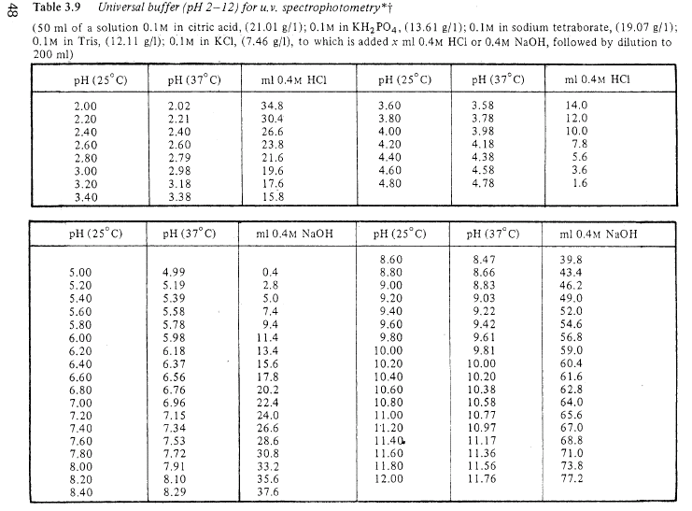

Refer to Universal Buffer in Appendix for details.
Deionized water of known density was titrated onto a mass balance. The accuracy of the buret could then be determined by comparing the volume given by the mass and density with the volume given by the markings on the buret.
Linear regression of the NaOH concentration-density data from 73rd CRC Handbook produced a density of 1.040 g/mL for an assumed concentration of 1.000 M. Eefer to NaOH Density under the Appendix for details.
Refer to Micropipet Calibration in Appendix dor details

