REPORT COVER PAGE

GROUP NUMBER: M2

PROJECT TITLE: MUSCULOSKELTAL SYSTEMS-
Quantitative Evaluation of Measurement Methods for the Musculoskeletal System
DATE SUBMITTED 12/05/02

ROLE ASSIGNMENTS

ROLE GROUP MEMBER

FACILITATOR……………………….. Lesleigh Redavid

TIME & TASK KEEPER………………Deepak Kollali

SCRIBE & PRESENTER ……………. Lillian Wang
Summary:
The bicep muscle was used to investigate how well the Biopac Pro represents the musculoskeletal system. The effect of static loading on a working bicep muscle was investigated using a range of free weights, resulting in a linear relationship between the mass lifted and the EMG voltage reading: [Voltage Reading (mV)] = 0.1466*[Mass (kg)] + 0.3078 for all subjects. Three tests were performed to evaluate the effect of placement of ground and positive/negative electrodes on EMG readings. Placement of ground electrodes on one arm and on two arms were tested using two common bicep electrodes in conjunction with four ground electrodes. Bicep electrode placement was also varied, as well as bicep electrode separation distance. The only of these variables found to significantly affect EMG output was bicep electrode placement; placements along the long head of the bicep were found to produce the best peak-to-noise ratios.

Objectives:
The Biopac Pro program provides a means to record and analyze a variety of applications on human and animal subjects. Using this program, the musculoskeletal system will be investigated and a quantitative measure of how well Biopac Pro is able to represent the musculoskeletal system will be determined. The bicep muscle on a human’s dominant arm will be the target muscle for observation and readings taken in the EMG form.

Specific Aims:
Specifically, a number of experiments designed to produce different muscle output readings will be performed. The effect of static loading on a working bicep muscle will be investigated using a range of free weights. The effect on varying the ground placement will also be examined and an optimal placement for the ground electrode will be determined. The distances between each bicep electrode will be varied and its effect analyzed. Through these analyses, a protocol to achieve consistent results and to minimize the sources of error when using the Biopac Pro will also be determined.

Background for proposed project:
- Referring to the Biopac Pro Website was helpful in determining what measurements the Biopac could provide as well as providing information on specific protocols to help improve the accuracy of the measurements taken.

Theory and Methods of Calculation:
- http://davidmlane.com/hyperstat/intro_ANOVA.html
This website helped explain the differences between a t-test and an ANOVA test.
- EMG signals were compared using the peak-to-noise ratio, which is calculated by dividing the peak-to-peak amplitude of the contraction period by the peak-to-peak amplitude of the relaxed state. Signals during the relaxation period are considered background noise because the bicep muscle is not doing work and is assumed to not be producing any significant voltage output.
- Subjects chosen were all between 19 and 21 years of age. However, other variables such as gender, ethnicity, physical strength, , height, weight, and level of activity greatly ranged.

Materials, Apparatus, Methods:
- BIOPAC Software: Biopac Student Lab PRO
- BIOPAC Data Acquisition Unit (MP30)
- BIOPAC electrode lead sets (SS2L)
- BIOPAC disposable vinyl electrodes (EL503)
- Electrode gel (GEL1) and abrasive pad (ELPAD)
- Free Weights (0, 2, 2.3, 4.5, 6, and 9kg)

Results:
Subjects 2 and 3 each performed two trials with one set of bicep electrodes and four ground electrodes in order to determine optimum ground placement.

Subject 1 performed several trials varying the distance between bicep electrodes to determine if distance between electrodes would affect the EMG readings. Four electrodes were placed on the bicep on the same axis to eliminate directional variations. (Refer to Diagram ###) All four electrodes shared a common ground, which was placed on the inner forearm. In all trials the lower electrode remained stationary. In Placements 1, 2 and 3 the distance between electrodes was 3.20cm, 6.70cm, and 10.50cm, respectively. The best results were obtained from Placement 2, which can be seen as the middle line of data in Figure 6. This was determined because it has a magnitude of 53mV versus 36mV for Placement 1 and 38mV for Placement 3.

STATIC LOADING:

Six subjects were required to perform 10 trials each using static load with a series of 6 masses of increasing size (0kg, 2kg, 2.3kg, 4.5kg, 6kg and 9kg). A plot of the average peak-to-peak voltage EMG readings against mass resulted in a linear trend. The following linear equation resulted: [Voltage Reading (mV)] = 0.1466*[Mass (kg)] + 0.3078. The value of the square of the correlation coefficient is 0.9841. The error bars represent the standard deviations.

Figure 1: Average EMG Voltage vs. Mass Lifted for Subjects 1 through 3

Individual plots of the average peak-to-peak EMG voltage readings against mass for subjects 1 through 3 resulted in linear trends. The values of the square of the correlation coefficient ranged from 0.971 to 0.987. The error bars represent the standard deviations.

Figure 2: Individual Average EMG Voltage vs. Mass Lifted for Individual Subjects

PLACEMENT OF GROUND ELECTRODES:

Two common bicep electrodes were used in conjunction with four ground electrodes on one arm. The white electrode was placed at the top of the bicep while the red electrode was placed at the muscle base. Refer to Diagram 1 for placements. Figures 3 and 4 are representative of the results obtained from the six subjects tested.

Diagram 1: Placement of Ground Electrodes on Single Arm

Figure 3 below represents the EMG readings for the four ground electrode setups on one arm. The blue in the graph is representative of electrode placement 1, the pink is representative of placement 2, the black is representative of placement 3 and the red is representative of placement 4.
Figure 3: Representative EMG results for Ground Electrode Placement Trials on Single Arm
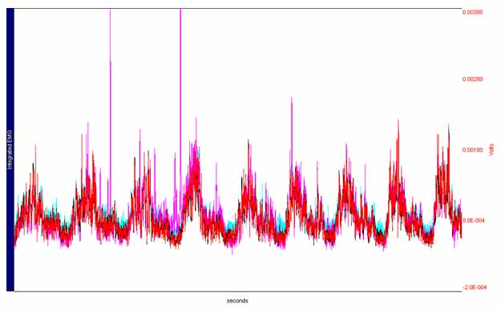
The average peak to noise ratio was determined for each placement. This ratio was used as the main criterion for determining the best electrode placement. Table 1, below, is a summary of the average peak to noise ratios and their respective standard deviations.
Table 1: Average Peak:Noise Ratio and Standard Deviation for EMG Ground Electrode Placement Trials on Single Arm
Placement | Average Peak:Noise Ratio | Standard Deviation
1 | 3.09702 | 0.87217
2 | 3.97884 | 1.042
3 | 3.15079 | 2.20393
4 | 3.28472 | 0.5764

Two common bicep electrodes were used in conjunction with four ground electrodes spread onto two arms. In these trials the subjects had the ground electrodes placed much further away from the bicep electrodes. The white electrode was placed at the top of the bicep while the red electrode was placed at the muscle base. Refer to Diagram 2 for placements.

Diagram 2: Placement of Ground Electrodes for Two Arms

Subjects’ left arm (not pictured in diagram) had the fourth ground electrode placed on the center of the bicep of the left arm.

Figure 4 below represents the EMG readings for the four ground electrode setups on one arm. The blue in the graph is representative of electrode placement 1, the pink is representative of placement 2, the black is representative of placement 3 and the red is representative of placement 4.
Figure 4: Representative EMG results for Ground Electrode Placement Trials on Two Arms
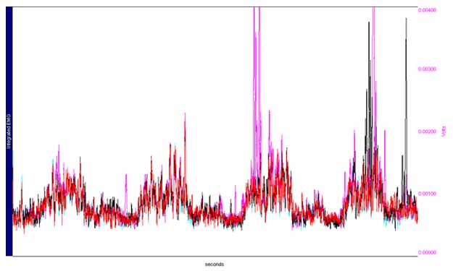
Table 2, below, is a summary of the average peak to noise ratios and their respective standard deviations for EMG Ground Electrode Placement Trials on Two Arms.
Table 2: Average Peak:Noise Ratio and Standard Deviation for EMG Ground Electrode Placement Trials on Two Arms
Placement | Average Peak:Noise Ratio | Standard Deviation
1 | 3.03492 | 0.4938
2 | 3.50417 | 0.87413
3 | 3.1114 | 1.66197
4 | 5.72262 | 2.76797

PLACEMENT OF ELECTRODES:

Four sets of bicep electrodes were used in conjunction with one common ground electrode on one arm. Refer to Diagram 3 for placements. Figure 5 represents a general trend of EMG results obtained from the six subjects tested. The upper three electrodes (1-3) were white as well as the fourth electrode on the inner arm. The fourth electrode close to the outer arm was red as well as the three lower electrodes (1-3).
Diagram 3: Placement of Electrodes and Ground for Figure 5.

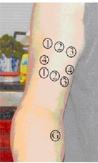

Figure 5: Representative Integrated EMG vs. Time for Placement of Electrode Trials (Placements 1 through 4) 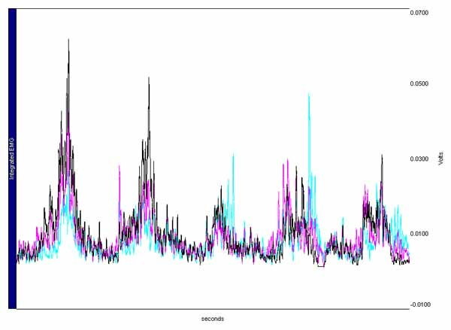

Four sets of bicep electrodes were used in conjunction with one common ground electrode on one arm. Refer to Diagram 4 for placements. Figure 6 represents the general EMG trend of results obtained from the six subjects tested. The upper three electrodes (1, 4, and 2) were white as well as the third electrode on the inner arm. The fourth electrode close to the outer arm was red as well as the three lower electrodes (2, 3, and 1).

Diagram 4: Placement of Electrodes and Ground for Figure 6
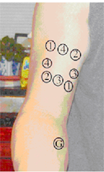

Figure 6: Representative Integrated EMG vs. Time for Placement of Electrode Trials (Placements 1 through 4) 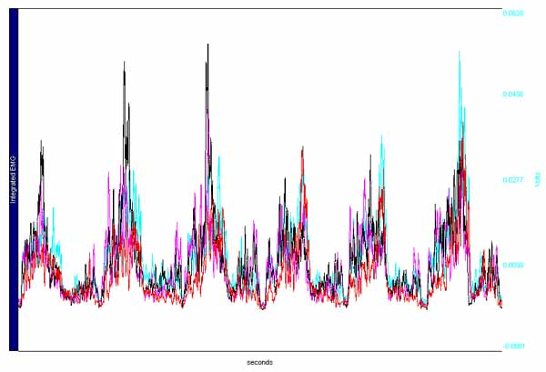
Table 3, below, is a summary of the average peak to noise ratios and their respective standard deviations for EMG Bicep Electrode Placement Trials.

Table 3: Average Peak:Noise Ratio and Standard Deviation for EMG Bicep Electrode Placement Trials

NOTE: Placements 5-8 are Placements 1-4 on Diagram 4
Placement | Average Peak:Noise Ratio | Standard Deviation
1 | 5.44783 | 1.50022
2 | 3.37743 | 0.81904
3 | 2.86451 | 0.72814
4 | 2.1961 | 0.88116
5 | 5.38046 | 1.07509
6 | 3.26064 | 0.69816
7 | 3.87378 | 1.93204
8 | 2.90471 | 1.40844

BICEP ELECTRODE SEPARATION:
Four electrodes were placed on the bicep on the same axis to eliminate directional variations. (Refer to Diagram 5) All four electrodes shared a common ground, which was placed on the inner forearm. In all trials the lower electrode remained stationary. In Placements 1, 2 and 3 the distance between electrodes was 3.20cm, 6.70cm, and 10.50cm, respectively.
Diagram 5: Placement of Electrodes for Bicep
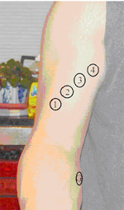

Figure 7 below represents the EMG readings for Variable Bicep Distance Trials

Figure 7: Representative EMG results for Variable Bicep Distance Trials
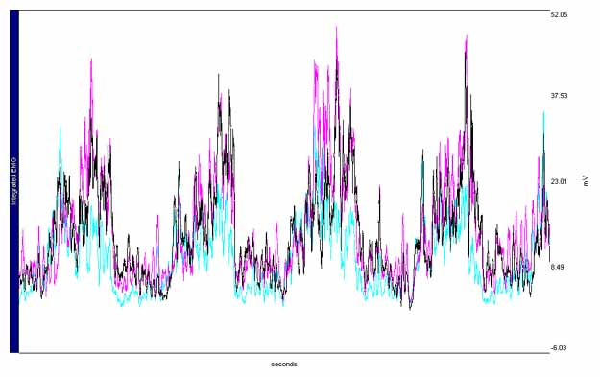

Table 4, below, is a summary of the average peak to noise ratios and their respective standard deviations for EMG bicep separation distance trials.

Table 3: Average Peak:Noise Ratio and Standard Deviation for EMG Bicep Separation Distance Trials
Distance (cm) | Average Peak:Noise Ratio | Standard Deviation
3.2 | 3.99616 | 0.40992
6.7 | 3.71231 | 0.47827
10.5 | 3.39682 | 0.88734

Discussion and Analysis of Results:
Two major tests were performed to evaluate how well the Biopac Pro represents the bicep muscle using EMG readings; static loading and electrode placement.

It is visible from Figure 2 that within each individual’s static loading EMG readings there is a linear relationship between average voltage and mass loaded. Although there was much variation between individual readings, as witnessed by the error bars, averages tended to fall along straight lines. The lengths of the error bars clearly increase as the load increases, and the reason for this increase in variation between trials from a single individual is most likely fatigue. Because a large number of static loading trials were performed per subject, avoiding the effects of fatigue was an important goal. To accomplish this, recovery periods of ten minutes were given to the subjects between trials, which is approximately twenty times the length of the trials themselves. This prevented large fluctuations due to fatigue; however, due to the order in which the masses were applied to each subject’s arm (from lowest to highest), fatigue affected the higher loads more than the lower ones.

Figure 1 shows a plot of average EMG voltage reading versus mass loaded for six subjects, the three subjects in Figure 2 plus three additional subjects. A linear relationship is exhibited in this graph. Once again, standard deviations of the voltage readings are larger for heavier masses, a result of the fact that each individual followed this trend. In order to keep deviations between the EMG voltage readings for different subjects to a minimum, several methods were used. First, masses were loaded to each subject’s arm at a constant distance from the elbow, in order to keep the amount of torque at the joint equal between subjects. Second, subjects were instructed during these trials to only flex the minimal amount needed to keep the forearm parallel with the ground, because it is possible to “lock” the joint by flexing the bicep more than is necessary while counteracting this by simultaneously contracting the tricep muscle. Finally, to prevent changes due to psychological factors, subjects were not allowed to see the EMG readings during their trials. Using these procedures the surprising result found was that all subjects, no matter what type of body build, exhibited similar results.
It was expected that those with larger muscle masses would have lower EMG readings because they would need to recruit fewer motor units to lift the same mass as those subjects with little muscle mass. This difference was not found to be very obvious in the results of this experiment, because all subjects’ data points fall close to a single line. A reason for this is that the electrical signals actually given off by the muscle are very small, orders of magnitude smaller than ECG signals. Biopac amplifies the input signal greatly to a level where signals are visible. However, this also amplifies any minute errors in measuring the electrical signal, such as those due to differing electrode contact strength and wire connections. Resultantly, small differences in actual muscle electrical signal due to varying motor unit size between subjects gets somewhat “blurred” by random small errors during amplification.

Figure 8: Compilation of Static Loading Data Points with 95% Confidence Intervals
Figure 8 shows all collected data points from the static loading experiment, along with the calculated best-fit regression line and the 95% confidence intervals of the data. The vast majority of the data points lie between the upper and lower confidence interval lines. This plot once again demonstrates the increase in the spread of measured values as loading increases. When the axes of this plot are inverted, a relationship can be determined whereby mass loaded is dependent on EMG voltage. Because the data from all subjects correspond well with each other, it is possible to work backwards from the Biopac EMG peak-to-peak voltage readings to estimate what load is being held by a subject. The relationship found is:
Mass [in kg] = 6.7136 * Voltage [in mV] - 2.0036
In addition, by using 95% confidence intervals, an uncertainty can be derived for this mass predicted from EMG voltage. It was found that the mass predicted by the above equation based of Biopac EMG peak-to-peak voltage has an uncertainty of ± 21.8%.

Three distinct tests were performed to evaluate the effect of placement of ground and positive/negative electrodes on EMG readings for six dissimilar test subjects. They were the placement of ground electrodes, the placement of bicep electrodes and bicep electrode separation. Statistical analysis for all three tests indicated whether the placement of the electrodes had a significant effect on the EMG readings taken by the Biopac Pro.

Due to the fact that a t-test can only compare two groups at any one time, it was decided that this was not a good choice of statistical analysis. If more than two groups need to be simultaneously analyzed, analysis using a t-test becomes difficult. This is because the number of t-tests increases geometrically as a function of the number of groups. Therefore an Analysis of Variance (ANOVA) test was used instead.
The ANOVA f-test is a function of the variance of the set of group means, the overall mean of all observations, and the variances of the observations in each group weighted for group sample size. One-way ANOVA tests differences in a single interval dependent variable among two, three, or more groups formed by the categories of a single categorical independent variable. ANOVA tests whether the groups formed by the categories of the independent variable seem similar (specifically that they have the same pattern of dispersion as measured by comparing estimates of group variances). If the groups seem different, then it is concluded that the independent variable has an effect on the dependent.
In an ANOVA test, if the F value is larger than the F critical value, the data is considered to be significantly different. Also, to verify that the results did not occur by random chance, the P value for the Alpha test needs to be less than an alpha value of 0.05 or 5%.
Three distinct tests were performed to evaluate the effect of placement of ground and positive/negative electrodes on EMG readings on six dissimilar test subjects. Placement of ground electrodes on one arm and on two arms were tested using two common bicep electrodes in conjunction with four ground electrodes. (Refer to diagrams 1 and 2 for placement).

An ANOVA statistical analysis was performed on the data collected comparing results for each of the four ground placements (represented by each color); the results are indicated in tables 4 and 5, below.
Table 4: ANOVA results for Placement of Ground Electrodes on Single Arm
ANOVA
Source of Variation | SS | df | MS | F | P-value | F crit
Between Groups | 4.06225 | 3 | 1.35408424 | 0.769804227 | 0.04592 | 3.098392654

Data from figure 3 produced an F value of 0.7698 which is less than the F critical value of 3.098. Since the F value is less than the F critical value, it can be concluded that the placement of ground electrodes did not have a significant effect on EMG readings. The P-value for placements on one arm is 0.046 which is less than the alpha value of 0.05. This verifies that the data recorded was not due to random chance. It was hypothesized that the reason for the lack of major change in peak:noise ratio due to ground placement was a result of the fact that the four ground placements only differed by a few centimeters. It was decided that the effects of varying electrode placement would be more visible if placements were chosen over a larger body range.

Table 5 below, illustrates the ANOVA results for the placement of ground electrodes on two arms. ANOVA analysis indicate once again that placement of ground electrodes did not have a significant effect on EMG readings. Data from figure 4 produced an F value of 0.7698 which is less than the F critical value of 3.098. However the ANOVA analysis also indicates that data from placement of ground electrodes on two arms could be the direct result of random chance. This is due to a P-value (0.524) greater than the alpha value of 0.05. So even though it can’t be proven statistically that the ground electrode placement significantly effects the peak:noise ratio, it is much more likely that it does in these two arm trials than in the one arm ground placement trials. As seen in Table 2, the two placements with the highest average peak:noise ratios are those on the upper forearm and on the opposite bicep. However, the standard deviation of the ratios from the opposite bicep is excessively high (48.3% of the mean) meaning that this high average value may not carry great weight. It is understandable why the upper forearm ground produced good results, as it was the closest to the bicep muscle and could therefore best remove background electrical signals from this immediate vicinity of the muscle.
Table 5: ANOVA results for Placement of Ground Electrodes on Two Arms
ANOVA
Source of Variation | SS | df | MS | F | P-value | F crit
Between Groups | 4.06225 | 3 | 1.35408424 | 0.769804227 | 0.524393381 | 3.098392654

Four sets of bicep electrodes were placed on the dominant arm of subjects with one common ground electrode in order to test the effect of eight various placements of positive/negative electrodes. (Refer to Diagrams 4 and 5) An ANOVA test was performed on the data comparing results for each of the bicep electrode placements. The results are indicated in table 6 for placements 1-8.

Table 6: ANOVA results for Placement of Bicep Electrodes (Placements 1-8)
ANOVA
Source of Variation | SS | df | MS | F | P-value | F crit
Between Groups | 39.1503 | 7 | 5.59289657 | 3.861209628 | 0.005975213 | 2.422630985

ANOVA analysis indicated that the placement of bicep electrodes had an effect on EMG readings. The data produced an F value larger than the F critical value (3.861 > 2.423). It can also be assumed that this result was not due to random chance since ANOVA analysis results in a very small P-value of 0.0059. Once it was determined that placement of bicep electrodes had an effect on EMG readings, the optimal electrode placement was determined. The criterion for determining the optimal placement of electrodes was the placement whose data resulted in the highest peak to peak: noise ratio. Referring to table 3, Placements 1 and 5 resulted in the highest peak to noise ratio with the smallest standard deviation. Therefore it was determined that Placements 1 and 5 were the optimal placements for the bicep electrodes. This can possibly be explained by the fact that the bicep has two heads. The longer of the two heads does more work when the palm is facing upward and fully extended curls are being performed. The shorter head has a similar function; however, it works more in rotating the forearm, which was not performed in this experiment.

In order to eliminate directional variations and isolate the effects of electrode separation, four electrodes were placed on the bicep along a common axis. These electrodes all shared a common ground, located on the inner forearm and a common positive electrode. (Refer to Diagram 5) An ANOVA test was performed and the results are indicated in table 7 below.

Table 7: ANOVA results for Placement of Bicep Electrode Separation:
ANOVA
Source of Variation | SS | df | MS | F | P-value | F crit
Between Groups | 0.89886 | 2 | 0.44943161 | 1.138612774 | 0.0438765 | 3.885290312

Data from figure 7 produced an F value of 1.139, which is smaller than the F critical value of 3.885. From these results, it can be concluded that the separation of bicep electrodes did not have a significant effect on the EMG readings. The P-value was 0.044, which is less than the alpha value of 0.05, which verifies the results did not occur by random chance. Over the range of 3-11cm, there is no significant change in peak to noise ratio resulting from the distance between electrodes. This can either be because the electrical output does not change significantly or due to the fact that the precision of EMG readings was too low to detect such small differences in electrical output.

Recommendations:
- Test a larger sample size for all parts of the experiment to encompass a more accurate representation of the general population.

Conclusions:
- A linear relationship was found between the mass lifted by the bicep muscle and the EMG voltage reading: [Voltage Reading (mV)] = 0.1466*[Mass (kg)] + 0.3078. Using the inverse of this linear relationship and its 95% confidence intervals, an estimate of an unknown load held by a subject can be approximated to within 21.8% of its actual value.
- Bicep electrode placements were found to have better peak-to-noise ratios when electrodes were placed on the long (outer) head of the bicep; such placements produced peak:noise ratios ranging from 5.38-5.45, as opposed to a range of 2.19-3.88 for other electrode placements.
- Ground placement and bicep electrode separation distance were found to have no significant effect on the EMG peak-to-noise ratio.

http://www.biopac.com/bslprolessons/prolessonsindex.htm
www.couplescompany.com/advice/chris/curl.htm

