PROJECT REPORT COVER PAGE

GROUP NUMBER: T1

EXPERIMENT NUMBER: 2-P5

TITLE: Quantitative Evaluation of an Electrooculogram (EOG)

DATE: December 15, 2002

ROLE ASSIGNMENTS

ROLE GROUP MEMBER

FACILITATOR Roanne Mejilla

TIME & TASK KEEPER Jimmy Sastra

SCRIBE Victoria Chou

PRESENTER Elizabeth Irish

summary

In this study, electrooculography was used to measure horizontal movement of the eye, by measuring potential produced by the medial and lateral rectus muscles. It was found that the absolute potential is not proportional to the absolute angle of the eye, however a linear relationship between the change in voltage and the change in angle was observed. The regression: dV = .013 (dtheta) +.007, with an R-squared value of 0.9982, was used in subsequent trials to calculate the change in theta. A comparison of the actual angle to the calculated angle yielded a linear relationship (calculated =1.1083 real-.979, R² = 0.9994). When displaying dots at random angles an average percent error of 20% was observed throughout measurements of dtheta. The method for calculating the absolute angle involved summating subsequent dthetas. Due to the accumulation of error, this method can only accurately predict angle measurements over a short interval, due to random walk phenomenon.

Objectives and Specific aims
- To use Electrooculography to find a relationship between eye position and the voltage produced.
- To improve accuracy and precision of EOG.

- Determine the position of the eyes as a function of the change in voltage, using visual focus in lateral eye movement with an accuracy of ± 2°.
- Determine which physical factors can lead to extraneous error and inconsistency.

Background
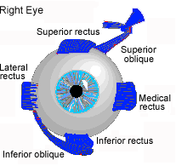
The eye is controlled by 3 sets of muscles. The Superior Rectus and Inferior Oblique are used for upward motion and for down-gazing, respectively. The Superior and Lateral Oblique rotate the eye. The Lateral and Medial Rectus move the eyes from side to side. More specifically, the Lateral Rectus is used for “abduction”- lateral motion of the eye moving outward towards the ear, and the Medical Rectus is used for “adduction”- lateral motion of the eye moving inward towards the nose. The pairing of 3 cranial nerves is responsible for innervating the muscles. Each set of muscles is reciprocally innervated; one muscle is relaxed, while the other contracts. The active muscles of each eye will vary in terms of lateral motion, but not in vertical motion.

Saccadic movement occurs when the eyes jump from one subject to another, fixating on successive points. Voluntary fixation movements occur when stimuli are flashed. This type of movement occurs during reading, where the eye moves across the visual scene. When the eye is following a moving stimulus, “pursuit” movement occurs. The eye saccadically jumps to follow the motion of the stimulus, gradually progressing into smooth motion.

Similar to the laws governing electromyography, electrooculography (EOG) measures the potential difference at the skin’s surface caused by muscle movement. The electrodes of EOG’s are placed on the inner and outer corners of the eye to record the side to side activity of the Lateral and Medial Rectus muscles. The electrodes are placed above the eyebrow and below the eye to record the up and down motion of the Superior and Inferior rectus, respectively. Because the muscles governing the vertical motion of the eyes are the same in both eyes, the electrodes can be placed to record activity in either the right or the left eye. The EOG must be carefully placed around the eye to record muscle movement because of its sensitivity to any signals received through the electrode. The signal has been observed to change even in the absence of eye movement. It is prone to drift and spurious signals. The area of the contact between the electrodes and the skin produces another source of variability. However, EOG offers physicians an inexpensive and invasive method for monitoring the behavior of the eye. It is used in the clinical setting to monitor sleep and dreaming, eye movement in infants, reading ability, and visual fatigue.

THEORY

  - The angle of the eyes is respective to the center point in between the eyes, and corresponds to the angular position of the dot on the screen. A trial recording the change in voltage with incremental changes in the position of the stimulus was used to construct a standard curve. The standard curve graphed the change in the EOG voltage as a function of the change in the angle of the eye. The linear relationship derived was used in subsequent trials to convert the change in voltage to a change in the angle of the eye.
  - The absolute angle of the eye was calculated by adding the change in the angle of the eye to the previous absolute angle of the eye.
  - The accuracy of EOG measurements were found by comparing the calculated angle of the eye, with the angle the dot appeared on the screen with respect to the eye.

MATERIALS AND METHODS

MatLab
Powerpoint
Frame to stabilize the head during experimentation
  - Using Powerpoint, a test was designed to monitor the acclimatization behavior of the eye. The subjects were instructed to focus on the points that appeared on the screen. The first slide contained one point in the center, which served as a baseline. (Θ=0˚). After five seconds, the next slide appeared, containing a point on the far left of the screen. The subject focused on this point for thirty seconds. Then the next slide appeared, containing a point on the far right of the screen. The subject focused on this point for thirty seconds.
  - Using Matlab, two tests were programmed to monitor eye movement across the screen. A baseline reading was recorded before each trial. The subject focused on a point in the center of the screen, which served as the Θ = 0˚ mark.
    - Pattern test: This exercise consisted of two phases, which occurred consecutively and in both left and right directions.
      - The subject looked at points which moved at increasing angles from the center, in both the left and right directions. (Θ = 11.1, 21.5, 30.6, 38.2, 44.5)
      - The subject looked at points which moved at increasing angles, but before proceeding to the next angle, the eyes returned to the center of the screen (Θ=0˚).
    - Linear Random test: The subject followed points on a line which appeared at random positions on a linear plane.

rEsULTS
Preliminary trial (Fig 1)
- The range of the average standard deviation from one subject is .01 to .036 mV
- The range of the average standard deviation between subjects is .02581 to .09282 mV.
Acclimatization (Fig 2)
- Decay of focusing on the left from the center is y = 0.100Ln(x) - 0.637 (R2 = 0.935).
- Decay of focusing on the right from the left is y = -0.166Ln(x) + 1.090 (R2 = 0.931).
Pattern/Random test
- A linear relationship between dθ and dV was derived from phase 2 of the pattern test, with an equation of y=.013x +.007 with an R² of .9982 (Fig 4).
- A linear relationship exists between the calculated and real Θ in phase 1 of the pattern test, Calculated = 1.1083 (Real) - .979 with an R² value of 0.9994 (Fig 5).
- The average error in dTheta is 0.167 degrees, the average %error in dTheta is 19.6%, and the average error in Theta is 9.0094 degrees(Fig 6A).
- A regression of the absolute %error of dTheta yields a slope of 0.363x (Fig 6B) with an R-squared value for 0.15.

tables and graphs

Figure 1: Averages of Absolute Voltages During a Preliminary Trial
 | Subject One |  | Subject Two |  | Subject Three |  |  | Subject Four |  | Average | Standard Deviation
Dot | Ave. | St. Dev | Ave. | St. Dev | Ave. |  | St. Dev | Ave. | St. Dev | Average | Standard Deviation
One | -0.378 | 0.036 | -0.554 | 0.018 | -0.324 | 0.024 |  | -0.406 | 0.022 | -0.4155 | 0.09151
Two | -0.206 | 0.02 | -0.31 | 0.02 | -0.166 | 0.026 |  | -0.19 | 0.02 | -0.218 | 0.06361
Three | -0.028 | 0.018 | -0.05 | 0.012 | -0.026 | 0.014 |  | -0.038 | 0.02 | -0.0355 | 0.02581
Four | 0.114 | 0.014 | 0.184 | 0.02 | 0.09 | 0.024 |  | 0.092 | 0.01 | 0.12 | 0.04648
Five | 0.24 | 0.01 | 0.38 | 0.012 | 0.218 | 0.02 |  | 0.216 | 0.016 | 0.2635 | 0.06666
Six | 0.312 | 0.014 | 0.512 | 0.018 | 0.296 | 0.018 |  | 0.325 | 0.014 | 0.3613 | 0.09282
Seven | 0.338 | 0.018 | 0.546 | 0.016 | 0.316 | 0.016 |  | 0.37 | 0.026 | 0.3925 | 0.09499
Baseline | -0.062 | 0.016 | -0.108 | 0.026 | -0.11 | 0.02 |  | -0.0825 | 0.016 | -0.091 | 0.03329
Figure 1: In this trial, a powerpoint animation flashed a dot across the screen, starting from the far left and progressing incrementally to the far right. The absolute voltage for four trials for each subject and among the four subjects was recorded.

Figure 2: Acclimatization Trend Test
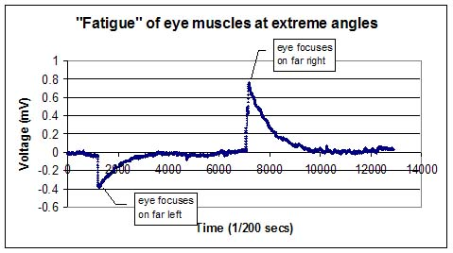
Figure 2 illustrates the logarithmic decay of EOG readings with respect to voltage. Each test subject was instructed to focus on the dots that appear on the screen. The first peak corresponds to the initial change in voltage that occurred when the subject’s eyes moved from the center of the screen to the point on the far left. The second peak corresponds to the change in voltage that occurred when the eyes focused on the point on the right side. The second peak is twice as big as the first peak because the eye must traverse twice the distance from the far left to the far right; compared to the distance the eye travels from the center to the far right. After approximately five seconds, although the subject was still focusing on the object in the extreme left or right side of the screen, the voltage gradually returned to the baseline voltage. This trend varied between subjects in terms of degree and rate of decay.

Figure 3: EOG Recording During the Matlab Pattern Test
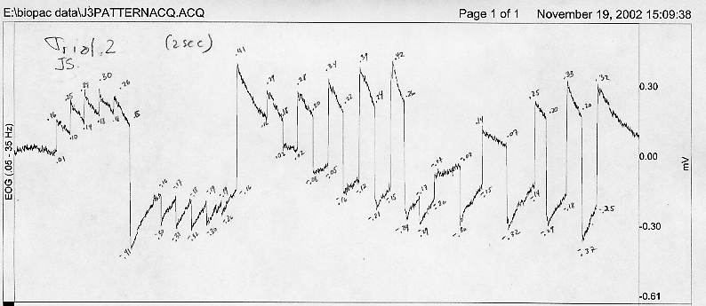
Figure 3 illustrates the EOG results of a subject performing the pattern test. The peaks to the left of the red line correspond to phase 1 of the pattern test and the peaks to the right of the red line correspond to phase 2 of the pattern test. Note: the potential peaks in part 1 (.16, .25, .28, .3, .26 mV) are not equal to the peaks of the corresponding angles in part 2 (.29, .28, .34, .39, .42 mV). The same holds for the negative angles. Peaks (-.30, -.31, -.31, -.3 -.28 mV) do not correspond to peaks (-.29, -.30, -.32, -.29, -.37 mV).

Figure 4: Standard Curve Derived from Part 2 of the Pattern Test
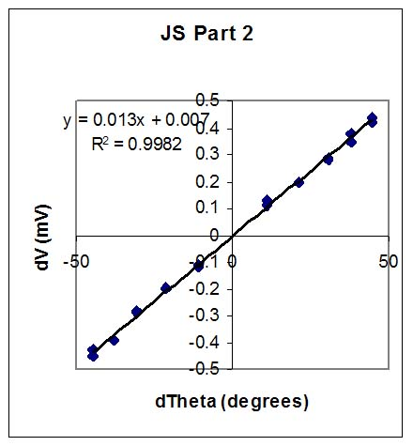

Figure 4 illustrates the behavior of dV and dθ during part 2 of the pattern test.

Figure 5: Comparison of Calculated Θ and Real Θ
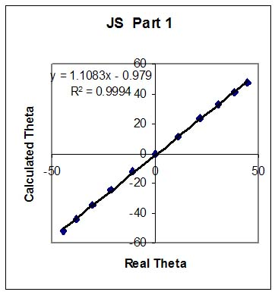

Figure 5 compares calculated Θ to the real Θ. Calculated Θ was found by using the regression from the standard curve of part 2 of the Pattern test: dV = .013 dΘ +.007 (Figure 4). The new absolute calculated Θ was found by adding the d Θ to the previous absolute calculated Θ.

Figure 6: Error Analysis
A B
Figure 7A shows the correlation between the error in degrees of dtheta and theta.
Figure 7B shows the consistency in absolute %error of dTheta for each data point.

DISCUSSION & ANALYSIS OF RESULTS

The preliminary trial was performed to determine the variability in the absolute voltage between different subjects. Because the deviation in the average voltages between the subjects ranged from .02581 to .09499, and the deviation in voltage between trials of individuals ranged from .01 to.036, performing trials on one individual would prevent much deviation (resulting from different muscle strengths or varying electrode placement between individuals (Figure 1)), and measurement of error would be emphasized on the BioPac Pro.

In the acclimatization test, an initial increase in voltage associated with the movement, was observed, but eventually, the voltage began to decay, settling at the baseline level (Figure 2). The initial rise in voltage is attributed to the rapid rise in action potential causing the muscles to move in the direction of the stimulus, and the decay is a result of the decrease in firing rate of the nerve. The firing rate after approximately five seconds becomes very small, and a potential can not be detected. This shows that absolute potential is not proportional to absolute angle, and was further investigated by the pattern test.

The potential peaks at the corresponding angles in part 1 and part 2 of the pattern test, are different, and the baseline does not yield a consistent voltage, adding to the evidence that absolute potential is not proportional to the absolute angle (Figure 3). Since focus returned to zero degrees, after each increasing angle, part 2 was used to derive a standard curve. The change in voltage which was found to be directly proportional to the change in angle, with linear relationship of dV = .013 (dtheta) +.007, with an R-squared value of 0.9982 (Figure 4). This calibration was used to predict angle of view in part 1 and compared to the real angle which was the angle at which stimuli were shown. A plot of real angle vs. derived angle showed that position could be accurately determined (calculated =1.1083 real-.979 (Figure 6)).

Error over a large range of random data points was observed in the random test, by providing random stimuli where the subject was not able to predict the next stimuli. A consistent %error with an average of 19.6% was found over all changes in angle (Figure 7). Since absolute angle was derived by summating the changes in angles, error in theta is analogous to the random walk phenomenon. The error in theta in degrees is shown in figure 7A, and is small (+4.7 degrees) in the first ten data points, but increases in the long term, with highest deviation of -19.5 degrees. The run was limited to 25 data points, but in the even longer run, deviation could increase even more as in the random walk phenomenon, and pose a problem. Predicting angles by adding changes in angle, is an adequate method in the short run, however in the long run could yield false angle measurement. A suggested solution, if this is used for an application, is to calibrate every ten or fifteen angle changes.

The average of the error in dTheta is 0.167, relatively small, showing that predictions are not over, or underestimations. This is important because Theta is determined by summing dThetas. If the average error of dTheta was high, we would be overestimating, and errors in dTheta would also consistently increase the error in Theta. Since errors are summated, error in Theta would keep increasing rather than following a random walk path.

A step in the study of vertical movement was taken, and it was shown that as in the horizontal eye movements, a direct linear relationship was found between dV, and dTheta, with an R-squared value of 0.96 (Appendix fig C). The R-squared value is smaller than found in the horizontal eye movements because noise was observed in the form of spikes, caused by the blinking of the eyes. This often occurred when, the eye changes angle, which complicated the measurements of dV. It was decided that this noise should be reduced, for example by applying filters, before any further investigation.

It was seen that decay was not proportional to the absolute angle as seen in figure 2. It was hypothesized that decay rate is proportional to absolute voltage. Another possibility is that it is proportional to change in angle. Due to time constraints, and since decay can not give us any clues on what the absolute angle is at any time, this was not further investigated in this lab.

CONCLUSIONS

      - EOG can predict the change in position in the lateral range:
- dV = .013 (dtheta) +.007
- calculated =1.1083
- real-.979
      - The accuracy and precision of EOG measurements on visual focus, restricting only to lateral eye movement, was found to be 19.6% degrees
      - Accuracy can be improved by performing multiple trials using the same electrode placements. Additionally interference from other muscles can be avoided by constructing a device to keep the head steady and also keep subjects’ distance from the screen constant.

SELECTED REFERENCES
- http://www.biopac.com/bslprolessons/prolessonsindex.htm
- http://www.ee.virginia.edu/~cmf6p/research_docs/EOG.pdf
- http://www.liv.ac.uk/~pcknox/teaching/Eymovs/emeth.htm
- http://web1.tch.harvard.edu/research/engle/ema.html

APPENDIX
Figure A: Comparison of d Θ to the Absolute Θ

Figure A compares the Calculated d Θ to the Absolute Θ using data from part 1 of the Pattern test.

Figure B: EOG recording of subject while reading
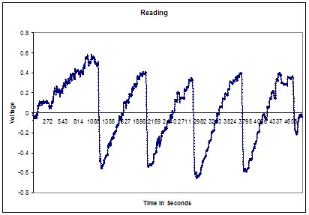
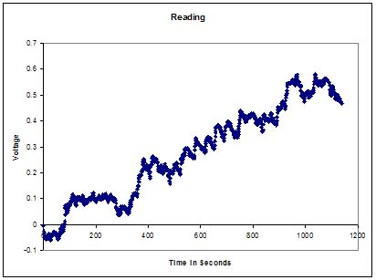

Figure C: Random Test on a Vertical Plane 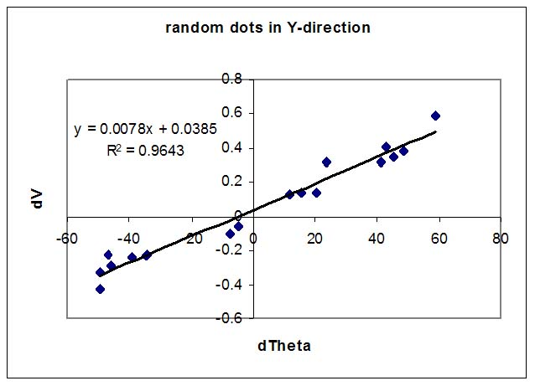
The linear random test was performed on a vertical plane.

