FINAL LABORATORY REPORT

GROUP NUMBER M1

TITLE Two-Compartment Modeling

DATE SUBMITTED 05/01/02

GROUP MEMBERS

Matthew DeNardo
Nicholas Fawzi
Courtney Morgan
Angela Xavier

Summary of Conclusions:

A two-compartment model of KCl solutions was created and compared to mass balance mathematical models for the concentration of KCl in each compartment. Flow between the compartments was modeled for steady-flow and sinusoidal-flow cases. Plots of analytical equations predicting the concentration in each compartment were compared by visual inspection as well as by taking the mean difference and mean percent difference between the theoretical and actual concentrations. For both conditions, the actual and theoretical curves had the same shape and time decay. For steady flow, the mean percent difference in concentration between experimental and mathematical model was 0.44% for compartment 1, and 2.7% for compartment 2. For sinusoidal flow, the mean percent difference was 4.5% for compartment 1 and 3.8% for compartment 2. Based on the resulting low mean percent differences, this modeling of a two-compartment system with mathematical equations was determined to be accurate. By varying the conditions of the mathematical model, it was determined that the peak concentration in compartment 2 is linearly proportional to the initial concentration in compartment 1 and inversely related to the volume of compartment 2 by a multi-term logarithmic function. These mathematical models can now be applied to modeling biological systems such as drug delivery and lactation.

BACKGROUND:

The main objective of the project was to model the flow of KCl solution through a two-compartment system under different flow conditions. The objective was accomplished through the completion of several specific aims. First a mathematical model was created for different flow conditions. Then, trials were run based on the conditions used in the mathematical model. Finally, the actual data was compared to the modeled data in order to check the accuracy of the model.

Compartmental modeling can be used to represent biomedical systems, such as a flow of molecules in the body. This is a class of models whose solution is a system of linear or nonlinear ordinary differential equations. Compartmental modeling allows for experimenting with behaviors of a system. By establishing a certain model under specific conditions, a system can be tested to determine how it will respond. Another use of compartmental modeling is to simulate a process or model a known disease process that creates data to study.¹ Several different systems may be modeled by increasing the number of compartments that best model the behaviors of interest. Although more compartments will result in more complicated solutions, all compartmental models are governed by a system of ordinary differential equations.² ³

There are real-life implications for compartmental modeling. For instance, compartmental modeling can be used to represent the delivery of a drug through the circulation as it is absorbed into tissues, where compartment one is the blood and compartment two is the tissue. Also, the study of human lactation has been represented through compartmental modeling. Combined with isotope dilution, the concentration in breast milk of a nutrient that is supplemented to the mother can be determined.⁴ Experimental nutrition is also an area of study that utilizes compartmental modeling. Models can determine how and what concentrations of certain vitamins, minerals, etc., will be absorbed by the body. Compartmental modeling also has biological uses outside of a model of a biological system within a body. The field of epidemiology has also benefited from compartmental modeling. Separate compartments represent different areas of society, and the model determines how society may be affected by an outbreak of an epidemic disease. ⁵

Background information for the project was also provided by the final project of Group T1, BE 310, Spring 2001. The basis of this experiment was the setup taken from this group. However, this year’s project built on last year’s project by including a model for pulsatile flow as a square-wave function and a sinusoidal function, as well as by investigating the factors that affect the concentration in compartment two.⁶

MATERIALS:
- 4 channel Peristaltic Pump
- Two Cole Parmer Conductivity Meters
- Various Plastics Syringes and tubing
- Various Glass Beakers
- 0.015M KCl solution
- De-ionized water
- Magnetic Stirrers
- Nitrile gloves
- Lab View
- Matlab
- Maple

METHODS:

The experimental set up of the model was created using an intake, two compartments, and an output into a waste container. After each compartment, the solution was drawn through the pump at the determined flow rate, and flow profile. The fluid was drawn up through a conductivity meter from both compartment one and compartment 2 so the concentration of KCl in each compartment could be recorded. Each compartment was placed on a magnetic stirrer so that the compartments were well mixed. Therefore, it could be assumed that the concentration was the same throughout the whole compartment. Initially, the intake compartment contained de-ionized water, the first compartment contained 0.015M KCl solution, and the second compartment initially contained de-ionized water.

Figure 1. Experimental setup.

Before starting any of the trials, the conductivity meters were calibrated to establish a relationship between concentration of KCl and conductance. The equation for the calibration was:
Concentration (M) = 0.0075*Conductance (mS) –0.0002

Each day before starting trials, the conductivity meters were calibrated against a 718mS standard solution to ensure the accuracy of their readings.

Three different experimental setups were used. On the first day in lab, the same set-up as that of Group T1, BE 310, Spring 2001 was used. This had 300 ml in each compartment, and a steady flow rate of 17ml/min. For the next set of trials, the volume was reduced to 150 ml in each compartment and flow rate was increased to 30 ml/min so more trials could be run in the allotted time. The next flow rate used was a square wave pulse going from 0ml/min to 30 ml/min with a 4 second period and 50% duty cycle. The third flow rate used was a sinusoidal pulse governed by the equation
Flow (L/sec) = 1/5000*sin (1/5*Pi*t)+3/10000

For these trials 20 ml were used in each compartment because the changes in concentration had to be relatively large with each pulse of the pump in order to observe the sine wave influence on each compartment’s concentration.

In order to compare the actual data to the expected data, a mathematical model of what the concentration should be depending on the flow conditions was created. A set of differential equations was created that described the concentration of KCl at any point in time. Maple was used to obtain the solutions of the equations, and Matlab was used to create graphs of the solutions and compare them to the recorded data.

RESULTS:

Mathematical Modeling

To model the two-compartment system under the different flow conditions, a mathematical relationship was derived from the mass balance for a set of well-mixed compartments. A set of differential equations was created to describe the number of moles in either compartment at any point in time. The differential equations were derived from a simple molar balance of the change in moles equal to the amount of moles in minus the amount of moles out for each compartment. (There are no generation or consumption terms for this experiment.) Change in moles over time for compartment one is taken to be a factor, k, multiplied by the concentration currently in that compartment. This factor, k, is defined as the flow rate divided by the volume of the compartment from which the mass is flowing.

Steady Flow:

For steady flow, the flow rate is constant, and therefore k is constant. The value of k is also the same for each compartment because flow rates and volumes are constant between the two compartments. Under steady flow conditions, the differential equations for the mass in each compartment are as follows:

Compartment 1 (steady flow):
Compartment 2 (steady flow):
As these equations correctly show, the mass balance for compartment 1 only contains an ‘out’ term, as there was no KCl being pumped into the compartment. Compartment 2 contains the same ‘out’ term, but also an ‘in’ term based on the solution for the differential equation for compartment 1 (the factor k multiplied by the concentration in compartment 1 at time t). The differential equations were solved with the following initial conditions: (1) the number of moles of KCl in compartment 1 at t = 0 was 0.0045 moles (2) the number of moles of KCl in compartment 2 at t = 0 was 0. The differential equations were solved in Maple for the moles in each compartment, and then the solution was converted to concentration by dividing the equation by the volume of the compartment. The solutions of these differential equations are below, in terms of concentration.

Solutions to the differential equations for steady flow:

Under ideal conditions, the plot of the concentration in each compartment versus time should look like this:

Figure 2: Two-compartment steady flow model
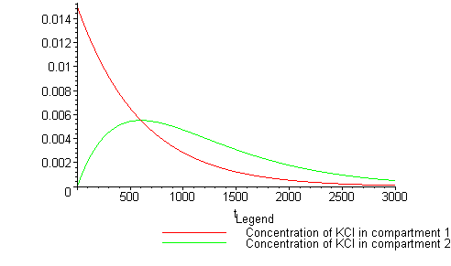
To see how well the model works, the actual data set from the steady flow trial was plotted on the same set of axes in Matlab.

Figure 3: Two-compartment steady flow data comparison
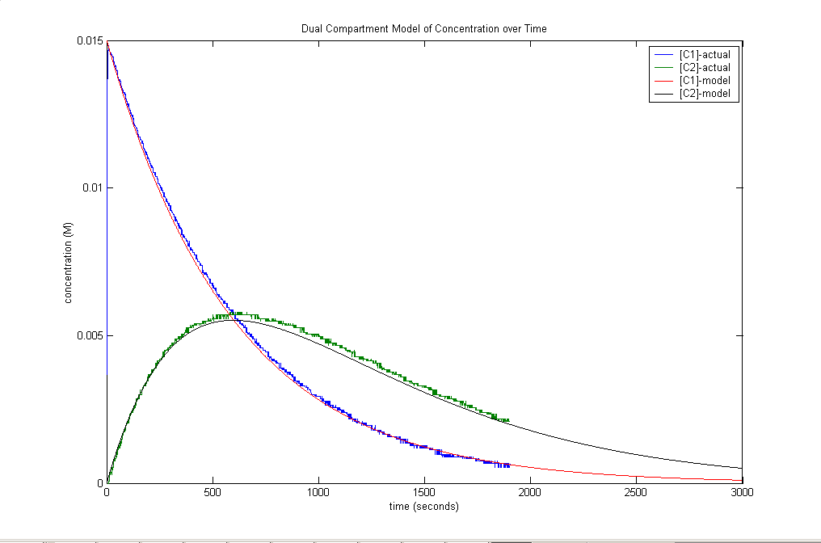
Square-wave flow:

Square-wave flow was modeled as a similar process as the steady flow model above. However, because the pump was on for 2 seconds and off for 2 seconds, it was assumed that the model was the same but would take twice as long for the KCl to completely pass through the system. Because of this, the solution for steady flow above was used to model the square-wave pulsatile flow, but the time t was doubled.

Figure 4 below displays the experimental data for a square-wave pulse flow on the same axes as the model described above.

Figure 4.
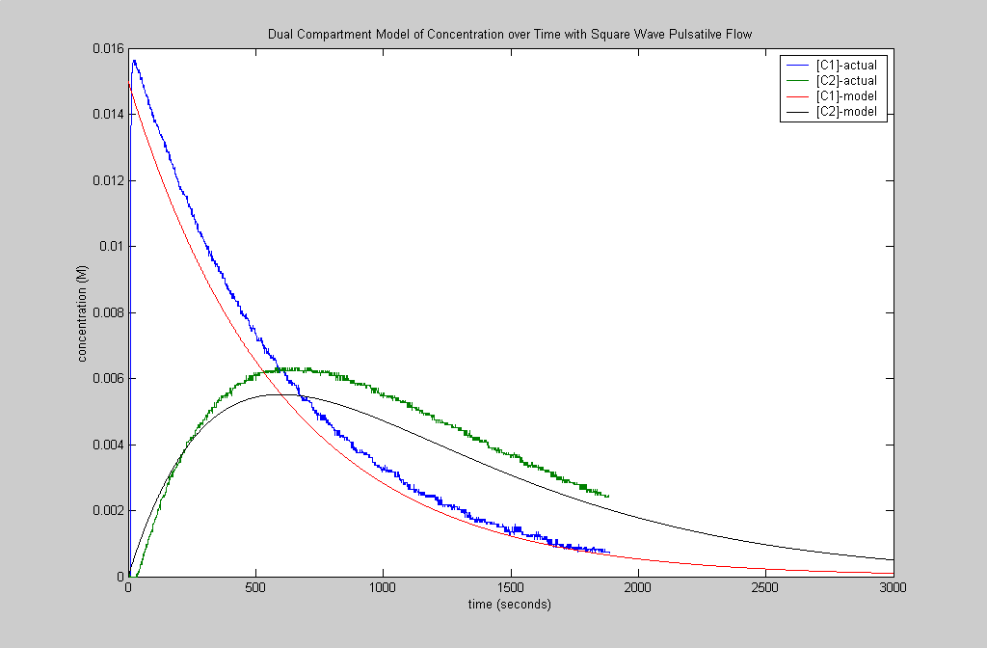
Discrepancies arise in this model as compared to that of the steady flow model. These differences were attributed to the stop-and-go motion of the pump. The pump could not achieve an instantaneous stop of flow, followed by an instantaneous starting of flow after two seconds. As a result, a true mathematical model would need to account for the time needed for deceleration and acceleration. The time needed for this is not accounted for in the model and explains the differences between the curves in Figure 4.

Sinusoidal flow:

Since the pump also had the ability to adjust its flow rate according to an input function, a non-steady flow condition was created in which the pump output was sinusoidal, with period of ten seconds. This long period was chosen so that the pump could smoothly change flow rates. The flow rate was set up to be varying by a sine function from the maximum pump speed to a minimum of 1/5 of the maximum pump speed. This factor of 1/5 the maximum pump speed was chosen so that the pump would not have to come to a complete stop. When a complete stop was included, the pump had difficulty reproducing the sine wave. The flow equation is as follows, where flow is in liters/second:

Equation for sinusoidal pump output:

As with steady flow, the molar balance is the same for the two compartments. However, the factor k is no longer a constant because the flow rate varies as a sine function. With the pump output now a function of time, rather than a constant, the differential equations become increasingly more complex:

Compartment 1 (sinusoidal flow):
Compartment 2 (sinusoidal flow):

As with steady flow, the differential equations for each compartment were solved in Maple using the appropriate initial conditions. The equations were again converted to concentration by dividing by the volume of the compartment. In terms of concentration, the solutions for the above differential equations are:

Compartment 1 (sinusoidal flow):

Compartment 2 (sinusoidal flow):

Figure 5 below is the graph of concentration versus time for the above equations.

Figure 5: Two-compartment sinusoidal flow model
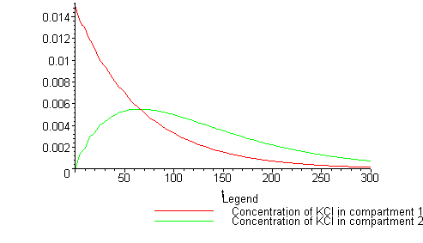

The figure below (Figure 6) is the actual data from trials of a pulsed sinusoidal flow plotted on the same axes as the above model in Figure 5.

Figure 6: Two-compartment sinusoidal flow data comparison
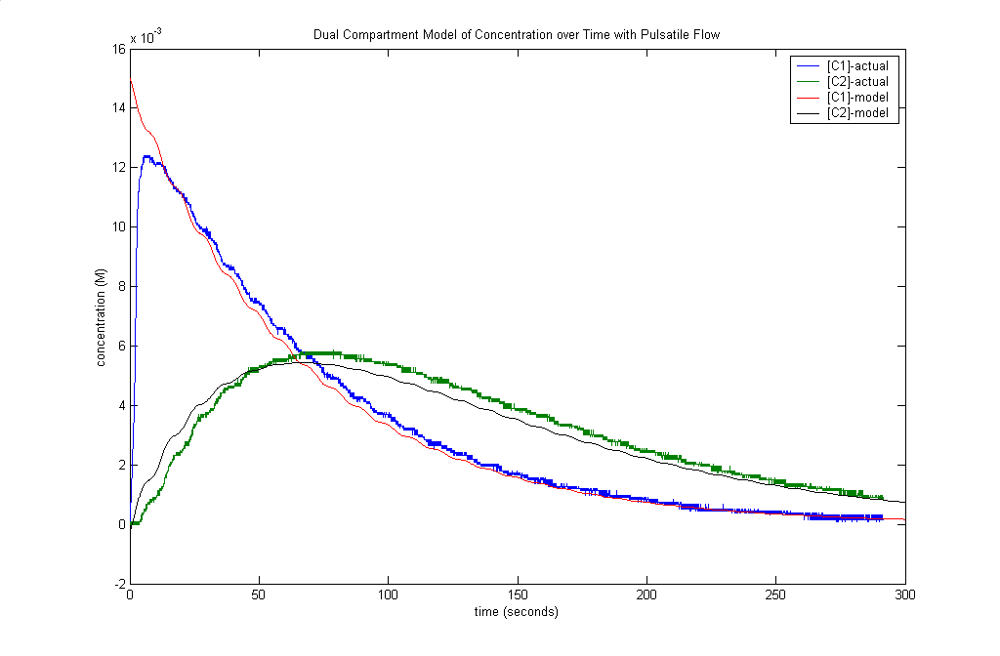
See Appendix for plots of additional trials conducted.

ANALYSIS:

In order to quantify how well the data matched the mathematical models used in this experiment, a comparison had to be created. A mean difference and standard deviation between the actual and predicted concentration of KCl at each time step was calculated in Matlab. Ideally, the mean difference and standard deviation for identical data sets would be zero. Displayed in the table below are the calculated mean differences and standard deviations for each compartment under non-pulsatile and sine pulsatile flow. The mean percent difference between actual and predicted concentration at each time step was also calculated by dividing the difference between actual and predicted by the predicted concentration at each time point.

The mathematical models have less than a 5% difference from the actual data, indicating that the equations derived give an accurate model for the actual flow of KCl between compartments.

An application of this model could be to determine the concentration in the second compartment of a system. In order to determine what affects the peak height of the curve for compartment 2, the effect of changing the pump flow rate and the effect of altering the volume of compartment 2 were explored by modifying the mathematical models. First, the value of k was increased by a factor of 100, but the volume was held constant elsewhere in the model. As a result, the increase in k reflected an increase in the flow rate by a factor of 100. When compared to the initial model, the peak height of the graph was the same. The effect of increasing the flow rate was only to “squish” the graph along the time axis, which is an indication that altering the flow rate only alters the amount of time required for the KCl to completely pass through the system.

Secondly, the effect of changing the volume of compartment 2 was explored in the model. In order accomplish this change, the value of the factor k was written in terms of volume two (i.e. flow/vol2). This applied only to the k factor for the “out” term of compartment 2. The k for the “out” term of compartment 1, which is the same as the k for the “in” term for compartment 2, remains the same because the volume of compartment 1 is not changed in the model. Inputting this into the equation for compartment 2, differentiating, and setting equal to zero determined the maximum height (maximum concentration) for compartment 2. This method finds the maximum concentration because the time at which the derivative is zero is equal to time of maximum concentration. The expression below describes this maximum height in terms of the volume of compartment 2.

Increasing the concentration of compartment 1 would also increase the maximum height of the curve for compartment 2. This increase is linearly proportional to the increase of concentration initially in compartment 1. (If you double the concentration in compartment 1, the maximum concentration of compartment 2 will also be doubled).

CONCLUSIONS:

- Compartmental systems can be modeled using the above apparatus, experimental setup, and differential equations.
- Steady flow and sinusoidal flow differential equations correlate with the experimental data to within 5% for each condition tested.
- The peak concentration in compartment 2 for this setup is linearly proportional to the initial concentration in compartment 1 and inversely proportional to the volume in compartment 2. It is not affected by flow speed between compartments assuming all flow rates remain equal.
- Pump limitations limit the ability to create true square-pulse flow and therefore limit the ability to model this flow mathematically.

REFERENCES:

- http://xerxes.sph.umich.edu:2000/geomed/modules/compart/lab.html
- http://tanami.rfpk.washington.edu/aboutrfpk.html
- Godfrey, Keith. Compartmental Models and their Application. Academic Press: London. 1983, pp. 35-57.
- http://www.nal.usda.gov/ttic/tektran/data/000008/68/0000086836.html
- http://www.fda.gov/cvm/antimicrobial/022200slides/Lipsitch/tsld004.htm
- Final Project, Group T1, BE 310, Spring 2001
APPENDIX:

Trial 1 performed with 300ml in each beaker and a steady flow of 17 ml/min with well-mixed compartments

Trial 2 performed with 300 ml in each beaker and a steady flow rate of 30ml/min with well-mixed compartments

Trial 1 performed with pulsatile flow as described in methods with well-mixed compartments and 150 ml in each compartment

Trial 2 performed with pulsatile flow as described in methods with well-mixed compartments and 150 ml in each compartment.

Trial 1 performed with sinusoidal flow as described in methods with 150 ml in each compartment and well-mixed compartments

Trial 2 performed with sinusoidal flow as described in methods with 20 ml in each compartment and well-mixed compartments

Trial 3 performed with sinusoidal flow as described in methods with 20 ml in each compartment and well-mixed compartments

Trial 4 performed with sinusoidal flow as described in methods with 20 ml in each compartment and well-mixed compartments.

Trial 1 steady flow of 30 ml/min with 150 ml in each compartment, with no stirring of the compartments

Trial 1 using the square wave flow as described in methods with 150 ml in each compartment, with no stirring of the compartments

Trial 2 using the square wave flow as described in methods with 150 ml in each compartment, with no stirring of the compartments

Trial 3 using the square wave flow as described in methods with 150 ml in each compartment, with no stirring of the compartments

Matlab program for steady flow:

clear all;

t=[0:1:3000]'; % time matrix for 3000 seconds, sample taken once per second
c1=.015*exp(-t./600); % concentration in compartment one
c2=.000025*exp(-t./600).*t; % concentration in compartment two

data=load('nonpulse.txt');
plot(data);
hold on;
plot(t,c1,'r');
hold on;
plot(t,c2,'k');
hold on;

xlabel('time (seconds)');
ylabel('concentration (M)');
title('Dual Compartment Model of Concentration over Time with Steady Flow');
legend('[C1]-actual','[C2]-actual','[C1]-model','[C2]-model');

Matlab program for square-wave pulse:

clear all;

t=[0:1:3000]'; % time matrix for 3000 seconds, sample taken once per second
c1=.015*exp(-t./600); % concentration in compartment one
c2=.000025*exp(-t./600).*t; % concentration in compartment two

data=load('squarepulse.txt');
plot(data);
hold on;
plot(t,c1,'r');
hold on;
plot(t,c2,'k');
hold on;

xlabel('time (seconds)');
ylabel('concentration (M)');
title('Dual Compartment Model of Concentration over Time with Square Wave Pulsatilve Flow');
legend('[C1]-actual','[C2]-actual','[C1]-model','[C2]-model');

Matlab program for sinusoidal pulse:

% compartmental modeling with pulsatile flow

clear all;

t=[0:0.2:300]'; % time matrix for 300 seconds, sampled every 0.2 seconds
c1=.015.*exp(-1/200.*(-10.*cos(1/5.*pi.*t)+3.*pi.*t)/pi)/(cosh(1/20.*1/pi)+sinh(1/20.*1/pi)); % concentration in compartment 1
c2=.000075.*exp(-1./200.*(-10.*cos(1./5.*pi.*t)+3.*pi.*t)./pi).*(-10.*cos(1./5.*pi.*t)./pi+3.*t)./(cosh(1./20.*1./pi)+sinh(1./20.*1./pi))+3.*exp(-1./200.*(-10.*cos(1./5.*pi.*t)+3.*pi.*t)./pi)./(200000.*pi.*cosh(1./20.*1./pi)+200000.*pi.*sinh(1./20.*1./pi)); % concentration in compartment 2

data=load('pulse.txt');
timescale=[0:1/30:291.7333]' % this time vector takes into account that these data were sampled 30 times per second (the end time was adjusted so that [data] and [timescale] were the same length
plot(timescale,data); % plots the timescaled data
hold on;
plot(t,c1,'r');
hold on;
plot(t,c2,'k');

xlabel('time (seconds)');
ylabel('concentration (M)');
title('Dual Compartment Model of Concentration over Time with Pulsatile Flow');
legend('[C1]-actual','[C2]-actual','[C1]-model','[C2]-model');

