BE 310 Project Report Spring 2002

TITLE: Testing Postural Stability in the Lateral and Sagittal Positions

DATE SUBMITTED: May 1, 2002

Group M3:
Marisa Kastner
Anoop Kowshik
Jared Shoemaker
Esther Wong

Abstract

Postural stability of the back is a useful biomarker. In the past, postural stability has been measured by correlating body sway to force plate measurements. The effects of various stimuli on postural stability have also been studied. In this experiment, a dual- axis accelerometer was used to measure postural stability and how it is affected by visual and somatosensory stimuli. A dual-axis accelerometer allows for measurement along two different axes simultaneously. Therefore, deviations in angle in both the lateral and sagittal planes could be recorded. Subjects were instructed to stand in positions minimizing the stability in the particular plane being tested. For testing visual stimuli, subjects were tested with eyes both open and closed. For testing somatosensory stimuli, subjects were tested while touching a smooth surface at non-mechanically supportive forces in the unstable plane. As hypothesized, visual and somatosensory stimuli improved the postural stability of the subjects.

Introduction

Accurate measurements of postural stability or sway may be used in a number of health related applications, ranging from strictly medical, to athletic, to everyday or recreational activities. With respect to medical applications, postural stability measurements may be used as biomarkers for geriatric studies. In addition, measurements may be used in analyzing the progress of amputee patients, persons undergoing chiropractic care, or individuals who have lost various degrees of vestibular function. Similarly, in the case of athletes either in training or recovering from injury, measurements of postural stability would be useful in evaluating their growth and development. Finally, in a more daily or recreational setting, measurements of postural stability may help improve guidelines for heavy-lifting safety as well as sobriety tests.
In addition to the importance of accurate postural stability measurements, somatosensory information has been shown to affect postural stability and sway. The following report aims to discuss measurements of postural sway as well as the effect that somatosensory stimuli has on this measurement.

Objectives and Hypotheses

The objectives in this experiment are to determine an appropriate method for using a dual-axis accelerometer to measure postural sway, to construct a means by which to attach a dual-axis accelerometer to the body, and to determine whether or not visual and somatosensory stimuli affect postural sway.
Three hypotheses were made in this experiment. First, it was hypothesized that subjects standing with eyes open will be more stable than those standing with eyes closed. Second, a somatosensory stimulus from finger touching in the unstable plane will produce more stability than not touching. Lastly, the effect on postural stability from visual stimuli was hypothesized to be equal to the effect from somatosensory stimuli.

Background

In their article entitled “Stabilization of Posture by Precision Touch of the Index Finger with Rigid and Flexible Filaments,” authors Lackner, Rabin, and Dizio of Brandeis University claim that “light touch of the index finger with the stationary surface at non-mechanically supportive force levels (<100g) greatly attenuates the body sway of subjects.” Furthermore, in the article “Stabilization of Posture by Precision Contact of the Index Finger,” Lackner again, along with authors Holden and Ventura, make claims that “postural sway during quiet stance increases if sight of the surroundings is denied [but that] information about body displacement provided by contact of the index finger with a stationary bar can be used to stabilize balance in the absence of vision.” More compactly stated, in the article entitled “Fingertip Contact Influences Human Postural Control,” authors Jeka and Lackner state simply that “touch contact was as effective as force contact or sight of the surroundings in reducing postural sway when compared to the no contact, eyes closed condition.”
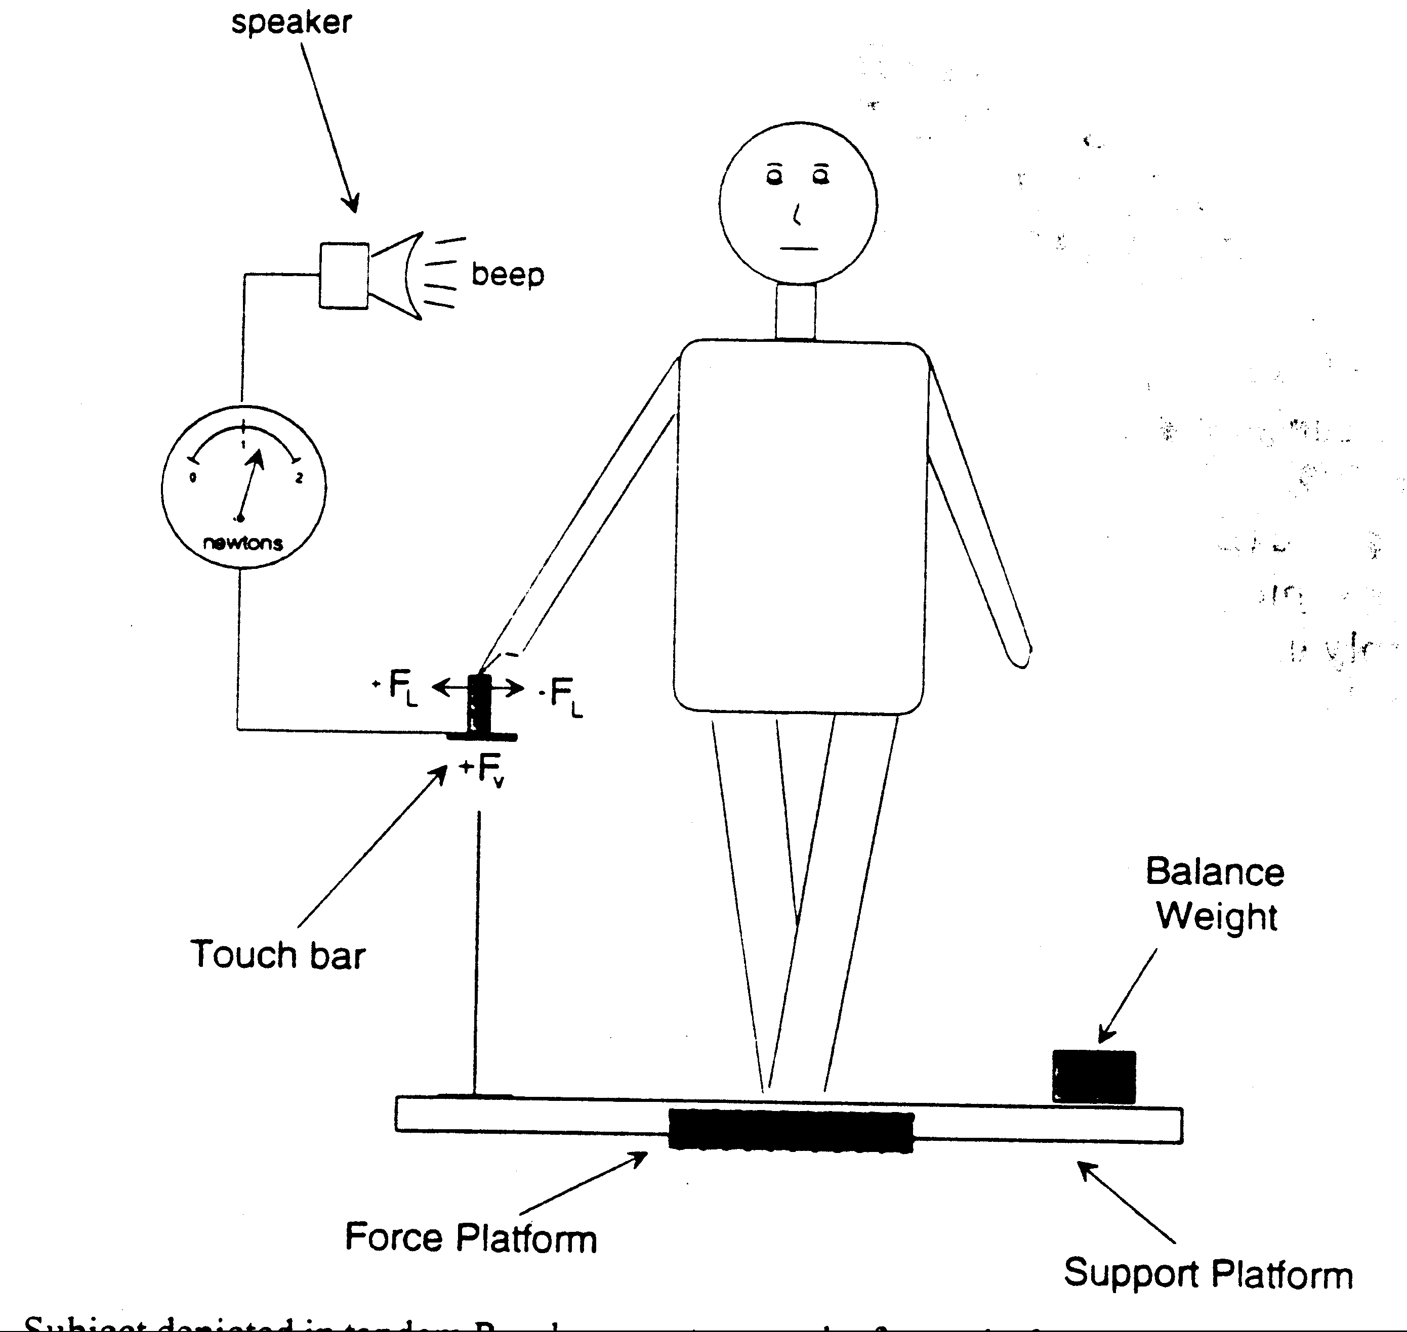
These postural sway measurements were taken with the subject standing on a force plate, (as displayed in Figure 1 below) where “at the low amplitude of body sway observed in these experiments, center of foot pressure displacement can be considered to be approximately equal to angular body sway.”
Figure 1: Subject standing in the tandem Romberg position on the force platform.

As shown in the diagram above, should the subject go above 1 N on the touch bar, an alarm sounds to inform the subject he/she has gone above the set amount of force.

Subjects in the above research situations were tested in two different stances. The first stance, tandem Romberg, allows for more accurate measurement in the lateral (side-to-side) direction. Subject stands heel-to-toe, as displayed in Figure 2 below.
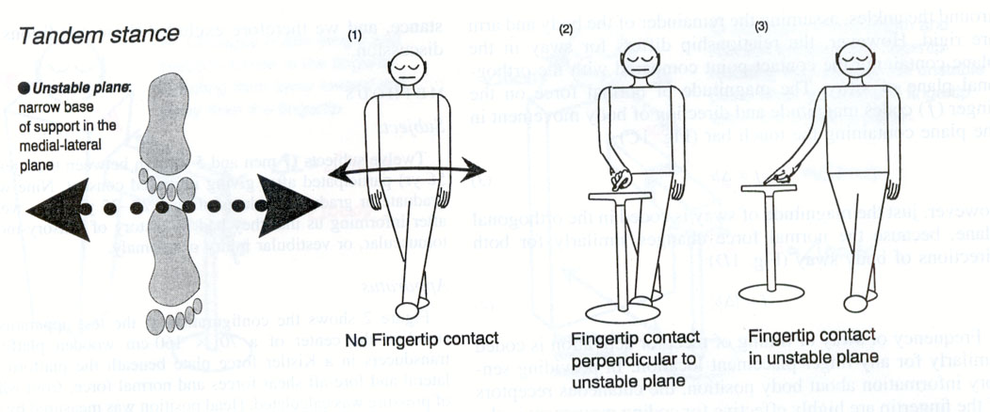

Figure 2: Subject standing in the tandem Romberg position for measuring lateral stability.

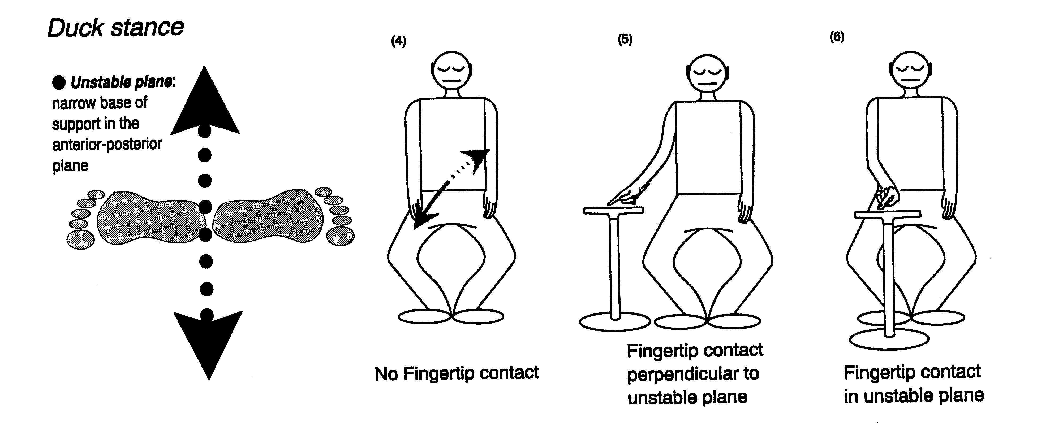
The second stance, known as the Duck stance, allows for more accurate measurement in the sagittal (front-to-back) direction. Subject stands heel-to-heel, with feet at a 180 degree angle, as displayed in Figure 3 below.

Figure 3: Subject standing in the Duck Stance position for measuring sagittal stability.

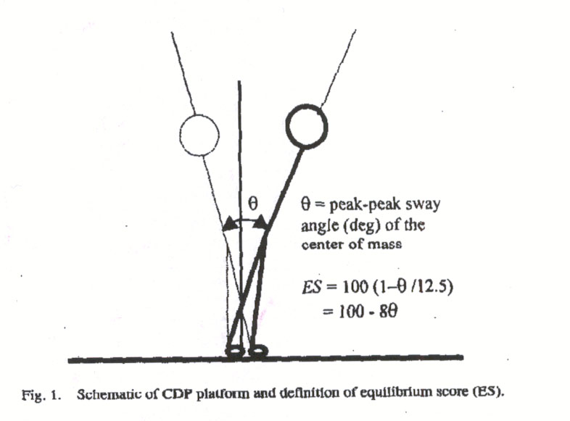
Finally, one article entitled “A Statistical Model for Interpreting Computerized Dynamc Posturography Data” suggested the equilibrium score (ES) as a way of normalizing the postural sway data. (See Figure 4 below).

Figure 4: Equilibrium Score calculation for normalizing postural sway.

While the data in the following experiment was collected using the back-angle dual-axis accelerometer rather than force plates, as in the articles, the ES score was still calculated using the peak-to–peak angle θ = 2*standard deviation, where the mean and standard deviations were calculated for each trial.

The 2g dual-axis accelerometer has a computer interface which allows Labview to simultaneously record data from both axes.

Materials

- ADXL202 dual axis, 2 g accelerometer
- Sponge container
- Back strap
- Scale
- Labview Program BackAngle1.VI

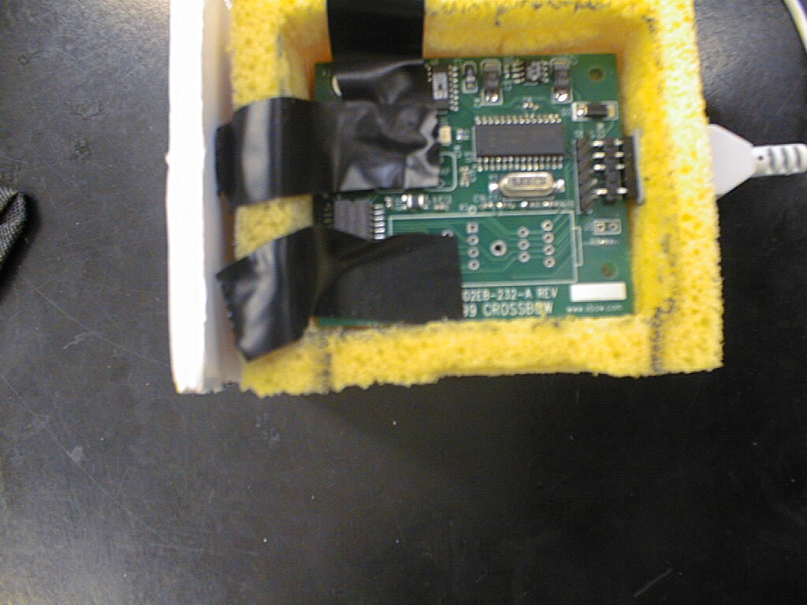
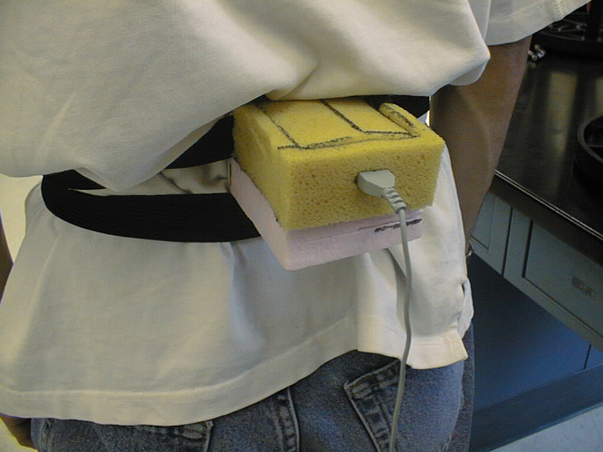

Figure 5: Picture of the apparatus. Figure 6: A subject during testing.

Methods

As shown in Figure 6, the accelerometer was attached to the lumbar region using an elastic strap wrapped around the body twice. The accelerometer, which could measure acceleration up to 2g or 19.6 m/s² in two axes, was connected to a computer via a serial port. The Labview program BackAngle1.VI was used to collect data.
Before each trial, the accelerometer was zeroed when the subject was standing up straight, with legs shoulder width apart, eyes open, and arms down by his/her sides. To test postural stability in the lateral plane, the tandem Romberg stance was used. After the accelerometer was zeroed, a 10-second reading was taken of the subject standing in the tandem Romberg stance with right foot in front of left, balancing in the middle. Four different conditions were tested: eyes open, eyes closed, eyes open with lateral touch in the unstable plane with right fingertip, and eyes closed with lateral touch in the unstable plane with right fingertip. The force applied was monitored on a scale so that it did not exceed 100 grams.
To test postural stability in the sagittal plane, the duck stance was used. Subjects were instructed to stand with heels touching, feet at approximately 180˚ angle. The distance between the heels was not to exceed one inch, if possible. 10-second readings were taken of the subjects in the duck stance with eyes open and eyes closed. Then the effect of sensory input was tested when subjects had their eyes open with anterior touch using right fingertip in the unstable plane, and eyes closed with anterior touch using right fingertip in the unstable plane. The force was again monitored to be less than 100 grams.

Data Reduction and Results

To quantify the results in a standardized form, the equilibrium score (ES) is used.

ES = 100 – 8*θ (1)

The angle θ represents the peak angle sway along the axis. However, this equation assumes that the axis of the body about which θ is measured is perpendicular to the ground. For many of our trials the subjects’ bodies were not perpendicular due to the different stances. To correct for this, the ES calculation had to be modified.
Instead of taking peak-to-peak angle sway for θ, the standard deviation of the mean sway angle was used. This way, the angle is taken with respect to the actual body axis. The standard deviation was doubled to account for sway in both directions in the same plane. This method is also more accurate since the standard deviation corresponds to the average sway during the trial.

θ = 2*(Angle Std. Dev.)
ES = 100 - 8*(2*Angle Std. Dev.) (2)

Before the ES could be calculated using equation (2), the data recorded had to be converted to angles. Since the values recorded were in g’s, the conversion used was:

arcsin(g) = angle (3)

Since the accelerometer was zeroed at the regular stance (back straight, feet shoulder width apart), the g at this stance would read zero. Since there is no body displacement, the angle is also zero which equation (3) confirms. When the subject bends completely parallel to the ground, in either the sagittal or lateral plane, the accelerometer will experience the full force of gravity, which is one g. The angle displacement of this position is 90 degrees which equation (3) confirms.

Table 1 below is an example of the data for one subject in the tandem Romberg stance. The results for all subjects can be viewed in the appendix.
Table 1: Sample results for Subject 1
 |  | No Touch |  |  |  | Touch
 | Eyes Open |  | Eyes Closed |  | Eyes Open |  | Eyes Closed
 | Lateral | Sagittal | Lateral | Sagittal | Lateral | Sagittal | Lateral | Sagittal
Average Angle | 0.911 | 4.691 | 1.369 | 4.177 | -0.175 | 3.433 | -0.065 | 4.114
Equilibrium Score | 90.616 | 91.108 | 78.823 | 80.292 | 92.401 | 92.445 | 90.151 | 90.880
Angle Std. Dev | 0.586 | 0.556 | 1.324 | 1.232 | 0.475 | 0.472 | 0.616 | 0.570
Percent Std. Dev | 64.370 | 11.848 | 96.677 | 29.488 | -271.622 | 13.756 | -943.615 | 13.855

Analysis

A higher ES corresponds to a more stable individual. With that in mind, several comparisons were made among each subject to determine the affect of somatosensory and visual stimuli on postural stability. In addition, the relative affect of a visual stimulus compared to a somatosensory stimulus was compared. If we expect both stimuli to have the same affect in postural stability, then we would expect the results to show an equal number of subjects more stable in the presence of one stimulus versus the other.
In the tandem Romberg stance, the subjects’ feet were toe to heel. This creates a smaller base length in the lateral plane, which makes it the unstable plane. Therefore, all trials in the tandem Romberg stance were only analyzed with respect to the lateral plane. Table 2 displays the comparisons made for the tandem Romberg stance in the lateral plane.

Table 2: Tandem Romberg stance, lateral plane comparisons
 | Visual Stimuli |  | Somatosensory |  | Combined
Subject | No Touch | Touch | Open Eyes | Closed Eyes
1 | - | - | - | - | X
2 | X | - | - | X | -
3 | - | - | - | - | -
4 | - | - | - | X | X
5 | - | - | - | - | X
6 | - | - | X | X | X
7 | X | X | - | - | -
8 | - | X | X | - | -

In the visual stimuli columns, a (-) means that the subject was more stable with eyes open than eyes closed and an (X) means the opposite, tested in the two cases of not touching and touching. For the somatosensory stimuli columns, a (-) means that the subject was more stable touching than not touching and (X) means the opposite, tested in the two cases of eyes open and eyes closed. For these columns, the hypothesis is that there will be more (-)s than (X)s. The last column is a comparison of the relative effects of each stimulus on the subject. A (-) indicates the subject was more stable with eyes closed and touching than eyes open and not touching. The hypothesis for this column is that there will be an equal amount of (-)s and (X)s.
The comparisons show that in the majority of the trials, only two subjects of the eight tested were more stable in the absence of the stimulus. In the case where somatosensory stimulus was tested when the subjects had eyes closed, three subjects were more stable in the absence of the touching stimulus. This indicates that the presence of either stimuli improves postural stability in most subjects. In the last column where the stimuli effects were compared, the results were split down the middle, as expected. This indicates that neither visual nor somatosensory stimuli has more of an effect on postural stability than the other.

Subjects standing in the duck stance placed their feet heel to heel horizontally. This shortens the base length in the sagittal plane making it the unstable plane. Only the results for the sagittal plane were analyzed for the duck stance.

Table 3: Duck stance, sagittal plane comparisons
 | Visual Stimuli |  | Somatosensory |  | Combined
Subject | No Touch | Touch | Open Eyes | Closed Eyes
1 | - | - | - | - | -
2 | - | - | - | - | -
3 | - | - | - | - | -
4 | - | - | X | X | X
5 | - | - | - | - | -
6 | - | X | X | - | -
7 | - | - | - | - | -

The markers indicate the same results as the table above.

By looking at the table it is obvious that the presence of stimuli increases postural stability. Only two subjects experienced the opposite when testing somatosensory stimuli while eyes were open. However, in the comparison column, six out of seven subjects showed greater postural stability in the presence of a somatosensory stimulus than a visual stimulus.

In addition to comparisons of stimuli stability making use of the standard deviations, the mean postural positions can be analyzed as well. In the unstable lateral plane, the averages were for the most part all positive, indicating that most subjects leaned more to the right during the trials. In the unstable sagittal plane, the averages were almost all negative, indicating that most subjects leaned forward during the trials. The average angles in the sagittal plane were significantly larger than those calculated for the lateral plane, indicating less stability in the sagittal plane. This makes sense intuitively because the left and right sides of the human body are more symmetric than the anterior and posterior regions of the body.

The dual-axis accelerometer was proven to be a useful tool in measuring postural stability. Studies similar to those discussed above may be used in real-life situations as a biomarker by performing multiple tests on subjects with different characteristics, including varying ages, sizes, health conditions, etc. Standard Equilibrium Scores can be determined and used for biomarker comparisons.

Future Studies

As per other articles on the subject, ideas for future studies include the use of different surfaces on which the finger is placed (smooth versus rough), as well as different planes (stable versus unstable) in which the finger may be placed. In addition, testing different visual stimuli, such as moving objects, would be another option.

Conclusions

- The presence of visual stimuli increases postural stability
- The presence of somatosensory stimuli increases postural stability
- In the lateral plane, visual and somatosensory stimuli affect postural stability equally. However, in the sagittal plane this could not be confirmed.
Appendix

Tandem-Romberg Stance
 |  |  | No Touch |  |  |  | Touch
 |  | Eyes Open |  | Eyes Closed |  | Eyes Open |  | Eyes Closed
 |  | Lateral | Sagital | Lateral | Sagital | Lateral | Sagital | Lateral | Sagital
Subject 1 | Average Angle | 0.911 | 4.691 | 1.369 | 4.177 | -0.175 | 3.433 | -0.065 | 4.114
 | Equilibrium Score | 90.616 | 91.108 | 78.823 | 80.292 | 92.401 | 92.445 | 90.151 | 90.880
 | Angle Std. Dev | 0.586 | 0.556 | 1.324 | 1.232 | 0.475 | 0.472 | 0.616 | 0.570
 | Percent Std. Dev | 64.370 | 11.848 | 96.677 | 29.488 | -271.622 | 13.756 | -943.615 | 13.855
2 | Average Angle | 0.854 | -0.232 | -0.013 | 0.801 | 1.623 | 3.171 | 1.947 | 1.240
 | Equilibrium Score | 87.321 | 90.788 | 99.773 | 78.765 | 91.646 | 92.165 | 91.355 | 92.244
 | Angle Std. Dev | 0.792 | 0.576 | 0.014 | 1.327 | 0.522 | 0.490 | 0.540 | 0.485
 | Percent Std. Dev | 92.840 | -248.015 | -113.028 | 165.684 | 32.177 | 30.178 | 27.752 | 39.089
3 | Average Angle | 2.168 | -4.146 | 1.032 | -4.793 | -0.123 | -2.915 | 1.642 | -7.755
 | Equilibrium Score | 76.130 | 86.412 | 70.334 | 84.223 | 84.995 | 88.090 | 83.989 | 86.903
 | Angle Std. Dev | 1.492 | 0.849 | 1.854 | 0.986 | 0.938 | 0.744 | 1.001 | 0.819
 | Percent Std. Dev | 68.816 | -20.482 | 179.610 | -20.571 | -762.424 | -25.533 | 60.926 | -10.555
4 | Average Angle | 0.736 | -1.693 | 3.234 | -6.086 | -1.185 | 2.608 | 0.258 | -1.987
 | Equilibrium Score | 90.722 | 91.574 | 85.035 | 87.085 | 91.791 | 90.799 | 85.000 | 88.321
 | Angle Std. Dev | 0.580 | 0.527 | 0.935 | 0.807 | 0.513 | 0.575 | 0.937 | 0.730
 | Percent Std. Dev | 78.782 | -31.109 | 28.924 | -13.262 | -43.295 | 22.049 | 362.973 | -36.738
5 | Average Angle | 2.280 | -0.914 | 2.376 | -2.800 | 0.456 | 0.205 | 2.263 | 1.348
 | Equilibrium Score | 90.903 | 89.456 | 84.193 | 86.882 | 91.189 | 92.264 | 87.306 | 89.743
 | Angle Std. Dev | 0.569 | 0.659 | 0.988 | 0.820 | 0.551 | 0.483 | 0.793 | 0.641
 | Percent Std. Dev | 24.938 | -72.100 | 41.582 | -29.286 | 120.699 | 235.306 | 35.063 | 47.551
6 | Average Angle | 4.827 | -3.923 | 3.436 | -0.880 | -1.261 | 3.355 | 2.112 | -5.791
 | Equilibrium Score | 89.608 | 84.887 | 87.553 | 82.542 | 89.586 | 90.873 | 86.812 | 87.686
 | Angle Std. Dev | 0.650 | 0.945 | 0.778 | 1.091 | 0.651 | 0.570 | 0.824 | 0.770
 | Percent Std. Dev | 13.456 | -24.079 | 22.643 | -124.036 | -51.623 | 17.003 | 39.037 | -13.289
7 | Average Angle | -0.347 | -3.137 | 1.986 | -1.684 | -1.416 | 0.206 | 2.953 | -4.077
 | Equilibrium Score | 84.252 | 87.065 | 87.308 | 87.807 | 89.894 | 90.903 | 90.392 | 92.249
 | Angle Std. Dev | 0.984 | 0.808 | 0.793 | 0.762 | 0.632 | 0.569 | 0.601 | 0.484
 | Percent Std. Dev | -283.661 | -25.774 | 39.937 | -45.249 | -44.615 | 276.466 | 20.335 | -11.883
8 | Average Angle | 1.534 | -5.026 | 4.333 | -2.152 | 0.160 | -1.421 | 3.021 | -2.654
 | Equilibrium Score | 90.872 | 90.195 | 89.688 | 87.661 | 90.274 | 83.151 | 92.121 | 92.326
 | Angle Std. Dev | 0.571 | 0.613 | 0.645 | 0.771 | 0.608 | 1.053 | 0.492 | 0.480
 | Percent Std. Dev | 37.192 | -12.193 | 14.874 | -35.831 | 380.616 | -74.087 | 16.303 | -18.073

Duck Stance
 |  |  | No Touch |  |  |  | Touch
 |  | Eyes Open |  | Eyes Closed |  | Eyes Open |  | Eyes Closed
 |  | Lateral | Sagital | Lateral | Sagital | Lateral | Sagital | Lateral | Sagital
Subject 1 | Average Angle | 0.082 | 4.696 | -0.324 | 6.147 | 1.680 | 2.510 | 1.157 | 6.059
 | Equilibrium Score | 87.19721 | 90.81971 | 70.11953 | 85.12177 | 87.63233 | 91.40775 | 88.37606 | 90.90213
 | Angle Std. Dev | 0.800 | 0.574 | 1.86753 | 0.92989 | 0.772979 | 0.537016 | 0.726496 | 0.568617
 | Percent Std. Dev | 970.793 | 12.218 | -576.164 | 15.127 | 46.006 | 21.393 | 62.799 | 9.384
2 | Average Angle | -1.679 | -15.753 | -0.337 | -22.811 | -1.096 | -13.004 | -1.277 | -19.491
 | Equilibrium Score | 89.20344 | 89.83771 | 88.59121 | 87.83852 | 91.52678 | 91.01912 | 90.20068 | 91.00553
 | Angle Std. Dev | 0.675 | 0.635 | 0.713 | 0.760 | 0.530 | 0.561 | 0.612 | 0.562
 | Percent Std. Dev | -40.182 | -4.032 | -211.521 | -3.332 | -48.338 | -4.316 | -47.942 | -2.884
3 | Average Angle | 3.157 | -31.736 | 1.557 | -33.839 | 0.296 | -27.983 | 3.610 | -30.406
 | Equilibrium Score | 44.8435 | 69.57153 | 50.58895 | 42.51335 | 78.73715 | 81.76575 | 73.28456 | 76.91847
 | Angle Std. Dev | 3.447 | 1.902 | 3.088 | 3.593 | 1.329 | 1.140 | 1.670 | 1.443
 | Percent Std. Dev | 109.210 | -5.993 | 198.311 | -10.618 | 448.676 | -4.073 | 46.251 | -4.744
4 | Average Angle | 0.524 | -4.502 | -0.555 | -3.699 | 1.232 | -2.847 | -1.768 | -3.191
 | Equilibrium Score | 92.29864 | 91.84122 | 91.13558 | 90.44153 | 93.04203 | 89.9133 | 92.19024 | 88.84991
 | Angle Std. Dev | 0.481 | 0.510 | 0.554 | 0.597 | 0.435 | 0.630 | 0.488 | 0.697
 | Percent Std. Dev | 91.806 | -11.326 | -99.809 | -16.150 | 35.290 | -22.146 | -27.605 | -21.842
5 | Average Angle | 1.403 | -9.357 | -0.874 | -5.264 | 1.852 | -10.361 | 1.982 | -6.401
 | Equilibrium Score | 89.53166 | 87.21147 | 84.78841 | 84.42145 | 91.19357 | 91.21794 | 90.04979 | 90.05681
 | Angle Std. Dev | 0.654 | 0.799 | 0.951 | 0.974 | 0.550 | 0.549 | 0.622 | 0.621
 | Percent Std. Dev | 46.647 | -8.542 | -108.740 | -18.496 | 29.715 | -5.298 | 31.375 | -9.709
6 | Average Angle | 4.763 | -29.994 | 0.496 | -40.863 | 1.655 | -18.592 | 3.035 | -18.483
 | Equilibrium Score | 86.23134 | 83.04523 | 78.90307 | 69.23117 | 85.09664 | 73.76335 | 88.87993 | 84.73912
 | Angle Std. Dev | 0.861 | 1.060 | 1.319 | 1.923 | 0.931 | 1.640 | 0.695 | 0.954
 | Percent Std. Dev | 18.066 | -3.533 | 265.831 | -4.706 | 56.277 | -8.820 | 22.899 | -5.160
7 | Average Angle | -3.921 | -1.622 | 2.939 | -9.524 | 1.380 | -6.710 | 0.212 | -7.414
 | Equilibrium Score | 90.28996 | 86.98652 | 84.21505 | 79.77463 | 91.56641 | 92.17156 | 88.68429 | 88.15438
 | Angle Std. Dev | 0.607 | 0.813 | 0.987 | 1.264 | 0.527 | 0.489 | 0.707 | 0.740
 | Percent Std. Dev | -15.476 | -50.146 | 33.562 | -13.272 | 38.196 | -7.292 | 333.579 | -9.985

Lackner et.al. “Precision contact of the fingertip reduces postural sway of individuals with bilateral vestibular loss.” Experimental Brain Research. 126:459-466, 1999.
Lackner, J.R., E. Rabin, and P. Dizio. “Stabilization of posture by precision touch of the index finger with rigid and flexible filaments.” Experimental Brain Research. 139 (4): 454-464, Aug. 2001.
Holden, Ventura, Lackner. “Stabilization of posture by precision contact of the index finger.” Journal of Vestibular Research. Vol 4. No. 4. 285-301, 1994.
Jeka and Lackner. “Fingertip contact influences human postural control.” Experimental Brain Research. 100:495-502, 1994.
Jeka and Lackner. “Fingertip touch as orientation reference for human postural control.” Multisensory Control of Posture. 213-221, 1995.
Feiveson, Metter, and Paloski. “A Statistical Model for Interpreting Computerized Dynamic Posturography Data.” IEEE Transactions on Biomedical Engineering. Vol 49. No. 4 April 2002.

