Determining the Damping Factor for the
First Four Frequencies of Vibration of a
Fixed-Free Beam and
Locating the Nodes of Vibration

Norman Cabanilla
Namrata Choudhury
Joshua Kachner
Gie Na Yu

Objectives:

We wanted to study the vibration of a beam fixed at one end and free at the other. Specifically, we wanted to find the damping factors for the first four modes of vibration as well as experimentally determine the location of the nodes for the first four modes of vibration.

Introduction:

When struck, a beam vibrates at certain natural frequencies based on the dimensions of the beam, the composition of the beam, and how the beam is clamped. The beam used in this experiment was an aluminum beam clamped so that its effective length was 826mm. It had a rectangular cross section, 38mm x 3mm. For this beam clamped at one end and free at the other, the first four undamped natural frequencies of vibration are 3.6Hz, 22.5Hz, 63.0Hz, and 123.5Hz. When the beam is struck, each mode of vibration, represented by the different frequencies, is excited to a different extent. The extent to which that frequency will be excited depends on the strength and the location of the strike. The beam vibrates until the damping effect of air brings the beam to a rest.

Each point on the beam vibrates according to the equation:

A(t) = A₀ exp(-ζ₀∗ω_{n0}*t) sin (ω_{d0}t + θ₀) + A₁ exp(-ζ₁∗ω_{n1}*t) sin (ω_{d1}t + θ₁) + … (1)

A_{n} is the amplitude that each frequency of vibration is excited. ζ_{n} is the damping factor for each frequency of vibration. ω_{n} is the undamped natural frequency of vibration. ω_{d} is the damped natural frequency of vibration. ζ_{n} and ω_{n} should be independent of how the beam is struck, while A_{n} should be proportional to the strength the beam is struck with and also depend on the location of striking. The harder the beam is struck; the amplitude of vibration should be greater. If a beam is struck closer to an anti-node of a particular frequency of vibration, this frequency will vibrate with greater amplitude. Conversely, if a beam is struck closer to a node of a particular frequency of vibration, this frequency will vibrate with less amplitude.

The shape of a standing wave of a particular frequency is described by Equation 2.¹

y(x) = A cos(bx) + B sin(bx) - A cosh(bx) - B sinh(bx) (2)

bL = 1.875, 4.694, 7.855, and 10.996 for the first four natural frequencies of vibration, where L is the effective length of the beam. The nodes for the first four modes of vibration, where y(x) = 0, are located at the positions listed in Table 1 below. Values are the fraction of the distance from the clamped end to the free end.

Table 1: Location of the Nodes on a Clamped-Free Beam1
Mode
1 | None
2 | 0.78
3 | 0.51 | 0.87
4 | 0.36 | 0.65 | 0.91
0=clamped end, 1=free end

Methods:

An accelerometer placed on the beam was used to measure the acceleration of that point in the beam. The amplitude of the acceleration is related to the amplitude of the displacement by the square of the frequency of vibration. As long as each frequency of vibration is studied independently of the others, the accelerometer output can be considered related to the displacement by a constant value. The beam was struck with a hammer that measured the impulse imparted to the beam.

The presence of the accelerometer as well as the damping influence of air affects the frequencies of vibration slightly. Still, it is not too difficult a task to use digital filters to isolate each individual mode of vibration. With the signal for each mode of vibration isolated, we then used envelope curves to calculate the damping factor for each frequency of vibration.

The FFT of a one second signal from the accelerometer was used to determine the magnitude with which each of the first four frequencies of vibration was excited. This magnitude was then normalized by the impulse imparted to the beam from the hammer. A plot of the normalized magnitude of vibration vs. location of beam striking was used to give a visual map of a standing wave for the frequency of vibration. The locations which gave rise to the smallest normalized magnitude of vibration were determined to be the nodes.

Throughout the experiment, BioPac Pro was used in data acquisition and data filtering. A gain of 2500x was set for both the hammer and the accelerometer, and a lowpass DC filter of 5kHz was set for data acquisition. A sampling frequency of 500Hz was used while acquiring data for damping factor determination. In locating the nodes, a sampling rate of 25kHz was used in order to reduce aliasing.
Results:

Damping factor determination:

The beam was struck as close to the free end as possible, and the accelerometer data was recorded using BioPac Pro. An FFT of the data showed the first four damped frequencies of vibration to be 3.5Hz, 18.8Hz, 63.2Hz, and 111.0Hz compared to the theoretical undamped natural frequency values of 3.6Hz, 22.5Hz, 63.0Hz, and 123.5Hz. Except for the damped fundamental frequency at 63.2Hz, all of the other damped natural frequencies were lower then the undamped natural frequencies, agreeing with theory of an underdamped system. There was a 60Hz signal in all trials as a result of electronic noise. Due to the proximity of this frequency to the 63.2Hz signal, an attempt to isolate the 63.2Hz signal with a band-pass filter created a signal also containing a 3.2Hz oscillation. In order to produce an envelope curve, the frequency of vibration under study needs to be isolated from all other signals, and this proved impossible using the filters available in BioPac Pro. Therefore, the damping factor for the 63.2Hz frequency could not be calculated.

The sequence of graphs below shows how the envelope curve method was used to find the damping factor for each frequency of vibration with the 3.5Hz frequency used as the example.

Data from the accelerometer was acquired, as seen in Figure 1.

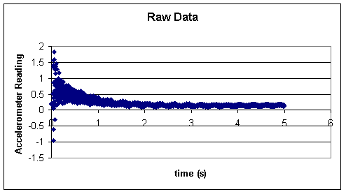
Figure 1. Raw data acquired from accelerometer.

The desired damped frequency was isolated from the acceleration data using a band pass filter. The output from the filter is shown in Figure 2.
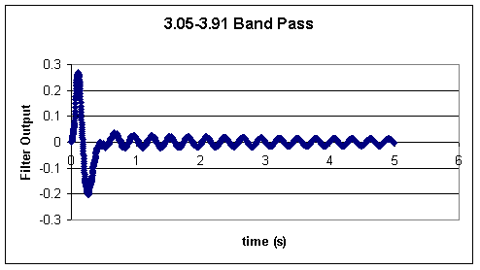
Figure 2. Filtered data using 3.05-3.91Hz Band Pass.

Excel was then used to isolate all of the data points that were local maxima, giving Figure 3.

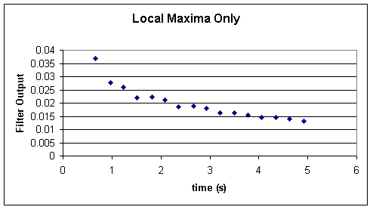
Figure 3. Local maxima of the 3.05-3.91Hz bandpass filtered data.

Then based on the following equation:

A(t) = A₀ exp(-ζω_{n}*t) * sin (ω_{d}t)

The Ln(A(t)) vs. t was plotted using only the local maxima, giving a line having a slope equal to -ζ∗ω _{n}, where ζ is the damping factor. This plot is shown in Figure 4.

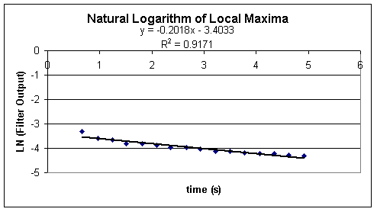
Figure 4. Ln(A(t)) vs. t plot of the 3.5Hz filtered data, producing a slope of -ζ∗ω_{n}.

The damping factors for each of the first four frequencies of vibration are given in Table 1.

Table 1. Experimentally found damping factors for the clamped-free beam in air.
Nodal mapping:

In order to illustrate the nodal mapping of the various vibrational modes, the FFT of the output signal from the accelerometer was used in order to gage the amplitude of the first four damped natural frequencies of oscillation. By dividing these amplitude values with that of the respective impulses conveyed to the beam by the hammer, one would be able to normalize the amplitude of each of first four frequencies. A visual map of the first four modes of vibration can be obtained by plotting this amplitude/impulse value ratio against the location at which the bar was struck by the hammer. In this experiment, three trials each were used to construct such a plot. Space intervals of 2.5 cm were used along the effective length of the bar. The locations which gave rise to the smallest normalized magnitude of vibration were determined to be the nodes. Locations which yielded the highest normalized magnitude of vibration were determined to be anti-nodes.

1st Fundamental Frequency (Fd=3.5 Hz)
0
0.002
0.004
0.006
0.008
0.01
0.012
0
0.2
0.4
0.6
0.8
1
Fraction of Effective Beam Length
Amplitude/Impulse
Figure 5 above illustrates the nodal map for the first mode of vibration. Note that Mode 1 has no indicated nodes.

Figure 6 above illustrates the nodal map of the second mode of vibration. There is a single node in the range 0.71-0.80 which agrees with the theoretical value of 0.78.

Figure 7 above illustrates the nodal map of the third mode of vibration. There are two nodes located in the ranges of 0.38-0.44 and 0.80-0.89. The first node is slightly closer to the clamped end than the theoretical value of 0.51. The second node agrees with the theoretical value of 0.87.

Figure 8 above illustrates the nodal map of the fourth mode of vibration. There are three nodes located in the ranges of 0.35-0.41, 0.59-0.65, and 0.86-0.92. All three nodes agree with the theoretical values of 0.36, 0.65, and 0.91.

Discussion:

From Table 1, the damping factor found for the fourth mode of vibration is significantly different from the damping factor found for the first and second modes of vibration. Thus, it is apparent that the damping factor is not a function only of the viscosity of the medium in which the beam is vibrating. Since we only studied the damping factor of a single beam struck in the same location while left to vibrate in a single medium, no more can be said about what the damping factor depends on. It would be an interesting study to vary some of these parameters to find how they relate to the damping factor.

For the first four modes of vibration, there are a total of six nodes. Five of these nodes agree with the theoretical node locations found by solving Equation 2 when y(x) = 0. This suggests that this is most likely the correct theory for a standing wave of a clamped-free beam.

Due to time constraints we were only able to determine the damping factor and node locations for one beam and one medium, that of air. Future possible experiments are listed below:

An equation relating the undamped natural frequencies of vibration, the damped natural frequencies of vibration, and the damping factor, ω_{d} = ω_{n} ( 1 – ζ²)^{1/2}, may be verified.

Different beams may be studied. Particularly, a beam without a natural frequency of vibration at or around 60Hz would be preferable, due to the limitations of digital filtering and the presence of 60Hz noise. By using different beams, one can see whether the damping factor depends on certain characteristics of the beam such as density, Young’s modulus, and cross section. Also, using different beams, it can be determined whether the location of the nodes is independent of the beam used.

It would also be interesting to determine the damping factor of a beam in different mediums and seeing how this related to the viscosity of the medium. Also, using different mediums, it can be determined whether the location of the nodes is independent of the medium used.

Conclusions:

- Damping factors are unique to a particular mode of vibration.
- The extent to which a particular frequency of vibration is excited depends on the location at which the beam was struck, ie. if the node of a particular frequency is struck, the beam will not vibrate at that frequency
- Equation 2 accurately predicts 5 out of the 6 nodes in the first four natural frequencies of vibration.

Reference:
1. http://www.biophysics.uwa.edu.au/music/music.html

