TITLE: ____ Use of Buffering to Modify Yeast Growth Rate _

GROUP NUMBER: ______T1____

GROUP NAME: __Yuen, Danoff, Rassiwalla, Abebe, Kotwal_

DATE DUE___4/28/04__

Background

Saccharomyces ceravisiae, the organism used in our experiment, is a species of budding yeast. Throughout history, yeast has proven to be very useful to mankind due to its essential role in the production of beer, bread, and wine. Recently, it has proved useful for the production of enzymes, pigments, antioxidants, and for various other medical applications.
Yeast are single-celled eukaryotic organisms that can undergo respiration either anaerobically or aerobically. Thus, yeast is a facultative anaerobe. Saccharomyces ceravisiae is perhaps the most widely used strain of yeast. It is one of the key strains used in bakery and brewing, and is now being used widely in many different labs as a classic example of an eukaryotic organism in molecular and cell biology. For example, Saccharomyces ceravisiae had the honor of being the first eukaryote to have its genome sequenced in 1996. It contains about 13,000,000 base pairs comprising over 6,000 genes. Of those, 23% are shared with humans.
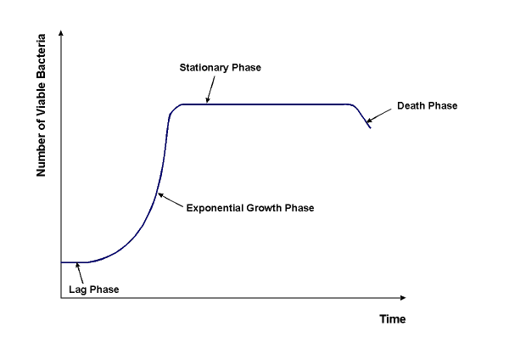
Yeast can respirate anaerobically producing ethanol, or aerobically producing carbon dioxide. Aerobically, the yeast can use less sugar in a smaller time frame to generate the same amount of ATP; so this experiment will only be concerned with the aerobic respiration of yeast. Respiration occurs in 3 steps: Glycolysis, the Kreb’s Cycle, and the Electron Transport Chain. As the yeast grows, it eventually starts to reproduce by simple cell division, or budding. A yeast culture will undergo four typical stages of growth if no outside interference during growth is encountered in the lab. The first phase, called the lag phase, is the stage during which the cells are preparing for division by producing any enzymes or cellular machinery required. This phase is characterized by the 0 slope on the graph. The next stage encountered is the log phase, during which the yeast are growing and dividing constantly without any hindrance or impedance in their doubling rate. A plot of the logarithm of absorbance vs. time of this stage would be linear. The slope of this line is termed the exponential growth rate constant. A higher constant correlates obviously to an increased rate of growth, or shorter doubling time. This phase will undergo the most analysis when determining the relative growth of yeast. The next stage to follow is the stationary phase. Eventually, the competition, lack of nutrients, and abundance of waste products slow down the efficiency of reproduction until it ceases. After which, the death phase will follow as the yeast can no longer reproduce and die off themselves.
There are many different factors that can influence the growth of yeast such as temperature, atmospheric pressure, osmotic pressure, availability of nutrients and O₂, and the pH of the growth medium. As seen in previous experiments, the pH of the extra cellular medium decreases with time as yeast grows. This can be the byproduct of a few different mechanisms. First, during respiration, H⁺ ions and CO₂ gas are produced. The carbon dioxide can then react with water to form even more H⁺ ions. Also, a proposed mechanism for the uptake of glucose into the yeast cells is active transport, with the driving force being the diffusion of H⁺ down its concentration gradient out of the cell. However, the yeast must still maintain an internal homeostasis in order to grow and reproduce. The enzymatic activity of the yeast is crucial to its survival for it regulates everything from cell growth and respiration to cell division, and a pH must be maintained at which the enzymes are intact and working at a relatively fast rate. To accomplish this, proton pumps are constantly pumping H⁺ ions out of the cell using ATP in the process. If the pH of the medium ever becomes too low or high, the cell will not be able to maintain its optimal internal pH levels, and the enzymatic activity may become hindered if not stopped all together. This will lead to cell death.

Aims/Objectives/Hypotheses

The primary objective of our experiment is to develop the most efficient growth medium for the culturing of yeast, specifically Saccharomyces cerevisiae at room temperature. In this specific experiment, we will be testing the effect of environmental pH on the growth rate of yeast. The pH will serve as the independent variable, and the exponential growth rate constant determined during the log phase of growth will serve as our primary dependent variable. The hypothesis of the experiment is that the optimal pH for yeast growth will be at pH 7, having the highest growth rate constant and shortest lag phase. In solution, it is known that yeast will reduce the pH of their environment. We believe that if a buffer is maintained in solution, and the H+ ions are neutralized as they are being pumped out of the cells, then the yeast can devote less energy, or ATP, towards maintaining an internal homeostasis. Also, as the concentration of H⁺ decreases in the extra cellular region, the concentration gradient of H⁺ ions across the cell membrane will increase leading to a larger driving force when introducing glucose into the cell. Thus, the cell may possibly need to expend less ATP during glucose uptake. So, as less ATP is being used, more energy can be used towards cell growth and division. This will lead to the higher growth rate constant predicted.

General Protocol

- Unbuffered growth medium (pH 6)
  - Titration of unbuffered growth medium with HCl
  - Measure pH using pH meter
  - Plot pH vs. moles of acid added
  - Determine buffer capacity
  - Prepare buffered growth medium using phthalate and phosphate (monobasic/dibasic) with respective salts at pH 5 and 7
  - Titration of buffered growth medium with HCl
  - Measure pH using pH meter
  - Plot pH vs. moles of base added
  - Determine buffer capacity
  - Add yeast to the different growth mediums and place on mixer
  - Calibrate Spectrophotometer and pH meter
  - Measure pH and absorbance at regular intervals
  - Plot absorbance vs. time and pH vs. time
  - Plot Ln(Abs) vs. Time to find exponential growth rate constants
  - Repeat for growth mediums at pH 5, 6 (control), and 7
  - Statistically test growth rate constants for each growth medium.

Methods

Week 1
Growth medium was prepared by the lab staff, in which each liter of the broth contains 50 grams of YPD powder. The power contains 50 grams yeast extract, 20 grams peptone, and 20 grams dextrose. Experimenting with different suitable buffers, we decided to use phthalate for pH 5 and potassium phosphate (monobasic/dibasic) for pH 7. Using index values, pH 5 and pH 7 buffers were prepared. The pH 5 buffer was created by adding .408 grams Phthalate to .904 mL of NaOH and diluted with growth medium to a 40 mL solution. The pH 7 buffer was created by adding .920 grams of monobasic sodium phosphate and 3.786 grams of dibasic sodium phosphate to a beaker and diluted to a 40 mL mixture with growth medium. All solutions were mixed using a magnetic stirrer until all salts completely dissolved. Unbuffered growth medium was used as a control with a pH of 6. After the buffers were made, all media were titrated with 0.1 M HCL to determine buffer capacities.

Weeks 2 and 3
Each week 80 ml of media (at pH 5, 6, and 7) was made following the same procedure as Week 1. For each media, 40 ml was drawn out into two sample tubes for a total of six samples a week. In both weeks, 2.1mL of yeast was added to each media. Yeast samples were placed on a rocker and grown at room temperature. The wavelength of the spectrophotometer was set to 550 nm and was calibrated using the growth medium. In addition, the pH meter was calibrated using standard buffer solutions. In Week 1, absorbance and pH readings were taken every 30 minutes, but this did not produce a well defined curve. (i.e. lag phases in the absorbance vs. time plots were not clearly visible) Adjusting accordingly in Week 2 to compensate for this complication, the sampling rate was reduced to 15 minutes a reading. In addition, temperature readings were taken every 90 minutes during both weeks of yeast growth. Media withdrawn into cuvettes for absorbance readings was placed back into the sample tubes after every reading. Placing media back into the original sample tubes is beneficial in that it would not limit the number of readings we can take, hence allowing us to choose any sampling rate.

Results

Titration of the buffers through experimentation showed that pH decreased slowly in small increments with each successive addition of 0.5ml of 0.1M HCl. Previous experiments show that yeast decrease their surrounding pH by approximately 1 unit over the course of 6 hours. By titrating the growth medium, we found that about .00017 mol of 0.1M HCL change the pH by one unit. Thus, the buffer capacities of the pH 5 and pH 7 solutions are large enough to resist the pH change of the growth of yeast in medium. The buffer capacity of the pH 7 solution was found to be statistically different than that of the pH 5 solution (p<.05).

Table 1. Buffer capacities of buffered/unbuffered growth medium used for pH 5, 6 (control), and 7.

The buffer capacities of the solutions of pH 5 and pH 7 resisted the pH change of the yeast. This can be seen from the pH vs. Time plot (Figure 1) in which the slope of the line was not found to be statistically different than zero (p<.05). Data from Week 3 shown in Figure 6 (See Appendix) also shows that pH remained constant throughout the duration of the experiment. Thus, pH was kept relatively constant for samples of buffered medium at pH 5 and pH 7.

Figure 1. Plot of pH vs. Time (Week 2), where pH 5 and pH 7 environments showed almost no change in pH.
Yeast growth was observed in all samples of pH 5 and pH 6, but was found to be very limited for pH 7. At a sampling rate of 30 minutes in Week 2, the Absorbance vs. Time plot does not reveal a clear and defined lag phase as seen in Figure 2. he lag phase appears to lie within the first 30 minutes of readings. Log phases for both pH 5 and pH 6 can be observed in Figure 2. Week 3 results have a more defined curve where the sampling rate was set to 15 minutes shown in Figure 7 (See Appendix). Lag phase for Week 3 appears to be the first 30 minutes.

“Lag Phase”
Log Phase

Figure 2. Absorbance vs. Time plot for all 6 samples at pH 5, 6 (control), and 7 at a sampling rate of 30 minutes for Week 1. (2 Trials per pH value)

According to Figure 3, it can be seen that the slope or exponential growth rate constants of pH 5 and pH 6 are similar to each other and different from pH 7. The selection of the points was determined by using a linear regression on a semi-logarithmic graph (R² > .95) Data from Week 3, seen in Figure 8 (see Appendix), showed repeatable results at pH 5, 6 (control), and pH 7, with pH 7 showing almost no growth.

Figure 3. Plot of Ln(Abs) vs. Time for Week 1, in which the slopes are the exponential growth rate constants for yeast in each growth medium.
The exponential growth rate constants for pH 5, 6 (control), and 7 are tabulated below in Table 2. pH 5 and pH 6 were both found to be statistically different from pH 7 (p<.05). The growth rate constant of pH 7 was .00239 + .00041 min⁻¹ exhibiting almost no growth. pH 5 and pH 6 had growth rate constants of .02208 + .00342 min⁻¹ and .02054 + .00171 min⁻¹ respectively. pH 5 showed a trend of higher growth rate constants than pH 6 in all samples except for trial 2. pH 5 was not found to be statistically different than pH 6. (p< .05)

Table 2. Exponential growth rate constants for all samples from both weeks.

Temperature differences were noted from Week 2 to Week 3. Temperatures from Week 2 and Week 3 were 28.67 + .86 ^{O}C and 30.25 + .49 ^{O}C respectively. This fluctuation in temperature was reflected in the data as the exponential growth rates constants were significantly higher in Week 3.

Table 3. Average temperature of the lab for Week 2 and Week 3.

Salinities of the solutions were calculated in terms of salts added. At pH 6 the salinity is set to zero, since no additional salt was added. The salinity of the solution is based purely on the amount of salt added to the growth medium. According to a plot of the growth rate constants vs. the salinity of a solution (ppt), data shows that for a very saline solution, yeast growth is minimal than for a less saline solution. However, some salinity in solution favors more yeast growth.
pH 6
pH 5
pH 7
Figure 4. Growth rate constants vs. Salinity of a solution (ppt) for each pH.

Osmotic pressure due to the concentration gradient of the added salts was calculated. The osmotic pressure of pH 5 and pH 7 were found to be .2 atm and 2 atm respectively. Thus, it is shown in Figure 5 that yeast subject to higher osmotic pressure is detrimental to yeast growth.

pH 5

pH 7

Figure 5. Growth rate constants vs. Osmotic pressure due to the concentration gradient of the added salts.

Data from this experiment proved that the pH 5 and pH 6 environments are significantly better than the pH 7 environment. pH 7 exhibited little to almost no growth dissimilar from the growth observed for pH 5 and pH 6. Results from week 2 and 3 were averaged since the difference caused by temperature is constant across all trials. No statistical difference was found for pH 5 and pH 6 (p<.05). Furthermore, our hypothesis that pH 7 would be the better of the 3 environments for yeast growth was proven wrong.

Discussion

Although the final results of the experiment proved inconclusive in terms of the hypothesis, several conclusive findings were still discovered. Throughout the course of the experiment it was determined that many variables other than pH are involved in affecting the growth rate of the Saccharomyces ceravisiae. Among these include temperature, buffer capacity, salinity, sugar concentration, light exposure and initial yeast concentration. While most of these were anticipated and kept as constant as possible, some variables were unexpected and hence affected our results. Specifically, we consider temperature and salinity, which were quite variable in the experiment.
Temperature is a major variable affecting metabolic rate. The effects of temperature were apparent in the statistical difference between the results of week 1 and week 2. All trials of pH 5 and 6 from week 2, which was several degrees warmer than week 1, had a significantly higher growth rate. Metabolism is dependent on enzymatic activity in the cell and several gas exchanges within the yeast cells and with their surrounding environments. Since the enzymatic activity and rate of these exchanges is dependent on temperature; temperature affects the overall metabolism and growth rate of the organism. This explains the higher temperatures leading to higher growth rates. Since this increase in growth rates was constant across all trials, results from week 2 and 3 could still be compared to each other. Also, this temperature difference didn’t affect our results because the results obtained from week 2 independently still support our overall conclusions when comparing across the weeks. This holds true for week 3 as well.
The buffer capacities were vital to the performance of the growth medium in acting as a buffer. To remain at the desired pH, the acid produced by the Saccharomyces cannot reach the solution’s buffer capacity. Also, it is preferable to keep the buffer capacities constant in all solutions, since any differences produce an additional variable otherwise. This wasn’t always possible since our supplies to make the buffers were limited. After mixing buffers of the desired pH, the buffer capacities were tested and found to be statistically different. Since they were both high enough that any amount of acid the yeast could produce would not change the pH, this difference was ignored. The difference in buffer capacity could possibly be controlled by using different concentrations of salts; however this would also affect the final pH.
Salinity is a major contributing factor to the growth rate of the yeast. In this case, it didn’t affect the rate so much as it completely limited any growth of the yeast. The mechanism by which this variable affects the growth rate is twofold; the salts in the solution combine with the sugars to create a concentration gradient, causing an osmotic pressure across the cell membranes. The salts also are digested by the yeast, causing an abnormal intracellular concentration of ions. This causes abnormal metabolic activity.
These two possibilities clearly explain the results of sample trials of pH 7. In this case, to obtain the buffer solution at the desired pH a total of 4.7 grams of salts were used. The solution has a corresponding salinity of approximately 112 ppt, slightly more than seawater. This creates a hypertonic environment in relation to the inside of the cell. Water rushes out of the cell to balance out the concentration gradient, creating an osmotic pressure on the cell. For the pH of 7, the osmotic pressure on the cells due to the salt alone was calculated to be around 2 atm. This is approximately 10 times the pressure in the other buffer of pH 5 (.2 atm). Hence the cells may have undergone a reduction in cell volume and eventual cell death probably occurred due to plasmolysis. (see figures 9 and 10 in appendix.)
Another explanation for why the pH 7 trial did not grow could be simply that the relatively basic solution denatured the proteins in the yeast cells. These proteins make up an integral part of the cell’s functionality; hence the cells were not able to function and died.
A continued study could prove to be very useful in finding the optimal growth environment of Saccharomyces ceravisiae. The natural course of study for this specific experiment would be to first try different buffers for the pH’s tested; thus determining repeatability of the results. Different buffers with salinity and other factors held constant may produce different results. Furthermore, additional pH levels need to be tested in order to determine the optimal range of growth. Since the principal results showed no statistical difference it is most likely that there isn’t one optimal pH but in fact a range. The results of this experiment could also be combined with the results of other yeast experiments to determine optimal pH, temperature, sugar concentrations, and other specifications of the growth medium.
There are several different possible applications of having an optimal growth medium for baker’s yeast. This could be applied to other organisms which behave and grow in a similar manner to this species. Optimal growth could prove useful in areas such as baking and fermentation, in order to maximize outputs. Some biomedical applications of this study include using this strain of yeast to produce enzymes and other needed materials in large quantities.

Appendix

Data

Figure 6. Plot of pH vs Time of buffered medium for pH 5 and pH 7 for Week 3.

Lag Phase
Log Phase

Figure 7. Plot of Absorbance vs. Time for all samples at pH 5, 6 (control), and 7 at a sampling rate of 15 minutes for Week 3.

Figure 8. Plot of Ln(abs) vs. Time, in which the slopes or exponential growth constants were determined for Week 3.

Buffer Capacity
Buffer capacity is defined as the amount of an acid or base that can be added to a volume of buffer solution before its pH changes significantly. We defined the buffer capacity of a solution as the amount of moles of acid added to change the pH by one.

Buffer Capacity = (number of moles of 0.1 HCl)
(pH change)

Buffer Preparation
Phthalate Buffer (pH 5) - .904 mL NaOH/.408 g Phthlate in 40mL growth medium
Phosphate Buffer (pH 7) - .92 g monobasic (KH₂PO₄)/ 3.786 g (K₂H₂PO₄) dibasic in 40mL growth medium

Salinity of Solution
Salinity – parts per thousand (ppt)

ppt = grams of salt/kilograms solution

Density of growth medium was found to be 1.05 g/ml.
The mass of the medium was found by adding the mass of the YPD media power (25 g) and water (500 g) added. The density was this total mass divided by the volume of water (500 ml).

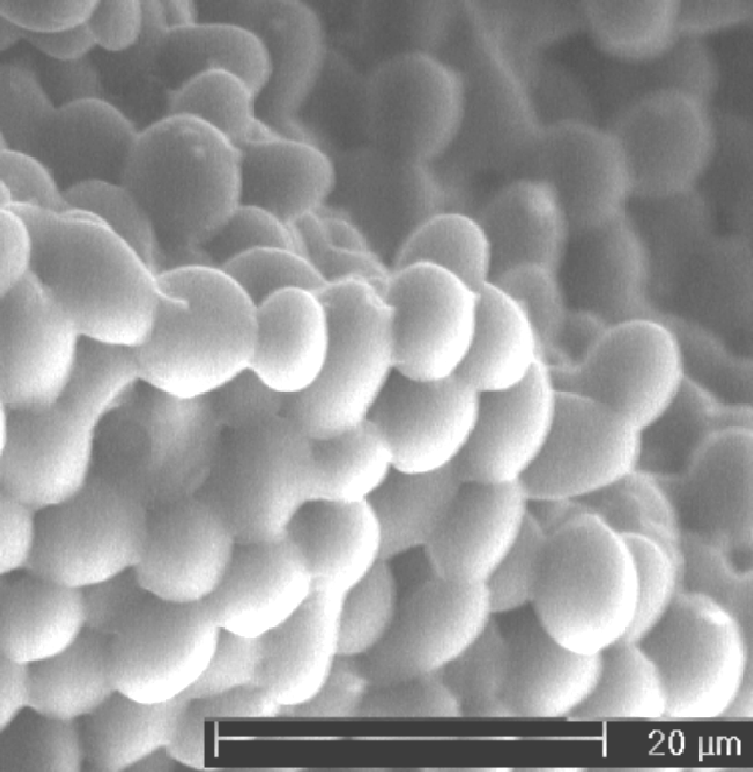

Figure 9. Yeast cells under normal osmotic pressure.
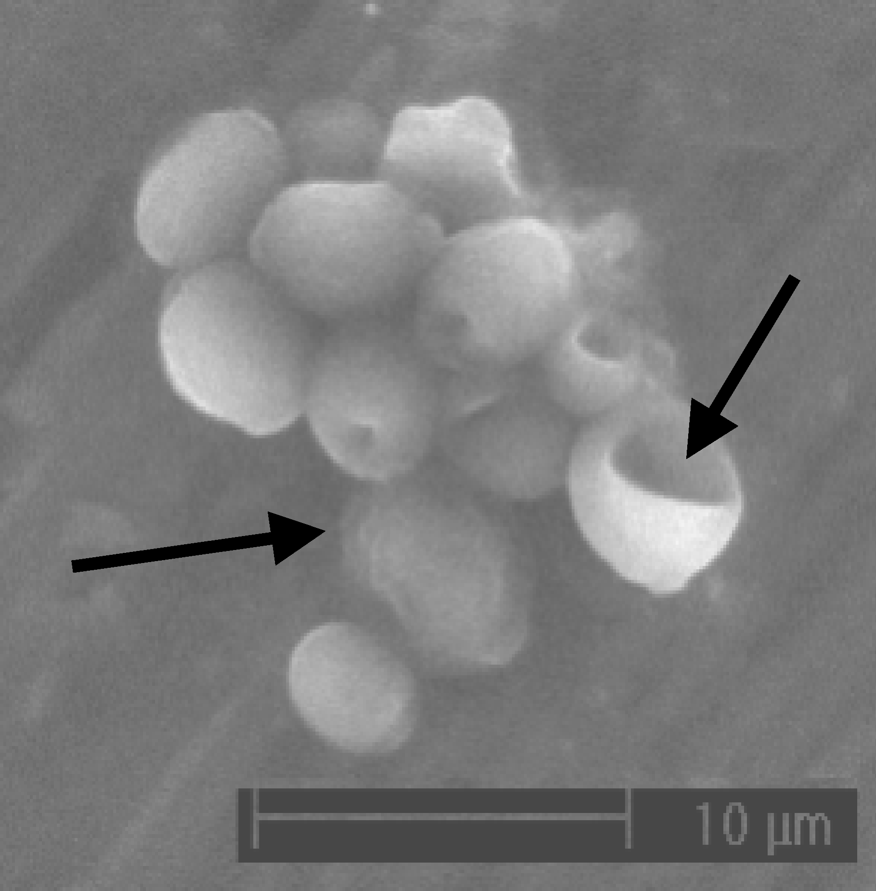

Figure 10. Yeast cells under high osmotic pressure.

Figures 9 and 10 from:
Pratt, Patricia et. al. The Effects of Osmotic Pressure and Ethanol on Yeast Viability and Morphology. Journal of the Institute of Brewing. Vol. 109, No. 3.
http://www.scientificsocieties.org/jib/papers/2003/G-2003-0922-103.pdf

Powerpoint slides:

http://www.cplpress.com/contents/C939.htm
http://en.wikipedia.org/wiki/Saccharomyces_cerevisiae
image from: http://www.corrosion-club.com/images/bacteriagrowth.gif

