GROUP NUMBER & NAMES: T10, Kevin Cronk, Jack Kent, Deep Maji, Chris Walstad
TITLE: Cyclic Testing of a Wooden Material
DATE: April 28, 2004

A. Brief Background

Fatigue failure occurs in structures that have undergone dynamic and repetitive stresses. After such loading, the material may fail at a considerably lower tensile strength than normal. Repetitive stresses cause a greater amount of stress raisers within the wood which increase the susceptibility of the material to crack initiation. These cracks propagate with each stress cycle until a critical crack size is reached and failure occurs. Fatigue testing is important because a material needs to maintain its structural integrity long after its initial use. Airplane wings, bridges and other structures that undergo millions of cycles of low level stress are manufactured to have a lifetime well over their usable life. In this experiment, wooden samples will be cyclically tested to determine how the wood reacts to various loading rates, load magnitudes, and weight percent water.

The structure of wood consists of a layered composite of cellulose microfibrils embedded in a hemicelluloses and lignin matrix. Wood cells are composed of four layers surrounding the lumen and are connected to one another via the middle lamella. Heckes et al. determined that the mechanical response of the individual cells was the same as the entire tissue, and thus the mechanical properties are governed by individual cells rather than the middle lamella and connections between cells. While the matrix ultimately determines the wood’s fatigue characteristics, the distribution of lignin plays an important role. The mechanical characteristics of wood vary greatly with water content. When dry the wood is brittle, but at high moisture contents it behaves like a ductile metal. Heckes et al. found that the reason for this variation in mechanical properties of wood with changing water contents is a “stick-slip” mechanism that allows would to plastically deform when wet. The stiffness of wood comes from the semi-crystalline polymeric cellulose microfibrils. The lignin should be the first to fail in fatigue testing, as it is a more brittle and weaker material compared with cellulose.

B. Hypothesis/Objectives

The objective of this project was to quantify the fatigue characteristics of a wooden sample under various loading conditions. We measured the number of cycles to 95% of original force, the net percent decrease in force over 200 cycles, as well as the fracture force and fracture displacement after cyclic loading. We measured these quantities for various load rates, water contents, extension, and masses of wood.
We hypothesize that increasing the load rate will make the material more prone to fatigue because wood is viscoelastic. This means that the load rate will affect the force exerted on the wood at various displacements. Also a faster fatigue rate will inhibit recovery of the sample thus putting more stress on the wood. We predict that increasing the water content of the wood will cause the wood to swell and make it more prone to fatigue. As the extension of the cyclic loading cycle is increased the wood will fatigue more rapidly because there will be a greater amount of force exerted on the wood during each cycle. We also believe that increasing the weight of the wood will improve its fatigue characteristics because it will increase the density and strength of the wood.

C. General Protocol

For this experiment, we used the Instron Model 4444 equipped with a three-point bending jig. Each wooden sample was placed in the center of the jig and then subjected to cyclic loading. The cyclic loading cycle consisted of repetitive stresses caused by the jig periodically moving between two fixed displacements. The displacements and rates of loading for each trial were inputs to the machine. The force versus displacement data was measured for 200 cycles and then the cyclic loading was stopped. The wood was immediately fractured in the Instron machine to determine the fracture force and displacement.

We defined a fatigue relaxation modulus to be the force at the maximum displacement versus number of cycles. This curve was found by plotting the force value at the maximum extension for each cycle. We analyzed this curve by finding the number of cycles to 95% of initial force and the net percent decrease in force over 200 cycles.

Fracture force was defined as the maximum point on the force versus displacement plot. The corresponding displacement was defined as the fracture displacement.

D. Specific Methods

Setup
- Find a number of samples of wood that range between 2.35 – 2.45 grams as well as 2.65 – 2.75 grams. Discard all other samples.
- Fracture 5 samples of each group using the Instron machine with a rate of 165 mm/min to determine a control fracture strength and displacement without fatigue.
- Place 10 wooden samples of weight 2.35 to 2.45 g in a container filled with water to soak for two weeks.
- Place 10 wooden samples of weight 2.35 to 2.45 g in the oven and bake for 3 hours.
- After the wooden samples are finished baking, reweigh the samples to determine the change in weight and the amount of water lost. Determine the percentage change in water content.
- After soaking the wood, reweigh the wood to determine the weight in water absorbed. Determine the percentage change in water content.

Testing
- Install the 3-point Jig into the Instron machine.
- Calibrate the Instron machine for each data group using Virtual Instruments.

Group Number | Load Rate (mm/min) | Extension (mm) | Initial Weight (g) | Soaked/Baked
I (Control) | 165 | 1 – 4 | 2.35 – 2.45 | N/A
II | 100 | 1 – 4 | 2.35 – 2.45 | N/A
III | 248 | 1 – 4 | 2.35 – 2.45 | N/A
IV | 330 | 1 – 4 | 2.35 – 2.45 | N/A
V | 165 | 1 – 4 | 2.35 – 2.45 | Baked
VI | 165 | 1 – 4 | 2.35 – 2.45 | Soaked
VII | 165 | 1 – 3 | 2.35 – 2.45 | N/A
VIII | 165 | 1 – 4 | 2.65 – 2.75 | N/A

- Cycle each sample for 200 cycles in order to achieve a constant total fatigue.
- Fracture the sample after cyclic loading to determine the fracture strength and displacement.
- Repeat each test 5 times for each group.

Analysis
- Using an original computer program written in Java, filter out the data points at which the extension is a maximum.
- Plot the force value at each of these filtered data points versus the number of cycles.
Determine the following two fatigue characteristics from the plot:
- Number of cycles to 95% of the initial force.
- Percent change in force over the entire 200 cycles.
- Plot force versus displacement for each fracture sample.
Determine the following two fatigue characteristics from the plot:
- Fracture force.
- Fracture displacement.
Perform the following statistical tests on each of the four fatigue characteristics.
- ANOVA comparison on groups I, II, III and IV to determine statistical significance of change in loading rate.
- ANOVA comparison on groups I, V and VI to determine statistical significance of percentage change in water content.
- T-test comparison between group I and VII to determine statistical significance of change in extension.
- T-test comparison between group I and VIII to determine statistical significance of change in weight.

E. Results

During initial testing we found that there is a strong correlation between weight and fracture strength of the tongue depressors. We also found that the weight of the wood varied from 1.9 to 3.1g. These facts led to large variability in our data when the wood was randomly sampled. When tested randomly the standard deviation in fracture strength for 10 samples was 13.8 N (11.9%). Thus it was deemed necessary to limit the range of weight within the samples. We decided to use two weight groups in our experiment: 2.35 to 2.45g and 2.65 to 2.75g. These ranges were chosen because there was enough wood samples within these ranges to satisfy our testing needs and these weights are intermediate and thus more representative of the entire wood sample group.

Figure 1
Figure 1: Shows the non-fatigued fracture strength versus weight for 6 samples within the 2.35 to 2.45g weight range. Notice the strong correlation between weight and fracture strength.

Figure 1 shows the fracture strengths of 6 wood samples within the 2.35 to 2.45g weight range. These samples were not fatigued prior to fracture. The average fracture force for this group is 104.91 ± 5.33 N. By specifying a limit to the weight of wood tested, the standard deviation in fracture strength was reduced from 11.9% to 5.1% of the total fracture strength.

Figure 2
Figure 2: Shows a typical force versus number of cycles curve. The curve represents the fatigue relaxation modulus we defined.

Figure 2 shows the force at each maximum extension versus the number of cycles. This curve was used to quantify two of the fatigue characteristics: the number of cycles to 95% of initial force and the percent change in force over all 200 cycles. The inverse logarithmic form of the curve shows that the rate of fatigue is initially very rapid but quickly becomes much slower.

Figure 3
Figure 3: Shows a typical force versus displacement curve during fracture. The maximum point represents the fracture strength and corresponding fracture displacement.

Figure 3 shows the fracture behavior of a typical (except Group VI) wooden sample after cyclic fatiguing. The maximum force and the corresponding displacement define the fracture strength and displacement of the sample. All of the samples except for the soaked group (Group VI) broke in tension. The samples in Group VI exhibited a non-typical fracture behavior in that the ends of the sample came in contact with the upper bar of the 3-point jig before a complete fracture occurred.

Figure 4
Figure 4: Shows the typical fracture behavior of a soaked wooden sample from Group VI

Figure 4 shows the fracture behavior of a typical soaked sample. The plateau represents creep prior to fracture when the sample exhibits increasing strain without increasing stress. The second incline represents when the sample ends impact the upper bar of the 3-point jig. This increase in force is not representative of the actual fracture force due to the interference of the testing apparatus. We defined the fracture force as the force at the plateau and the fracture displacement as the maximum displacement on the plateau.

The groups to be tested were defined as specified in the specific methods section. All of the groups were compared to the samples loaded under 165 mm/min, 1 - 4 mm extensions, and no soaking or baking (Group I).

Table 1
Group | Number of Cycles to 95.0% | % Change in Force | Fracture Force (N) | Fracture Displacement (mm)
I | 4.4 (SD=1.95) | 7.37 (SD=1.55) | 98.7 (SD=11.29) | 8.12 (SD=3.77)
II | 3.2 (SD=1.1) | 11.33 (SD=6.26) | 96.49 (SD=4.85) | 5.17 (SD=0.50)
III | 2.75 (SD=.96) | 11.13 (SD=3.21) | 97.43 (SD=4.24) | 5.23 (SD=0.53)
IV | 3.4 (SD=1.52) | 11.02 (SD=1.52) | 103.95 (SD=3.64) | 6.87 (SD=3.61)
V | 4.6 (SD=2.3) | 9.73 (SD=2.77) | 120.62 (SD=9.34) | 6.526 (SD=1.20)
VI | 2.0 (SD=0) | 28.79 (SD=2.28) | 42.90 (SD=3.82) | 8.66 (SD=0.36)
VII | 5.6 (SD=3.13) | 6.7 (SD=1.12) | 103.23(SD=8.51) | 5.344 (SD=0.32)
VIII | 2.4 (SD=0.55) | 11.36 (SD=2.49) | 105.07 (SD=12.01) | 5.49 (SD=0.34)
Table 1: Shows the number of cycles to 95%, the percent change in force over 200 cycles, and the fracture force/displacement after cyclic loading for all groups. The group numbers are those specified in the specific methods section.

We found that the soaked wood (Group VI) fatigues faster and more dramatically than the control group (Group I). The number of cycles to 95% for the soaked wood is 2.0 ± 0 which is significantly less (p<.05) than the 4.4 ± 1.95 cycles to 95%. We also found that the soaked wood has a greater (p<.05) percent change in force over 200 cycles, 28.79 ± 2.28 %, than that of the control group, 7.37 ± 1.55 %. The fracture force after cyclic loading (42.90 ± 3.82 N) for soaked fatigued wood was found to be significantly less (p<.05) than the control group (98.7 ± 11.29 N).

The baked wood (Group V) was found to have a significantly higher fracture force (p<.05) after cyclic loading (120.62 ± 9.34 N) than the control group (98.7 ± 11.29 N).

We found that the 2.65 to 2.75 g wood (Group VIII) has a lower number of cycles to 95% (2.4 ± 0.55) and a greater percent change in force (11.36 ± 2.49 %) over all 200 cycles than the control group of weight 2.35 to 2.45 g (Group I). The control group required 4.4 ± 1.95 cycles to reach 95% of initial force and the percent change in force after all cyclic loading was 7.37 ± 1.55 %.

All of the remaining results were found to be statistically equivalent (p>0.05) to the control group. Thus we found that the extension and loading rate did not significantly alter the fatigue characteristics of each wooden sample.

F. Discussion

The aim of this project was to quantify the fatigue characteristics of a wooden sample under various loading conditions. Initially, we planned on choosing a force and rate combination that would break each of the wooden samples in a reasonable time period (five minutes). However, the first week of testing demonstrated that there was a threshold combination of force and rate. If the combination was above this threshold, the sample would break almost immediately (less than five cycles). This is not representative of actual fatigue. If the combination was below this threshold, the sample would not break within 10 minutes of testing, which was unacceptably long due to time constraints. This led us to develop alternative methods of quantifying fatigue. By setting a constant maximum extension, we realized that the force at this extension decreased over time. This allowed us to quantify the rate and magnitude of fatigue over a set number of cycles.

As mentioned in the results, we found that the soaked wood (Group VI) fatigues faster and more dramatically than the control group (Group I). This can be explained by the process of swelling. After soaking for two weeks, water was absorbed into the matrix of the wood, as shown by the average increase in mass of 88.2%. The swelling of the wooden samples was also clearly visible and the gap distance in the 3-point jig had to be increased to accommodate the enlarged wooden stick. When water is introduced into the matrix, the distance between cellular components is increased which subsequently decreases the effectiveness of bonding. Therefore, with decreased bonding strength, the wood becomes more susceptible to fatigue.

We found that as the weight of the wooden sample increased, the number of cycles to 95% of initial force decreased. In other words, the heavier wooden samples fatigued faster. Although it would naturally make sense for the denser wood to be more resistant to fatigue, the reason for this discrepancy is due to the extension. The extension was kept constant in these tests; therefore, the force applied to reach these extensions was greater for the denser wood because a greater overall force is needed to reach the same extension. Thus because the applied force is greater for the heavier and denser samples, it will fatigue faster and reach 95% of its initial force much more quickly. In the future, testing other weight ranges aside from 2.35 – 2.45 g and 2.65 - 2.75 g could lead to a better understanding of this phenomenon as well as establish a better correlation.

We tested four different loading rates; however, no statistical difference was found between them. The reason for this is that the loading rates were not varied enough to significantly affect the fatigue characteristics of the wooden sample. Due to time limitations the smallest loading rate chosen was 100 mm/min. There is a possibility that all of the loading rates tested are similar enough that they do not affect the wood differently. It would be ideal to fatigue 5 samples at approximately 5 mm/min, but this would take 140 minutes per sample. Another possibility is that the loading rates chosen were not high enough to significantly affect the recovery of the wood. To truly challenge the relaxation modulus of the viscoelastic wood, it might be necessary to load the wood at a rate much faster than 330 mm/min (our fastest rate). The Instron machine was not capable of loading at a faster rate, thus the wooden sample was able to fully recover between each cycle. Because fatigue characteristics rely on the inability of the wood to fully recover between cycles, no significant difference was found between the load rate and any of the four fatigue characteristics. In the future, if we were to use a faster load rate or perhaps change the way in which we quantified fatigue characteristics, we would be able to find a correlation between load rate and fatigue.

When the extension was changed, there was a trend seen between different samples. As the extension that the wood was fatigued at increased, the wood fatigued faster and with a greater magnitude. The samples fatigued with 4 mm extension took 4.4 ± 1.95 cycles to 95% of initial force and the net decrease in force over 200 cycles was 7.37 ± 1.55 %. The samples fatigued with 3 mm extension took 5.6 ± 3.13 cycles to 95% of initial force and the force decreased by 6.7 ± 1.12 % over all of the cycles. This result is intuitive because the larger extension requires more force to reach and thus each cycle subjects the sample to a larger force. However, it was shown that there was no statistical difference between the two extensions. With more time, we could test several different extensions as well as samples to determine if the correlation in our two sample groups was statistically significant.

Although we made every attempt to feasibly determine the fatigue characteristics of the wood, one major cause of error was the force with which we fatigued the wood. While holding the load rate and the extension constant, the force that the Instron machine applied varied with each sample, and we used the change in force to quantify the fatigue of the wooden sample. However, we fatigued the wood at roughly 80% of its fracture strength. Typically, wood is fatigued at about 20 - 40% of it fracture strength. Therefore, our higher load force would possibly introduce cracks that would not typically occur in fatigue testing. Thus this limits the accuracy and applicability of our project. However, with more time and the ability to test each sample for a greater number of cycles, our methodology would have garnered a better quality and more accurate set of data.

Throughout the lab portion of this project, there were a couple unanticipated pitfalls that could easily be avoided and would be useful for future reference. The first week of experimentation was intended to work out details of the theorized protocol. All the work put into this process was nullified once it was noticed that the fatigue characteristics varied heavily with weight (originally, it was assumed all of the wood was uniform). Knowledge of this would save precious time and enabled further testing to be performed. It was also found that fatigue could be measured more easily in a short period of time using the characteristics described in the specific methods rather than examining the number of cycles to failure. The latter method was impractical due to inconsistency and time limitations. Since we did not know which variables would significantly affect fatigue characteristics, we performed a few tests on many different variables. It would be beneficial to concentrate future experiments on just one variable. Soaking the wood produced good results, and it would have been interesting to do enough testing to correlate the percent of water absorbed to fatigue. Time limitations also prohibited further study of the affect of varied extension, and although a trend was noticed there were not enough samples to find statistical differences.
G. Appendix

I. Presentation slides
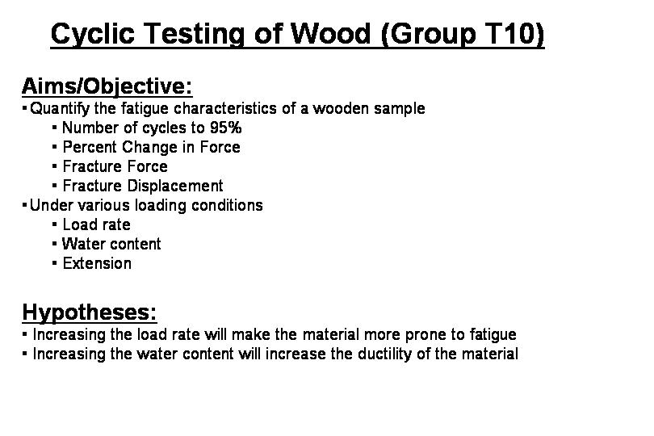
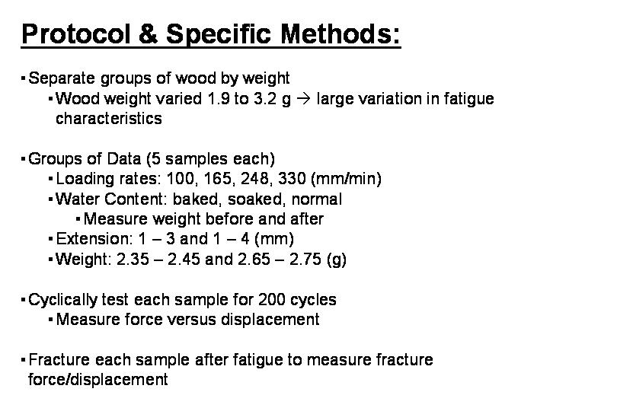
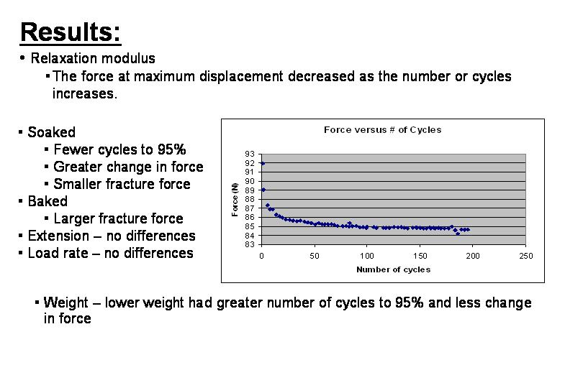
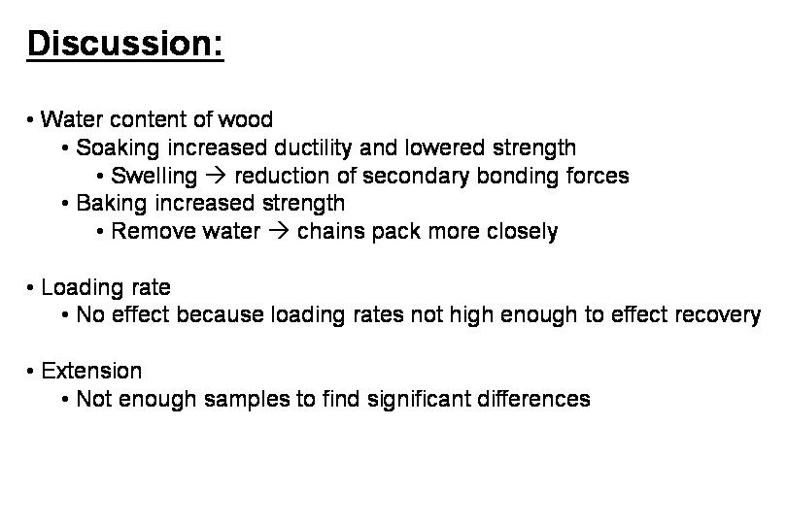
II. BEHelper.java – a data analysis program
/**
* The analysis is performed by entering the following to the command
* line (must be in the directory of the .class files):
*
* java BEHelper cycleDirectory fractureDirectory outDirectory percent
*
* Where cycleDirectory is the directory in which the excel spreadsheets
* generated during the cyclic loading of the wood are stored,
* fractureDirectory is the directory where the fracture spreadsheets
* are stored, outDirectory is the directory you wish the finished
* files to be placed in, and percent is the critical percent you wish
* to find data about (in our case 95%).
*
* The output from this program consists of a file results.xls which
* contains a table of all of the results and excel spreadsheets
* that contain the fatigue relaxation modulus for each
* cyclic loading test. These files are prefixed by an 'f'.
*
*/

import java.io.*;
import java.io.PrintWriter;
import java.util.Arrays;
import java.util.StringTokenizer;

public class BEHelper {

/**
* Parses the cycle data and generates the finished cycle files
* @param cycleDir the directory that contains the cycle data
* @param outDir the directory where the new files should be placed
* @param percent the critical percent to base results on
*/
private static void parseRawData(String cycleDir, String outDir, double percent) {
try {

File inDirectory = new File(cycleDir);
File[] fileList = inDirectory.listFiles();

for(int i=0; i<fileList.length; i++) {

BufferedReader in = new BufferedReader(new FileReader(fileList[i]));

File outFile = new File(outDir + "\\f" + fileList[i].getName());
PrintWriter out = new PrintWriter(new FileOutputStream(outFile));

String line = null;
StringTokenizer tokenizer = null;

int numberOfCycles = 0;

double points = 0;

double newExt = 0;
double newForce = 0;

double pastExt = 0;
double pastForce = 0;

double criticalForce = 0;
int criticalTime = 0;

double initialForce = -1;
double finalForce = 0;

boolean increasing = true;

while( (line = in.readLine()) != null) {

points++;

pastExt = newExt;
pastForce = newForce;

tokenizer = new StringTokenizer(line,"\t");

newExt = Double.parseDouble(tokenizer.nextToken());
newForce = Double.parseDouble(tokenizer.nextToken());

if(increasing && (newExt < pastExt)) {
increasing = false;

numberOfCycles++;

if(initialForce < 0 ) {
initialForce = pastForce;
}

if( (criticalForce == 0) && ( pastForce <= (initialForce * percent) )) {
criticalForce = pastForce;
criticalTime = numberOfCycles;
}

finalForce = newForce;

out.println(pastExt + "\t" + pastForce + "\t" + ((points-1)/20));
} else if (!increasing && (newExt > pastExt)) {
increasing = true;
}
}

out.println("end");

if(criticalForce == 0) {
out.print("No " + (percent * 100) + "% force reached\t");
} else {
out.print( criticalTime + "\t" + criticalForce + "\t");
}
out.print(initialForce + "\t" + finalForce + "\t");
out.println( (initialForce - finalForce) + "\t"
+ (initialForce - finalForce)/initialForce*100);
in.close();
out.close();

}

} catch (Exception e) {
System.out.println("Chris screwed up");
e.printStackTrace();
}
}

/**
* Parses the finished cycle data as well as the raw fracture data
* to generate a results table (results.xls)
* @param dir the directory of the finished cycle files
* @param fractureDir the directory of the fracture files
* @param percent the critical percent
*/
private static void parseResults(String dir, String fractureDir, double percent) {
try {
File directory = new File(dir);
File[] fileList = directory.listFiles();
File fractureDirectory = new File(fractureDir);
File[] fractureList = fractureDirectory.listFiles();
Arrays.sort(fileList);

PrintWriter out = new PrintWriter(new FileOutputStream(dir + "\\results.xls"));

// print the table heading
out.println("Sample\tRate (mm/min)\tWeight (g)\tCondition\tExtension (mm)\t# Cycles\t" +
"Cycles to " + (percent*100) + "%\tForce at " + (percent*100) +
"%\tInitial Force (N)\tFinal Force (N)\t Change in Force (N)\t" +
"% change in Force(N)\tFracture Force (N)\t" +
"Fracture Disp (mm)");

for(int i=0; i<fileList.length; i++) {
BufferedReader in = new BufferedReader(new FileReader(fileList[i]));
String fileName = fileList[i].getName();
if(fileName.equals("results.xls")) { break; }
char sample = fileName.charAt(fileName.length() - 5);
String rate = fileName.substring(9,12);
double weight = Double.parseDouble(fileName.substring(14,16));
String condition = "";
if(fileName.charAt(16) == 'c') {
condition = "Normal";
} else if(fileName.charAt(16) == 'b') {
condition = "Baked";
} else {
condition = "Soaked";
}
char extension = fileName.charAt(4);

int numberOfCycles = 0;
double criticalTime = 0;
double criticalForce = 0;
double initialForce = 0;
double finalForce = 0;
double changeInForce = 0;
double percentChangeInForce = 0;

String line = in.readLine();
while( !line.equals("end")) { line = in.readLine(); numberOfCycles++; }

out.print(sample + "\t" + rate + "\t" + weight + "\t" + condition + "\t"
+ extension + "\t" + numberOfCycles +"\t");

line = in.readLine();
StringTokenizer tokenizer = new StringTokenizer(line,"\t");
while(tokenizer.hasMoreElements()) {
String s = (String)tokenizer.nextElement();
if(s.charAt(0) == 'N') {
out.print("None\t");
} else {
out.print(s + "\t");
}
}
Pair p = null;
try {
p = getMax(fractureList[i]);
} catch(ArrayIndexOutOfBoundsException e) {}
if(p != null) {
out.println(p.getFirst() + "\t" + p.getSecond());
} else {
out.println("Missing File\t");
}

if(sample == '5') {
out.println("Average");
out.println("Stdev");
out.println();
}
in.close();
}
out.close();
} catch(Exception e) {e.printStackTrace(); }
}

/**
* Gets the fracture force and displacement for the file
* @param file the fracture data file to use
* @return a pair that encapsulates the fracture force and displacement
*/
private static Pair getMax(File file) {
BufferedReader in = null;

try {
in = new BufferedReader(
new FileReader(file));
} catch (IOException e) {
e.printStackTrace();
return null;
}

String line = null;
double maxForce = 0;
double maxExt = 0;
try {
while( (line = in.readLine()) != null) {
StringTokenizer tokenizer = new StringTokenizer(line, "\t");
double nextExt = Double.parseDouble((String)tokenizer.nextElement());
double nextForce = Double.parseDouble((String)tokenizer.nextElement());
if(nextForce > maxForce) {
maxForce = nextForce;
maxExt = nextExt;
}
}
} catch (IOException e) { e.printStackTrace(); }

Pair pair = new Pair(maxForce,maxExt);
return pair;
}

/**
* Parses the specified files and creates the output files
* @param args see the class description for how to use
* this method
*/
public static void main(String[] args) {
if(args.length != 4) {
System.out.println("Usage: java BEHelper cycleDirectory " +
"fractureDirectory outDirectory percent");
System.exit(0);
}
parseRawData(args[0], args[2], Double.parseDouble(args[3]));
parseResults(args[2],args[1], Double.parseDouble(args[3]));
}
}

/**
* A helper class that encapsulates a pair of data
* For this experiment it contains a force and displacement pair
*/
class Pair {
double item1;
double item2;
public Pair(double i, double j) {
item1 = i;
item2 = j;
}

public double getFirst() { return item1; }
public double getSecond() { return item2; }
}

Kretschmann, David. "Velcro Mechanics in Wood." Nature Materials 2 (2003): 775-776. 25 Apr. 2004 <http://www.nature.com/cgi-taf/DynaPage.taf?file=/nmat/journal/v2/n12/full/nmat1025.html>.
Heckes, J et al. “Cell-wall recovery after irreversible deformation of wood.” Nature Materials 2 (2003): 810-813. 25 Apr. 2004 <http://www.nature.com/cgi-taf/DynaPage.taf?file=/nmat/journal/v2/n12/abs/ nmat1019.html&dynoptions=doi1083174417>

