Suture Methods and Mechanical Properties

Charles Dunlap, David Jordan, Michelle Kam, Pooja Sethi and Ling Zhou

Group W10, 28 April 2004

Background : Since the beginning of surgical history, sutures have been the surgeons primary means of repairing damaged tissues, cut vessels, and surgical incisions. By definition, a suture is a thread that either approximates or maintains tissues until the natural healing process has provided a sufficient level of wound strength or has compressed blood vessels in order to stop bleeding. Since their invention, sutures have been comprised of many different materials. By the twentieth century, however, cotton and treated natural materials have come to be the most widely used materials. Sutures are probably the largest group of devices implanted in humans; their use is one of the most common practices in the medical field and thus has direct effect on a great majority of the world’s population.
Taken into consideration in the manufacturing and in the use of sutures are properties including stress-strain relationship, tensile strength, and elasticity. Properties such as force-displacement relationship and tensile strength have a direct effect on how much force at a given rate the closure will be able to withstand. Flexibility, or elasticity, in relationship to tensile strength is also of high priority in suture manufacture; for example, a suture material that has a sufficient diameter and strength to hold muscle edges together might not fare well because its rigid microfilament structure might cause it to become too stiff for handling. A unique combination of these mechanical properties renders one suture type better than another, and this can be dictated by the material from which the suture is made and the manner in which it is tied.

Introduction

Two common types of suturing techniques are the lock stitch and the pulley stitch. Locked sutures have increased tensile strength; therefore, they are useful in wounds under moderate tension or in those requiring additional hemostasis because of oozing from the skin edges. This type of suture has an increased risk of impairing the microcirculation surrounding the wound, and can cause tissue strangulation if placed too tightly. Therefore, locked sutures should be used only in areas with good vascularization. In particular, the running locked suture may be useful on the scalp or in the postauricular sulcus, especially when additional hemostasis is needed.
The pulley suture is a modification of the vertical mattress suture. When pulley sutures are used, a vertical mattress suture is placed, the knot is left untied, and the suture is looped through the external loop on the other side of the incision and pulled across. At this point, the knot is tied. This new loop functions as a pulley, directing tension away from the other strands. The pulley suture facilitates greater stretching of the wound edges and is used when additional wound closure strength is desired. In contrast to the locked suture, pulley sutures are useful for relieving wound edge tension.

Aims and Objectives: In this experiment our aim is to find the best method of suturing between the Pulley and Locked stitch.

PROTOCOL

General Protocol

Two types of suture methods, the running lock stitch and the pulley stitch, were compared for ultimate force before failure, stitch elasticity, and gap deformation. For each suture type, 10 samples were fabricated and tested, within strict protocol to limit variability. A camera was used to take a picture of the samples as weights were added in increments of 50g. Using the image analysis protocol, these pictures were analyzed for stitch and gap deformation, from which a stress-strain curve was derived. The table of ultimate failure forces was also created from the points of failure, the points at which the applied force cause separation of the system, specifically when the suture ripped through

METHODS

Specific Methods

Sample Fabrication
- To minimize variation in samples, polyester thread and sheet of foam rubber surrogate were used to create four stitches per sample.
- For the running locked stitch, the closing loop from suture n is used to lock suture n-1, creating a series of evenly spaced stitches, completed with one knot.
- The pulley stitch is sewn with a double vertical loop and locking the far-side loop into the near side loop, creating two distinct sutures with independent knots.
- Each of the 10 samples were done by the same person. Stitch length and position were kept consistent by putting a plastic grid on the rubber and pushing the needle through one end of the grid holes.

Sample Testing Protocol
- The camera and the samples were maintained a constant distance of 6.5cm away from each other throughout the experiments.
- Each sample was suspended from one clamp and a second clamp was placed on the sample’s other end.
- Weights, beginning with 50g and increasing by increments of 50g up until the failure point, were added to the bottom clamp. Immediately after each weight was added, a picture was taken of the sample with the LabView and the weights were promptly removed to prevent creep deformation. When adding subsequent weights, the entire weight was assembled and then placed on the sample as to avoid excessive loading or force on each sample.
- The ultimate failure force and type of failure (thread, substrate, knot) was recorded. Failure was determined as the point where the suture ripped through the surrogate and consequently the system fell apart.


Figure 1. This figure depicts an image after 250 threshold has been applied in Photoshop.

Image Analysis
- The middle suture in each image file is chosen as the suture to be analyzed.
- Using PhotoShop we applied a 250 threshold to remove the grey areas and to give uniformity in determining the suture. (See Figure 1.) Pixel values having values larger than 250 (representing the light-colored foam rubber) will become white and the other pixels (representing either the black suture or the gap in between the foam rubbers) will become black.
- Suture length is defined as the number of pixels taken from the top to the bottom of the thin vertical black stripe of the suture chosen.
- For strain calculations, the initial length of the suture is taken as the length of the suture measured on the image corresponding to a weight of 50g.
- Gap distance between the rubber foam is defined as the number of pixels in the vertical direction taken up by the black horizontal band immediately to the side of the chosen suture.
- Calibration between the number of pixels and actual length is done by taking an image of a ruler. The number of pixels for 1cm on the ruler is measured and a conversion from pixels to length is calculated. The measurements are repeated for 2cm and 3cm. The average of the conversion values are taken as our final conversion from pixels to length.

Statistical Analysis

- Significance level for all tests was set at 0.05
- Data in bar graphs are represented as mean ± standard deviation
- Compare average length of sutures between groups with t-test.
- Analyze variance within groups (running locked group and pulley group) using ANOVA.
- In sutures, compare strain at failure and strain at standard stress (400g) between groups using t-test.
- In surrogate, compare deformation at failure and at standard stress between groups using t-test.

RESULTS

Characterization of Suture Structure

ANOVA showed a significant difference in the lengths between samples within the same method (running p=7.58*10⁻⁹; pulley p=1.69*10⁻⁸), but t-tests proved that there was no difference in average lengths between the two methods (p=.307). The variance within methods was 11.4% and 12.4% for running and pulley respectively. This was done to ensure that suture length was consistent between the different groups, eliminating this as a factor affecting the mechanical properties.
Ave Stitch Length Summary
Sample | Running | Pulley
1 | 0.764 | 0.688
2 | 0.782 | 0.719
3 | 0.729 | 0.778
4 | 0.684 | 0.847
5 | 0.792 | 0.969
6 | 0.788 | 0.830
7 | 0.969 | 0.931
8 | 0.965 | 0.997
9 | 0.893 | 0.952
10 | 0.913 | 0.896
Ave | 0.828 | 0.860
SD | 0.100 | 0.107
Table 1. This table shows the average lengths of the four stitches that compose each sample.

Comparison of Failure Force

T-tests showed no difference in ultimate failure force when comparing the running vs. pulley ( p= .839). The average failure force for the running locked stitch was 8.08 ± 0.78 N. The average failure force for the pulley stitch was 7.89 ± 1.41 N (See Figure 2). The standard deviations
were large, expressed as percents, for the running locked stitch 18.10% and for the pulley stitch, 18.85%.

Figure 2. This chart shows that ultimate failure forces for the 10 samples of each suture method. There was no significant difference in failure force between the two methods, (p=0.84).

TABLE 2
Summary of Structural and Mechanical Properties for Pulley Sutures and Running Locked Sutures
Suture Type |  | ε Suture Failure |  | ε Average 400g |  | Gap Deform. Failure |  | Gap Deform. at 400g
Running Locked |  | 0.510362 |  | 0.133012 |  | 0.4251 |  | 0.139444
Pulley |  | 0.37033 |  | 0.1235652 |  | 0.6169 |  | 0.1951

Strain Characteristics of Sutures

The strain in sutures was monitored and recorded using the Sharp CCD camera and the LabView Virtual Instrument Software. The running locked construct was tested (n=8) was tested under tension, as described in methods, and compared to the pulley construct (n=10). The average failure strain was found to be significantly higher for the running locked at 0.51 ± 0.09 ε, compared to the pulley stitch (0.37 ± 0.06 ε) at p =0.004. At a standard load (400 g), there was not a significant difference between constructs (p=0.69).

Deformation Characteristics of Gap

The elongation in the gap between surrogate materials was also monitored by the camera software package, and images were analyzed using Adobe Photoshop. There were significant differences in surrogate elongation between the two constructs. The elongation was greater at both failure and standard loading for the pulley stitch construct than for the running locked stitch construct. The elongation at failure for the pulley stitch construct was 0.617 ± 0.12 cm compared to the running locked construct 0.425 ± 0.12 cm, (p=0.04). The elongation in the surrogate under standard loading was also greater for the pulley stitch (0.1951 ± 0.047 cm) than for the running locked stitch (0.139 ± 0.053 cm) (p=0.027).

Stress Strain Characteristics of Sutures

To see differences in stress strain behavior between constructs, all sample strain data at a given stress were average and plotted (see Figure 3.) Both constructs had a linear elastic region. The extent of this region was determined by performing linear regressions to subsets of the data and selecting for best linear correlation. For the running locked stitch, the linear region extended to 0.177 ε and Young’s modulus was 2.504 kg (R²=0.9956). For the pulley stitch, the linear elastic region extended to 0.124 ε and Young’s Modulus for this region was 2.753 kg (R²=0.9966). We compared slopes using the Generalized Linear Modeling function of the Genstat program. We found the slopes of the linear elastic regions were not statistically different (p=0.03). This accounts for both suture types showing the same strain at standard loading, as standard load was within the elastic region
Figure 3. This figure represents average strains among samples at a given stress. The stress strain curve for the running locked suture in continuous, while that for the pulley stitch shows marked discontinuities at 700g and 800g loads.

Figure 4. Figure three shows the optimal linear elastic region for the two stress strain curves. The regions are linear with a high correlation coefficient and statistically the slopes of the lines are not different.

Properties of Structural Materials

 | Suture Material |  | Surrogate Material
Mean | 1008.333333 |  | 1500
Std Dev | 58.45225972 |  | 35.35533906
% Var | 0.057969183 |  | 0.023570226

Table 3. Data shows variance in properties of materials is very small compared to the variance in the mechanical properties of the suture constructs.

Analysis of Deviation

Failure force data was collected for both surrogate material and suture. Data is summarized in Table 2. Variance in yield strength of suture material was less than 6%. Variance in Surrogate material failure strength was less than 3%.

Correlation of Failure Force to Structure

We first looked at failure force and the average suture length of the four sutures in a sample. We found no correlation for (R²=0.3385). We next correlated failure force to the standard deviation of the lengths of the four sutures in each sample. We hypothesized that if there was a large amount of variation in the suture length, this would weaken the construct. We, again, found no correlation (R²=0.1416).

Figure 5. This figure shows the correlation curves and the coeeficients for failure force vs. average suture length and failure force vs. deviation in suture length.

DISCUSSSION

In this experiment, we sought to determine whether running locked sutures, or pulley sutures were “better” from a mechanical standpoint. To do this we first must define what we mean by better. Our most basic notion of superiority involved ultimate failure force, favoring the tougher suture. After pilot studies, we refined our definition in a more clinical setting. We thought of mechanical factors that would affect the patient. These included surrogate deformation, which would correlate to skin and tissue deformation and possibly pain. We also took into account suture failure strain.
In our attempt to determine the source of the large variation in the failure force for our suture samples, we correlated failure the failure force of a each sample to representative structural properties. The standard deviation of the failure strength was 18.10% for running lock stitches and 18.85% for pulley stitches. In order to isolate the source of deviation, we ran several tests to evaluate both our materials and our methods. Failure force data was collected for both surrogate material and suture material to determine the effect of material property variance on suture construct properties. We loaded the surrogate material and the suturing string to failure and checked for possible deviations. We found that both the surrogate and the string, in loading conditions similar to that of our experiment (see protocol), exhibited very little deviation. In n=5 trials, the surrogate showed failure strength deviation of only 2.01% and the string, only 5.71%, far short of the observed deviation in our experiment.
We then looked for a correlation between the variation in the precision of the suturing and the failure strength to see if that may be a source of variation. As mentioned in the specific methods, we found the variation of suture within every sample, their average suture lengths, and the initial gap between the surrogates. There was no correlation between these variables and the failure force (R²<0.40 in all cases). However, this only shows that the easily quantified properties of the suturing technique have no correlation with failure strength, and that we cannot conclusively rule out the role of complex interactions between the string and the surrogate skin that we cannot quantify.
We also realized that our method of loading the suture could have contributed to the error. We foresaw that due to significant creep (see supplemental figure 1.), uneven load times may cause variations in failure strength. Even though we addressed this with a very stringent loading procedure as detailed in protocol, we were not able to offset differences in creep due to differences in loading force as we approached the upper limits of loading; for example, the effect of creep would be different for a trial with a failure strength of 1000N than for one with a failure strength of 500N, because there would be more overall loading time for the 1000N trial and it would also be loaded with greater force.
In addition, the incremental loading decreased the accuracy of the failure strength, but since we increased loading by 50g per load, the maximum error from it is 6.20% of the average failure strength for running lock stitches and 6.09% for pulley stitches.
As can be seen from supplemental figures 2 and 3, the samples all stretched differently. In figure 2 and 3, both under a load of 600 grams, it can be seen that the former stretches evenly while the latter sags in the middle and thus forms stress raisers.
We could have used the area of the gap as a measure of the gap at failure. However, this was not necessary because we had obtained a statistically different gap width at failure using our more conservative method of quantifying gap width. Our results showed that the gap width was larger for the pulley stitch, and as the maximum gap width, which occurs right in the middle of two stitches, were larger for the pulley stitch than the running-locked stitch, we conclude that the area of the gap would be even larger for the pulley stitch.
This is a testament to the complex interactions between the string and the surrogate skin, and that small, unquantifiable variances in suturing can result in significantly different results under loading. We hence concluded that the large variation in failure strength is a function of all the said properties.

CONCLUSIONS

We have concluded that for suturing applications when it is foreseeable that the wound may be subjected to some stress, the running locked stitch is an all around better choice. Although the failure strengths were the same, the running locked stitch had much better strain properties. Running locked stitches strained significantly less at failure and maintained wound closure better at both standard loading and failure loading. Based on these mechanical criteria, we believe that the running locked stitch would minimize infection, wound swelling and pain, and the need to revision surgery. These coupled with the facts that running locked stitches are faster and easier to sew make the running locked stitch superior.

Supplemental Material

Supplemental Figure 1. Image showing the effects of creep deformation

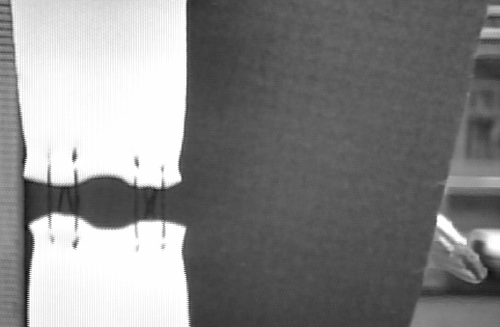

Supplemental Figures 2 and 3

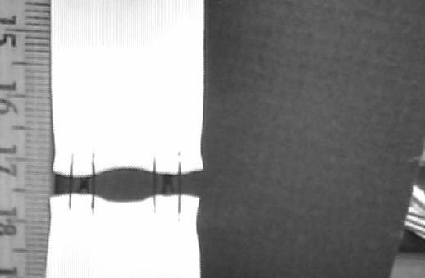
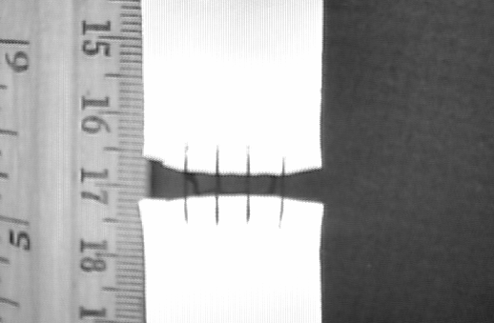
2. Pulley Stitch under 600 grams 3. Running locked stitch under 600 g.

Acknowledgments: Group W10 would like to acknowledge Professor Beth Winkelstein, Al Giandiomo, and Lou Greco. Thanks for a great semester.

