Calorimetric Determination of Caloric Content in Yeast Food Constituents
GROUP NUMBER: W7
GROUP NAME: Reidich, Wang, Lee, Kuchinskas, Costello
Final Project
4/28/04

Background

The yeast medium used in lab is made up of three constituents: dextrose, peptone, and yeast extract. Using the Parr Oxygen Calorimeter, the caloric value of these three components can be measured. Dextrose is a form of glucose, peptone is essentially a combination of amino acids, and yeast extract is primarily dried protein. Literature values for dextrose give its heat of combustion as 3694 cal/gram. Due to their complex structures, heat of combustion values could not be attained for peptone and yeast extract. In order to determine caloric content, careful calibration of the calorimeter is required. This is done using benzoic acid (which has a heat of combustion of 6318 cal/gram), to determine W (the energy equivalent of the calorimeter). It is also necessary to determine if W is constant, and a property of the calorimeter, or if it depends on the caloric value of the sample, and if so, what the nature of the dependence is. Once the calorimeter is calibrated, caloric values can be attained for each yeast medium constituent. Furthermore, these caloric values may be correlated with yeast growth, since calories can be converted to energy by organisms.

Hypotheses/Objectives/Aims

The ultimate goal of this experiment was to find the caloric content of three types of yeast food: dextrose, peptone, and yeast extract. In order to do this, W, which is the energy equivalent of the calorimeter in calories/degrees Celsius, must be first determined.

It was hypothesized that W would be a property of the calorimeter, meaning it should be statistically the same for both groups (α<0.05). It was also hypothesized that W would be independent of the caloric value of the sample being tested and could be used to predict values outside the calibration range of the calorimeter. This was particularly important because W is later needed to calculate a wide range of caloric values. A graph of W versus caloric content should yield a slope of zero if this hypothesis is true.

It was expected that the caloric values would be statistically the same as those found in the literature. It was also hypothesized that caloric content of the samples will be the same for both groups. Lastly, a correlation was expected between caloric content of the medium and the growth rate dependence of the medium as determined by other experimenters. It was predicted that the constituent with the highest caloric content would contribute the most to yeast growth and thus yield the highest growth constant.

General Protocol

The experiment consisted of two main parts: (1) finding W, and (2) determining the caloric values of the yeast foods. In order to find W, nine benzoic acid pellets were burned and using their known heat of formation (H), W was calculated based on the temperature rise of the water. Five samples were within the calibration range of 0.9-1.25 grams, three were below this range, and one was above. The samples burned outside of the calibration range were not used to determine W, but rather confirm confidence in the W determination.

To determine actual caloric contents, five samples of peptone, five samples of yeast extract, and six samples of dextrose were burned. Peptone and yeast extract were burned in pellet form. However, in order to overcome the fact that dextrose would not ignite, dextrose powder with a benzoic acid pellet were burned for each dextrose trial. The temperature change and the W (calculated from part 1) were used to find the caloric values.

In all trials, it was necessary to correct for sulfuric acid, nitric acid, parts of the sample that remained unburned, burned wire, and ambient heat loss. Sulfuric corrections were based upon literature values per sample. Nitric acid corrections were found via titration. Parts of the sample left unburned and burned wire were corrected for by mass differences. Ambient heat was accounted for via a formula.

Specific Methods

The following is the procedure for each trial:
- To calculate W, use the pellet maker to prepare benzoic acid pellets (5 pellets within the calibrate range from 0.9-1.25 grams, 1 pellet ~ 1.5 grams, 1 pellet ~0.5 grams, 1 pellet ~0.6 grams, 1 pellet ~0.7 grams). The out-of-range values are used to see if W can be used to accurately predict values outside the calibration range. A larger number of lower values were used because those are the most relevant for the samples, since the other samples had a lower caloric content than benzoic acid.
- For samples, use the pellet-maker to prepare the sample [peptone~1 gram each (5 pellets), yeast extract~1 gram each (5 pellets), dextrose~1.2 grams (3 powder samples) and ~0.6 grams (3 powder samples). All 0.6 gram dextrose samples were combined with a benzoic acid pellet ~0.6 gram, and all 1.2 gram dextrose samples were combined with a benzoic acid pellet ~0.4 grams. The benzoic acid to dextrose mole ratio was varied to test for a chemical reaction between the two that would affect the temperature change. A 1.43 benzoic to dextrose ratio should yield the same heat of formation as a .43 benzoic to dextrose ratio.
- Take initial measurements of the mass of the pellet, wire, and weighing dish.
- Put sample inside weighing dish, and set up the apparatus such that the wire almost touches the sample.
- Close the lid and pressurize the sample container to 30 atmospheres of oxygen.
- Fill the calorimeter with 2000 g of water and load the sample container inside.
- Close the calorimeter lid. Collect temperature data for 5 minutes while the calorimeter is idle. When the rate of temperature change appears to be constant for 5 minutes, ignite the sample.
- Allow the calorimeter to run until the rate of temperature change is constant for 5 minutes.
- Stop the calorimeter and take final mass of the wire (in this way, account for burned wire) and weighing dish (unburned sample). Wash out all interior surfaces of the sample container, add two drops of methyl orange, and titrate with 0.709 N sodium carbonate (nitric acid correction). The weight percent sulfur was calculated from the manufacturer’s specifications for weight percent sulfate. Only for peptone was the percent sulfur greater than 0.1% and so the appropriate correction was included in the H for peptone.
- Use the initial and final temperatures, given information (H for benzoic acid, W for samples), and corrections, to calculate appropriate W (benzoic acid) and H (sample) values.
- Energy Equivalent of the Calorimeter
W = H * m + wire + acid
Change in T
Where H is 6318 cal/gram, m is the mass of the sample burned, and wire and acid are respectively calories contributed by burnt wire and nitric acid.
H = T * W – wire – acid - sulfur
m
Where symbols are the same as above and sulfur is the calories contributed by the sulfur (for peptone only).
- Run t-tests for the W values obtained for both groups, the caloric contents for both groups, and the caloric contents and literature values. T-tests were also run between the H values obtained for the maximum and minimum temperatures for situations like that depicted in Graph 2. To further test confidence in W, it was calculated using the literature value from the heat of combustion of dextrose and the data from the dextrose trials. This value was compared to the W obtained from the benzoic acid using percent difference.

Results

Graph 1
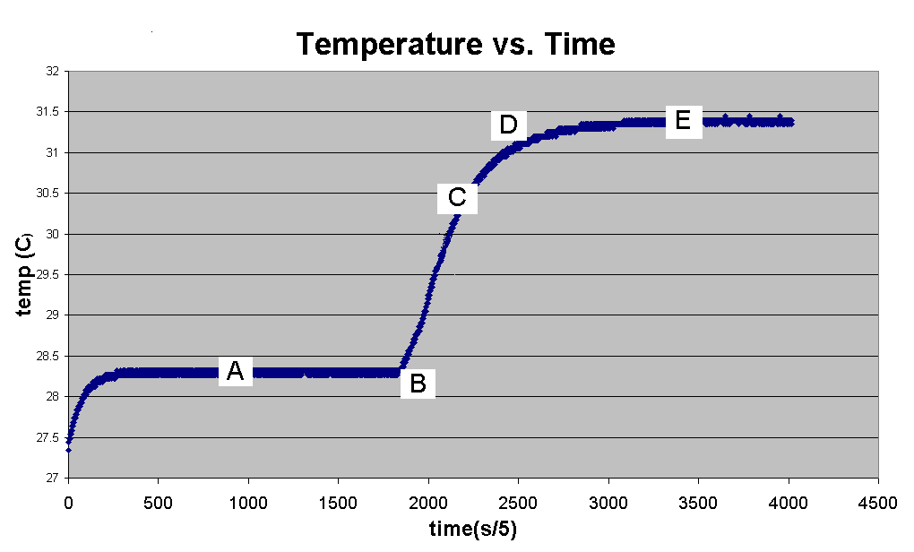

Graph 1 shows a typical Temperature vs. Time curve from which data was extracted. Region A indicates a 5 minute period during which the temperature was read in order to account for heat being absorbed by the water. Point B is the time at which the calorimeter was fired. The region containing point C is the time when the temperature rose as a result of burning the sample. Specifically, point C is the value at 60% temperature rise. Point D is the first time point at which the temperature becomes constant after the rise. The region containing point E is the time when the rate of temperature change is again constant for a 5 minute period.

In order to account for temperature gains or losses to the environment, adjustments must be made utilizing the regions described above. The formula for this is:
Change in T = T_{D} – T_{B} - slope_{A} (time_{C} – time_{B}) – slope_{E} (time_{D} – time_{C})

Graph 2
Temperature vs. Time
y = 1E-05x + 30.3
30.27
30.28
30.29
30.3
30.31
30.32
30.33
0
200
400
600
800
1000
1200
1400
Time (sec)
Temp (degrees Celsius)
Graph 2 shows a typical region during which temperature change remained constant, such as region A or D in Graph 1. When enlarging this region, one can see that the temperature is not, in fact, constant, but instead jumps between two points with a few sporadic points in between.

As shown by Graph 2, areas that appear to have a constant temperature, in fact, deviate. Although when temperatures were read from the graph a consistent method was used, statistical analysis of the T_{max} and T_{min} during the region shown in Graph 2, indicate that there is a statistically significant effect on the values of W and H when using the different temperatures. These values are displayed in Table 1.

Table 1

 | Benzoic Acid (W) | Dextrose (H) | Peptone (H) | Yeast extract (H)
W or H | 2452.625 | 3720.179 | 5110.870 | 4624.112
W_{max} or H_{max} | 2515.888 | 4084.195 | 5353.107 | 4774.333
W_{min} or H_{min} | 2425.743 | 3465.620 | 5010.185 | 4349.308
%diff b/t max and min | 1.590 | 8.853 | 3.759 | 2.308

Table 1 shows how W or H can deviate when the temperature jumps, as shown in Graph 2, are taken into account.

Graph 3

Graph 3 shows a plot of the W found for the various masses. W appears to be fairly constant regardless of mass, but this cannot be said for sure since the curve that is fit to the data has a poor R² value.

Table 2

Heat of Combustion, H (cal/g)
 | Dextrose | Peptone | Yeast Extract
Avg | 3720.179 | 5110.870 | 4624.112
stdev | 108.595 | 82.505 | 42.565
% stdev | 2.919 | 1.614 | 0.920

Table 2 shows the heat of combustion for the dietary constituents tested in the lab. Unfortunately dextrose was the only literature value that could be found, but it was, in fact, statistically the same as the literature value.

Table 3

W from benzoic acid trials | 2452.625 cal/g
W from dextrose trials | 2451.16 cal/g

Table 3 confirms that further statistical analysis indicated that the W obtained from calibration trials using benzoic acid and the W calculated using the literature heat of combustion value for dextrose for the dextrose trials were statistically the same (α<.05).

When comparing data with Tuesday's lab, it was found that W and the heat of combustion value for dextrose were statistically the same. However, the heat of combustion values for peptone and yeast extract were not the same.

The H values for the dextrose powder with benzoic acid pellets at different stoichiometric ratios (between benzoic acid and dextrose) were statistically the same.

In addition to the outlined procedures, the caloric content of a Saltine cracker was also tested and was found to be 4134.056 cal/g. This yielded a 1.89% error from the value given in the Nutrition Information on the package.

Discussion

The most important aspect of the experiment was to determine the nature and value of W, the energy coefficient of the calorimeter. This was necessary because due to the differences in caloric content of the different compounds and the restrictions on the mass of sample that could be burned, it would have been impossible to match the caloric values of all of our samples to that of the benzoic acid sample. For instance, the smallest amount of benzoic acid that could be burned for calibration was 0.9g. This corresponds to 5686.2 calories. If one then wanted to measure the caloric content of a compound that had, for example, a value of 1000cal/g, he would need to burn 5.69g which exceeds the limit for the calorimeter. Therefore, it was important experimentally that W be found to be independent of the caloric content of the sample.

This was approached by burning five benzoic acid samples in the calibration range (.9 to 1.25g) and constructing a graph of the values of W against sample size (see Graph 3). Ideally, this graph would have a slope of zero indicating that W was independent of sample size. In fact, the graph did produce a reasonable slope, but with a very poor R² value. To deal with this, another approach was adopted. New trials were conducted with masses of benzoic acid outside of the calibration range. The W found within the calibration range was then used to predict the heat of combustion outside of the calibration range and was found to do so with high accuracy (an average of 0.78% difference from the literature value). To check the validity of the W obtained from calibration trials using benzoic acid, W was also calculated using the literature heat of combustion value for dextrose for the dextrose trials. Values obtained from each method were found to be statistically the same, and resulted in only a 0.06% difference between them. Although the R² value from Graph 3 may indicate doubt regarding W as a property of the calorimeter, due to the aforementioned statistical analysis, it was finally accepted that W was independent of sample size.

When attempting to run trials with dextrose it was found that dextrose could not be ignited in either a powdered or pellet form. To solve this problem, a small pellet of benzoic acid was added to the powdered dextrose to help with the ignition. This was successful, and the H for dextrose was extracted from the data. This also added the factor of a potential reaction between dextrose and benzoic acid, however, which could contribute to the experimental value of H. Rather than simply comparing the experimental value with the literature value, further trials were run at a different stoichiometric ratio of benzoic acid to dextrose. The different ratios were designed to change the extent of any possible reaction occurring (especially if a limiting reactant was involved). The values of H derived from the two different ratios were statistically the same and so it was determined that any reaction had only a negligible contribution.

Ideally, W and H could be calculated by only taking into account the heat released and the mass of the sample. Unfortunately, the experimental setup adds several confounds. The heat released into the water does not result entirely from the burning of the sample. The heat from the burned wire was taken into account by weighing the amount of wire before and after each trial and multiplying by the caloric content per gram of water. Additionally, there are acids formed in the oxygen rich environment of the calorimeter. These were addressed by titrating the bomb washings. The calories added by nitric acid are the same as the milliliters of 0.0709M base used to neutralize the washings. The sulfuric acid was compensated for in the data whenever the wt% of sulfur was greater than 0.1%. This was only true for peptone, as determined by the manufacturer’s specifications for wt% sulfate. Also, rarely did the entire sample burn. This was addressed by weighing the sample dish before and after each trial. Lastly, a complex formula is used to address ambient heat (see Graph 2).

It was found that even over regions of nearly constant temperature there were fluctuations between two temperatures. While the effect of the difference between these two temperatures on the overall temperature rise is very small, it is magnified when multiplied by H or W which are order of magnitude of 10³. Additionally, the determination of H carries with it the temperature error that went into W. To address this issue, the graphs obtained from the trials were enlarged in the regions just before and just after the temperature rise to isolate the maximum and minimum temperatures recorded. W and H were then recalculated to find the maximum and minimum values for the two, employing the maximum and minimum temperature changes. For W and for H of all three compounds, the maximum and minimum were found to be statistically different (with the most extreme case having a 15% difference), indicating that the effect of these small (.005 to .01 degrees Celsius) fluctuations had a statistically significant effect on the data.

Although the calorimeter is an instrument to create consistent environment, there are still possible errors when operating it. There is error involved with the lack of precision regarding the pressure of oxygen in each firing (±0.025atm). Also, the input energy from the electrical firing may not be consistent for each trial.

The statistical differences in the data from the two groups may have stemmed from massing procedures. Small factors may include using different balances between the two groups to mass samples. Using the same balance between the two groups could have minimized potential errors in massing the wire, compound, and water. However, in the data presented in this report, usage was limited to one mass balance in order to reduce error.

Through experimentation, it was found that peptone has the highest caloric content. Following from the hypotheses, one would expect this to correlate to the highest growth constant for dextrose in the group that was experimenting on yeast diets. However, the Yeast Diet Group found that dextrose played the largest role in yeast growth, while cutting peptone and yeast extract in the medium did not have nearly as much significance on growth. This may be explained by the fact that organisms use different metabolic pathways to break down foods, and not all calories can be converted to energy or growth with the same efficiency. For example, gasoline is calorie-rich, but due to its highly explosive and toxic nature, it is not fit for human growth or consumption. Also, dextrose is a form of glucose, suggesting the possibility that the sugar is what promotes yeast growth. This original hypothesis was overly simplistic and failed to take in any variables except caloric content.

