Pressure Flow Through a Coiled Tube
Group M5
BE 310 Spring 2004
Amy Garber
Liani Hernandez
Chris Mullin
Melissa Simon

Abstract

Pressure Flow experiments were performed on coiled tubing to investigate the effects of coil orientation, radius of curvature, and fluid viscosity on the flow. From Poiseuille’s Law and theories and experiments of W.H. Dean and C.M. White, a relationship between pressure and the Dean Number (De = Ud/ν (d/D)^{1/2}), was determined to be Pd²/LμU =32(0.37De^{0.36}). From this relationship, a plot of the non-dimensionalized pressure versus the function of the Dean Number should have a slope of 32. Coil orientation experiments showed that the slope for the horizontal descending orientation, 31.35 ± 7.24 and is the only one that overlaps 32, and is the orientation that most minimizes the effects of gravity. The experiments varying radii of curvature, tubing of 1.7 cm and 14.32 cm radii of curvature had slopes of 31.93 ± 1.38 and 34.34 ± 2.23, respectively. For a 10% sucrose solution, a 4.04 cm radius of curvature had a slope of 26.42 ± 6.97. These experiments indicate that the pressure flow method and the experiments and theories of W.H. Dean and C.M. White are an effective way of analyzing flow through coiled tubing.

Background

Flow through straight tubes has been studied extensively over time, while flow through coiled tubing has been studied in significantly less detail. The Hagen-Poiseuille Law is a special case of the Navier-Stokes Equation that describes laminar flow in straight tubes. From the Hagen-Poiseuille Law, change in pressure through a length of tubing can be related to characteristics of the fluid and tube dimensions, with the equation
$$\frac{ΔP}{l}=\frac{\text{32}μU}{d^{2}}$$
where l is the length of tubing, µ is the kinematic fluid viscosity, U is the fluid velocity, and d is the tube diameter.
In curved tubes, resistance to flow is always greater, as the more rapidly flowing central portion of the fluid is forced outwards by centrifugal forces, while the slower portions of the fluid are forced inwards. Experiments by W.H. Dean quantify flow by the introduction of a new dimensionless number, the Dean Number. The Dean Number is a slight modification of the Reynolds Number, and is defined as:
$$\text{De}=\text{Re}\sqrt{\frac{d}{D}}=\frac{\text{Ud}}{ν}\sqrt{\frac{d}{D}}$$
where d is the tube diameter, D is the diameter of curvature, U is the fluid velocity, and ν is the dynamic viscosity.
C.M White experimentally determined that the Dean Number can be related to the pressure drop in a tube, by a function of the Dean Number, defined as:
$$f(\text{De})=0\text{.}\text{37}{\text{De}}^{0\text{.}\text{36}}$$
by which the resistance of laminar flow in a straight tube (defined in the first equation) can be multiplied. This yields the equation:
$$\frac{ΔP}{l}=\frac{\text{32}μU}{d^{2}}f(\text{De})=\frac{\text{32}μU}{d^{2}}0\text{.}\text{37}{\text{De}}^{0\text{.}\text{36}}$$
Thus, a plot of $\frac{Δ{\text{Pd}}^{2}}{lμU}$ vs. $0\text{.}\text{37}{\text{De}}^{0\text{.}\text{36}}$should be a linear relationship with a slope of 32.

Methods and Materials

• tank with supports for holding water
• 1/8 inch ID tubing 46’ in length
• pressure manometer
• graduate cylinder to collect water and timer
• flow cutoff valve
• 4 cylinders with varying radii of curvature to wrap tubing around
• 10% sucrose mixture

Week 1:
- The water tank was set up according to the diagram below, and the 1/8” ID tubing was wrapped 13 times around a cylinder with radius of curvature 14.5 cm.
- The needle valve was opened to obtain a slow flow and get air bubbles out of the tubing. A series of pressure-flow measurements were conducted by opening the cutoff clamp a given amount, recording the pressure from the manometer, and collecting the flow in a graduated cylinder for a short time to determine the flow rate by massing the flow collected in the graduated cylinder and dividing that volume by the time it took to collect the flow. While the flow was being collected, the end of the tube was kept at the same height so the flow rate would not be altered.
- Water was added to the tank over the course of the flow rate measurements to avoid the tank running dry. 5 measurements were taken at different flow rates (controlled by the amount that the clamp was opened). The first flow rate consisted of the clamp being opened a very little amount so that only drops were coming out the end of the tube, and the last measurement consisted of the flow rate when the clamp was wide open so that the maximum flow rate was obtained from the system. In all of the measurements, the pressure was recorded with the manometer, and flow rate was also recorded.
- This procedure was done on 5 different orientations of the apparatus. The orientations were as follows: two vertical orientations (Figure 2), two horizontal orientations (Figure 1), and one horizontal orientation rotated 90°.

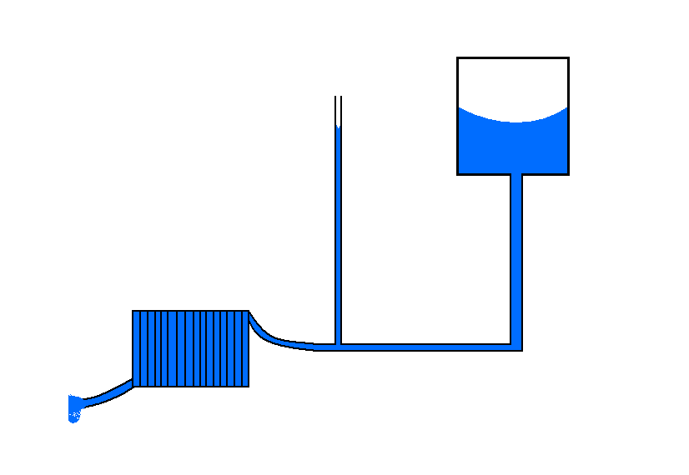
Water tank
Needle valve
cylinder
Manometer tube

Figure 1: Horizontal Orientation of Apparatus

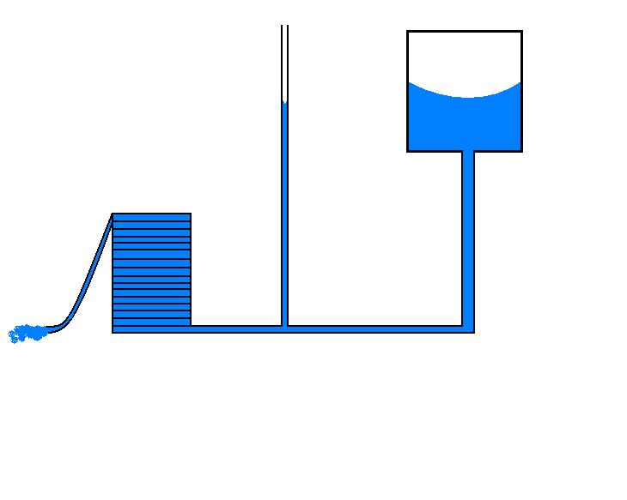
Water tank
Needle valve

Manometer tube
cylinder

Figure 2: Vertical Orientation of Apparatus

Week 2:
- The 1/8” ID tubing was wrapped around cylinders with varying radii of curvature according to the table below and positioned in the horizontal descending orientation.
Radius of curvature (cm) | Number of coils
1.7 | 105
14.3 | 14
5.4 | 37
4 | 58
- The same procedure from Week 1 was repeated to determine several pressure-flow measurements.
Week 3:
- The 1/8” ID tubing was wrapped 57 times around a cylinder with radius of curvature 4.04 cm according to the same diagram as in Week 1 using the horizontal orientation of the apparatus.
- The procedure from Week 1 was repeated with one exception. Instead of using pure water, a 10% sucrose solution with viscosity 1.17 mPa*s was put into the water tank. The 1/8” ID tubing was completely dry before beginning the procedure.

Results

Initially five coil orientations were tested to determine the optimal orientation for obtaining flow data that is uninfluenced by gravity and other factors. The flow and pressure measurements for the five coil orientations (vertical ascending, vertical descending, horizontal ascending, horizontal descending and rotated horizontal ascending) were applied to the modified Poiseuille flow equation for coiled tubing: P/L = (32μU/d²)*f(De), and Pd²/LμU vs. f(De) is graphed below in Figure 3. Ideally, the slope of each of these lines should be 32. As can been seen in Figure 3, the slope for the horizontal descending orientation is 31.35 ± 7.24 and is the only one that overlaps 32. Although the R² value of 0.842 is the worst of the five, since it is the only one that agrees with the expected slope of 32, this orientation was used in future experiments.

Figure 3: Graph of Pd²/LμU vs. f(De) for the five coil orientations tested.

Once the orientation was established, various radii of curvature were tested. Radii of 1.7 cm, 4.04 cm, 5.4 cm and 14.32 cm were tested and the resulting Pd²/LμU vs. f(De) graphs are shown below in Figure 4.

Figure 4: Graph of Pd²/LμU vs. f(De) for the four radii tested.

Finally, viscosity was varied to see if the modified Poiseuille relationship would hold for a sucrose solution. For a 10% sucrose solution, the slope of the Pd²/LμU vs. f(De) curve was calculated to be 26.42 ± 6.97, however if the point (1.04, 35.5) is eliminated, then the slope becomes 30.91 ± 2.35. The 10% sucrose data is shown below in Figure 5.

Figure 5: Graph of Pd²/LμU vs. f(De) for the 10% sucrose solution.

A summary of the slopes found for the five experimental coil conditions are shown in Table 1. The three highlighted rows satisfy the modified Poiseuille model since the slopes overlap 32.

Radius of Curvature (cm) | Solution  (% sucrose) | Slope | Std. Error
1.7 | 0 | 31.93 | 1.38
4.04 | 0 | 36.0 | 1.26
5.4 | 0 | 19.05 | 0.62
14.32 | 0 | 34.34 | 2.23
4.04 | 10 | 26.42 | 6.97

Table 1: Summary of the slopes obtained for each of the five coil conditions.

Discussion

The results of the orientation experiment proved that the optimal orientation is horizontal descending, since this was the only orientation with a slope of 32 on the Pd²/LμU vs. f(De) graph. This makes sense intuitively since both the horizontal position and the descending coiling would minimize gravity effects. In addition, since the terminal end of the coil is at the same level as the bottom of the manometer, differences in height do not have to be accounted for when making the pressure measurements.
With the horizontal descending orientation, five experimental conditions were tested, four radii of curvature with water and one with 10% sucrose solution. Of these five conditions, three had slopes on the Pd²/LμU vs. f(De) graph that overlapped with the expected slope of 32, and with a radius of 4.04 cm, the slope was 36 ± 1.26, which is close to 32, although it does not actually overlap. Therefore, it can be concluded that the modified Poiseuille method of analyzing flow through coiled tubing is appropriate. Two other methods of dimensional analysis, involving the Euler number and head loss, were attempted to analyze the data and both we not successful. The details and results of these approaches are discussed in the appendix.
For those data sets that did not have a slope overlapping 32, the error can be attributed to a number of factors. First, the pressure readings could be affected by the height of the outlet of the flow not being kept constant. If it is above the inlet, then the pressure reading is not accurate. Also, since the manometer is positioned before the coiling, there is an additional pressure drop as the flow moves through the coils that is not accounted for. In addition, for some reason, there may not have been fully developed laminar flow, however this is not very likely as the theory behind the pressure flow experiment assumes that the flow through the tubing is fully developed at the time it flows under the pressure gauge. The entrance length is defined as the length of the tube from the tank to the pressure gauge. The pressure gradient becomes fully developed if the entrance length is three or four times the diameter, and the mean velocity profile becomes fully developed if the entrance length is 30 to 60 times the diameter. In this experiment, the diameter of the tubes was never more than a quarter of an inch, meaning that the length of tubing before the pressure gauge had to be more than one inch in order to have a fully developed pressure gradient. Since this condition was satisfied in the experiment, the flow can be considered to be fully developed. It is also possible that the coil itself was wound too tight, constricting flow. Lastly, a major source of error may be attributed to a source tank that was not completely full, contributing to a loss of water pressure.
The concept of pressure flow has many useful applications in both the cardiovascular and respiratory systems. In the cardiovascular system, blood flows though arteries, veins, and capillaries, and pressure for this flow is generated by the heart. Similarly, changes in pressure lead to air flow through the respiratory system. By understanding the effect that the Reynolds Number, Dean Number and the Darcy Friction Factor have on laminar (Poiseuille) flow, we can understand the processes of blood flow through the cardiovascular system and air flow through the respiratory system.

Conclusions

The experiment verified three hypotheses: first, that our mathematical model that was based on the theories and experiments of W.H Dean and C.M. White would accurately describe flow through a coiled tube. Second, it was verified that our model would still hold up even though the viscosity of the solution was varied. Third, it was verified that the orientation of the coiled tube had an effect on the data, and we attributed this effect to gravity.
Several sources of error in this experiment could be avoided in the future. First, the position of the manometer could be moved to somewhere within the coiled tube, so the actual pressure drop within them could be recorded. The entry length could be varied, probably increased to insure fully developed laminar flow within the tube. The length of the tube itself could be varied to observe any effects it has on the data. Lastly, if more time was allowed, more viscosities would be tested, as only two (pure water and 10% sucrose) are not enough to statistically prove our model holds for varying viscosity.

References

Prandtl, Ludwig. Essentials of Fluid Dynamics. Hafner Publishing Company (New York: 1952). 98-99, 161-168.

T3 Final Report, BE 310. “Measurement of Pressure-Flow Relationship in a Curved Tube”. Spring 2002.

M5 Experiment 2, BE 310. “Measurement of the Pressure-Flow Relationship in a Straight, Horizontal Tube”. Spring 2004.

Appendix

Two other methods of data analysis were attempted and both had little success. The first method involved a non-dimensional approach to this problem, using the Euler number ΔP/ρu², as the non-dimensionalized version of pressure. From this approach of dimensional analysis, the Euler number is equal to some function of length, diameter, and Dean Number. By removing a non-dimensional length from this function, we have the equation: ΔP/ρu² = L/d f(De). As shown in Table 2, this function of the Dean Number is not equal to the C.M. White’s experimental function f(De) = 0.37De^{0.36}. This new function could be determined experimentally, but this is well beyond the scope of the project, and would require much further experimentation.

Radius of Curvature (cm) | U (m/sec) | Eu | (Eu*D)/L | f(De)
1.70 | 0.12 | 492.93 | 0.11 | 2.18
 | 0.11 | 498.29 | 0.11 | 2.11
 | 0.09 | 571.39 | 0.13 | 1.96
 | 0.07 | 659.79 | 0.15 | 1.80
 | 0.05 | 741.09 | 0.17 | 1.61
 | 0.02 | 938.49 | 0.21 | 1.19
5.40 | 0.02 | 1933.85 | 0.44 | 0.87
 | 0.05 | 811.33 | 0.18 | 1.30
 | 0.07 | 652.08 | 0.15 | 1.46
 | 0.10 | 513.11 | 0.12 | 1.64
 | 0.12 | 447.10 | 0.10 | 1.74
 | 0.13 | 420.87 | 0.10 | 1.81
14.32 | 0.03 | 653.64 | 0.15 | 0.89
 | 0.07 | 527.43 | 0.12 | 1.20
 | 0.09 | 452.56 | 0.10 | 1.31
 | 0.11 | 375.53 | 0.09 | 1.45
 | 0.13 | 350.83 | 0.08 | 1.52
 | 0.15 | 329.79 | 0.07 | 1.60
4.04 | 0.03 | 988.00 | 0.22 | 1.07
 | 0.05 | 772.45 | 0.17 | 1.39
 | 0.07 | 668.52 | 0.15 | 1.53
 | 0.10 | 559.50 | 0.13 | 1.71
 | 0.11 | 518.07 | 0.12 | 1.80
 | 0.12 | 504.35 | 0.11 | 1.85

Table 2: Comparison of the non-dimensionalized pressure (PD/Lρu²) to the f(De). Since columns three and four are not equal, the f(De) for this non-dimensionalized pressure is not equal to f(De) = 0.37De^{0.36}.

A second approach to the data analysis would be to non-dimensionalize the pressure in the form of head loss, equal to h_{L} = ΔP/ρg = (32μUL/ρgd²) * f(De). This function of the Dean Number is also not the one defined by C.M. White’s experimental function f(De) = 0.37De^{0.36}. This function could similarly be determined experimentally, but this would require more trials and is well outside the scope of the project.

Radius of Curvature | U (m/sec) | P/pg | 32μUL/ρgd2)*f(De) | %diff
1.70 | 0.12 | 0.75 | 1.04 | 38.47
 | 0.11 | 0.64 | 0.92 | 44.85
 | 0.09 | 0.48 | 0.69 | 44.34
 | 0.07 | 0.34 | 0.50 | 45.89
 | 0.05 | 0.21 | 0.33 | 57.33
 | 0.02 | 0.05 | 0.10 | 113.79
5.40 | 0.02 | 0.06 | 0.06 | 0.62
 | 0.05 | 0.22 | 0.26 | 18.73
 | 0.07 | 0.34 | 0.41 | 19.89
 | 0.10 | 0.51 | 0.63 | 23.71
 | 0.12 | 0.62 | 0.79 | 27.75
 | 0.13 | 0.72 | 0.91 | 26.71
14.32 | 0.03 | 0.06 | 0.10 | 77.49
 | 0.07 | 0.25 | 0.32 | 28.62
 | 0.09 | 0.34 | 0.44 | 28.45
 | 0.11 | 0.51 | 0.65 | 28.65
 | 0.13 | 0.61 | 0.78 | 26.79
 | 0.15 | 0.75 | 0.93 | 24.06
4.04 | 0.03 | 0.07 | 0.11 | 59.81
 | 0.05 | 0.23 | 0.29 | 27.85
 | 0.07 | 0.34 | 0.42 | 23.95
 | 0.10 | 0.52 | 0.64 | 21.96
 | 0.11 | 0.64 | 0.77 | 20.52
 | 0.12 | 0.74 | 0.86 | 17.25

Table 3: Comparison of the two equations of head loss. Column four compares the standard definition of head loss, P/pg, with (32μUL/ρgd²) * f(De). The large percent differences show that the f(De) of 0.37De^{0.36} does not apply in this equation.

