Tendon Stiffness
and Strain Distribution

April 28, 2006

BE 210-101
Group #4B
Joseph Frey
Chrysta Irolla
Dipal Patel
Akivaga Tsingalia
Background

Various tendons in the body are occasionally subjected to strains that may cause them to tear. These tendons should be repaired in a way that does not limit range of motion and maintains the stiffness of an intact tendon. Using a combination of tensile testing and suture testing, the performance of a sutured tendon can be compared against that of an intact tendon, with respect to both stiffness and strain distribution. Previous experimentation has tested the tensile properties of chicken skin, producing force-displacement curves (Figure 3, Appendix). The samples of chicken skin were placed in an Instron 4444 and subjected to uniaxial tension until the sample tore. Stiffness values of each sample were tabulated from the slopes of the initial linear regions of the force-displacement curves (k=F/d, where k=stiffness (N/mm), F=force (N), d=displacement (mm)). This same process will be used to calculate the stiffness of samples of chicken tendon. Additionally, previous experimentation tested displacement of sutures using image analysis with a CCD camera (Figure 4, Appendix). Image analysis will again be used in this experiment, but a Progressive Scan Color Camera will be used instead to take constant images as tension is applied. The camera will monitor the strain of three areas of the sutured tendon: above the repaired area, around the repaired area and below the repaired area. The same areas will be monitored for the intact tendon. Using these images, the strains of each of the three areas can be compared to note differences in strain distribution for sutured and intact tendons.

Hypotheses and Aims

The experiment primarily aims to assess the difference between the stiffness of sutured and intact tendons. Such an assessment can be used to qualify the extent to which sutured tendons mimic the properties of, and act as sufficient replacements for intact tendons. Additionally, the experiment aims to qualify the difference in strain distribution in sutured and intact tendons. Sutured tendons are assumed to be weaker near the point of repair, and therefore it is believed that strain will be more highly concentrated in this area. The intact tendons, assuming that they have fairly consistent material properties, will have no such concentration of strain.

The expected distribution of strain in sutured and intact tendons leads to the prediction of their respective stiffness values. Because the intact tendons distribute strain over a larger area than sutured tendons, the stiffness of the intact tendons will be greater than the stiffness of the sutured tendons. This expectation stems from the relationship between stiffness and displacement: as the displacement of a material decreases, the stiffness of the material will increase proportionally (k=F/d). Therefore, the stiffness of the intact tendons will be greater, because the displacement (analogous to strain) in any one area of the intact tendon will be less than the displacement of the sutured tendons near the area of repair. T-tests will be used to quantify the significance of the difference in stiffness values between the sutured and intact tendons.
Equipment
Major Equipment
- Instron Model 4444 with Tensile Attachment
The Instron Model 4444 will be used to apply uniaxial tension to tendon samples. The crosshead speed and sampling rate of the machine will be configured to take proper readings of the displacement of samples in response to the monitored applied force.
- Computer with LabView Program
A computer and the LabView Program will be needed to monitor the output of the Instron Model 4444. The program will construct force-displacement graphs for each tendon sample.
Supplies
- Cutting board
A cutting board will be necessary to place the chicken legs on while removing the tendon samples.
- Razor blade and scissors
A razor blade and scissors will be used to remove tendons from chicken leg samples and to cut suture materials into desired lengths.
- Tongs
Tongs will be used to aid in placement and holding of tendon samples.
- Marking pen
A marking pen will be used to mark three regions of each tendon sample. These markings will be monitored by the scan camera and will be used to tabulate the displacements of each marked region.
- Rulers and Calipers
Rulers will be used to measure the length of each tendon sample. Calipers will be used to determine where to place stitches on the sutured tendons: the placement of these stitches needs to be consistent to maintain credibility of the data, and will therefore have to be very accurate. Rulers will also be used to determine the placement of markings on each tendon sample to be monitored by the scan camera.
- Sewing needle
A sewing needle will be used with SUPRAMID suture material to suture the tendon samples.
Newly Purchased Equipment and Supplies
- Chicken legs
Chicken legs will be used as the source of tendons for the experiment because of the relative ease of obtaining the tendons.
- 1/3” Progressive Scan IEEE 1394 Color XGA Camera
A progressive scan camera will be used to monitor the displacements of the marked regions on each suture sample. Because the Instron Model 4444 applies constant force, a progressive camera is necessary to constantly monitor the tendon samples.
- SUPRAMID suture material
SUPRAMID is a non-absorbable material of braided nylon, and will be used in sutured tendon samples.
Proposed Protocol and Methods

Gather and Prepare Tendon Specimens
- Carefully remove tendons from chicken leg samples and cut into ten 2-inch specimens.
- Cut five of the ten tendons into 1-inch pieces.
- Sew five sets of 1-inch tendons together using the needle and SUPRAMID suture material, making each stitch 0.25 inch in length. Create two evenly spaced running stitches along the length of the repair.
- For the sutured tendons, place markings above and below sutured area, creating an area of 0.25 inches in length. Place marking above and below the sutured area, creating two additional areas of 0.25 inches in length.
- For intact tendons, place markings in the same areas as the sutured tendons, creating three areas of 0.25 inches in length on each sample.

Instron Set-Up
- Set the Instron Model 4444 to “SI” mode and calibrate, noting error in load outputs as compared to known weights.
- Specify the speed and direction of movement of the crosshead before starting the first trial. The sampling rate should be set at 5 points/second.

Specimen Tensile Testing
- Use the video camera to isolate the marked regions of each tendon, making sure that the change in length of all areas can be monitored as tensile force is applied to the tendon samples. The video camera should take continual images of the tendon samples as force is gradually applied. An image of a marked ruler in the position of the tendon should be taken in order to calibrate the pixilation of the images. The camera and Instron sampling rates should be equivalent, in turn setting up the camera to take images at 5 frames per second. All images should be saved for future analysis.
- Insert a tendon sample into the machine and secure with clamps. Make sure the no-load position is kept constant for all samples.
- Test five intact tendons and five sutured tendons until rupture with the Instron Model 4444 using the tensile attachment. Record data of applied force and displacement.
- Make note of any important elements of the rupture, including rupture location and other noteworthy details.

Data Analysis
- Construct force-displacement graphs for each tendon sample, calculating values of stiffness.
- Use camera images to tabulate the total displacement of each section of all tendon samples. Calculate the averages of each section for sutured tendons and intact tendons.
- Analyze data, comparing stiffness and strain values of sutured tendons and intact tendons. Use a t-test to assess if the difference in stiffness values between sutured and intact tendons is significantly different. Use a t-test to compare strains of the middle sections of sutured and intact tendons, and quantify the difference in strain values in all sections of sutured and intact tendons.

Anticipated Results

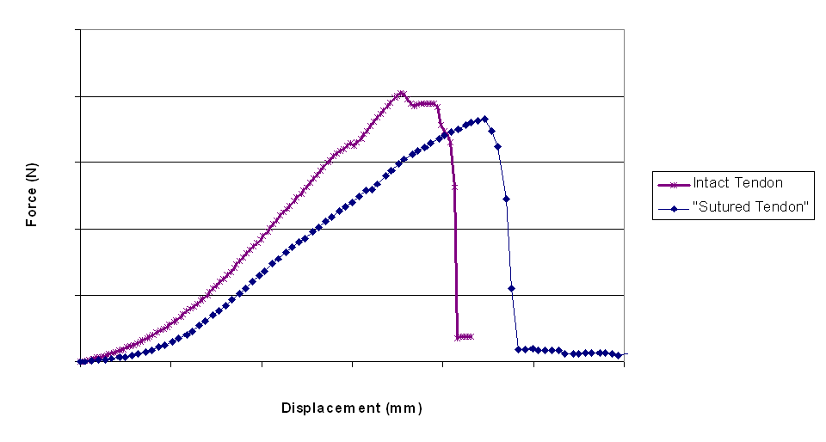
It is expected that the average stiffness of intact tendons will be significantly greater than the average stiffness of sutured tendons. The values of stiffness will be calculated from force-displacement graphs created from data collected during tensile application (Figure 1).

Figure 1. Sample force-displacement curve for tendon under tensile application. Stiffness values will be tabulated from the slope of the initial linear region of the graph (k=F/d). It is expected that the curve for intact tendons will have a greater slope than the curve for sutured tendons.
The results obtained from the proposed experiment is expected to match those of the Mayo Clinic study, in that the average maximum stiffness attained by an intact tendon will be higher than the average maximum stiffness attained by sutured tendons (Figure 5, Appendix) . The stiffness of sutured tendons will be significantly less than the stiffness of intact tendons (one-tailed t-test with p-value less than 0.05).
It is also projected that the strain experienced by the sutured tendons will be greatest in the area of repair, while intact tendons will evenly distribute strain. Strain values will be tabulated from camera images of the tendons under applied tension, and the values will be placed into a table for future analysis (Figure 2).

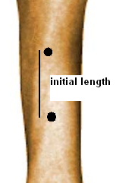
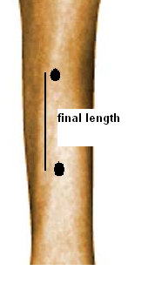
Marked Region #1: Upper Segment
Sutured Tendons |  | Intact Tendons
Sample | Strain (mm) | Sample | Strain (mm)
1 |  | 1
2 |  | 2
3 |  | 3
4 |  | 4
5 |  | 5
Average |  | Average

Figure 2. Sample tendon images, cropped to focus on one of the three marked regions. The image on the left shows the tendon before tensile application and the image on the right shows tendon after tensile application. Strain values will be calculated from the difference in the final and initial lengths (marked by black lines) and placed into three tables, one for each of the three marked regions of the tendons (a sample table is shown above).

It is expected that the tabulated values will show that sutured tendons consistently distribute strain most around the area of repair, leading to constant laceration in that area. Intact tendons will distribute strain more evenly, and will have no such concentrated area of strain.
Potential Pitfalls and Alternative Methods/Analysis

For this experiment there are several factors which could impede the experimenters’ ability to obtain accurate data. The main categories of anticipated error are systematic error, random error and human error.

Systematic Error

There will be error in quantifying the strain in specified areas of the tendon using the 1/3” Progressive Scan IEEE 1394 Color XGA Camera. This camera will allow for high exposure video of the entire tendon while the Instron is applying a gradually increasing force. However, the calibration of pixels to millimeters will lead to inaccuracy. This error will be quantified by taking five readings of the calibration scale and using the average and standard deviation of these readings for future conversions.
The SUPRAMID suture material is not an ideal suture material for tendon repair because it gradually loses its tensile strength. However, degradation will not impact this experiment because the sutures will not be placed in vivo or observed for a long period of time. Alternative methods of using more stable sutures would pose complications for sewing, because these sutures would be too rigid for hand-sewing methods.
Another experimental pitfall involves securing the tendons within the Instron attachments without slipping. To help prevent slipping, a piece of double sided tape can be bound to both the sample and the clamp.

Random Error

The tendons attained from the chicken legs will be small and difficult to work with, and will have individual irregularities because of being obtained from different chicken legs. This pitfall can not be avoided but should be attempted to be quantified. Error in the thicknesses of the tendons, for instance, should be recorded by measuring the thickness of each tendon sample and noting deviations.
There is also an accountable error of +/- .05 mm in the ruler being used to measure sample lengths.

Human Error

Human error creates inconsistency in measuring the length of each tendon. Also, the cutting and stitching of the tendons will vary from sample to sample. It is impossible to produce an identical stitch placed in the exact same location for each tendon, and this human error will depend on the experimenters’ personal skill and precision. It will also be difficult to maintain a consistent interpretation of camera images; specifically, the reading of pixel distances could vary with each image. In order to minimize all of these errors, it is suggested that one group member be assigned a specific task or variable to measure, and that they use a consistent method for measurement.

Budget (Total $1721.40)
Item | Price | Quantity | Total
Chicken legs | $3.25 for 1 package (4 legs) | 50 packages  (each group receives 10 legs) | $162.50
Scan Camera | $1356.00 | 1 | $1356.00
SUPRAMID | $101.45 for 12  20-inch pieces | 2 Packages  (each group receives 24 in. of suture) | $202.90
 |  |  | $1721.40
- Chicken legs ($162.50 for 200 legs)
Product Details:
Sold by The Fresh Grocer: Perdue chicken legs family pack ($3.25 for 4 legs)
ISBN No: 214414603157
Justification:
Money for 200 legs is allocated so that 20 groups, each with 10 chicken legs, can perform the experiment.
- 1/3” Progressive Scan IEEE 1394 Color XGA Camera ($1356)
Product Details:
Sold by RMA Electronics Inc.
Manufacturer: Sony
Model No: DFW-X710
Technical Specifics: Selectable image size and frame rate (1-15 frames/sec)
XGA Output image-1/3 type IT CCD, 1024(H) x 768(V)
Justification:
The selected camera has high pixilation (1024H x 768V) and a maximum frame rate of 15 frames per second. The high-resolution streaming images the camera captures will allow for more accurate strain measurements when converting from pixels to mm. The frame rate is adjustable and can therefore be matched to the sampling rate of the Instron Model 4444. Only one camera is needed since it is expected that 1 group will perform the experiment at any given time.
- 4-0 Looped SUPRAMID EXTRA suture for Tendon Repair ($202.90 for 2 boxes)
Product Details:
Sold by S. Jackson, Inc.
Order Code: LHR-40, sterile nylon non-absorbable sutures
Product Specifications : 3/8 reverse cutting needle
Single-armed, packed 12 per box
5-0 looped cable-type suture (20 in)
Justification:
SUPRAMID suture material will be used in this experiment because of its expected ease of use in sewing, and low cost. Additionally, SUPRAMID is used in real-life tendon repair, and the data can therefore be related more to real-life applications than data obtained with thread sutures. Since the tendons are fairly small, each group is allotted 24 in. of suture and it is expected that they will use about 4 in. to sew each pair.

Appendix
Chicken Skin Testing, Short Length
0
1
2
3
4
5
6
7
8
9
10
0
5
10
15
20
25
Displacement (mm)
Force (N)
Trial 1
Trial 2
Trial 3
Trial 4

Trial 5

Figure 3.Force-displacement curve obtained from previous experimentation (Experiment 3 data) of tensile application on five samples of chicken skin. Stiffness values were tabulated from the slopes of the initial linear regions of each curve.
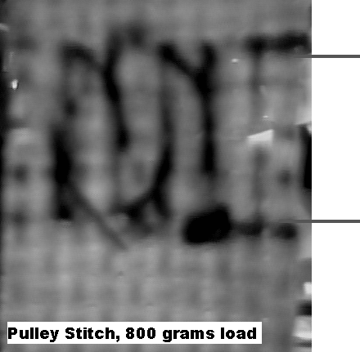
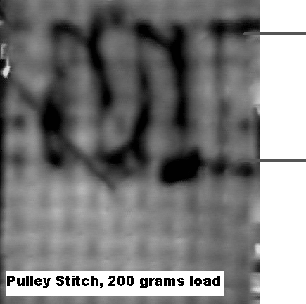

Figure 4. Images of suture displacement obtained from previous experimentation of sutures under uniaxial force (Experiment 5 data). Strain values were calculated from images by noting the difference in initial and final lengths between the top and bottom of the sutures.

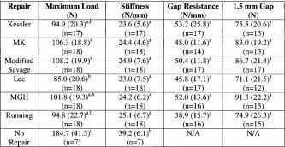

Figure 5. Data obtained from the 2000 Mayo Clinic Study comparing suture methods in canine tendons. The data shows that the average stiffness of the sutured tendons (24.2 N/mm) was consistently less than the average stiffness of the tendon with no repair (39.2 N/mm).

Footberg Ltd., synthetic and non-absorbable sutures, Retrieved 2006, April 12, http://www.footberg.com/sutures/snas/supramid_en.html
An, Kai-Nan., Amadio, Peter C., Zobitz, Mark E., Zhao, Chunfeng., 2000 “Comparison of Mechanical Properties of Various Suture Repair Techniques in a Partially Lacerated Tendon” Journal of Biomechanical Engineering, Vol. 122, No. 6, pp. 604–607.
RMA Electronics, Inc., Model #DFW-X710. http://www.rmassa.com/manu/sony.htm.
S. Jackson, INC., SUPRAMID pricing, Retrieved 2006, April 12, http://www.supramid.com/displayold.asp?ITEM=lhr-40
An, Kai-Nan., Amadio, Peter C., Zobitz, Mark E., Zhao, Chunfeng., 2000 “Comparison of Mechanical Properties of Various Suture Repair Techniques in a Partially Lacerated Tendon” Journal of Biomechanical Engineering, Vol. 122, No. 6, pp. 604–607.

