GROUP 102A: Khan, Zeeshan; Pham, Quang; Roche, Christine; Zelman, Hannah
TITLE: A Comparison of Suture Type: Dermabond Liquid Adhesive vs. Traditional Sutures
DATE: Friday, April 28, 2006
A. Background

Dermabond Liquid Adhesive is currently used by doctors to close superficial wounds to the skin. It is applied as a thin layer of ‘purple glue’ over the wound while the doctor holds the skin together. Dermabond can be used as a substitute to traditional sutures, forming a strong but flexible bond over the area to which it is applied and protecting the wound from infection-causing bacteria.

In this experiment, BioBrane, a biosynthetic wound dressing, serves as a substitute for the interwoven white material used in Experiment #5. Based on the results of Experiment #5, the Pulley stitch was found to resist separation better than the Vertical Mattress stitch (see Figure A1). Due to its superior relative performance, the Pulley stitch will be used to reconnect half of the separated BioBrane samples. The remaining half of the BioBrane samples will be reconnected using Dermabond.

The relative performance of each of these two connective methods can be determined by their ability to resist separation under quasi-static tension in the form of increasing masses applied to the bottom of the suspended BioBrane samples. The vertical deformations experienced by the samples as measured in their middle sections, which includes the gap within the sample, will be considered indicative of their performance level (see Figure A2 for picture of segments). The connective method showing the least deformation will be determined as having greater relative performance.

B. Hypothesis and Objectives

The purpose of this experiment is to expand on Experiment #5 by quantifying planar tensile deformations and strains as a means of assessing the relative performance of the Dermabond adhesive to Pulley stitches.

This experiment also serves educational purposes. It helps one to understand the experimental approaches used to systematically estimate displacement data and derive strains for uniaxial loading. One will also become familiar with the experimental challenges of using image data acquisition for deformation analysis.

The hypothesis of this experiment is that the middle sections of the Dermabond samples will exhibit less vertical deformation than the middle sections of the suture samples. The ability to assess this hypothesis requires that the deformation in the BioBrane material itself can be considered negligible in comparison to the deformation at the connective site (the middle section).

C. Equipment

Major Equipment:
- Sharp CCD Camera
- BE310 Camera VI Software

The Camera will be used to take still pictures of the suspended samples. The Software is necessary to make height measurements of the samples in the pictures in order to determine vertical deformation.

Lab Equipment:
- Clamps
- Weight Set (various weights ranging from 10g to 1kg)

The clamps will be needed to hold the sample stationary while weights are added to increase the uniaxial tension.

Supplies:
- 100% Cotton Thread & Sewing Needle
- Razor Blade, Scissors & Cutting Board
- Ruler
- Marker Pens

The thread and needle will be used to suture one half of the BioBrane samples together with the Pulley stitch. The ruler will be used to calibrate the system and to determine the number of pixels in one inch. The marker pen is used to make horizontal lines across the samples whose relative positions will be tracked during loading and used as a reference for the height measurements.

Newly Purchased Equipment:
- BioBrane
- Dermabond

BioBrane is expected to act as a substitute for human skin and will be used as the sample material for all trials. Dermabond will be used to reconnect one half of the BioBrane samples and its connective ability will be compared to that of the Pulley stitches.
D. Proposed Protocol

I. Set-Up

1) Familiarize oneself with the equipment and Pulley suture technique.
2) Align the clamp system and camera for an optimal field-of-view.

II. System Calibration

1) Take a picture of a ruler hanging from the top clamp using the Sharp CCD Camera. Use the BE210 Camera VI program to determine how many pixels there are in one inch.

III. Tensile Testing of Dermabond vs. Pulley Suture

1) Cut eight 7/8 x 2 inch samples of BioBrane and draw seven equally-spaced straight lines across the width, creating eight ¼ inch width segments. Cut through each sample along the fourth line.
2) Pulley stitch four samples together using 100% cotton thread. Make three equally spaced sutures connecting the two pieces while maintaining ¼ inch spacing between each suture.
3) Connect the remaining four samples by applying 2 layers of Dermabond (waiting one minute between layers) over the 7/8 inch width. Keep the samples stationary for three minutes.
4) Using the first sample, clamp the top segment (segment #1) and the bottom segment (segment #8) to the system. Take a picture of the suspended sample.
5) Add individual masses of 100, 250, 500, and 1000 grams to the bottom clamp, taking a picture after each addition once the system equilibrates.
6) Repeat steps 4 and 5 for the remaining seven samples.
7) Using the BE310 Camera VI program, measure the vertical deformation in the segment second from the top clamp (segment #3) and the middle section (segments #4 and #5 with the gap in between) corresponding to each additional mass. The vertical deformation in segment #3 is considered representative of the deformation occurring in the BioBrane itself while the vertical deformation in the middle section is representative of the deformation in the connective method used.
8) Graph the average height of the middle section versus applied mass for both connective methods.
9) Determine the stronger of the two connective methods by comparing the mean ± SD of the maximal vertical deformation values of the Dermabond and suture sample sets.
10) Analyze differences between suture types with a one-tailed paired t-test. Accept significance at P ≤ 0.05.
11) Calculate and compare the axial strains corresponding to the middle section for both connective methods.
E. Anticipated Results

The average vertical deformation in the middle section of the Pulley stitched samples is expected to be greater than that of the Dermabond samples. The increased deformation in the Pulley samples would indicate decreased performance of the stitches, relative to the Dermabond, in their ability to keep a gap closed under uniaxial tension. The intensity of the vertical deformation in the middle section of both sets of samples is quantified by their average tensile strain. The Pulley stitch is anticipated to experience a greater intensity of vertical deformation resulting in the Pulley samples having strain values greater than those for the Dermabond samples.

The incremental increases in weight applied to the bottom of the suspended samples are expected to lead to a gradual increase in the separation in the gap for both samples. This would result in a linear relationship between the height of the middle section and the mass added (see Figure 1 below).
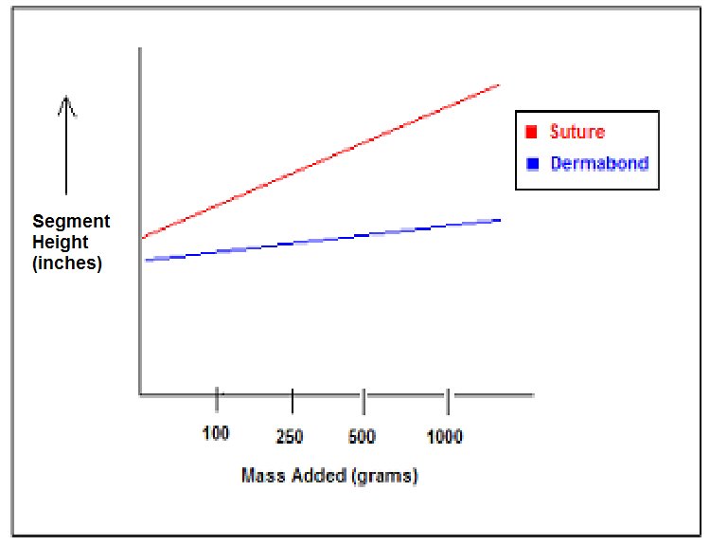

Figure 1. Anticipated Average Height of the Middle Section v. Applied Mass. The slope of the best-fit-line corresponding to the Pulley suture data is expected to be greater than the slope corresponding to the Dermabond data, indicating greater maximal vertical deformation in the middle section of the Pulley suture samples.

BioBrane is a manufactured material and is therefore expected to be uniform within a sample as well as across all eight samples. The height measurements of segment #3 of each sample are considered to be indicative of the deformation occurring in the BioBrane material itself as the sample is subjected to uniaxial tension. The maximal deformation values from segment #3 are expected to be negligible in comparison to the maximal deformation values measured in the middle sections of the samples. The segment #3 deformation values will be considered negligible if they differ from the middle section deformation values by greater than two magnitudes difference. The vertical deformation in the middle section is expected to be indicative of the amount of gap separation due only to the connective method used.

F. Potential Pitfalls and Alternative Methods

In the previously preformed Experiment #5, the interwoven material used for the samples experienced negligible deformation in comparison to the vertical deformation measured in the middle sections of the samples. The deformation the middle section was therefore attributed primarily to the separation of the sutures and not to the stretching of the material. The BioBrane material to be used in this experiment would also need to experience negligible vertical deformation in order for the relative performance of the two connective methods to be compared.

The BioBrane may in fact experience significant vertical deformation as increasing mass is applied to the suspended samples. The deformation in the middle section could not then be attributed solely to the connective method but also to the BioBrane material. The maximal vertical deformation in the BioBrane (as determined by segment #3 measurements) could exceed that of the connective method (as determined by the middle section measurements) in which case the relative performance of the connective methods could not be determined. It is also possible that the BioBrane will tear under the applied load before any measurements can be recorded, as the maximum quasi-static stress that can be endured by the BioBrane is unknown.

Dermabond is currently used on natural human skin. The BioBrane material used in this experiment is expected to act as a substitute for human skin but it is unknown whether the Dermabond or Pulley suture will be effective at holding the separated BioBrane together. While it is expected that the Dermabond will adhere to the BioBrane and will be strong enough to hold it together, it is a possible that the two substances will be incompatible. There is also a chance that the Pulley sutures will tear through the BioBrane and fail to reconnect the separated sample. Finally, it is also possible that the BioBrane will not be held in place by the clamps for the duration of the experiment, resulting in difficulty when measuring the segment heights.

The white interwoven material used in Experiment #5 could be used in place of the BioBrane in an attempt to eliminate the pitfalls of the BioBrane described above. The interwoven material is known to minimally deform and to be effectively held in place by the clamps. If the Dermabond does not adhere to the white interwoven material, an alternative, over-the-counter adhesive could be substituted for Dermabond. While the glue may not be used as a connective method in medical practice, it is similar to the Dermabond in that it reconnects the sample in a continuous adhesive layer. The relative connective performance of an intermittent suture versus a continuous adhesive under quasi-static tension could be tested using the alternative adhesive.

G. Budget

A BioBrane box contains five 5” x 5” sheets. Each sheet can be cut as shown in Figure 2 below to provide twelve 7/8” x 2” samples. A total of 60 samples can be made from one box of BioBrane (5 sheets times 12 samples/sheet). A total of 160 samples would be needed for 20 groups to perform the experiment (20 groups times 8 samples/group). Therefore, 3 boxes of BioBrane would be needed for a semester (160 samples times 1 box/60 samples).
2”
2”
2”
2”
7/8”
5”
5”
1
6
11
12
4
2
5
7
8
9
10
3
7/8”
7/8”
7/8”
7/8”
7/8”

Figure 2. One 5”x5” BioBrane sheet. Twelve samples can be obtained from one sheet. All dimensions are in inches.

The total cost of purchasing new materials for one semester is $781.95 which is well under the budget constraint of $2,000 (see Table 1 below).

Item | Website | Individual Price | Quantity | Final Price
BioBrane Box of 5 | www.allegromedical.com | $245.00 | 3 | $735.00
Dermabond | www.chinookmed.com | $46.95 | 1 | $46.95
 | Total |  |  | $781.95
Table 1. Anticipated Quantity and Prices of New Materials. Prices do not included possible taxes and shipping charges. Both products are readily available from the respective websites. BioBrane is manufactured by UDL Laboratories Inc. and is a registered trademark of Bertek Pharmaceuticals. Dermabond is manufactured by ETHICON Inc.

BioBrane is expected to act as a substitute for human skin while its innate uniformity will lessen variations between samples. Dermabond is to be used to reconnect one half of the BioBrane samples and its connective ability will be compared to that of the Pulley stitches. Both BioBrane and Dermabond can easily be stored at room temperature and no extra precautionary measures are necessary.
H. Appendix

Figure A1. Average Height of Middle Section v. Applied Mass from Experiment #5. Average height values calculated using the 4 samples corresponding to each type of suture. Larger slope of the best-fit-line for the Vertical Mattress Stitch (7E-5 in/g) as compared to the Pulley Stitch (4E-5 in/g) suggests greater vertical deformation in the Vertical Mattress Stitch.

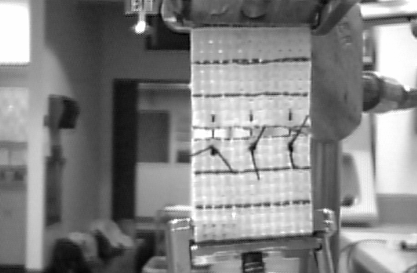
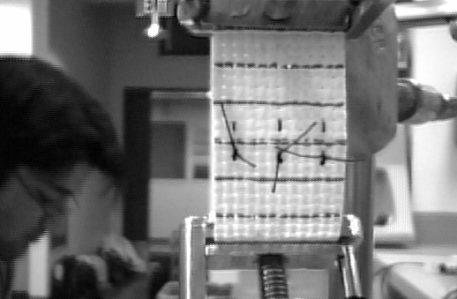
middle
section
segment 3

Figure A2. Images of undeformed (a) and maximally deformed (b) Vertical Mattress sample. Note the position of the middle section and segment #3.

