Electrophoresis Protein Detection & Instron Tensile Testing:
The Reinforcing Properties of Myosin in Muscle
BE 210
Victoria Grace Behrend
April 24th, 2007

A. Background:
Actin and myosin are the main reinforcing proteins in the sarcomeres of skeletal and cardiac muscle and also enable both involuntary and voluntary muscle contraction. In skeletal muscle thin actin filaments are evenly spaced between a hexagonal lattice of myosin II thick filaments, whereas in cardiac muscle the alteration of thick and thin filament segments results in cross-striation. When the myosin II heads bind and hydrolyze ATP, it results in the ATP-driven sliding of actin and myosin filaments past one another that causes muscle contraction. (References:1) It has been shown not only that the force a muscle can exert when contracted is a result of the interactions of dynamic actin-myosin networks (References:2), but also, that the concentration of myosin in a muscle cell is directly related to the force the muscle can exert when contracted (References:3). Given that compression and tension are related quantities, this experiment aims to determine if higher concentrations of myosin in muscle contributes to greater tensile strength of the muscle. To test this question, this experiment will combine methods from the Muscle Protein Detection Using Electrophoresis experiment (References:4) and the Instron Tensile Testing experiment (References:5). Five samples of skeletal muscle and five samples of cardiac muscle from the same pig will be provided to each group. The group should then take each sample and cut it in half. Using gel electrophoresis and Matlab techniques, the concentration of myosin present in one half of each sample will be determined. Then, the Instron will be used on the second half of the all of the samples to determine their Elastic moduli. In order to properly grip the tissue samples and to ensure consistent breakage, fine serrated jaw face inserts will need to be purchased for the Instron 4444 machine. The results from Group #5’s electrophoresis experiment show that the concentration of myosin in skeletal muscle is significantly greater than that in cardiac muscle, while the concentrations of actin in both types of muscle are not significantly different (Appendix:3). Based on this information and the knowledge that muscle force, and thus strength, is directly related to the concentration of myosin present in muscle cells, it is hypothesized that porcine skeletal muscle will have a higher elastic modulus (one-tail p-value<0.05) than that of the porcine cardiac muscle as related to a higher myosin concentration. If this hypothesis is confirmed, it may imply that myosin is the primary protein in determining the tensile strength of skeletal and cardiac porcine muscle. This could also lead to significant real-world applications such as more myosin-like filaments being engineered into muscle tissue grafts to help surgically repair bad skeletal or cardiac muscle tears in humans.

B. Hypothesis/Objectives and Aim(s):
I. SPECIFIC AIMS/GOALS:
The goal of this experiment is to use both gel electrophoresis image analysis and deformation techniques to correlate the concentration of myosin present in muscle with its tensile strength. Two tissue samples will be analyzed: 1. Porcine Skeletal Muscle 2. Porcine Cardiac Muscle. The tissue samples will be cut in half so that half of the samples can be used for gel electrophoresis analysis and their corresponding halves can be deformed using the Instron 4444 machine to determine the Elastic moduli of the tissue samples. Additionally, all tissue samples will be taken from the same pig. These two steps will introduce fewer variables into the experiment. To calculate the amount of myosin present in each muscle sample, molecular sizes of the bands will be determined based on the size of the known standard as well as through the use of the Matlab algorithm. Using specific loading protocols, the halves of the muscle samples will also be placed into the Instron 4444 machine and the applied forces and deformations of the samples will be recorded until they rupture. At this point, the elastic moduli of the two different tissue samples will be calculated, as the forces and the deformations will be known.
Specific aims that will be carried out in order to accomplish the objective:
- Dye the gel to better visualize the travel distance of the proteins.
- Identify myosin bands of each muscle type on the gel.
- Quantify the concentrations of myosin present in porcine skeletal muscle and cardiac muscle.
- Quantify and compare the elastic modulus of the porcine skeletal muscle to the elastic modulus of the porcine cardiac muscle.
II. QUANTITATIVE HYPOTHESES:
Based on the knowledge that:
- Myosin concentration in a muscle cell is directly related to the force the muscle can exert when contracted and thus the strength of the muscle (References:3)
- There is a significantly higher concentration of myosin in porcine skeletal muscle than in porcine cardiac muscle, and there are not significantly different concentrations of actin present in either type of muscle (Appendix:3),
It is hypothesized that:
I. The slope of a linear regression between concentration of myosin and elastic modulus of the porcine skeletal muscle sample will be statistically significantly greater (one-tailed p-value<0.05) than that of the porcine cardiac muscle sample.

C. Equipment:
I. Major Equipment:
- Instron Model 4444 benchtop materials testing machine, to test the tensile strength of the porcine skeletal and cardiac muscle
- BioRad Mini Protean II & III Cell Electrophoresis System, to run the gel and determine the concentration of myosin present in the porcine cardiac and skeletal muscle samples
- Power Supply (BioRad PowerPac Basic & 300), to supply the voltage to run the samples on the gel
II. Lab Equipment:
- 4-15% ReadyGel Polyacrylamide gel, to run the samples on
- SDS buffer, undiluted, to make the buffer solution for the gel to run in
- Distilled water, to make the buffer solution for the gel to run in
- Loading buffer, to mix with the muscle samples for loading
- 1.5 ml microfuge tubes with DTT, to denature the proteins in the samples and enable them to
run through the meshwork of the gel
- 1.5 ml microfuge tubes, to pipette the liquid from the denatured muscle samples into so that
they can be made into samples to run in the gel
- SDS-Page Molecular Weight Standards, to be able to estimate the molecular band size of the
proteins in the muscle samples
- Coomassie Blue Stain, to bind to the protein bands and stain them
- Destain solution, to heighten the color difference between the stained gel and stained protein
bands
- Heating block, to help denature the proteins
- Plastic container, to dispose of pipette tips and other waste
- Pippettes and tips (regular and gel-loading), to insert sample into the gel
- Gloves, to avoid skin contamination
- Scalpel, scissors, and cutting board, to properly cut the samples and to open the gel for use
- Length measuring instruments: calipers & rulers, to have accurate sample measurements
- Weight set (500 g, 1 kg, 2 kg), to calibrate the load cell transducer of the Instron 4444
- Safety glasses, to protect your eyes from flying particles during specimen breakage
- Wet paper towels, to keep the muscle specimens moist between performing gel electrophoresis
and Instron tensile tests
III. Supplies & Newly Purchased Equipment:
4 porcine cardiac muscle samples and 4 porcine skeletal muscle samples, provided from purchased hearts and chops
Fine serrated jaw faces for flat specimens (0-6.4 mm in thickness) Instron catalog #: 2703-006

The fine serrated jaw faces are necessary in order to properly grip very moist and elastic muscle samples and to ensure consistent rupture points in the middle of the samples, as opposed to breaking at the clamps. In theory, sand paper could also be stuck into the clamps that are currently on the Instron 4444 machine; however, while the sand paper may grip the samples better than just the clamps that are currently on the machine, they would nowhere approach the gripping capability of the 25 teeth/inch jaw clamps and could not ensure as consistent breakage. Porcine cardiac and skeletal muscle samples will be used because they are the cheapest muscle samples that can be bought and are the most accessible, comparable only to chicken muscle samples.
D. Proposed Methods and Analysis:
I. PROPOSED METHODS:
Gel Electrophoresis: Part 1 (2 hours)
I. Buffer Solution:
Refer to Lab Manual (References:4)
II. Sample Preparation:
1. Upon receiving the eight muscle samples (four porcine skeletal and four porcine cardiac) cut away from each sample a 50 mm x 25 mm piece to be used for the Instron. Try to make each of these samples 3.5 mm in thickness. Use a ruler and caliper to respectively confirm such measurements. Record the length, width, and thickness of each of these samples. Store those pieces in wet paper towels, and use the remaining samples for myosin detection using gel electrophoresis. For these remaining samples, make sure to add a consistent amount of tissue for each sample to the loading buffer.
2. Refer to Lab Manual (References:4)
III. Electrophoresis Gel and Device Setup:
Refer to Lab Manual (References:4)
IV. Sample Loading:
Refer to Lab Manual (References:4)
*Make sure to add 25 ul of each of the eight cardiac and skeletal samples as well as 10 ul of ladder.
V. Running the Gel:
Refer to Lab Manual (References:4)
*Instead of turning the power supply of the machine to 100 V, set it to 80 V to allow it to run for one hour instead of about forty minutes, providing more time for the next part of the experiment.

Instron Tensile Testing (1-2hours, done during waiting periods of Gel Electrophoresis)
I. Instron Set-Up:
1. While the gel is running, bring the 8 50 mm x 25 mm samples to the Instron 4444 machine. Calibrate the load cell transducer by following step 2 of the Instron Set-Up and Surrogate Tensile Testing from the Lab Manual (References:4)
2. For each sample, make sure to specify a loading rate on the Instron 4444 of 10 mm/min and a sampling rate of 10 samples/second. These rates should help lead to the production of very smooth stress vs. strain curves.
II. Instron Specimen Tensile Testing:
Refer to Lab Manual (References:4)
*Make sure to have the same no load geometry for all specimens, which should be about 25 mm of sample (in length) between the two clamps.
*May only have time to run four of the samples (i.e. cardiac or skeletal) while the electrophoresis gel runs. Make sure to watch your time and to disconnect the gel box from the power supply after an hour when the blue line of dye has just run off the gel into the solution. The remaining four muscle samples can be run in the Instron during the gel staining and destaining processes. While working with the gel make sure to keep the Instron muscle samples in wet paper towels!

Gel Electrophoresis: Part 2 (2 ½ hours)
VI. Staining:
Refer to Lab Manual (References:4)
VII. Destaining:
Refer to Lab Manual (References:4)
VIII. Imaging:
Refer to Lab Manual (References:4)

Total time spent in lab: 4 ½ hours
II. PROPOSED ANALYSIS:
Identify the bands of myosin in the gel by comparing against the size of the known standard. Use the Matlab algorithm to quantify the pixel values and then concentrations of myosin in each band on the gel for each skeletal and cardiac sample. To determine the Elastic moduli of the samples, first determine the stress and strain of each sample: 1. To determine stress, use the formula Stress = F/A, where F is the force (psi) output by the Instron and A is the cross-sectional area of each sample, being sample thickness x sample width. 2. To determine strain, use the formula Strain = deformation/gage length, where deformation (in) is output by the Instron and gage length is the original length of the sample. Make sure to convert all mm values to inches. Then, use Matlab to plot a stress vs. strain curve and get the slope of the linear portion of each graph, since the break should be a linear elastic one, using data cursor to specify the interval values of the linear portions and polyfit methods to get the elastic moduli. Again, since the break should be a linear elastic one, when plotting concentration of myosin for each sample versus its elastic modulus, a linear regression should be run. Take the slopes from these regressions and separate them into cardiac and skeletal groups (two groups of four values). Then, run a t-test between these two groups, making the skeletal muscle Group 1 and the cardiac muscle Group 2. If the one-tailed p-value is less than 0.05, the hypothesis is confirmed and porcine skeletal muscle has a significantly greater elastic modulus than porcine cardiac muscle, which can most likely be attributed to a significantly higher concentration of myosin.

E. Potential Pitfalls and Alternative Methods/Analysis:

If the hypothesis is not proven, either myosin could be shown to not be the main contributing protein to tensile strength of a muscle, rather some component of the extracellular matrix of muscle cells such as collagen, or it could be shown that the strength of a muscle and the force it can exert when contracted is not related to the tensile strength of the muscle, or the results could be attributed to experimental and analytical error. For example, in the meat packing industry, often animals are fed to levels of morbid obesity and thus are not able to move much and exercise. Depending on how the pigs were raised, this could skew the data in terms of determining the elastic moduli of the skeletal versus cardiac muscle.

Additionally, there are several potential pitfalls for the gel electrophoresis part of the experiment. For example, during image analysis, the ROI’s, thresholds, and pixel values may contain visual experimental error based on the discretion of the person analyzing the gel because it is often difficult to discern between background color of the dyed gel and the dyed protein band. Additionally, while myosin concentration should be roughly the same in all of the skeletal samples and in all of the cardiac samples, its concentration in samples and also how dark the dyed protein band is is dependent on the amount of tissue mixed with the 250 ul of loading buffer. It is therefore important to make sure that the same volume of muscle sample across all of the skeletal and cardiac samples is added to the buffer. Fluctuations influence band expression as well as Matlab analysis, which is dependent on the darkness of the bands. It is therefore important to make sure that a consistent amount of tissue is added to the buffer.

There are also several potential pitfalls for the Instron part of the experiment. For example, there could be ocular error in placing the Data Cursor in Matlab to determine the linear interval over which to perform the polyfit regression to determine the elastic moduli of the stress vs. strain curves. In order to completely avoid this, one could instead use Hooke’s law and the average stress and strain values to get the average elastic moduli for each tissue sample. However, since there could potentially be a large spread of stress and strain values, the polyfit regression method even using Data Cursor may be more accurate than finding average elastic moduli since the regression method more directly takes all specified points into account.

F. Budget:

Three major items will need to be purchased for this experiment, resulting in a total expenditure of $1598.00. Please refer to Figure 1 below:

Equipment and Supplies to Purchase
Item Needed | Supplier | Equipment Specifications | Cost
Fine serrated jaw faces for flat specimens | Instron Industrial Products, Grove City, PA 16127 | Diamond serrated surface, 25 teeth per inch, accommodates specimens 0-6.4 mm in thickness, accessory width: 25mm, accessory height: 57 mm. Adapts to an Instron 4444 500 N load cell, which is already in lab. Catalog number: 2703-006 | $1,570
Four pig hearts | Local butcher at the Reading Market, Philadelphia, PA 19104 | Hearts and corresponding chops must be from the same pig | $16
Four pork chops | Local butcher at the Reading Market, Philadelphia, PA 19104 | Hearts and corresponding chops must be from the same pig | $12
Total |  |  | $1,598

Figure 1. This figure details all of the necessary purchases to be made for this experiment. The fine serrated jaw faces are especially useful for gripping slippery muscle tissue samples and ensuring consistent rupture points in the Instron 4444 machine. One heart and one pork chop are enough to provide four samples of skeletal muscle tissue and four samples of cardiac muscle tissue for each of five laboratory groups; thus four hearts and four chops are necessary to provide four samples of each muscle type for all of the twenty lab groups. It is also important to note that the hearts and chops from each pig must be carefully catalogued as to ensure that the skeletal muscle and cardiac muscle samples are all coming from the same pig for each laboratory group in order to eliminate variables such as different pigs’ ages, diets, exercise regimens, diseases, genetic dispositions, etc.

G. Appendix:

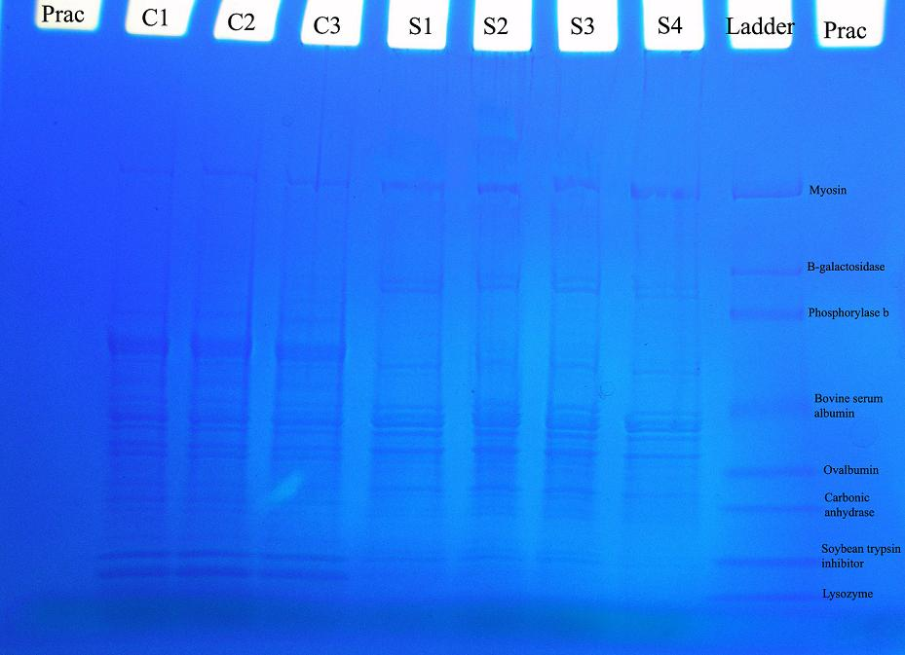

20 ul 25ul 25ul 25ul 25ul 25ul 25ul 25ul 10ul ul
Appendix: 1. Digital image of Group 5’s electrophoresis gel analyzing cardiac and skeletal muscle tissue samples. Image analysis of electrophoresis gel was conducted by MATLAB. The image was taken using an Olympus SP310. The volumes of sample used are indicated at the top of each well, where “C” indicates cardiac muscle and “S” indicates skeletal muscle. The location of the myosin protein in the gel is indicated by the bands encompassed by the large white rectangle at the top of the image as well as the label “Myosin” on the side of the gel.
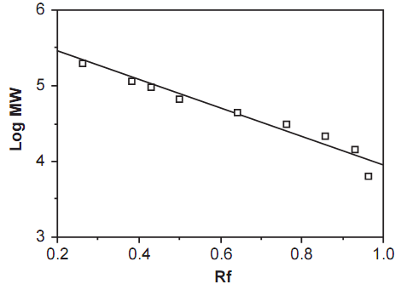
Appendix: 2. This curve was generated by Group 5 by plotting the log of the molecular weights of the standards versus the relative mobility of the proteins in the gel. Using this plot in conjunction with the formula: R_{f}= d_{protein}/d_{dye} (References:4) the position of each actin band was determined so that the pixel value and thus concentration of actin present could be quantified.
 | MYOSIN |  | ACTIN
Type | Skeletal | Cardiac | Skeletal | Cardiac
Mean PV | 4.710833 | 2.244633 | 2.2817 | 2.297867
SD PV | 2.8153 | 1.4716 | 1.417482 | 1.473833
Appendix: 3. This figure was created by Group 5, containing the average pixel intensity values (PV) for actin and myosin protein bands. Since higher pixel values can be related to higher concentrations present, the data indicates that there is more myosin in porcine skeletal muscle as compared to porcine cardiac muscle, with a one-tailed p-value of less than 0.05 (p=0.005, n=3) and respective myosin concentrations of 4.71 M ± 2.82 M and 2.24 M ± 1.47 M. Additionally, the data indicates that there is no significant difference in the amount of actin present in porcine skeletal and cardiac muscle, with a p-value of greater than 0.05 (p=0.44) and respective actin concentrations of 2.28 M ± 1.42 M and 2.29 M ± 1.47 M.
References:

- Alberts B., Johnson A., Lewis J., Raff M., Roberts K., & Walter P. Molecular Biology of The Cell, Fourth Edition, Chapter 16. Garland Science: 4th Edition. New York, NY, 2002.

- Muscle force emerges from dynamic actin-myosin networks, not from independent force generators. Baker J.E., Cooke R., Karatzaferi C. Am J Physiol 284:1678-1679, 2003. http://ajpcell.physiology.org/cgi/content/full/284/6/C1678.

- Widmaier E.P., Raff H., Strang K.T. Vander’s Human Physiology, The Mechanisms of Body Function, Tenth Edition, Chapter 9. McGraw Hill:10th Edition. New York, NY, 2006.

- Winkelstein, B.A. BE 210 Bioengineering Laboratory II, Laboratory Handout, Spring 2007: Experiment #1, Muscle Protein Detection Using Electrophoresis.

- Winkelstein, B.A. BE 210 Bioengineering Laboratory II, Laboratory Handout, Spring 2007: Experiment #3, Instron Tensile Testing: Structural & Material Properties of Chicken Skin.

