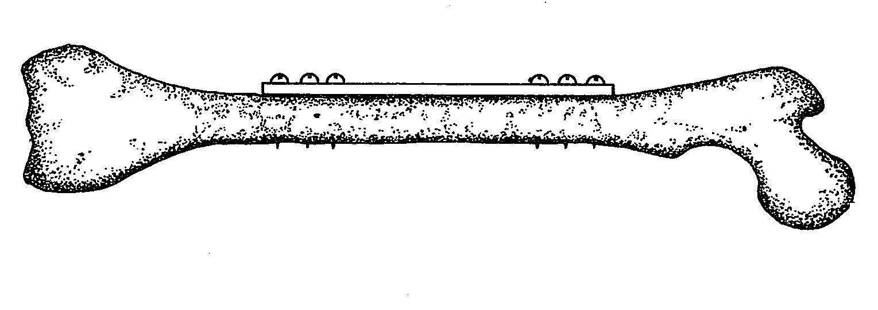
Failure Properties of Chicken Bone Under Varying Fixation Conditions
Kenny Chan
BE210
April 25, 2007

Background
Bone fixation with metal bone pins or screws is a relatively common procedure for securing fractured bones in place while they fuse back together. The goal is to limit movement to allow proper healing (Woo, et. al), and so this experiment will test the yield force of fixated chicken leg bones with different screws amounts. In practice, the number of screws used to set a fracture depends on the specific physician or fixation plate used. It is sometimes suggested that at least four screws be used to prevent moment-induced fracture separation from rotational movement of the bone (Lower). Some previous studies have tested the effects of screw configuration on the strength of fixated bone (Selvan, et. al), but few test the effect of varying the number of screws used in fixation.
This experiment expands on Experiment #4, which tested properties of chicken bones such as failure strength and elasticity using three-point testing. It was possible to calculate stress in Experiment #4 because physical measurements (i.e. the dimensions) of the bone could be obtained. However, when testing a fixated bone, complex interactions arise between the plate, screws, and bone. For instance, the pull-out and toggle (or compressive) force experienced by the bone screws (see Appendix, Figure 1) is hard to calculate, as is the area being acted upon by the metal plate. Since the concern with bone fixation is the ability to support a bone in place, though, the ultimate load (the maximum force experienced during testing) will be considered a sufficient property to analyze. Previous literature on the subject of testing bone fixation methods supports the use of force-displacement data and ultimate load as an appropriate measure (An 40, Selvan, et. al).

Objective
The aim of this experiment is to see whether the number of screws used in bone fixation affects the ultimate load of fixated chicken bone. It is hypothesized that chicken bone fixated with four screws will have a higher ultimate force than with two screws.
Chicken bones will be kept intact and not be fractured prior to fixation to simulate the situation where bones already well into the healing process are exerted. This is more realistic than fracturing the bones beforehand because fracture patients are often immobilized for a significant amount of time after bone fixation, allowing partial healing to occur. It is also indicative of the importance of stabilizing bones long after fixation because the original fracture site is still fragile for a few months afterwards (Woo, et. al)

Equipment
Major equipment:
- Instron model 4444 attached to a PC to test the fixated chicken bones and record the force-displacement data for later analysis.
Lab equipment:
- Metric calipers and ruler to measure the chicken bone and determine the proper placement of the fixation plate.
- Scissors and knives for cleaning the chicken legs of any flesh
- Cutting board for cleaning the chicken legs of any flesh
- 2 Sharpie permanent markers to mark screw sites on the chicken bone
Supplies (Based on 20 lab groups, see Budget for quantity calculations):
- 200 (1.5”x3/16”x0.1875”) stainless steel plates with four holes drilled along the length, cut from 12.5’ of stainless steel bars, to serve as fixation plates (see Appendix, Figure 2 for detail)
- 600 wood screws, #2 thread size, 1/4”, #1 Phillips head (McMaster-Carr P/N: 98685A220) for screwing bone fixation plates in place. This screw length is based on the measurements of the chicken bones used in Experiment 4, which had a mean minor axis width of 0.289” and a mean major axis width of 0.342”.
- 120 Chicken legs to be cleaned and for the bone to be tested
- 1 Small scrap wooden block to put underneath the chicken bone while drilling so that the drill bit does not come out of the other side of the bone and damage lab surfaces
Newly-purchased equipment:
- 2 #1 Tip Phillips head screwdrivers to fix the screws in place.
- 1 Corded power drill for making pilot holes in the chicken bone to prevent them from cracking when the screws are screwed in.
- 1 3/64” diameter drill bit to make appropriately-sized pilot holes. This sized is based on the recommended drill size for the found in the McMaster-Carr specifications for the screws found in the Appendix
- 2 small adjustable C-clamps to hold the chicken bones in place while drilling holes.
Note: These unique newly-purchased supplies and equipment do not have to be used, just ones of similar specifications. They must be purchased apart from what is available for other experiments because no other supplies or equipment in the lab are suitable for this experiment.

Proposed Methods and Analysis
Sample groups: 6 chicken bones per lab group, split up into ones using four screws for fixation (n=3) and two screws for fixation (n=3).

Basic setup: Refer to laboratory manual to clean and prepare the chicken bones for testing. Set up and calibrate Instron based on laboratory manual instructions. (Estimated time: 30 min)

Bone fixation: Measure the chicken bones to find the midpoint of their length. Mark this point and align it with the midpoint of the steel plates. Place the steel plates on the widest, flattest portion of the bone to facilitate bone fixation. Mark the position of the holes in the plate. Place the marked bone on the wooden block and put both on a lab counter. Secure the bone and wood to the counter with the C-clamps. Use the power drill to make pilot holes in the bone, whose number depends on how many screws are to be used on the specific chicken bone (i.e. four holes for four screws). Drill all the way through the bone to allow the entire screw to penetrate. Gently screw the fixation plate into the bone using the screwdriver and provided screws. Tighten screws until the plate is flush with the bone, but do not exert any additional force to prevent cracking the bone. (Estimated time: 90min-120min)

Testing: Position the bone on the three-point bending adapter of the Instron device according to Figure 2 in the Appendix. That is, place the plate in the dorsal direction (face-up). Follow laboratory manual instructions to test the bones, using a loading rate under 10mm/min, which is consistent with prior bone fixation studies (Selvan). Record and save force-displacement data. (Estimated time: 60min-90min)

Data analysis: The goal is to test the ultimate load of the fixated bones. Determine the ultimate load of each of the specimens from the force-displacement data using a consistent method. One way to ensure consistency is to use a MatLab algorithm that goes through every point and finds the one with the highest force. This is the ultimate load.
To statistically test the hypothesis that the use of four screws in bone fixation will result in a higher ultimate force that the use of two screws, run a one-tailed unpaired t-test with the following null and alternative hypotheses:
H₀: μ_{F-ult, 4 screws} = μ_{F-ult, 2 screws}
H_{a}: μ_{F-ult, 4 screws} > μ_{F-ult, 2 screws.}
Use p=0.05 as the significance level for rejecting the null hypothesis. Analyze the implications of using two versus four screws in fixation, focusing on possible rotational motion of the bone under loads and how this could affect results (it may be useful to qualitatively note this during testing). Describe any sources of error in the experiment.

Potential pitfalls/Alternative methods
The major issue with this experiment will be the interaction between the plate, screws, and bone. As mentioned in the Background, there are several factors that could affect a bone’s ability to bear loads. The expectation, based on the literature, is that bone rotation may be an influential factor when comparing the effect of the number of screws. Since the bone is not fractured prior to testing in this experiment, there are a couple of possible failure situations, keeping in mind that force will initially be applied onto the steel plate and the two extremities of the bone (see Appendix, Figure 2). Situation 1: Breakage at the bone extremities from either or both of the lower Instron struts. Situation 2: Breakage near the center of the bone. Situation 1 is unfavorable because it will not be measuring the ultimate force at the supposed fracture site (as mentioned in Objectives, the experiment is designed to simulate bone fixation far into or after the healing process is complete). A longer metal plate may help prevent Situation 1 from happening by reinforcing a longer portion of the bone. However, chicken bones naturally vary in length, so it is difficult to predict the length of metal required.
Even with Situation 2, there is the chance that ultimate force will not capture the reinforcing effect of the fixation plate and, more importantly for the hypothesis, the number of screws on the chicken bone. For instance, if the bone fails during testing, then the steel plate is still being loaded, which could result in a second elastic region of the force-displacement diagram or a higher ultimate force than what is actually experienced by the chicken bone by itself. Therefore, a different measure of failure could be used that might better gauge the effects of the fixation. It might be preferable to measure the load at the limit of proportionality, which would indicate the point at which the bone starts to fracture and bend beyond its elastic deformation region. In a medical context, it would actually be more useful to know at what point a bone will begin to re-fracture. The load at the limit of proportionality could then be statistically tested to determine the effects of varying numbers of screws.
Other problems might occur in the fixation of the bone, especially if special care is not taken in drilling holes and screwing in the screws. Too much torque applied while putting in the screws can splinter the bone or compromise its structural integrity (Weigle, et. al). This would affect the results by lowering the ultimate force of the fixated bones. To minimize this error, it is important that the bones are clamped securely in place while the fixation is performed.
The natural difference in bone length, thickness, and width (and thus the moment of inertia of the bone) will be a source of variation in the results; i.e. thicker bones will be stronger. While it was possible to account for this in Experiment 4 by calculating strength (as opposed to stress), there are too many interactions between the bone and fixation assembly to accurately calculate the stress exerted on the midsection of the bone. Stress occurs at various sites, as described in the Background. There is no way to accurately measure the total stress on the bone, so ultimate force will have to suffice. Natural deviations in bone dimensions will ideally not obscure the results; this could be the case if the effect of screw amount is significant enough.
Lastly, axial loading might better mimic the natural loading of femurs or other leg bones. Screw number would become even more important, with compressive force in the vertical direction adding more of the load directly onto the screws (An 40).

Budget:
Note: the total cost factors in the quantity, it is the unit cost times the quantity in parentheses
Total Cost: | Description (Quantity): | Part/Model Number: | Supplier
$69.97 | Ryobi 18V Corded Power Drill (1) | P230 | Home Depot
$9.54 | 3” Opening, 2” Deep light-duty C-clamp (2) | 1430-K | Home Depot
$0.00 | Scrap wood block about 12”x6” (1) | - | MEAM shop
$7.74 | #1 Phillips Screwdrivers (2) | 5682A45 | McMaster-Carr
$2.33 | 3/64” Diameter Multi-purpose drill bit (1) | 29315A115 | McMaster-Carr
$18.20 | #2 thread, ¼” long, #1 Phillips head, brass wood screws (500) – see Appendix for specifications | 98685A220 | McMaster-Carr
$48.63 | 1.5”x3/16”x0.1875” stainless steel bars (18’) – see Appendix for specifications | 8986K41 | McMaster-Carr
$250.00 (quoted price) | Machining of metal into 120 1.5” segments and drilling of 4 holes in each (see Appendix, Figure 2) | N/A - Labor | Monarch Hardware
$49.50 | Chicken legs (120) | - | Fresh Grocer
$455.91 | Total

Quantity calculations:
500 screws: (20 groups)*(6 legs)*(4 screws) = 480 screws, but sold in 100s
18’ of SS bar: (20 groups)*(6 legs)*(1.5”)=180”=15’, but sold in 6’ sections
120 Chicken legs: (20 groups)*(6 legs) = 120 legs @ $3.30/pack of 8 legs ($0.89/lb)

Appendix
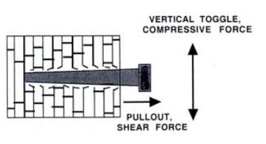
Figure 2. Experimental setup of fixated bone with load vectors shown (not to scale)
Figure 1. Forces exerted on the fixation screws and screw sites (adapted from An)

Supply specifications:

The SS fixation plates will be machined with four holes for the screws, at a diameter of 0.09” to accommodate the screw diameter with a small amount of leeway:
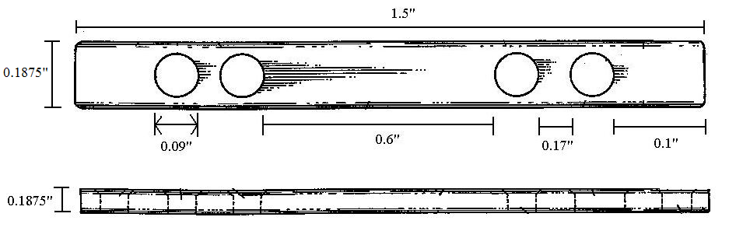
Figure 2. Not drawn to scale. Drawing adapted from Woo, et. al

References
An, Yuhuei H., Ed. Internal Fixation In Osteroporotic Bone. 1st. Thieme Medical Publishers, Inc., 2002

Lower, Jerry L. “Bone fixation plate.” US Patent 4,573,458. 4 Mar. 1986.

Selvan, V. T., Oakley, M. J., Rangan, A., and M. L. Al-Lami. “Optimum configuration of cannulated hop screws for the fixation of intrascapsular hip fractures: a biomechanical study.” Injury. 35(2): 136-141.

Weigle, R. M., Duggan, S., Foster, C., Miner, J., Vantucci, J., and M. Woozley. “Drill guide for bone plate fixation.” US Patent 4,502,475. 5 Mar. 1985.

Woo, Savio L-Y. and Wayne H. Akeson. “Compatible internal bone fixation plate.” US Patent 4,403,606. 9 May 1980.

