Effect of Decalcification on the Fracture Energy of Chicken Bone
BE 210
Ryan Goldstein
April 25, 2007
BACKGROUND
Bones are composed of a collagen fiber matrix, which is reinforced and strengthened by hydroxyapatite mineral crystals (Ca₁₀(PO₄)₆(OH)₂). Osteoporosis is a bone disease in which the bone mineral density, primarily consisting of hydroxyapatite, is reduced (by 2.5 standard deviations below peak bone mass, as defined by the World Health Organization). An individual with osteoporosis has weaker bones that are more at risk of fracture. A visual representation of the effect of osteoporosis is shown in Figure 1 in the appendix. It is possible to simulate the effect of osteoporosis on bone by utilizing a decalcification solution in order to reduce bone density by removing a portion of the original hydroxyapatite crystals.

In Experiment 4 (Fracture Properties of Chicken Bones: Bending Testing), it was found that the fracture energy for non-decalcified bone at a deformation rate of 50.8 mm/min is 1.184 ± 0.361 J. Fracture energy is measured by calculating the integral of the force displacement plot from zero force until failure force. This lab expands on Experiment 4. Fracture energy will be measured in the same way as in the previous lab at a constant deformation rate. Plots of force vs. deformation will be generated for both decalcified and non-decalcified bone, and the integral from zero force to failure force will be estimated via the trapezoidal rule (using the trapz() function in Matlab on the raw data, described in Figure 2 in the appendix). The amount of decalcification will be quantified by measuring bone density via water displacement before and after decalcification. A detailed procedure can be found in the Proposed Methods & Analysis section.

HYPOTHESIS/OBJECTIVES AND AIMS
The primary goal of this experiment is to determine the effect of decalcification (reduced bone density) on the fracture energy of chicken bone via a three-point bending test. Additionally, a qualitative relationship will be developed between decalcification and fracture energy (does fracture energy decrease with increased decalcification?). It is hypothesized that the fracture energy of non-decalcified bone will be significantly greater than that of decalcified bone, and that fracture energy will decrease as amount of decalcification increases.

Secondary goals consist of properly obtaining data to be used in calculations in order to derive significant and meaningful results, familiarization with a decalcification technique, and understanding the importance of hydroxyapatite on the material properties of bone.

- Experimental Goals:
  - To determine the effect of decalcification (reduced bone density) on the fracture energy of bone using a three-point bending test.
  - To attempt to develop a qualitative relationship between relative amount of decalcification and fracture energy.

- Educational Goals:
  - To reinforce the process of obtaining data used in calculations to derive significant and meaningful results.
  - To become familiar with a bone decalcification technique.
  - To emphasize the importance of hydroxyapatite mineral crystals in bone strength.
EQUIPMENT
- Major Equipment
  - Instron Model 4444
  - Computer (equipped to obtain force and deformation data from the Instron)
- Lab Equipment
  - Knives
  - Cutting Board
  - Electronic Balance
  - 100 ml Graduated Cylinder
  - Three 1000 ml Beakers
- Supplies
  - Deionized Water
- Newly Purchased Equipment
  - Regular•CalTM Decalcifying Solution
  - 15 Chicken Legs
  - Bone Saw

The Instron and computer will be used to obtain the data used to generate the deformation plots for each bone sample.

The knives and cutting board will be used to prepare the bone samples for testing. The electronic balance and the 100 ml graduated cylinder will be used in calculating the mass and volume change, respectively, before and after decalcification in order to calculate the change in bone density. The beakers will be used to store the bones in either DI H₂O or decalcifying solution before the three-point bending test.

The deionized water will be used in water displacement testing, as well as soaking the non-decalcified bones in order to account for moisture-related changes in fracture energy – keeping the control group as similar as possible to the test groups, except for the changes being analyzed.

The Regular•CalTM decalcifying solution will be used in decalcifying the two bone groups intended to undergo this process. The 15 chicken legs are the test subjects. They will be split into three groups: non-decalcified, slightly decalcified, and very decalcified. The bone saw will assist in cutting off the epiphyses of the bones in order to expose both the outside and the inside of the bone to the decalcifying solution.
PROPOSED METHODS & ANALYSIS
- Solution Preparation (5 min.)
  - Label one 1000 ml beaker as “non-decalcified”, another as “slightly decalcified”, and the other as “very decalcified”.
  - Fill the “non-decalcified” beaker with 500 ml DI H₂O and the other two with 500 ml of Regular•CalTM decalcifying solution.

- Bone Preparation (90 min.)
  - Using the knives and cutting board provided, remove the meat and skin from the 15 bones. (20 min.)
  - Use the bone saw to remove the epiphyses of each bone, leaving approximately 6.5 cm of relatively uniform-diameter bone. (15 min.)
  - Remove the bone marrow by flushing with water and using knives as necessary. (15 min.)
  - Determine the mass of each bone using an electronic balance. (10 min.)
  - Determine the volume of each bone by placing each into the 100 ml graduated cylinder along with DI H₂O and measuring the change in the level of the water. (30 min.)

- Bone Decalcification and Testing (240 min.)
  - Place five bones in each of the three beakers and note the time.
  - Calibrate the Instron as described in the lab manual for experiment 4, ensuring that the two bottom supports are approximately 6 cm apart.
  - After 30 minutes, remove the five bones from the “non-decalcified” beaker, wipe off each bone with paper towels, and load each into the Instron for deformation testing. Ensure that each bone is loaded until fracture.
  - After 90 minutes, remove the five bones from the “slightly decalcified” beaker, wipe off each bone with paper towels, recalculate the density as described above, and then test each bone with the Instron to failure.
  - After 180 minutes, remove the five bones from the “very decalcified” beaker, wipe off each bone with paper towels, recalculate the density as described above, and then test each bone with the Instron to failure.

- Analysis
  - Determine the failure force for each of the 15 trials and use the trapz() function in Matlab to calculate the integral from zero force to the failure force, described in Figure 2 in the appendix. This is the fracture energy.
  - Determine the change in bone density for the two sets of bones that underwent decalcification by subtracting the initial density measurement from the final density measurement. Δdensity should be approximately zero for the non-decalcified group and negative for the two decalcified groups.
  - Perform three unpaired, two-tailed t-tests assuming equal variance on the initial (pre-decalcification) bone densities of the three groups to verify that the bone densities initially are not significantly different (α = 0.05).
  - Perform unpaired, one-tailed t-tests assuming equal variance on the final (post-decalcification) bone densities of the non-decalcified and slightly decalcified groups and on the slightly decalcified and very decalcified groups to verify that the bone densities decrease significantly between the three groups (non-decalcified > slightly decalcified > very decalcified) (α = 0.05).
  - Perform unpaired, one-tailed t-tests assuming equal variance on the fracture energies of the non-decalcified and slightly decalcified groups and on the slightly decalcified and very decalcified groups to determine if the fracture energies decrease significantly as bone densities decrease (α = 0.05).
  - Conclusions:
    - If all resulting p-values are found to be less than 0.05, one can conclude that the fracture energy of non-decalcified bone is significantly greater than that of decalcified bone, and that fracture energy decreases as decalcification increases.
    - If the densities and/or fracture energies of the two decalcified groups are not found to be significantly different, but the densities and fracture energies are both significantly less than that of the non-decalcified bone, it cannot be concluded that increasing decalcification results in decreased fracture energy. However, one can still conclude that decalcified bone has significantly lower fracture energy than non-decalcified bone.
POTENTIAL PITFALLS & ALTERNATIVE METHODS/ANALYSIS
There are several sources of potential concern for this lab. First, the relatively small sample size (n = 5) for each group could prove to be a problem. Various factors that are uncontrollable in this lab, including age, health, and gender of the chicken from which the bone is extracted, will be amplified with a relatively small sample size. Initial bone densities are compared in the analysis (part c) to hopefully verify that the bones are initially not significantly different so as to provide stronger validation of the results (i.e. that they are not resulting from extraneous sources, like environmental factors). A larger sample size would result in more sound statistical analysis and more certainty in stated conclusions; however, due to time constraints, large sample sizes are not feasible.

To be able to yield meaningful results from this lab, there must be a significant difference between each group, as delimited in part d of the analysis. It is suggested that this t-test be performed before the second and third sets of the three-point bending tests. For example, if there is not a significant difference between bone densities of the non-decalcified group and the slightly decalcified group, the slightly decalcified group should be placed back in the decalcifying solution for another 30-60 minutes. Similar logic should be used between the slightly decalcified and very decalcified groups.

An additional potential source of concern is that if too much decalcification occurs, the bone may become rubbery and result in increased and unrealistic fracture energy. The procedure was written to account for this as much as possible. The Regular•CalTM decalcifying solution fully decalcifies bone within 8-10 hours, according to the manufacturer. If the time in solution for the bones does not approach this range, the risk of over-decalcification is small.

The final source of concern is the density measurement. Since calcium generally makes up less than 10% of the total bone mass, the density must be measured very carefully. To minimize error resulting from bone density measurement, care must be taken to ensure that the bones are as dry as possible prior to measuring the mass (by utilizing paper towels and vigorous shaking). Small variations in water content of the bone can drastically change the density measurement. Removing the bone marrow inside the bone before measuring mass and volume is important in standardizing the density measurements. Ultimately, each bone from the same group must be treated nearly identically so as to be able to derive meaningful conclusions from the data.

BUDGET
Item | Quantity | Specifications | Supplier | Total Cost
Regular•CalTM Decalcifying Solution | 20 L | H₂O, 90% CH₂O₂, HCl, selected buffers and ethers | BBC Biochemical  800.635.4477 | $395.00
Chicken Drumsticks – 40 lb box | 300 legs (~250 lbs) | 4.25” to 5.25” long, skin and meat on bone | Fresh Grocer  800.545.7176 | $206.19
TD Industrial 16” Variable Speed Scroll Saw | 2 | 400 to 1600 spm, 120 V | Toolking  800.696.8665 | $267.97
 |  |  | Grand Total | $869.16
REFERENCES
“Image Normal/Osteoporotic Bone.” International Osteoporosis Foundation. 23 Apr. 2007
<http://www.iofbonehealth.org/newsroom/resources/image-normal-osteoporotic-bone.html>
L Knott, C C Whitehead, R H Fleming, and A J Bailey. “Biochemical Changes in the
Collagenous Matrix of Osteoporotic Avian Bone.” Biochem J. 310 pt3 (15 Sept. 1995): 1045-1051. Pubmed. Division of Molecular and Cellular Biology, University of Bristol, U.K. 23 Apr. 2007
Kotha, S P., W R. Walsh, Y Pan, and N Guzelsu. “Varying the Mechanical Properties of Bone
Tissue by Changing the Amount of Its Structurally Effective Bone Mineral Content.” Bio-Medical Materials Engineering 8 (1998): 321-334. Pubmed. ScienceDirect. University of Pennsylvania, Philadelphia. 23 Apr. 2007

APPENDIX
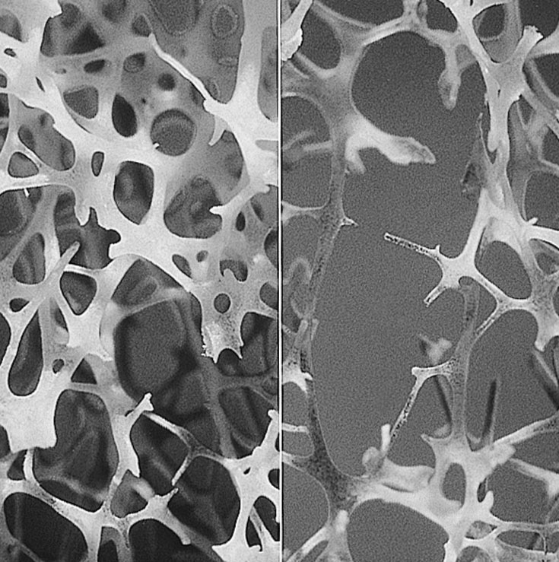
Figure 1: Normal vs. Osteoporotic Bone. The image on the left shows the collagen fiber matrix of a normal bone, and the image on the right shows that of an osteoporotic bone.

fractureEnergy = trapz(displacement,force);
Figure 2: Matlab Command. This command is used to calculate the fracture energy, with the displacement/force data beginning when the load is first applied to the bone and finishing at the displacement which results in bone failure. This function estimates the integral of the force/displacement plot. The resulting value is the fracture energy for that trial, estimated with the trapezoidal rule.

