SNAP-25 PROTEIN ANALYSIS
Benjamin Hsu
April 25, 2007

A. BACKGROUND
Nerve signal transmission relies on nerve cell reception of neurotransmitters, which are secreted by neighboring nerve cells in vesicles called synaptosomes. Both synaptosomes and nerve cells are equipped with membrane proteins, including SNAP-25, which aid in membrane fusion events that are central to neurotransmission events. Oyer et al., Nieman et al., and Solimena et al. have found that SNAP-25 has homological relationships to proteins known to be involved in synaptic events and is selectively cleaved by neurotransmission inhibiting neurotoxins, which suggests their involvement in the membrane fusion and neurotransmission process. The amount of SNAP proteins in two different types of nerve tissues—brain and peripheral nerve—will be the focus of this experiment. In a previous experiment, it was found that heavy chain myosin, a protein central to muscle function, was present in different amounts in cardiac and skeletal muscles. This was attributed to the fact that cardiac and skeletal muscles have inherently different functions in the body. The brain is responsible for the majority of nerve signals sent in the body, from those that control voluntary movements, to those that control breathing, heart rate, and other vital functions. Periphery nerve cells are transmission agents, and therefore do not experience the same duty load as brain neurons do. Because brain tissue and nerve tissue have different functions as well, it may be logical to assume that functional proteins, such as SNAP would be present in different amounts in the two types of tissue. The use of antibodies to selectively bind to SNAP-25 proteins and column chromatography will facilitate the isolation of SNAP-25 proteins, and SDS-PAGE can be used to determine the relative amounts of SNAP-25 present in each tissue sample. This experiment represents an expansion of Experiment 1: Muscle Protein Detection Using Electrophoresis.

B. HYPOTHESIS/OBJECTIVES AND AIMS
The objective of this experiment is to determine whether or not a relationship between the relative amounts of protein found in two different types of functional tissue can be established. More specifically, the purpose is to build off of findings in a previous experiment that showed that heavy chain myosin is present in different amounts in skeletal and cardiac tissue. In that experiment, it was reasoned that the difference in protein presence was due to the fact that the different muscles have different functions. While skeletal muscle cells must be able to sustain lengthier contractions and extended periods of force application, cardiac muscles must be able to produce power in quick bursts that are relatively short compared to what is required of skeletal muscles. Similarly, the brain serves as the functional center of vertebrates. It controls the majority of autonomous events (breathing, blinking, heart beating, digestion), as well as voluntary events (ie: movement). On the other hand, peripheral nerves serve mostly to transmit nerve signals from the brain to the targeted region of the body. Because of the higher demand on the brain’s function, it is logical to assume that more neurotransmission events (which involve SNAP-25) take place in the brain than in nerve cells. As a result, the hypothesis of this experiment is that brain cells will have a significantly greater presence of SNAP-25 than will nerve tissue. The tissues studied in this experiment will be rat brain (cerebellum) tissue and rat sciatic nerve tissue. As part of the experiment, students will learn how to isolate proteins from tissue samples through a series of stages: creating a protein digest from specific tissue samples, protein specific chromatography, and the use of SDS-PAGE.
C. EQUIPMENT
Major Equipment
IgG chromatography columns (2 per group) – The IgG chromatography columns are necessary to purify the SNAP-25 proteins. SNAP-25 proteins will be tagged with specific anti-SNAP-25 monoclonal antibodies. These monoclonal antibodies are of isotype IgG1, which will selectively bind to the beads in the IgG chromatography columns. Once successfully bound, elution solution can be used to wash the SNAP-25 proteins back into solution.

Gel electrophoresis apparatuses (1 per group) – The gel electrophoresis apparatus is necessary to separate SNAP-25 from solution, as SDS-PAGE is the most common and useful method of achieving this end. Also, because the proteins will appear as bands in the gel, gel electrophoresis is necessary to allow quantification of the results, ie: how much protein is present in each tissue sample.

Computer with image analysis software (1 for all) – Image analysis software will be used to quantitatively analyze the amounts of protein present in each sample, as was performed in Lab 1: Muscle Protein Detection Using Gel Electrophoresis.

Lab Equipment
Microfuge tubes (20 per group) – These will serve as containers for the samples.

Pipettes (250 uL, 10 uL) – Because the volumes involved in protein isolation are on the order of 10⁻⁶, it will be necessary to have pipettes that are capable of accurately drawing these volumes.

Beakers (various sizes, as needed; available in lab) – Beakers will be necessary to collect any fluids produced during the course of the experiment, whether they be necessary (ie: SDS mixture) or waste.

Heat block – This is necessary for the protein digestion part of the experiment.

Supplies
Gels for electrophoresis, associated buffer solutions (2 per group) – The gels and buffer solution are necessary for running the SDS-PAGE portion of the experiment.

Coomassie blue and protein digest solution – These are necessary to create the protein digest and staining the gels for image analysis.

(see newly purchased section for necessary supplies)

Newly Purchased Equipment/Supplies
Rat brain tissue and rat sciatic nerve tissue samples – These are necessary as they are the targeted samples of this experiment.

Anti-SNAP-25 and IgG chromatography columns – These are necessary for the purification of SNAP-25 proteins from the tissue sample.

D. PROPOSED METHODS AND ANALYSIS
The proposed methods are similar to those employed in the muscle protein detection experiment, with several key changes.

Protein Digestion and Separation (~ 120 minutes)
In this section, it is important to maintain consistency across the two samples. Volumes of loading buffer and anti-SNAP25 must be the same for the brain and nerve tissue samples. The amount of solution drawn out of the tissue digest must be the same as well. Ensure this by first drawing out 200 uL of tissue digest solution, and extracting 10 uL incrementally until an additional 10 uL cannot be drawn.
- Prepare 1 L of 10% SDS (by volume) solution.
- Samples of rat brain and sciatic nerve of equal mass (0.2 g) will be provided to you in two separate tubes, as will be tubes with DTT. Start the procedure with the rat brain tissue sample, and repeat for the sciatic nerve tissue.
- To each tube, add 250 uL of loading buffer and allow to sit for 5 minutes. Afterwards, pipette all the liquid out into a separate tube. Add 1 uL of anti-SNAP25 antibodies to the solution. Allow to sit for 15 minutes.
- Add 100 uL of DI water to the sample. Prepare two chromatography columns as laid out in the Pierce Protein A/G Manual. Run the entire solution through IgG1 chromatography columns and discard the waste solution. Be sure to use one column for the brain tissue, and the other for the nerve. This step sequesters the SNAP-25 proteins in the column beads and removes the rest of the proteins from solution.
- Wash the chromatography column with an a volume of elution solution (provided with the column) equal to the volume of protein digest you were able to isolate in step 2, to wash out the anti-SNAP-25-SNAP-25 protein complex. This step ensures that the only proteins in the solution used for the remainder of the experiment will be the SNAP-25 proteins from the given tissue sample. Be sure the elution drips into a microfuge tube.

Load two gels into the gel electrophoresis chamber as described in the Protocol for Experiment 1: Muscle Protein Detection Using Electrophoresis. (~ 10 minutes)

Electrophoresis (~ 90 minutes)
For the each tissue, you will need to have 5 lanes. Because the solution from which you will be drawing your samples has already been run through a chromatography column, it is unnecessary to run a standard, because the only protein in the solution will be the anti-SNAP-25-SNAP-25 complex. Should more than one band appear, the lower molecular weight band will be the SNAP-25 antibody, and the higher molecular weight band will be the SNAP-25 protein. Because higher molecular weight proteins travel a smaller distance in the polyacrylamide gel, the SNAP-25 band will be closer to the loading well than will the SNAP-25 antibody band, should it appear at all. Loading procedures should be followed as noted in the Protocol for Experiment 1: Muscle Protein Detection Using Electrophoresis.

- Fill the chamber with the 10% by volume SDS solution until the loading wells are submerged. Be sure that the inner and outer chambers have the same level of SDS solution.
- The first five lanes of the gel should be loaded with the purified SNAP-25 protein in the brain tissue. Load 20 uL of protein in each well.
- The next five lanes of the gel should be loaded with the purified SNAP-25 protein from the nerve tissue. Load 20 uL of protein in each well.
- Place the lid on the chamber and hook the electrodes into the power source. Set the voltage to 110V and press the “Running Man” button to start the electrophoresis. Allow roughly 1 hour for the electrophoresis process.

Proceed with the Stain, Destain, and Imaging as described in the Protocol for Experiment 1: Muscle Protein Detection Using Electrophoresis. (~120 minutes)

Data Analysis and Statistical Tests
The completed gels will approximately resemble the gel shown in Figure A of the Appendix. Use the image analysis program provided on BlackBoard to analyze each band of SNAP-25 protein that appears on the gel. The image analysis will output several numbers, the most important of which is cumulative sum of pixel values, which represents the sum of all the pixel values of pixels above the threshold. A higher value correlates to a greater amount of protein. The analyzed image that the program outputs should resemble the gel shown in Figure B of the Appendix. Note that the image has been converted to grayscale so that pixel values can be easily compared. Calculate mean and standard deviations for the values of each set (brain tissue and sciatic nerve tissue). To test for significance, run a one-tailed unpaired t-test (n=5) assuming (un)equal variances. Should the standard deviation of each set be within15% of its respective mean, assume equal variances. Otherwise, assume unequal variances.

E. POTENTIAL PITFALLS AND ALTERNATIVE METHODS/ANALYSIS
Several major issues that could arise and possibilities to avoid these aberrations are detailed in this section.

Protein bands are not easily visible.
If the protein bands are not easily visible, the image analysis program will produce a very low pixel value, which indicates a very low presence of protein. Because the protein pixels will be nearly as faint as the background gel, the image program will likely mistake some of the background for protein, and some of the protein for background, which will most likely cause the amount of protein detected to be lower than actual values. This may be a reflection of actual protein presence in the tissue, in which case the data stand as they are. In the event that this is experimental error, several steps can be taken to minimize this error. First, it is important to ensure that no concentration gradient forms in the protein solution during the loading process. This can be avoided by using the pipette to pump the protein solution a few times before finally drawing the loading sample, to ensure even distribution of protein throughout the solution. Second, it is important to ensure that the staining process is allowed adequate time to complete. Allow the full 45 minutes prescribed in the protocol, or even more if the bands are not easily visible after that period of time.

Chromatography does not fully drain during draining of the SNAP-25 proteins.
Without full draining of the chromatography solution, it will be impossible to be sure all the necessary proteins have been sequestered. This will cause a very low presence of protein to be detected. To rectify this situation, in the event that there is not full drainage, continue to add elution solution until the original volume of protein solution has moved through the column. However, if this is required for only one of the tissue samples, be sure to add an equal volume of elution solution to the other tissue sample solution. This is necessary to ensure that any significant difference in protein presence is due to actual differences rather than experimentally induced differences (ie: if one protein solution is more dilute than the other, the more dilute solution will necessarily show a lower protein presence regardless of the actual nature of the tissue).

Protein band smears and it is impossible to determine where the SNAP-25 protein band is.
Analyzing the entire band will suggest that there is a much larger amount of protein than there really is. Even though the chromatography step should assure that the only proteins in the loaded solution are SNAP-25 and the anti-SNAP-25, there is distinct possibility that other proteins ended up in the solution. In this case, there are two ways to resolve the issue. First, the lane in which this occurred could be discarded, and one of the sets would have n=4 instead of n=5. Should this occur in multiple lanes, it would be better to use “correct” lanes to estimate the location of the SNAP-25 protein band and analyze that region only. This inherently relies on the assumption that each experimental loaded sample had the same concentration of protein. In order to minimize systematic error, it would be run the analysis on the region of error several times and then taking an average. A low variance in the data would suggest that much of the error has been minimized.

F. BUDGET
(1) 240 mL Protein A/G Binding Buffer – from Pierce (#54200) – Unit price: $33. Total Cost: $33

(1) 1 L Protein A/G Elution Buffer – from Pierce (#21001) – Unit price: $62. Total Cost: $62

(1) Disposable Polystyrene Columns (100 pack) – from Pierce (# 29920) – Unit price: $100. Total Cost: $100

(2) Immobilized Protein A/G – from Pierce (#20421) – Unit price: $299. Two are needed because each of the four columns requires 1 ml while one unit comes with 3 ml. Total Cost: $598

(1) 200 uL Monoclonal Anti-SNAP-25 antibody – from Sigma Aldrich (#S5187) – Unit price: $346. Total Cost: $346

(4) Rat Sciatic Nerve (25 samples, 0.02g each) – from Pel-Freez Biologicals (#56026-2) – Unit Price: $60. Four are necessary because each group needs 0.2 grams to match the starting weight of cerebellum tissue. Total Cost: $240

(1) Rat Cerebellum (20 samples, 0.2 g each) – from Pel-Freez Biologicals (#56008-2) – Unit price: $60. Total Cost: $60

Grand Total: $1439.00
References
Bark, I.C. et al., Journal of Molecular Biology. 233, 67 (1993).

Instructions Immobilized Protein A/G. Pierce Supply.
http://www.piercenet.com/files/0128sd6.pdf, <April 23, 2007>.

Monoclonal Anti-SNAP25 Product Information. Sigma.
http://www.sigmaaldrich.com/sigma/datasheet/s5187dat.pdf, <April 20, 2007>.

Pel-Freez Biologicals Website. http://www.pel-freez.com, <April 23, 2007>.

Sigma-Aldrich Website. http://www.sigmaaldrich.com, <April 21, 2007>.

Walch-Solimena, Christiane et al. “The t-SNAREs Syntaxin 1 and SNAP-25 Are Present on
Organelles That Participate in Synpatic Vesicle Recycling”. Journal of Cell Biology. Vol
128:4. February 1995, pp. 637-645.

G. APPENDIX
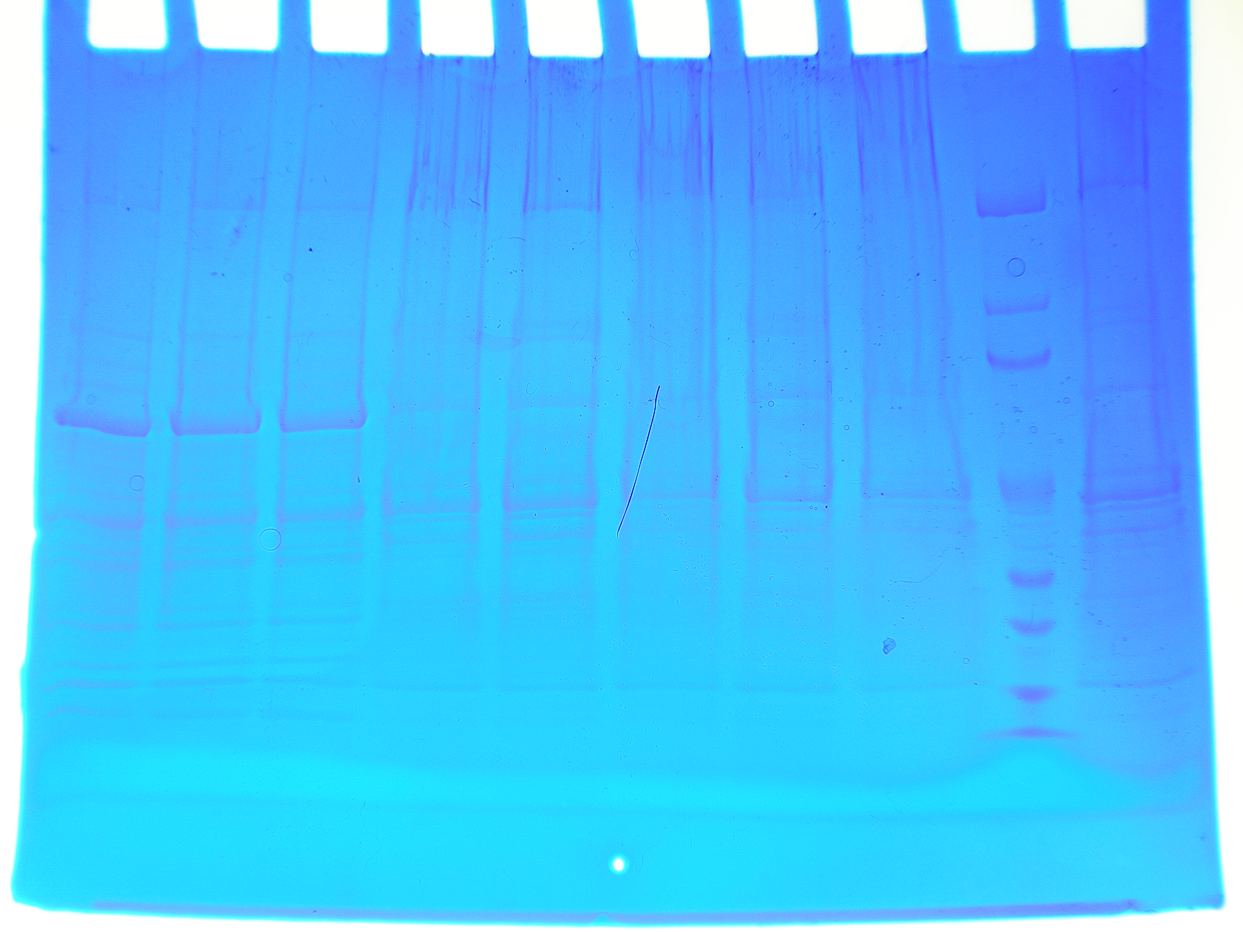
Figure A: A completed and stained gel will resemble the picture above. Darkened bands are protein. The experimental lanes (8 leftmost and last lane on the left) have more bands than should appear in this experiment. A maximum of two bands should appear in the gel from this experiment – 1 for the anti-SNAP-25 antibody, and 1 for the SNAP-25 protein.
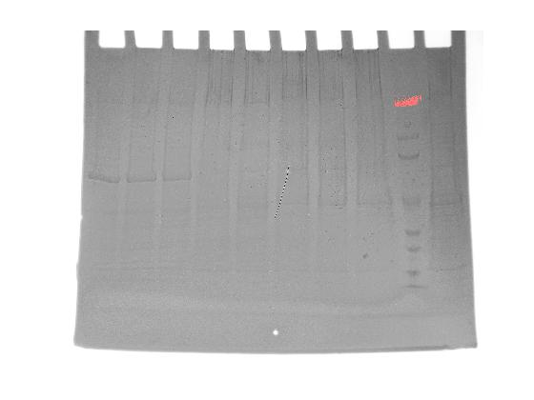
Figure B: Once the image analysis program has been run on the experimental gel, the protein band for which the analysis has been run will be reddened as with the red area above.

Walch-Solimena, Christiane et al. “The t-SNAREs Syntaxin 1 and SNAP-25 Are Present on Organelles That Participate in Synpatic Vesicle Recycling”. Journal of Cell Biology. Vol 128:4. February 1995, pp. 637-645.
Bark, I.C. et al., Journal of Molecular Biology. 233, 67 (1993).
Monoclonal Anti-SNAP25 Product Information. Sigma. http://www.sigmaaldrich.com/sigma/datasheet/s5187dat.pdf.
Instructions Immobilized Protein A/G. Pierce Supply. http://www.piercenet.com/files/0128sd6.pdf

