Neil Jikaria
April 25, 2007
Instron Tensile Testing: Material Properties of Repaired Chicken Skin
Background

Sutures have long been a commonly used method of repairing damaged skin in humans. During the “Imaging Techniques” lab, several different suture methods were used and it was determined which suture type was most effective at resisting displacement in the surrogate wound. From this lab, it was determined that the pulley stitch method allows a significantly (p = .0130) smaller strain than the horizontal mattress method. However, the effectiveness of these suture types was tested using cross-stitch fabric, which does not have similar properties in comparison to human skin. In addition, during the “Instron Tensile Testing” lab, the material properties of chicken skin were found to be constant and independent of the rate at which it was strained. The basis for testing these pieces of skin was that they were whole and not damaged or repaired in any way.
By combining the two experiments previously mentioned, it is possible to test the changes in the structural properties of skin as a result of repair. The goal of this proposed new experiment is to emulate the changes that occur in human skin after repair. By comparing the elastic modulus of both whole (not sutured) and repaired (sutured), it is possible to determine these changes.

Hypothesis and Objectives

The central hypothesis is that pig skin that is repaired using the pulley stitch will have a significantly lower elastic (Young’s) modulus than whole skin when subjected to a tensile load. The specific objectives of this experiment are:
- To use specific structural properties to determine the material properties of a biological sample.
- To quantify the differences between repaired and whole pig skin samples when they are subjected to a tensile load.

Equipment

Major Equipment
- Instron Model 4444 benchtop materials testing machine

Lab Equipment
- Scalpel
- Length measuring instruments: calipers and rulers
- Marker pens

Supplies
- Nylon thread (suture material)

Newly Purchased Equipment
- 20 Fetal Pigs (one per group)

The fetal pigs were chosen as the skin sample because of the closeness of porcine skin to human skin. When sutured together, porcine skin accurately represents the properties of human skin that has been sutured together, due to a similar protein content and underlying structure (Zhang).

Proposed Methods & Analysis

In order to begin the experiment, the pig skin samples must be prepared to fit the Instron. As determined during the “Instron Tensile Testing” lab involving chicken skin, the ideal dimensions for the skin samples were found to be 1 inch wide by 1.5 inches long. Since the clamps of the Instron are only 1 inch wide, this allows for the entire sample to be held in the clamps. The fetal pigs will be unskinned, and therefore must be skinned using the scalpel. Remove the skin from the body of the pig, since skin from this part of the pig will be of uniform thickness. Be sure to remove the excess fat and connective tissue that holds the skin in place. Prepare 10 samples of the appropriate size in order to test them. Keep each sample moist, surrounded by wet paper towels.
Taking 5 of the samples, cut across the width of each skin sample at the center of the sample, as measured by the ruler. This will yield two equally sized skin samples. Using the marker, draw two lines, one 1/4” inch and the other 1/8” from the 1-inch-wide edge of the skin sample. These are the lines at which the sutures will be placed. Using Figure 1 (as shown in Appendix) as a guide, use the pulley stitch method to suture the two skin “flaps” together. The first stitch should be placed 1/8” from the edge, with each subsequent stitch 1/4” from the last. This results in four stitches holding the two “flaps” together. Tie off the stitches after the fourth stitch, and repeat for each of the remaining skin samples. Measure the thickness of each sample, as close to the sample as possible.
Proceed with the loading of the Instron as described in the lab manual, ensuring that there is a slight overlap of the skin above and below the top and bottom clamps, respectively. Adjust the Instron using the Jog button to ensure that the sample is taut within the clamps. Record the initial displacement of the clamps as reported by the Instron as the gage length. Run the Instron with the LabView software, setting the strain direction to “Up” and the strain rate to “30 mm/min.” This strain rate was found to be the ideal rate while testing chicken skin in the Instron, since it allows for more data points to be collected. Set the sampling rate to the default value of “20” points per second. The units for data collection are force in Newtons and displacement in millimeters. Output the data to a Microsoft Excel file for further analysis. Repeat this with each sample, starting with the whole (not sutured) samples first, followed by the repaired (sutured) samples.
Once the testing of each sample is completed, calculate the cross-sectional area of the sample, using the initial geometry measured before testing. Divide the force values put out by the LabView program by this cross sectional area to determine the force per unit area, or stress. In addition, calculate the strain by dividing the displacement values by the gage length. Plot a stress vs. strain curve in Matlab (see Figure 2 in Appendix). Calculate the Young’s modulus by determining the slope of the linear portion of each stress vs. strain curve. The linear portion of the curve is defined as the upward-sloping portion of the curve, before any decrease in the stress. Ensure that the same number of data points is selected for each trial.
The slope is calculated by selecting this linear portion and fitting a first order polynomial curve to this line. Once the slopes (elastic modulus values) for each trial have been calculated, determine the variance of the slope data sets. Depending on the variance values (if they are equal or unequal) perform the appropriate two-sample t-Test. Variances can be considered equal if they are within 5% of their respective means.
Due to the time constraints of the lab, the sample preparation should take no more than two hour, which leaves up to 4 hours to run Instron tests and assemble data. It may be necessary to create plots of the data while still in the lab in order to see if any parts of the experiment must be repeated.

Potential Pitfalls & Alternative Methods

While testing chicken skin in the Instron, it was found that the skin is prone to slippage while in the clamps. This was primarily caused by excess moisture and fat left on the skin during sample preparation. In order to prevent this from happening, the sample must be cleaned with the scalpel and properly dried with a paper towel. In addition, the skin should protrude slightly from above and below the top and bottom clamps in order to make sure the skin is secure. Slippage of the skin will result in the Instron reporting a failure even if the sample has not failed. If the skin does slip, it is possible that the trial may have to be repeated, since the data reported by the Instron will not accurately represent the failure point of the skin sample.
In addition, while determining the linearly elastic region of the curve, there may be a tow line (see Figure 2 in Appendix) present at the beginning of the curve, which represents the displacement of the clamps as the sample was stretched to its maximum tautness. This tow line may mean that the elastic region for some trials will be longer than in others. In order to prevent this, it is imperative to keep the number of data points used for the line consistent across each trial. This can be accomplished by finding the trial with the least data points in the linear region, and using this number as a guideline for how long the linear region should be across all trials.
Another potential pitfall of this experiment involves the failure of the repaired (sutured) skin samples. It may not always be clear if failure occurs as a result of the material properties of the suture or as a result of the material properties of the skin. In order to prevent this uncertainty, each trial should be qualitatively analyzed while the sample is being loaded in the Instron. It should be noted whether the overall failure resulted from the failure of the suture or from the failure of the skin. Similarly, as the chicken skin experiment proved, the skin sample was prone to break near the clamp rather than at the center of the sample. Though this is unlikely in the repaired (sutured) samples, it may occur in the whole (not sutured) samples, and therefore must be noted. It was determined during the chicken skin experiment that a failure at the clamp can still be considered a total failure, and therefore this event can be disregarded.

Budget

The only additional supplies that must be purchased are 20 fetal pigs, one per group, to be used as a source of skin samples. The supplier for these pigs will be Carolina Biological Supply Company.

Catalog # | Item | Quantity | Unit Price | Subtotal | Shipping | Total Cost | Budget Remaining
22-8404 | Pig | 20 | $16.60 | $332.00 | $33.20 | $365.20 | $1634.80

The pigs are preserved in a non-toxic solution, and are not injected with latex to show artery and vein systems. Each pig measures 10-13” in length (Carolina).

Appendix

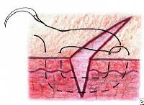
Figure 1. Diagram of pulley stitch method (Mackay-Wiggan).

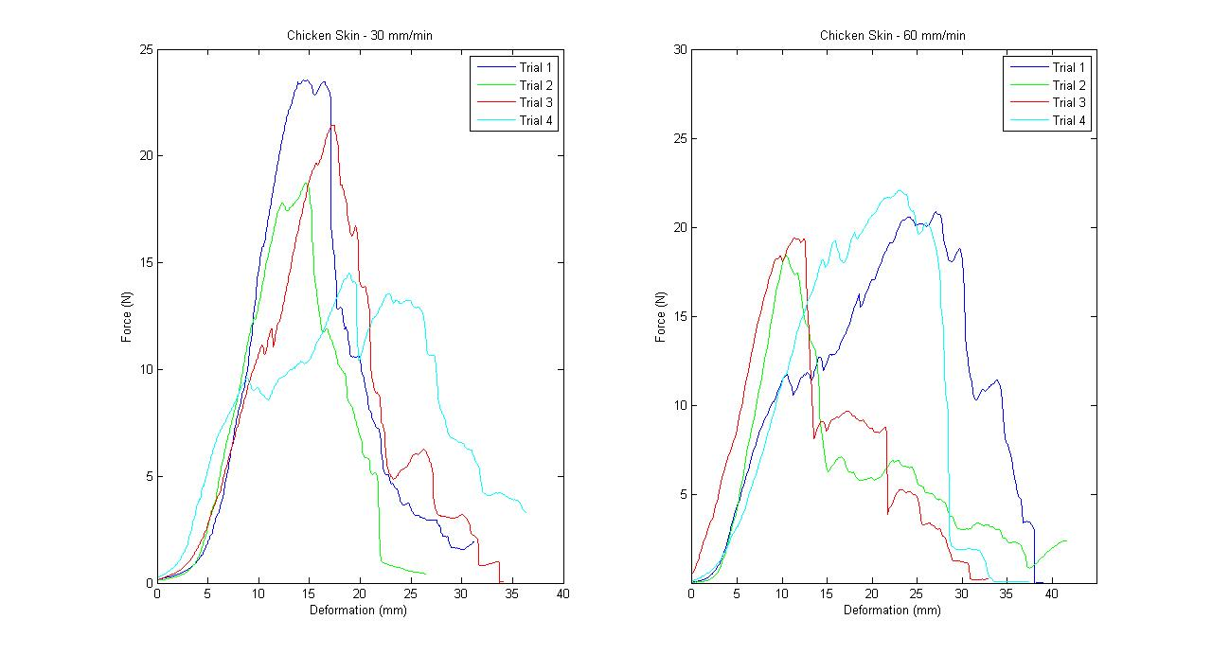
Figure 2. Sample stress-strain curve. Note the tow region at the left side of the curve.
References

Carolina Biological Supply Company. “Pigs, Carolina’s Perfect Solution.”
<https://www2.carolina.com/webapp/wcs/stores/servlet/ProductDisplay?jdeAddressId=&catalogId=10101&storeId=10151&productId=39396&langId=-1&parent_category_rn=1285|98|1029|1032>

Mackay-Wiggan M.D., Julian. “Suturing Techniques.” eMedicine. 1 Feb 2007.
<http://www.emedicine.com/derm/topic828.htm>

Zhang, Zili and Nancy A. Monteiro-Riviere. “Comparison of Integrins in Human Skin, Pig
Skin, and Perfused Skin: An In Vitro Skin Toxicology Model.” Journal of Applied
Toxicology. Volume 17, Issue 4 (247-253). Jul-Aug 1997.
<http://www3.interscience.wiley.com/cgi-bin/fulltext/25000056/PDFSTART>

