Instron Tensile Testing: Structural & Material Properties of Pig Muscle
Swati Kasundra
April 25, 2007
A. Background

Two types of muscle tissue found in the pig are cardiac muscle and smooth muscle. Each of these two muscle types has different arrangements of proteins which result in various functions, structural properties, and material properties. The main difference between cardiac muscle and skeletal muscle is that cardiac muscle is striated and has sarcomere units. This allows for a network to be formed in the tissue due to the myofibrils consisting of heavy and light protein chains. As a result of the networked tissue, cardiac muscle can withstand very strong contractions. Smooth muscle on the other hand has heavy and light chains packed together irregularly not allowing it to withstand contractions as strong as cardiac muscle is able to withstand.

Similar to Experiment 3, Tensile Testing of Chicken Skin, it is observed that material properties and structural properties affect the ultimate strength and Young’s modulus of a sample. The ultimate strength is the largest value of stress a sample can handle before permanent deformation will occur as shown by point U in Figure A of the Appendix. As observed in the chicken skin, Young’s modulus is the slope of the stress-strain graph and varies as a result of each material’s stiffness. Instead of varying the geometry of one material and observing its inherent material properties as done in Experiment 3, two different materials will be tested and differences in their material properties will be compared.

B. Objectives & Hypothesis

The objective of this lab is to get a better understanding of how the various material properties and structural properties of cardiac muscle and smooth muscle of a pig affect their respective relationship between applied load and material deformation. It is also important to become familiar with using MATLAB to analyze the stress-strain relationship and observe the differences in deformation.

The hypothesis is that cardiac muscle will have a greater ultimate strength than smooth muscle due to its networked myofibrils that allow it to withstand very strong contractions. As a result, cardiac muscle will also have a greater Young’s modulus.

C. Equipment

Major Equipment
- Instron Model 4444
This is needed in order to stretch the pig skin and cause deformation by applying a constant simple uniaxial load.

Lab Equipment
- Length measuring instruments: rulers and calipers
The measuring instruments will be used to measure all the muscle samples and make sure they are of similar geometry.
- Scissors, scalpel, and cutting board
The cutting instruments are needed to cut all the muscle samples to a uniform geometry. The scalpel will be used the most to cut the samples.
- Weight set (500g, 1kg, 2kg)
The weights are needed to standardize the Instron before using it to stretch the pig muscle.
- Piece of foam (1/4 inch thick Confor Slow Recovery Polyurethane Foam)
This piece of foam will be used to do practice runs on the Instron to determine what geometry the muscle samples should be cut in and what speed the muscle should be stretched at in order to get the optimum data.

Supplies
- 4 Cardiac Muscle Samples (from 4 pig hearts)
- 4 Smooth Muscle Samples (from 4 pig stomachs)
These different muscle types are going to be tested and their results are going to be compared in order to determine the differences in their material properties and structural properties.

D. Proposed Methods & Analysis

The first step in the experiment is to prepare the muscle samples. There will be 4 of each the cardiac muscle sample and the smooth muscle sample. In order to make 8 geometrically similar samples, the hearts and stomachs must be cut to produce a sample of length 6.5cm, width 2.5cm, and thickness 2mm. All of the heart and stomach pieces should be cut at similar parts of the organ, and the heart muscle should be cut so that the striations run vertically.

The next step is to standardize the Instron by checking if the load cell output measurements are valid according to the applied loads. Similar to Experiment 3, the foam should then be used to do some trial runs to become familiar with the Instron once again. From these sample runs, various loading rates and sample rates should be tested to find an adequate rate for the pig muscle. The force and displacement data output for these sample runs should be plotted in MATLAB on a stress-strain graph. In addition, finding the ultimate strength and Young’s modulus should be practiced from this data.

The actual length, width, and thickness of each specimen should be recorded before it is tested in the Instron to aid in accounting for slight differences in results. Each sample should be placed in the Instron and should not have any slack between the two clamps before the stretching begins. The length of the muscle sample between the two clamps, the gage length, should also be measured before the stretching begins to ensure that equal lengths are being tested. From the foam sample runs, a loading rate of 90mm/min should be determined to be adequate for the experiment with a sample rate of 20Hz. Test each sample according to these rates and record the force and displacement data. Each sample should be stretched until the muscle is completely torn and has reached its failure strength.

Once all the force and displacement data is recovered, its analysis can be done using MATLAB. The force and displacement data must first be converted into stress and strain values using the stress and strain equations shown in the Appendix. These new values are then used to make stress-strain graphs for each sample. From these 8 graphs, an ultimate strength must be achieved by finding the maximum stress value as shown by point U in Figure A of the Appendix. In order to find Young’s modulus for each sample, the slope of the beginning linear portion of the graph must be taken.

To determine if the hypotheses are correct, statistical analysis of the data must be undergone. A one-tailed, unpaired t-test must be used assuming equal or unequal variances depending on the data recovered. There will be two t-tests that will be conducted, one for the ultimate strength and one for Young’s modulus. These results will allow us to learn if there is a significant difference in the ultimate strength and Young’s modulus between cardiac muscle and smooth muscle.

E. Potential Pitfalls & Alternative Methods/Analysis

The geometry of each muscle sample will vary slightly causing variations in the results. Every sample will not have the same dimensions cut exactly, and each heart and stomach will vary in its age, mass, and physical condition. These variations can be accounted for by recording the exact measurements and appearance of the muscle sample cut. In addition, the gage length must also be measured for each sample because not every sample will be clamped exactly the same, and this cross sectional area will affect the deformation occurring. The gage length measurement will also help in understanding the difference between samples that had slack and those that might have been stretched slightly.

When the samples are being stretched in the Instron, they will all tear in different places on the sample. This will result in various stress-strain graphs with inflections or kinks at different points on the curve. Each sample also fails at various loads. Often times, different layers of the muscle fail before the final failure point is reached. This causes kinks in the graphs as shown by point A in Figure B of the Appendix. Kinks may also be caused by slippage of the muscle from the clamps of the Instron.

All of these irregularities in the stress-strain curve make it difficult to analyze the data for each muscle. In order to achieve a certain amount of consistency in the values gotten from the curves produced, a constant retrievable method for the values must be used. The values for the ultimate strength should be the greatest stress value that is shown on the curve. This means excluding the kinks on the curve. On the other hand, the kinks must be taken into consideration for the Young’s modulus value. In order to find Young’s modulus from the graph, the slope of the linear portion of the curve should be taken until the first kink is reached. The kinks are failure points for the sample and should not be included in the Young’s modulus calculation because they account for permanent deformation. By excluding the kinks, only a linear stress and strain relationship is affecting the value of Young’s modulus.

F. Budget

- Pig Hearts
The pig hearts will be bought in a package of 10 at a cost of $45.95 from WARD’S Natural Science store¹. Although only 4 hearts are need per lab group, the other six may be saved for use by another group.
- Pig Stomachs
Four pig stomachs will be bought at a price of $16.95 each from WARD’S Natural Science store¹.

The total cost for the 20 lab groups will amount to $1723.63 (8 10 packs of the pig hearts and 80 pig stomachs).

G. References

(1) WARD’S Natural Science. (2007). WARD’S Natural Science. Retrieved April 23,
2007, from http://wardsci.com/

H. Appendix

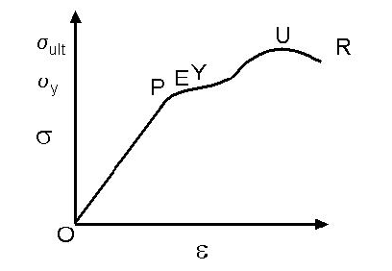
Figure A: A stress-strain graph useful in understanding material response characteristics including different strengths of materials being tested. Point U is the ultimate strength of the material while point P is the proportionality limit below which the slope of the linear proportion of the stress-strain relationship will result in Young’s modulus.

Stress Equation: σ = F/A Strain Equation: ε = Δl/l

Where F is force, A is the area over with the force is applied, l is the gage length, and Δl is the change in length.

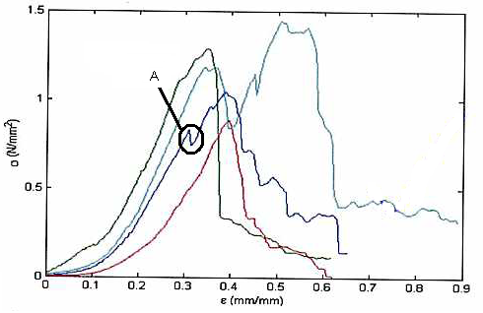
Figure B: The circled portion depicted by point A is an inflection in the chicken skin sample caused by various failures of the sample layers at different times before the final failure point.

