Effect of Heat on Muscle Protein Detection
by Gel Electrophoresis

BE210 Final Proposal

David Lam
April 25, 2007
BE210

Background

Gel electrophoresis is perhaps the most frequently performed technique in molecular biology. Its functionality as a reliable and simple protein existence test as well as a protein concentration quantifier has solidified its popularity in research laboratories. Two important factors in gel electrophoresis are band intensity and procedural time. This experiment expands on BE210 Experiment 1 and seeks to determine the effect of heat on band intensity. Further experimentation may test procedural time.

In native state, proteins are folded in their tertiary structure. Detection of proteins is a common research step to verify whether certain proteins are present in a sample. In this lab, mammalian proteins from cardiac, smooth, or skeletal muscle are solubilized in solution and coated with SDS detergent. SDS is a strong negative denaturing agent which will unfold the proteins into their primary structure and impose the same negative charge on each protein. Then, when the samples are run on the electrophoresis, proteins will be separated exclusively by their size. Comparison of bands to the bands of known molecular weights will provide an estimation of the size of the protein tested. In addition, the intensity of the protein band can be exploited via a MATLAB image analysis program to determine the concentration of protein in the sample. Band contrast, defined in this lab as the difference in pixel color values between the protein band and the destained gel, will be compared in the heated and non-heated gel. Higher band contrast results in better separation of band intensities, possibly yielding higher precision and accuracy.

The impact of heat on protein gel electrophoresis band intensity and experimental time has been tested independently by Wu and Welsh, and Kurien and Scofield. Kurien and Scofield showed that enhanced heat, in addition to dramatically decreasing the time required for staining and destaining, also significantly increased the detection sensitivity. For a 1.5mm gel, the staining time was 5min at 55, 62.5 or 70 min while the destaining time was 45, 45 and 20 min respectively. This is in contrast to BioRad’s staining protocol which calls for 30-45 min of staining followed by two 45-minute periods of destaining. Improved band contrast and shorter electrophoresis time would contribute to enhanced experimental effectiveness and efficiency.

Objectives and Aims

Hypotheses
MAJOR: The microwave-heated gel will have a higher band contrast, or a greater difference in pixel values between protein band and gel, than the non-heated gel.
MINOR: The standard deviation of the concentration of the selected protein derived from the microwave-heated gel will be lower than that of the non-heated gel.

Experimental Goals
- Quantify mammalian muscle protein by gel electrophoresis.
- Test the effect of heat on protein gel staining and destaining.
Educational Goals
- Learn the molecular biology technique of gel electrophoresis including its function and applications.
- Become familiar with protein structure and size, and how this can be exploited and quantified through electrophoresis.
Equipment

All equipment below is required for performing a gel electrophoresis. Specimens must be properly prepared for electrophoresis with DTT, SDS detergent, and the heat block. Gel, staining solutions, and electrophoresis systems are essential equipment for this lab. A microwave is necessary to heat the gel, which is the primary test of this experiment, in stain or destain solutions in the plastic container.

Major Equipment
- BioRad Mini Protean II & III Cell Electrophoresis System
- Power Supply (BioRad PowerPac Basic & 300)

The electrophoresis system and the power supply are required to operate a protein gel. The power supply controls the electric field applied onto the gel and should be set at 100V to ensure the proteins are appropriately separated in a reasonable amount of time.

Lab Equipment
- 10 1.5mL microfuge tubes with DTT
- 10 1.5mL microfuge tubes
- Heat block
- Plastic container
- Pipettes and tips (regular and gel-loading)
- Scalpel
- Scissors
- Digital Camera

The above lab equipment forms the basis for the pre-electrophoresis preparation. Mammalian tissue samples are cut and prepared with the scalpel and scissors. DTT helps to break down the tissue to release proteins into the solution. The samples are kept in microfuge tubes and placed on the heat block for denaturing along with SDS. After electrophoresis, the gel is placed into stain/destain solutions in a plastic container with a lid. The digital camera takes gel photographs.

Supplies
- 4-15% ReadyGel Polyacrylamide gel (1 per group)
- SDS buffer (undiluted)
- Loading buffer
- Muscle specimens (cardiac, smooth, or skeletal)
- SDS-PAGE Molecular Weight Standards
- Coomassie Blue stain
- Destain solution

SDS buffer denatures the protein. The gel is loaded inside the electrophoresis apparatus with loading buffer. A molecular weight standard “ladder” is run with the gel to identify the sizes of unknown proteins in other lanes. Coomassie Blue stains the gel after electrophoresis.

Newly Purchased Equipment
- Microwave

The microwave is the source of heat for the gel heating experiment.
Proposed Methods & Analysis

To examine the influence of heat on protein expression, the gel must obviously be tested with heat and without heat. A sample non-heated gel is shown in Appendix 2. It is difficult to see all the bands clearly as the band contrast is rather low. To maximize resources and minimize costs, the gel will be cut in half vertically in the middle after electrophoresis is completed. There are 10 lanes on the gel. Each half will contain a lane of molecular weight standard followed by four lanes of the prepared muscle protein sample. Eight of the lanes on the 10-lane gel should come from the same source. The type of muscle sample is not significant, as long as it is the only muscle sample used. See Appendix 1 for the gel lane loading pattern.

The protocol for the muscle protein sample preparation and gel electrophoresis setup and operation remains the same as the one in BE210 Experiment 1. Choose only one of the muscle specimens: cardiac, skeletal, or smooth. After cutting, dissolving, and denaturing the samples with SDS and heat block, load them onto the correctly set up gel electrophoresis apparatus. The preparation should take about 20 minutes and the electrophoresis will last about 40 minutes.

After electrophoresis is completed with the bands near the bottom of the gel, remove the gel from the apparatus. Each half will be placed into labeled plastic containers containing enough Coomassie stain to cover the half gel. Label the non-heated box as A and the heated box as B.

Staining and Destaining Gel Box A
- Let the box sit idle in Coomassie stain for 40 minutes to stain.
- Drain stain from the box. Rinse the gel with water to remove remaining stain remnants.
- Add destain solution until the gel is covered.
- Let sit idle for 45 minutes.
- Drain destain solution and add fresh destain solution.
- Let sit idle for 45 minutes.

Staining and Destaining Gel Box B
- Heat the closed box in the microwave at the highest setting for 30 seconds.
- Remove the box from the microwave and let sit for 40 minutes.
- Drain the stain from the box and rinse the gel with water to removing remaining stain.
- Add destain solution until the gel is covered.
- Heat the covered box in the microwave at the highest setting for 30 seconds.
- Let sit for 45 minutes.
- Drain destain solution and add fresh destain solution.
- Let sit idle for 45 minutes.

Take digital photos of each gel with a digital camera. The initial setup of samples and gel apparatus along with the electrophoresis run should take about 60 minutes. Staining and destaining will take about 135 minutes. Imaging should take less than 10 minutes. Therefore the entire experiment should last just under 3.5 hours.

Analysis of the two half gels is performed by inputting the digital photograph into the MATLAB image analysis program. By now, protein bands should be distinct from the rest of the gel. To quantify these differences, select the protein that has the best expression throughout all the gel lanes. Use this protein band as the region of interest (ROI). Find the pixel color values of this region of interest for all 8 protein sample lanes and record the data. Choose four random points on the gel not occupied by bands and record the pixel color values.

Record average and standard deviation values for the pixel color values of the two molecular standards and the protein of interest in both the heated and non-heated gel. Use Microsoft Excel to perform an unpaired two-tailed t-test between the 4 pixel values of the heated gel and the 4 pixel values of the unheated gel. Determine if there is statistically significant difference (p<0.05) between the values obtained via the two different staining and destaining protocols. As a minor test, compare the standard deviations of the pixel color values for the heated and non-heated gels.

Segmentation tools in MATLAB can help to determine the best expressed protein or to calculate protein concentration as a function of band size. The function “[bin thresh] = edge(I, ‘sobel’)
where I is the loaded image will automatically determine the edges of your protein bands. By using “bin = edge(I, ‘sobel’, thresh) and specifying a threshold based on the previous threshold value, over-expressed and under-expressed protein bands can be separated. To create a clearer image between the bands and the destained gel, the imdilate, imerode, and imfill imaging functions will expand the white pixels region, shrink the white pixels region, and fill in black pixel holes with white pixels, respectively. A combination of these strategies will yield an unambiguous picture of the gel and protein bands for possible concentration analysis.

Potential Pitfalls & Alternative Methods and Analysis

There is possibility for various types of experimental and analytical error. Since only 20μL is loaded for each protein sample and the pipette error is 0.5μL, half of the lowest unit of the pipetter, this translates to a possible 2.5% error. Due to cohesion of the loading liquids, which are often viscous if not properly dissolved and mixed, the pipetter may not take up and/or release all of the 20μL desired. Loading samples mixed between neighboring lanes of the gel represent another error. The standard was loaded on the outer ends of the gel in both cases both for consistency and for the fact that end lanes are more prone to error due to the loading apparatus. A polyacrylamide gel is a porous separation matrix. Since the image analysis is a sensitive procedure, even slight non-homogeneities in the gel would skew results. In the MATLAB image analysis, ROIs, thresholds, and pixel values contain some discretion by the individual who performs the analysis as much of the process requires recognizing and selecting certain areas of the gel. With only four lanes in each of the two half gels for analysis, small errors can easily accumulate into a significant error in the final results.

The method of quick stain and destain of a protein gel as tested in this experiment should not be applied to DNA gels. At room temperature, double-stranded DNA is stable but at increased temperature, the two strands of the DNA begin to separate in a process known as melting. This property is utilized in temperature gradient gel electrophoresis where sequence variation within [DNA] domains causes the melting temperatures to differ, and molecules with different sequences will stop migrating at different positions in the gel. This procedure does not separate the proteins based on their size as is desired.

In this experiment, differences in pixel color values between heated and non-heated protein gels were used to evaluate band contrast. Band contrast is significant when the concentration of protein samples is required. If band contrast is low between all lanes, then image analysis in MATLAB will yield similar pixel color values. When band contrast is high, there is greater range in the pixel values leading to higher accuracy in determining protein concentration. Therefore, greater band contrast essentially results in increased concentration accuracy and precision between the four samples.

Procedural time is an equally important factor in gel electrophoresis. Especially if a researcher simply wishes to check for existence of a certain protein in a sample, the recommended electrophoresis length of over two hours from start to end is certainly a hassle. An extension of this experiment would test if heating the gel and then staining and destaining for shorter time periods would produce similar band intensities of non-heated gels at regular stain and destain times. The introduction of a second variable, namely time, to the experiment produces potential difficulties in solely attributing the effectiveness of heat to one variable.

Since the microwave model is rather generic, the specific impact of wattage was not considered. In this case, the GE microwave has 700W and was heated for 30 seconds. More specific experiments may vary both of these settings to generate the gel with the highest contrast. Although the Ready Cell manual for the polyacrylamide gel does not make reference to any temperature effects, it is possible for the gel to melt under heat. Hence, even slight melting of the gel may introduce error to the band intensities. The 700W and 30 seconds range is consistent with previous experimental attempts and should not produce adverse effects.

Further experiments should investigate the effect of heat on more gel samples to confirm experimental results. Since only one protein was investigated, other mammalian muscle proteins can be subjected to the experiment as well. A more comprehensive study would test the effect of heat on band intensity at varying amounts of heat. This can be done by changing the microwave exposure time or using a heat bath to enclose the gel box at different water temperatures.

Budget

The only equipment required in addition to those already listed in BE210 Experiment 1 is a microwave, which will be responsible for all heating functions. As the microwave will only be utilized for heating small plastic containers containing polyacrylamide gels and stain/destain solutions, a basic compact microwave will suffice.

Here is an example of a microwave that can be purchased for the lab. Any similar microwave that is clean and performs the heating task is adequate.

Name: GE 0.7 Cubic Feet Compact Microwave – White-on-White
Model: JES735WJ
Cost: $58.99 at Best Buy as of April 25, 2007
Dimensions: 10.3” X 17.9” X 13”
Weight: 23 lbs.

This compact microwave boasts a rotating turntable of diameter 9.6” to ensure equal heating on all sides, 10 power levels, and 700W wattage. As the microwave will be used for only several minutes by each group during the six-hour lab period, purchase of one model is sufficient for all groups’ needs.

Appendix

Appendix 1: Order, content, and volumes of the 10-lane gel with Lane 1 at the left end of the gel.
Lane | 1 | 2 | 3 | 4 | 5 | 6 | 7 | 8 | 9 | 10
Content | Standard | Muscle | Muscle | Muscle | Muscle | Muscle | Muscle | Muscle | Muscle | Standard
Volume | 10μL | 20μL | 20μL | 20μL | 20μL | 20μL | 20μL | 20μL | 20μL | 10μL

Appendix 2: Sample digital image of an electrophoresis gel of cardiac and skeletal muscle tissue samples from BE210 Experiment 1. Note the molecular weight standard on the rightmost lane.

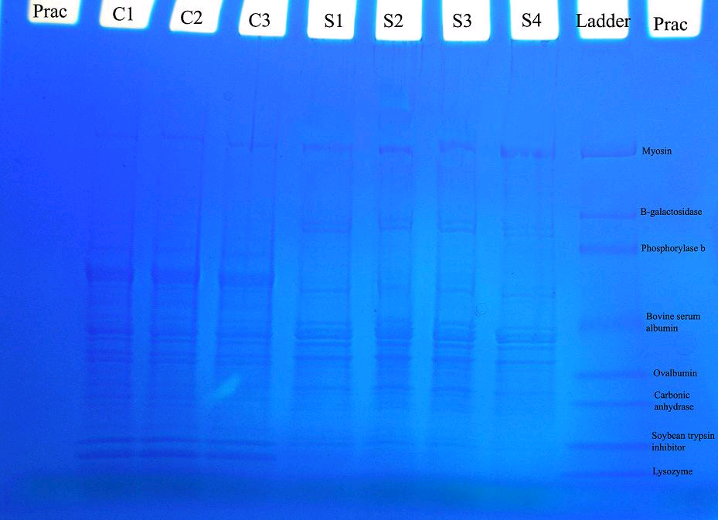

References

Kurien, BT, Scofield, RH. “Heat mediated quick Coomassie blue protein staining and destaining of SDS-PAGE gels.” Indian Journal of Biochemistry and Biophysics. 35.6 (1998): 385-9.
BioRad. (2006). Ready Gel Cell Resource Guide. Hercules, CA: BioRad Laboratories.
Winkelstein, B.A. “Muscle Protein Detection Using Electrophoresis.” BE210 Lab Manual. 2007: 1-14.
Muyzer, G. “Application of denaturing gradient gel electrophoresis (DGGE) and temperature gradient gel electrophoresis (TGGE) in microbial ecology.” Antonie van Leeuwenhoek. 73.1 (1998): 127-41.
Costa, Frances. “Method for Quick Coomassie Blue Staining of Polyacrylamide Gels.” The American Biology Teacher. 62.4 (2000): 285-287.
GE 0.7 Cu. Ft. Compact Microwave - White-on-White - Model: JES735WJ. 25 April 2007. Best Buy Co., Inc. <http://www.bestbuy.com/site/olspage.jsp?skuId=7180953&type=product&productCategoryId=cat05020&id=1115366839181>

