April 24, 2007
Stephen McKenna
Tensile Testing of Sutured Skin and its Effects on Elastic Modulus
Background

Everyday emergency room doctors and surgeons have to seal wounds using stitches. It is up to them to decide where a stitch must go and what type of stitch to use based on a variety of circumstances, such as site of the wound and thickness of the skin. From previous studies of two commonly used suturing techniques (running locked and pulley) it was determined that there is no significant difference in the strength (deformation per unit load) of these two (see Figure 1 in Appendix). Also important to the doctor’s decision is the size of the wound. If the doctor closes a very large wound, there is a significant amount of stretching of the skin that may be painful or malignant for the patient. This is the reason why elastic modulus will be analyzed so that a limit can be determine as to how much skin is able to be stretched before other methods (such as skin grafts) are necessary. Preliminary data has found that the elastic modulus of chicken skin, which is considered to be very similar in mechanical properties to human skin, falls between 3.80 MPa and 5.71 MPa (see Table 1 in Appendix). Using the Instron 4444, this experiment will aim to determine the elastic modulus of chicken skin when sewn together using both of the aforementioned suturing techniques. Therefore, this experiment will combine techniques used in the BE 210 lab manual from experiments 2 and 3.

Hypothesis/Objective and Aims

This study aims to quantify the effects different types of suturing techniques have on the material properties of skin by measuring the elastic moduli of sutured skin and non-sutured skin. Since the string that constitutes each stitch also undergoes deformation when a force is applied by the Instron, it is hypothesized that there will be a significant difference between the elastic moduli of sutured skin and non-sutured skin. Because it has been previously proven that the running locked stitch and pulley stitch show no difference in strength, it is also hypothesized that they will exhibit no significant difference in elastic modulus under the assumption that they act identically on the material. In order to describe this difference, this study aims to quantify elastic modulus through the use of Matlab and its curve fitting feature. From these values it can be statistically shown with an unpaired t-test (of either paired or unpaired variance depending upon the variance shown in these models) whether or not there is any significant difference between the elastic moduli of sutured and intact chicken skin, and whether or not different techniques of sutures affect elastic modulus.

Equipment

In this assay the Instron 4444 table-top mechanical testing machine will be used. The clamps of the Instron are approximately one inch wide and hold the sample in place while the machine applies an upwards force increasing at a rate specified by the crosshead speed. The sampling rate of this instrument is also user controlled. Using a LabView computer program, this instrument can transmit a digital signal to a PC. Using this signal the PC translates the digital signal to force and displacement, thus creating a plot as the data is collected. The sampling rate chosen by the user determines the number of points the PC is able to plot per second. A higher sampling rate will produce a plot with a much smoother curve; on the other hand, a lower sampling rate will cause the plot to have large jumps and sharper curves. A higher sampling rate is desired so that no important segments of the curve are lost.

Other lab equipment will be necessary in this experiment. Calipers will be needed in order to measure the dimensions of the subjects accurately. The smallest measurement allowed by the calipers is 0.1mm.

Scissors will be necessary to cut the chicken skin from the meat. A scalpel can also be utilized to facilitate cutting the skin from the meat as it can be used to reach down further into the area between the skin and the meat. Caution must be used in order to avoid personal injury when using these instruments.

A cutting board will also be needed once the skin has been successfully removed. Using the scalpel and calipers, measure and cut the sample into the desired dimensions on the cutting board.

Extra supplies will also be needed for this experiment. A suture kit will be supplied to each group so that once all the desired pieces are cut, those specified to be joined by a stitch can be sewn together using the suture kit.

Each group will also need paper towels for this experiment. The paper towels will need to be moistened and then wrapped lightly around the samples so as to keep them fresh and hydrated.

Additional supplies besides the ones found in the laboratory will also be needed. For this experiment each group must be supplied with fresh chicken legs. These will be needed in order to extract the multiple samples used in this study.

Proposed Methods & Analysis

Each lab group will be supplied with 5 chicken legs. Removal of the skin from the meat must occur on top of a cutting board. With extreme caution, cut the skin loose from the part that connects to the knee. Using the scalpel cut the pieces of tissue under the skin that attach it to the muscle. Be careful not to make any additional cuts to the skin so that you may cut the required dimensions with ease later on. As soon as the skin is removed from the meat of the chicken leg cover the skin with damped paper towels to maintain freshness and hydration of the sample. This should take up to 10 minutes to do carefully.

From each of these 5 legs one (4.8 x 6.0)cm piece of skin can be extracted. Since this experiment requires three groups of subjects (one non-sutured group, one bound by the pulley stitch, and one by the running-locked stitch), it is best to cut each (4.8 x 6.0) cm piece into four pieces with length and width of (2.4 x 3.0) cm. The thickness of each sample must also be measured at the central axis using the calipers in order to determine the cross sectional area of each sample in order to determine stress later on. Cross sectional area is measured in the center because this is where it is expected to break and it cannot actually be predicted where it will really break. This should take no longer than 20 minutes at a normal pace. This configuration allows for 20 pieces to be cut from 5 chicken legs that are to be distributed between 3 groups, it is best for each group to contain 6 samples. This leaves two extra pieces of skin that can be used as practice runs so that each group can get accustomed to the Instron. Also, since n = 6 > 3, statistical tests can be applied.

After cutting all 18 pieces to be examined, cut 12 of them exactly in half (1.5 cm in length per half) and have one group member sew together 6 samples using the pulley stitch, meanwhile, have another group member sew together 6 samples using the running-locked stitch. See figure 2 in Appendix for illustrations of each stitch. This can be very time consuming and should be done by both members simultaneously. An inexperienced sewer may need up to 45 minutes.

After cutting each sample, load them one at a time into the clamps of the Instron. Since the width used (2.4 cm) is approximately one inch the samples should fit with ease into the clamps of the Instron. After loading in the clamps, measure each sample’s dimensions once more, this will be the dimensions needed in the report. Before each run make sure that the data is going to be sent to the PC in SI units (mm and N), refer to the BE 210 lab manual for further details on this. Also make sure that a different filename is chosen for each run so as not to overwrite any important data from other runs. Be sure to label the files in a way that you can clearly recognize them later. Also, be sure the designate the no-load configuration before the first trial and keep it constant throughout the course of the experiment. The crosshead speed must also be held constant at 20 mm/second in this case. It will take at least an hour to finish testing 18 samples at this speed. This brings the total time down to 2 hours and 15 minutes, more than enough in a 6 hour lab period. And because the use of the Instron only lasts for one hour, it is possible for at least two groups to share an Instron in the same 6 hour period.

Matlab will be used to analyze each specimen’s elastic modulus. First, place all of the force-displacement data gathered from the Instron into one Microsoft Excel spreadsheet and save. Using this data and the required Matlab skills, write a program that will convert force-displacement to stress-strain using measured cross sectional areas and the original length of each sample. This program must then analyze these stress-strain curves to determine the portion of the curve with the best linear fit to ensure with 95% confidence that this region is in fact the elastic modulus. Make sure to tabulate data according to which group it belongs to in a new excel spreadsheet.

Because the variance between these three populations is unlikely to be equal, a t-test assuming unequal variance must be conducted in all the following t-tests. For this experiment three t-tests are needed. First, a t-test between the elastic moduli of the running locked and pulley stitches will determine whether or not the type of suture used affects the elastic modulus (previously hypothesized to not affect the elastic modulus of skin). Second, a t-test between the elastic moduli of the running locked stitch to the elastic moduli of the non-sutured samples. Finally, run a t-test between the elastic moduli of the pulley stitch and the elastic moduli of the non-sutured samples. These three t-tests will prove or disprove the hypothesis that the elastic modulus of skin is affected by sutures and also the sub-hypothesis that the elastic modulus of skin will not be different in skin sutured by two different techniques.

Potential Pitfalls and Alternative Methods/Analysis

There are a few elements contained in this proposal that suggest to or could lead to possible sources of error. The first possibility of something not going to plan begins with the freshness of the chicken legs used. If they are not the freshest possible, or have been altered in some other way such as freezing or other harsh temperatures, then the elastic properties of the skin could be altered. This may cause some samples to break prematurely or simply stretch much further than they would in vivo. This can be avoided by buying the freshest possible chicken legs and using them the day they are purchased so any unnecessary refrigerating or freezing can be avoided. It is also important that the samples stay fresh while in queue. Dampened paper towels serve well for this purpose and should stay on the samples at all times unless being tested.

Another large source of error comes from where the measurement of cross sectional area is taken. The width and thickness of each sample is measured at the center of each subject. However, since chicken skin is not perfectly continuous, it is possible that many of the samples will not break at the center. To account for this error, the point at which each sample breaks must be recorded and accounted for in the final discussion.

Sampling rate effects the quality of data collected. As said before a higher sampling rate is optimal for data analysis, but too high will inundate the programs data collection and cause it to run too slowly. However, a preliminary test using the extra skin samples can be used to determine the best sampling rate. First, set a sampling rate of 10 samples per second. If this proves to be too low, the move on to a higher sampling rate of 20 samples per second. On the other hand, this could be too high. In that case, the sampling rate can be set to 5 samples per second so the program can plot the force deformation data faster. Once this optimal sampling rate is chosen, use it for all preceding runs without adjusting it any further.

Some chicken legs may be significantly smaller than the others and may not be able to give 4 samples of the desired dimensions of 2.4 cm x 3.0 cm. In this case the total number of samples extracted may only be 18 or less. If this happens it is best to decrease the number of samples per group to 5 so that there are enough samples to be used as a test to optimize the sampling rate and to learn how the Instron works. 4 or 3 samples can also be used, but 2 would be too few in order to perform any statistical analysis.

Budget

This experiment will require the acquisition of enough chicken legs so that each group has 5 the work with. Since there are 20 groups in BE 210 it is required that there are at least 100 chicken legs. 17 six-packs of drumsticks cost $42.50 according to Uncle Harry’s Online Grocery Store. These drumsticks are distributed by Purdue Farms and contain no hormones or steroids¹.

References

1. Uncle Harry’s Online
http://shopuncleharrys.dukestores.duke.edu/index.php?main_page=product_info&products_id=3376

Appendix

Elastic Modulus (MPa)
Sample | 3cm | 6cm
1 | 1.59 | 4.59
2 | 3.30 | 4.33
3 | 6.06 | 7.08
4 | 4.25 | 6.85
Average | 3.80 | 5.71
Standard Deviation | 1.86 | 1.45
Table 1. Values for elastic modulus of chicken skin 3cm and 6cm in length, p=0.157.

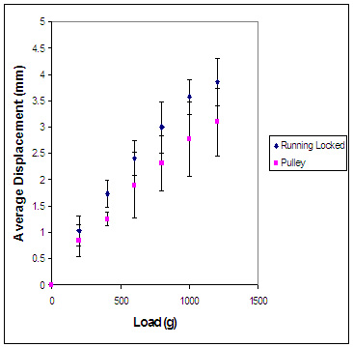
Figure 1. Average values for running locked and pulley stitch. Error bars indicate standard deviation, p=0.518.

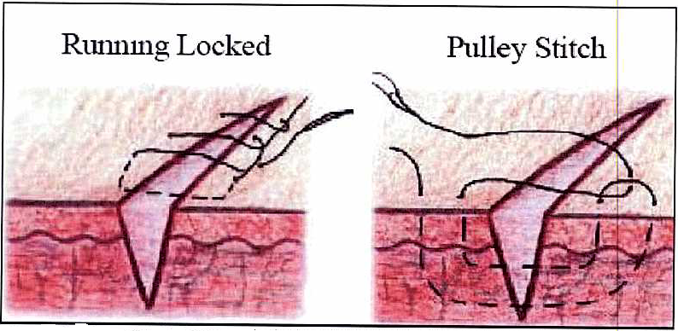
Figure 2. Diagram of the running locked stitch (left), and the pulley stitch (right)

