Tensile Testing:
The Elastic Properties of Different Muscle Tissues

Date Due: 4/24/07
Group Number: 7
Lab coordinator’s Name: Robert I. Mozia
Background

Testing tissue performance is an important way to determine critical tissue properties, such as Young’s modulus, that may affect the types of biological applications of a certain tissue, such as muscle tissue. These properties, called material properties, are affected by the chemical structure of the tissue, and are independent of size, shape and loading conditions.¹ Muscle tissue is a specialized tissue type made for contraction. Muscle tissue comes in three varieties: skeletal, smooth, and cardiac.² These tissues contain special cell groups called sarcomeres that are composed primarily of actin chains and myosin II protein. These Myosin II proteins are composed of light and heavy protein chain groups and movement of these chains cause contraction of the muscles.
Previously, a comparison of cardiac and skeletal muscle in the electrophoresis experiment yielded results that revealed that the mean Myosin light chain II (MLC II) concentrations in skeletal and cardiac muscle samples of the same size to be, 1.35 E -03 M and 1.46 E -03, respectively. A two-tailed unpaired t-test assuming unequal variances did not show the skeletal and cardiac samples to be significantly different (p = 0.71). Yet, this should not be the case, since there are many structural and functional differences between the muscles that directly impact the concentrations of myosin in each. Cardiac muscle must be able to withstand constant contractions which are both very strong and involuntary.² It achieves this by being structurally different from other muscle types, with branched and cross-linked myofibrils and sarcomeres that help resist failure due to strong contractions. Many of the typical muscle structures in cardiac tissue are either shortened or broadened, and additional specialized structures are incorporated into cardiac muscle. Skeletal muscle, on the other hand, contracts with neural stimulation (voluntary contraction) and contracts for a much shorter time than cardiac muscle, both of which require a greater myosin concentration. ² Repeating the Tensile testing experiment with these two types of tissue could serve as another way to confirm the protein amounts and functions (specifically MLC II) in these tissues by quantifying the muscles’ material properties.

Hypothesis/Objective and Aim(s)

The purpose of this experiment is to use tensile testing to determine the Young’s modulus of both skeletal muscle and cardiac muscle at high strain rates. The moduli will then be compared to each other to determine if one is significantly different from the other.

It is hypothesized that the Young’s modulus of cardiac muscle will be less than that of skeletal muscle at high strain rates, because cardiac muscle is specialized to withstand very strong contractions. The result of this specialized structure, however, is a reduction of myosin, and thus MLC II light chains, in the structure of a typical cardiac muscle sarcomere.² Since Young’s modulus is a measure that describes stiffness, a lower modulus of high strain rates would be indicative of a muscles structure which contains more cross-linked structures and less myosin. This material property would serve as further conformation that cardiac muscles have fewer MLC II groups than skeletal muscles. This would also illustrate how characterizing the material properties of biological tissue through tensile testing lends further credibility to the classification of the amounts and uses of proteins in different tissues by other techniques, such as electrophoresis.
Equipment

Major Equipment:

- Instron Model 4444 table-top mechanical testing machine

The tensile testing will be done using the Instron mechanical testing machine. The Instron has a clamp for the tissue sample on the bottom and supplies an upward force from a second clamp opposite the bottom. The machine produces digital signals that correlate with the force being applied to the sample. A LabView program that is directly interfaced with Instron provides graphs illustrating force versus displacement of the sample, and allows the user to make modifications to the Instron, such as cross head speed, and direction of movement.

Lab Equipment:

- Knives
- Scalpel
- Cutting board
- Calipers
- Rulers

The knives, scalpel, and cutting board will be used to create manageable sample sizes from the cardiac and skeletal muscles. The ruler will be used to estimate the length of the sample and calipers will be used to determine cross sectional area once the sample is firmly in place within the Instron clamps.

Supplies:

- Foam
- 2 pig hearts (cardiac muscle)
- 4 pork chops (skeletal muscle)

Foam will be used to familiarize the students will the capabilities of the Instron. 2 pig hearts should provide sufficient material to create enough samples (at least 5) cardiac muscle to test. 4 pork chops should provide sufficient material to create enough samples of skeletal muscle to test.

New Purchased Equipment:

- None

The current laboratory equipment should be sufficient to perform this laboratory.
Proposed Methods & Analysis

General Description
Calibration and setup of the Instron. Creating samples out of cardiac and skeletal muscles tissues. Place each sample in the Instron clamps and perform tensile testing till failure. Record the data using LabView. Create a MatLab program in order to obtain graph of stress versus strain. Calculate Young’s modulus using stress versus strain graph. Perform statistical analysis to tell if the Young’s modulus of cardiac muscle is significantly different from that of skeletal muscle.

Calibration and Setup of the Instron (1 hr.*)

- Calibrate Instron model 4444 bench top materials testing machine:
ο Use 500 g weight to assess the accuracy of the Instron²
ο Use foam pieces in the shape of samples to test the capabilities of the Instron, test possible high strain rates, and become familiar with LabView program
ο Set the displacement rate to 100 mm/min (or other optimal cross head speed)
ο Set cross head direction as upward
ο Start vacuum pump.

Sample Preparation (1 hr.*)

- Create samples from the cardiac and skeletal muscle provided:
ο Using the knife and scalpel, cut at least five rectangular samples out of pig heart (cardiac muscle) provided on the cutting board
ο Samples should be 50mm by 20 mm (depth may be variable)
ο Repeat this procedure for the skeletal muscle provided
- Keep samples uniformly moist until time of testing.

Tensile Testing (2 hr.*)

- Place a cardiac muscle sample in the Instron:
ο Lower the upper clamp into a position that enables a sample to be secured within it
ο Place a sample in the Instron; hit vacuum switch located on each clamp to secure the sample²
ο Manually move upper clamp with the Jog button so that the sample is in a position with little slack; measure width and depth with a caliper, and length with a ruler
- Test cardiac muscle sample till failure:
ο Start the Instron via LabView
ο Failure is achieved when the sample is completely torn apart; stop the Instron when this is achieved
ο Collect and save data gathered using LabView
- Repeat this process for the other cardiac and skeletal muscle samples

Graphing the Raw Data

- Plot Stress-Strain and Force-Displacement by creating a program in MatLab:
ο Identify elastic regions on the graphs (see APPENDIX).
ο Use MatLab to divide Force data in the elastic region by cross-sectional area of each sample to find stress, and divide displacements in the elastic region by gage length to find strain
ο Plot the values in a Stress-Strain graph
ο Use MatLab to calculate the average Young’s modulus, E, of each sample type, using the formula, E= stress/strain

Statistical Analysis

- Compare the difference of the Young’s Modulus’ found for each muscle type:
ο Use a one-tailed t-test assuming unequal variance to distinguish whether the lengths are significantly different.

*Note: total estimated time for this laboratory is four hours assuming a group of four experimenters working on the lab. Graphing and Statistical analysis is not included in this time estimate, as they are related to analyzing the raw data, not obtaining the raw data.

Potential Pitfalls & Alternative Methods/Analysis

Potential Pitfalls & Alternative Methods
The first pitfall comes from the sample preparation. Creating samples could alter the internal structure of the muscles if the muscles are pulled or torn improperly while they are being cut. A simple way to reduce the likelihood of this happening would be to sharpen the knives and scalpel used to cut the skeletal and cardiac muscles to a point where they easily pass through the muscle. Extra care in cutting the samples would also reduce the amount of preliminary strain on the muscle sample.
After the samples were prepared and loaded into the Instron in the previous laboratory, it was observed that sometimes tear would occur at the ends and not in the middle. To prevent this, the sample lengths could be made greater so that ample pieces of the sample would be fastened into the clamps. This would also hopefully prevent slippage, which was also observed in some of the samples in the preliminary laboratory.
One other pitfall that can be somewhat accounted for are the environmental factors that effect the muscle tissue before it is being tested. The primary concern is hydration, since muscle tissue in vivo is constantly hydrated and would not function properly if dehydrated. The other concern is that the muscle tissues are not coming from the same source; that is each heart will come from a different pig, and each piece of muscle tissue will come from a different pig. With the respect to the hydration concern, this could be accounted for by soaking the muscle tissues in water prior to the actual laboratory, and keeping all the muscle tissue moist and hydrated until the time of individual sample testing. As for the different tissue donors, the experimenter will have to assume all the tissue samples are healthy, and that the different donors will not have too great an effect on the experimental results.
Finally, it must be considered that muscle, especially skeletal muscle is arranged in longitudinal strands (see Figure 3, APPENDIX). The muscle should be loaded and clamped as illustrated in Figure 3. If the muscle was to be cut and loaded into Instron in the wrong direction, it could fail at a much lower force than when cut and loaded correctly. Since each group will be given ample amount of skeletal muscle to make samples, it would be wise to create two practice samples from each piece of muscle and test which direction requires the most force to achieve failure. This problem may be neglected in the cardiac muscle due to its cross-linked structure.

Potential Pitfalls & Alternative Analysis
Graphing and analyzing the data may be made difficult by the special force-displacement properties of muscle. These properties are characterized in part by the Hill Relationship. Muscle is characterized by both an active and passive tension component in its force-displacement relationship (see Figure 2, APPENDIX). Active tension derives from the interaction between myosin and actin active tension. Passive tension can develop in the muscle's complex connective tissue when the muscle is not active.³ The proposed experiment assumes that a graph indicative of only passive tension will be generated from the data gathered in the experiment. However, if this is not the case, it may be prudent to look at only the elastic region of the active tension portion of the graph in order to allow for less complicated data analysis.

Budget

Supplies/Newly Purchased Equipment | Quantity | Price | Total price
Pig Heart (cardiac muscle) | 40 | $ 5.95 | $ 238.00
Pork Chops (skeletal muscle) | 40 lbs | $ 2.39/lb | $ 95.60
Polyurethane Foam | 20 sheets | $ 4.85 | $ 97.00
*All prices w/o sales tax
 |  | Grand Total | $ 430.60

1) Pig Heart (cardiac muscle)
Supplier: Sargent-Welch (WWR International), Catalogue Number: WL428-40
Supplier Contact Information: Website: http://www.sargentwelch.com/, Phone: 1-800-727-4368
Description: Pig Heart without Pericardium; Large specimen for general study and dissection; Vacuum packed. The pig’s heart will be the source of cardiac muscle for the experiment.

2) Pork chops (skeletal muscle)
Supplier: The Fresh Grocer, Catalogue Number: none
Supplier Contact Information: Website: http://www.thefreshgrocer.com/, Phone: 215-222-9200
Description: Bone-in center cut pork chops family pack. The pork chops will be the source of skeletal muscle for the experiment.

3) Polyurethane Foam
Supplier: McMaster-Carr, Catalogue Number: 86375K133
Supplier Contact Information: Website: http://www.mcmaster.com/, Phone: 404-629-6500
Description: Quick-Recovery Super-Resilient Polyurethane Foam; thickness: 1/8 “, length: 12”, width: 12”; The foam will be used to become accustomed to the functions of the Instron.
References

1. Winklestein, B., Ph.D, Mannickarottu, S., & Coats, B., Ph.D (Eds.). (2007). Bioengineering 210 Laboratory manual. University of Pennsylvania.

2. Martini, R. (n.d.). Chapter 10: Muscle Tissue. Retrieved April 11, 2007, from
http://cwx.prenhall.com/bookbind/pubbooks/martinidemo/chapter10/

3. Thomas, D. (2001, January 5). LENGTH-TENSION PROPERTIES OF MUSCLE . Retrieved April 21, 2007, from http://moon.ouhsc.edu/dthompso/namics/ltprops.htm

APPENDIX
The MatLab program allowed the user to identify visually relevant regions, below you will find the criterion that was set forth in order to determine the relevant data.

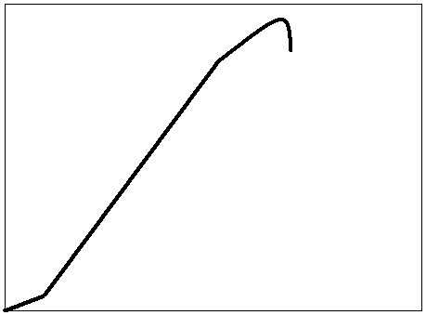
Lag Region
Linear-Elastic Region
Proportionality Limit
Rupture Point
Figure 1 Sample Elastic Deformation Curve, Stress-Strain/Force-Deformation.

Criteria for linear-elastic region selection (for Stiffness and Young’s Modulus measurement).
1. Any non-linear regions starting from the no-load origin are to be ignored.
2. Any linear regions that start from the no-load origin are to be ignored if the following conditions are met.
i. The region is very small in comparison to the overall curve.
ii. The linear region is interrupted by a second linear region of different slope but constitutes a much greater portion of the curve.
3. Any oscillations about a constant slope are negligible.
4. Any drastic and sustained changes in slope constitute and event that ends the linear- elastic region.
4. Any points at which linear progression is interrupted by a drop in stress level constitute an event that ends the linear-elastic region.
5. In an ideal curve, the “lag” conditions outlined in points one and two would not exist and slope oscillations would be minimal. In this case, the end of the linear-elastic region would be when the curve changes from linear to concave down (the proportionality limit)

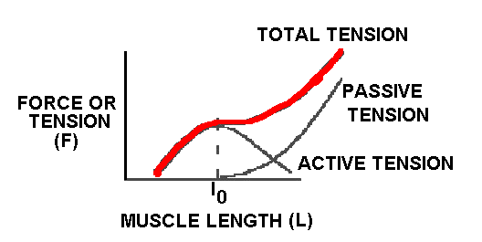
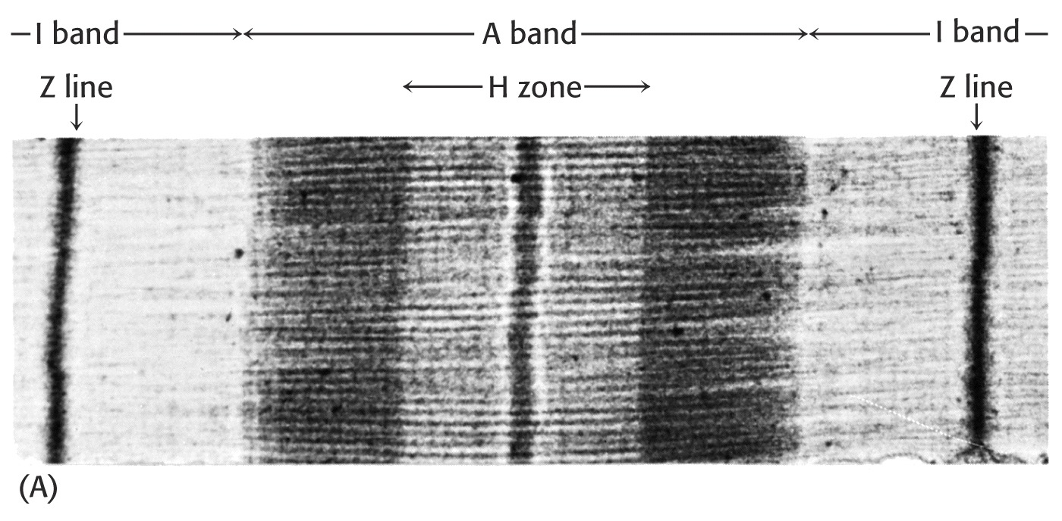
Longitudinal direction
CLAMP
CLAMP
Figure 2 Sample Total Tension Force- Displacement Figure 3 Skeletal muscle Electro- micrograph
Curve

