Polyacrylamide and Agarose Gel Electrophoresis Using Muscle Proteins

Alicia Nelson
BE 210
4/25/07

Background
Electrophoresis is a technique used to separate proteins based on their molecular weight. Proteins that compromise the three different types of muscles (skeletal, cardiac, and smooth) will be isolated and separated based on size. To analyze the gel, the proteins will need to be stained so one can visualize them and use the image for data analysis. The stain binds directly to any protein it has access to and so the gel that allows the most contact of proteins to the dye will produce an apparently higher concentration, even if both samples were originally loaded with the same concentration of that specific protein. Therefore, this lab will expand an experiment in the current BE 210 curriculum titled “Muscle Protein Detection Using Electrophoresis”. The expansion will focus on agarose, another type of gel material, in addition to the current polyacrylamide. This proposed experiment will determine if using an agarose gel is more efficient in staining these muscular proteins and, as a direct result, easier to analyze due to the more defined bands.
Figure 1 in the Appendix shows the polyacrylamide gel used in the original experiment when loaded with 20 μl of muscle protein supernatant, and shows faintly-stained proteins.⁶ To improve the quality of this gel for analysis, one has two options: use more total protein (higher concentration or more volume) in the polyacrylamide gel or try a different type of gel to possibly create a more defined band that is closer to the actual concentration. In addition to determining which gel gives the staining dye better access to proteins, students will choose which gel is easier to compare proteins within different types of muscle, based on possible presence of a significant difference. Accurate concentrations are needed to best compare the same protein in different types of muscles and to develop the correct concentrations of medicines that can potentially manipulate the proteins that interfere with normal muscle function.

Hypothesis/Objective

A. Experimental Hypothesis
The purpose of this experiment is to determine whether an agarose gel or a polyacrylamide gel most accurately stains muscular proteins. Accurate will be defined as: if a significant difference exists in the average protein concentration of a specifically identified protein, then the gel with the higher concentration will be concluded more accurate for staining muscular proteins (assuming both gels are initially loaded with the same concentration of protein, discussed later). The hypothesis of this experiment is if both polyacrylamide and agarose gels are loaded with the same concentration of proteins, then the proteins in the agarose gel will have a significantly higher (more accurate) concentration due to the ability of the staining dye to bind to more proteins. The percent of polyacrylamide used for this experiment will be 4-15%, whereas the percent of agarose used will be 10%. While both of these percents are optimal for the size of proteins to be loaded, a more dense concentration of polyacrylamide in parts of the gel will be used. Therefore, the dye will have less material to work through in the agarose gel compared to the polyacrylamide gel and will have easier access to the protein.

Educational Objectives
- Learn the techniques of electrophoresis
- Become familiar with two different gel types and loading techniques for both.
- Visualize how proteins move through the gels (agarose-horizontal, polyacrylamide-vertical)
- Gain knowledge on computational methods used to analyze molecular weights of proteins and their concentrations
Equipment

The following list of equipment is necessary for this experiment to be completed successfully. Use of equipment for specific steps/methods is described in the BE 210 lab manual with additions/modifications in the methods/analysis section of this proposal.

Major Equipment
- Polyacrylamide gel box – BioRad Mini Protean II & III Cell Electrophoresis System
- Horizontal gel-box system
- Power supply with 2 outputs

Lab equipment
- Pipettes of 20 μl, 200 μl, and 1000 μl
- Regular tips and special gel-loading tips
- Heating block
- Balance
- Plastic weigh boats
- Plastic Containers (4)
- Scalpel
- Scissors

Supplies
- 4-15% ReadyGel Polyacrylamide gel
- 10% Pre-cast Agarose gel

SDS-Page Molecular Weight Standards
- SDS buffer, undiluted
- Loading buffer
- 1.5 ml microfuge tubes with DTT
- 1.5 ml microfuge tubes
- Cardiac, Smooth, and Skeletal muscle specimens
- Coomassie Blue Stain
- Destain solution
- TAE 10x buffer

Newly purchased equipment
- 10% pre-cast agarose gel – To save time compared to hand-made agarose gel, need agarose to be the material used to make the gel in contrast to polyacrylamide
- TAE 10x buffer – TAE buffer provides better resolution of fragments >4 kb, preferred over TBE (Tris-Borate-EDTA) buffer, which provides better resolution of 0.1 to 3 kb fragments.¹
- Horizontal gel system – Agarose gel cannot run nor be supported in a vertical system.

Proposed Methods and Analysis
Follow basic procedures as detailed in the BE 210 laboratory protocol for Experiment 1: Muscle Protein Detection Using Electrophoresis with the following changes to the noted sections.

Section A: Buffer Solution (10 minutes)
2. Dilute the 10x TAE buffer by 10 to make 1x TAE. Add 90 ml dH₂O to 10ml 10x TAE.

Section B: Sample Preparation (30 minutes)
Addition to 4. For each muscle tissue, cut a piece of tissue sample approximately the size of a pencil eraser and weigh. Add or cut off more from other samples so the same weight of muscle is used for each sample, minimizing potential differences in protein concentration. Place it in the appropriately labeled microfuge tube with DTT.

Section C: Electrophoresis Gel and Device Setup (30 minutes)
Section C Part II:
1. Become familiar with the horizontal gel station and locate positive (red) and negative (black) terminals. (Figure 2, Appendix)
2. Request a pre-casted agarose gel. Each group only gets one so be careful. Open the package and carefully remove the gel from the package.
3. Place the agarose gel on the middle platform of the provided gel station. The wells of the gel should be closest to the black terminal so the proteins can run toward the positive (red) terminal.
4. Fill the gel box with 1x TAE buffer until the buffer just barely covers the gel and fills the holes of the gel with buffer. Migration of DNA is slowed and band distortion can occur when too much buffer covers the gel. A reduced voltage gradient across the gel results in slower migration.

Section D: Sample Loading (20 minutes) Each group will have 10 wells, two of which will be used for trial loading. Students should decide which wells to load which type of muscle protein. If comparing two types of muscles, students should optimally use 4 wells for each muscle type. .
6. Loading the agarose gel. Attach a regular pipette tip to the end of the same pipette.
7. Load a trial sample and practice dispensing the trial into the agarose gel. If the sample contains a loading dye that colors the sample, you should see the sample stay contained within the loading well. Each agarose gel has ten wells, so depending on your experiment, up to two may be used for trial loading.
8. Load each sample each in a different well. Be sure to dispense all samples slow enough that no sample is forced upward. Also be sure that bubbles within the pipette tip do not interfere with dispensing the sample. Use a NEW pipette tip for each lane.
9. Load 10 μl of the molecular weight standard after all samples have been loaded.

Section E: Running the Gel (90 minutes)
1b. Position the gel against the side of the box with no space between the two. Place the lid on the horizontal gel box without disturbing the placement of the gel. Connect terminals to appropriate spots on the box (red on red, black on black) and other end to power supply. (Agarose gel will also run at 100V)
5b. Run the agarose gel for 60 minutes.

Section F: Staining (60 minutes - Follow as stated, placing each gel in separate staining boxes.

Section G: Destaining (90 minutes) - Follow as stated

Section H: Imaging (10 minutes) - Follow as stated

Section I: Analysis
1. Use Matlab to create a standardization curve by plotting the log of the known molecular weights against the relative mobility for each protein in the standard for both the polyacrylamide and agarose gels.
2. Determine the molecular weight of at least three proteins from the regression equation of the standardization curve and interpolating the standardization curve.
3. Identify these proteins to use for comparison
4. Determine the concentration of each protein by finding the cumulative value of positive pixels and then multiplying it by the conversion factor (found from the assumed 2ug/μl concentration of the standard bands and averaged cumulative value of positive pixels of the standard bands)
5. Average the concentration for the protein in both the polyacrylamide and agarose gels.
6. Perform a two-tailed t-test on the two sets of concentrations to determine if there is a significant difference between the two types of gel. If additional analysis is to be performed, students should use the gel with higher concentration of protein to determine further conclusions.

Potential Pitfalls & Alternative Methods/Analysis
Many factors can affect the results of obtaining clearly defined bands that give the most accurate concentration. One of the most important factors in the above experiment is the selection of pre-cast agarose gel. Agarose gels vary in concentrations and gels can even be made using a gradient concentration. The concentration of agarose would greatly affect how the proteins move through the gel, how the dye is able to bind to the protein, and the shape of the band after electrophoresis (fuzzy vs. defined). To avoid these pitfalls, a 10% gradient would be better than a 3-8% gradient because the proteins found in the muscle samples during the original experiment were of weights 13kDa (smoothelin-a) ¹, 43kDa (musclin) ², and 59kDa (dystroglycan) ³. In addition, myosin has a molecular weight of 500kDa⁴, so a gel would have to accommodate a wide range of weights. Agarose gradients of 3-8% separate protein molecules with molecular weights of 200-400 kilodaltons⁵ so this percent gradient would not work for the proteins identified in the previous experiment.
Therefore, there should be several preliminary experiments before the students perform the aforementioned experiment. These experiments could vary the agarose concentration and even instate a gradient. 3-8% would not be ideal, but the experiments may conclude there is a concentration other than 10% (or a gradient) that works better with muscular proteins. Once the preliminary experiments are completed, the concentration that separates the greatest number of bands while maintaining defined bands for each, will be chosen to use for this proposed experiment.
In addition, the original experiment called for 5-40 μl of sample, so the wells need to be large enough to support up to 40 μl of sample, if that is the students’ chosen loading volume. Therefore, a gel with a 50 μl/well volume was favored over 30, 20, and 15 μl to allow students to decide which sample volume they would load and to permit consistency with the volume loaded in the polyacrylamide gel. This allowance of volume choice may create a potential pitfall, as too much protein, as well as too little protein, can disrupt the optimal band shape, and analysis of concentration. If too much protein is loaded, the band will be fuzzy and if too little protein is loaded, the band will be too faint. The same concentration must be loaded for both polyacrylamide gels and agarose gels to provide a comparable experiment, but it is unknown if the same volume in both types of gel will be optimal for protein analysis.
The optimal sample volume loaded cannot be determined based only on volume because one group (group 1) may cut 0.75g of muscle and another group (group 2) may cut 2.75g of muscle. Assuming each gram of muscle has the same proportion of protein, group 1 could load three times as much volume as group 2 and theoretically each well would contain the same amount of protein. Therefore, one could suggest optimal weights and volumes to use (minimal differences would still exist due to the fluctuating concentration of different proteins throughout a muscle). As shown in Figure 1 (appendix), the bands were faint in the original polyacrylamide experiment and 20 μl of each sample was loaded into each well.⁶ Based on these results, recommendation of at least 25 μl sample is suggested when using 2.74 ± 0.01 g of muscle.
Data analysis would also affect the results if the students further analyze the data (i.e. to compare size of protein). Specifically, the resolution of the ruler used can cause fluctuation of the calculated molecular weight. Shown in a previous experiment, changing the distance traveled by the band by the resolution of the ruler, 1mm, the smoothelin-a protein (59.0 ± 0.6 kDa) would change the average by ±0.8 kDa.⁶ To reduce these possible deviations, several additional trials should be completed to average differences. The students may want to run two gels of each type to have twice the data, provided they have enough time. Two times the data would minimize differences in data analysis.

Budget
The following is a detailed potential expense report, totaling $696.40:

$92.50 ($9.25 x 10) Ready Gel TBE Gel, 10% agarose in TBE, 10-well, 50 µl, 8.6 x 6.8
cm (W x L) from Biorad.

$91.90 TAE (Tris-Acetate-EDTA) 10x concentrate buffer, no DNase or RNase detected, 4 liters
each. 0.4 M Tris acetate, pH approx. 8.3, containing 0.01 M EDTA, from Sigma Aldrich.

$512.00 ($261.00 x 2) Horizontal Gel Kit, gel bed is 7.5cm x 10 cm (W x L) from C.B.S.
Scientific

References:

1. Nishizawa et al. “Musclin- a Novel Skeletal Muscle-derived Secretory Factor.” Journal of
Biological Chemistry. Vol. 279, Issue 19, 19391-19395. May 7, 2004.
http://www.jbc.org/cgi/content/full/279/19/19391

2. Durbeej and Campbell. “Biochemical Characterization of the Epithelial Dystroglycan
Complex.” Journal of Biological Chemistry. Vol. 274, Issue 37, 26609-26616. September
10, 1999. http://www.jbc.org/cgi/content/abstract/274/37/26609.

3. Niessen et al. “Smoothelin-a is Essential for Functional Intestinal Smooth Muscle
Contractility in Mice.” Gastroenterology. Nov. 2005, 129(5):1592-1601.
http://www.gastrogournal.org/article/PIIS0016508505017336/abstract

4. Paul Dreizen et al. “Myosin” Journal of General Physiology. Vol 50, 85-118. Rockfeller

University Press, 1967. http://www.jgp.org/cgi/reprint/50/6/85

5. “Precast Gels, 8 cm x 10 cm” product description. Ward’s Natural Science. Accessed April
22, 2007. http://wardsci.com/product.asp?pn=IG0011679

6. Alicia Nelson, Albert Park, Amulya Penmetsa, Charlotte Tsui. “Protein Muscle Detection
Using Electrophoresis.” March 2007, not for publication.

Appendix

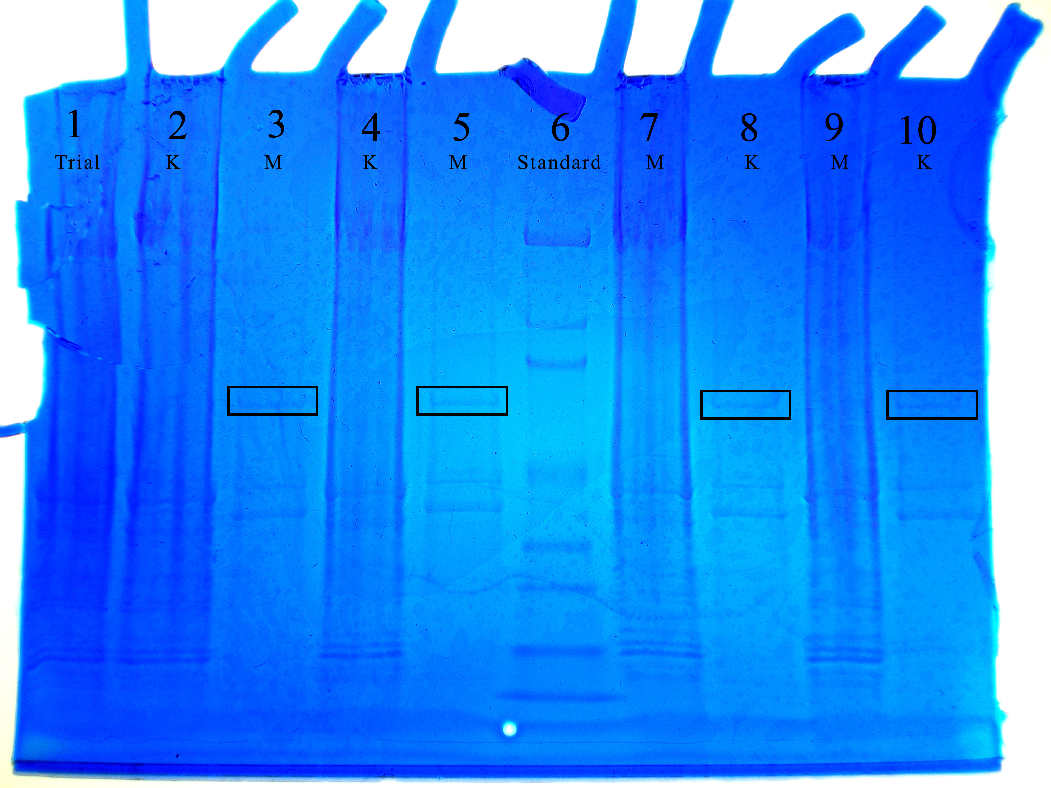

Figure 1. Electrophoresis gel of proteins in the smooth and skeletal muscles. Lanes marked with ‘M’ represent lanes containing smooth muscle cell proteins, while ‘K’ refers to lanes with skeletal muscle proteins. The boxes refer to the chosen protein, smoothelin-a, bands of the smooth muscle samples.

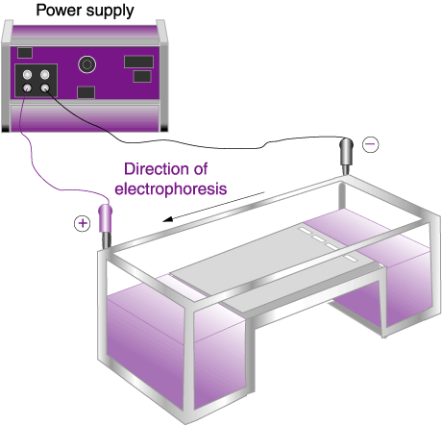
\

Figure 2. Agarose gel and vertical
electrophoresis (protein separation)

