Testing Techniques for Determination of Strain
Lauren Pietruszynski
April 25, 2007

A. Background
This experiment is designed to combine the “Imaging Techniques for Measuring Suture Displacement During Uniaxial Tension” and “Instron Tensile Testing: Structural & Material Properties of Chicken Skin”. Both of the experiments use equipment that measures the force and displacement of a material. The clamps used in the “Imaging Techniques for Measuring Suture Displacement During Uniaxial Tension” however, are a much cheaper way of measuring strain using force and displacement data. If these clamps measure the strain as well as the Instron (used in the Instron Tensile Testing: Structural & Material Properties of Chicken Skin experiment), then for any experiment requiring a specific strain found using a static force, a clamp configuration can be used rather than requiring the purchase of an Instron machine. The goal of this experiment is to determine whether there is a significant difference between the strains found using the two techniques so as to determine whether using the clamps is an accurate way of determining strain. It was determined in the “Instron Tensile Testing: Structural & Material Properties of Chicken Skin” experiment that a cross-sectional width of 1-cm compared to a cross-sectional width of 0.50-cm does not affect the failure displacement of chicken skin (Figure 1 & 2). It will be assumed for this experiment that this is also true for the surrogate testing (Confor Polyurethane foam). Thus, for this experiment, a 0.5-cm cross-section will be used so as to enable more samples to be cut.
B. Hypothesis/Objective and Aim(s)
Goal
- To determine whether there is a significant difference in the observed strain of a material when using two different pieces of equipment to perform the experiment.
Hypothesis
- There will be no significant difference between determining strain using an Instron (4444 model) and two clamps with weights.
Objectives
- To determine strain using various experimental procedures.
- To derive strains for simple uniaxial loading.

C. Equipment
Major Equipment
Instron Model 4444 Benchtop Materials Testing Machine
  - To perform the tests on half of the samples and determine displacement and force. Will help determine the strain at specific forces.
CCD Camera (640x480 pixels
  - Takes pictures of the samples before and after deformation from the clamps in order to find the displacement.

Lab Equipment
Clamps and Stand
  - Used to hold the other half of the samples (not used in the Instron) so the weights can be placed on the clamps and determine strain at specific forces.
Calipers
  - Used to Measure the width of the material, and other length measurements needed throughout the experiment
Weight Set
  - Creates the force on the clamps used to test the strain of the material

Supplies
Scissors
  - Used to cut the foam into testable samples
Rulers
  - Used to make length measurements needed throughout the experiment (i.e. gauge length)
Marker Pens
  - Used to mark the material in the clamps so the deformation will be easier to measure when looking at the picture on the computer using the CCD camera.
Stopwatch
  - Measure time from weight attachment on clamp to end of displacement. Used to determine velocity.

Newly Purchased Equipment
Confor Slow Recovery Polyurethane Foam
  - Used as the material to test the strain. This material was chosen for this experiment because it worked well in the “Instron Tensile Testing: Structural & Material Properties of Chicken Skin” experiment; there was a clear and distinct linear region in the force v. displacement graph (Figure 1 and 2), and the material was easy to keep in the clamps of the Instron.

D. Proposed Methods and Analysis
- Surrogate Harvest and Preparation (~30 min)
1. Cut the Confor Polyurethane Foam into 20 rectangular samples, with a length of 3cm and a width of 0.5cm.
- Clamp Set-Up and Surrogate Testing (~1 hr)
    - Follow the procedure detailed in the lab manual for the “Displacement Measurement: Image Analysis” keeping in mind that there will be no sutures, instead just one piece of material. (NOTE: Don’t forget to convert weight into force when determining force applied to the sample)
- Determination of Loading Rate for Instron (~30 min)
    - Using an extra piece of foam cut a rectangle in the same dimensions as the samples (3cmx0.5cm). Take a picture using the CCD camera of the surrogate in the clamps before any weight has been added.
    - Using a stopwatch, determine the amount of time needed from the moment the weight (whichever weight was chosen as a weight to test the strain) is placed on the lower clamp to the moment that the weight stops moving and the full deformation has occurred.
    - Take a picture of the deformed sample in the clamps using the CCD camera
    - Using the calibration information determined in Part B (Clamp Set-Up and Surrogate Testing) and the picture taken of both the un-deformed and deformed sample, determine the deformation caused by the weight by measuring the pixel distance (Figure 3 & 4) and then converting the pixel distance into millimeters. There will be a slight difference in the measurement of the foam samples compared to the suture samples in Figures 3 & 4 as the foam samples will need to be measured using markers on the foam itself as close to the clamps as possible, and measuring the entire gauge length.
    - Using the equation Distance/Time=Rate, divide the deformation (in millimeters) by the amount of time needed for deformation. This is the velocity which will be used as the loading rate for the Instron.
- Instron Set-Up and Surrogate Testing(~3 hr)
    - Set up the Instron as directed in the “Tensile Testing: Elastic Properties” experiment, following steps 1 and 2.
    - Cut extra foam pieces into 3cmx0.5cm rectangles to serve as practice for using the Instron.
    - Next you will need to set the gauge length. This allows the original length to be the same for every sample, and ensures that the deformation begins at zero. To do this, according to the Instron Manual,
        - Drive the crosshead up or down, as required, using the JOG keys on the Frame Control Panel. Use a ruler to determine the exact spacing between contact faces of upper and lower grips, or anvil and compression plate.
        - Press the G.L. RESET key to enter the gauge length into system memory.
The AT G.L. LED should become steady. This LED will then go out whenever the crosshead is moved from gauge length.
NOTE: Once the gauge length has been set, the crosshead will always return to this position upon hitting the RETURN button.
    - To ensure that the Instron will stop at the same weight as the weight used on the clamps, you will need to set electronic limits on the Instron (NOTE: Don’t forget to convert back into Newtons when determining the force applied)
        - Press the LOAD limit key (MIN or MAX) for the required limit. The related LED lights and the current limit value appears on the Main Panel Display.
        - Enter the value, of the limit on the keypad. The displayed number flashes until it has been entered into the system
        - Press ENTER on the keypad. The number stops flashing
        - Press the CROSSHEAD ACTION key for the limit just entered. Indicator LEDs (ACTION and STATUS) for the limit will light
        - Press STOP
    - Continue with the setup detailed in the lab manual starting with part 4 (In “Tensile Testing: Elastic Properties”). For the crosshead speed use the speed determined from the testing using the clamps.
    - Use the same procedure in step 4 of the lab manual (h-r of “Tensile Testing: Elastic Properties) to test the surrogates, remembering to hit the RETURN key for the Instron to return to the original gauge length after each specimen.
Protocol
- Load each of 10 samples into the clamps and test at the same specific weight using the weight set.
- After the first sample has been run through the clamps, determine the displacement and time needed for displacement. Then determine the loading rate needed for the Instron machine using Rate=Distance/Time
- Load each of the other 10 samples into the Instron and test at the same weight as used in the clamps and using the loading rate determined above. Record the displacement
- Determine the strain at the specified weight from the force and displacement values using the equation for strain (Figure 5).
- Use a one-tailed unpaired t-test assuming unequal variances to determine if the strain found using the Instron is significantly different than the strain found using the clamps.

E. Potential Pitfalls & Alternative Methods/Analysis
Since the Instron machine tests samples by stretching at a constant speed while the clamps have the acceleration of gravity, there could be a difference in the strain determined because of different loading rates. To minimize this error, at least one sample must be run first in the clamps. From this, the displacement can be determined, as well as the time taken for the weight to reach its final displacement. Using the equation Rate=Displacement/Time, the loading rate for the Instron can be taken as the displacement of the weight divided by the time taken to reach that displacement. This will minimize the error caused by using different rates.
The low resolution of the camera can affect the accuracy of determining the deformation of the material. However, in the “Imaging Techniques for Measuring Suture Displacement During Uniaxial Tension” experiment it was determined with 95% confidence that the camera yields an interval of the mean displacement ±3.2% (Figure 6).

G. Budget
Confor Polyurethane Foam (1/4” thick)
Each group will receive a 12”x12” sheet of Slow-Recovery Super-Resilient Polyurethane Foam, with a ¼” thickness, ordered from McMASTER-CARR online.

Item number: 86195K31
Cost Per Sheet: $4.63
Total number of groups: 20
Total Cost: $92.60

References
Cheng, Gina et al. (Group 101-3) “Imaging Techniques for Measuring Suture Displacement During Uniaxial Tension”. 4/12/07.

Cheng, Gina et al. (Group 101-3) “Instron Tensile Testing: Structural & Material Properties of Chicken Skin”. 2/22/07.

“Displacement Measurement: Image Analysis” & “Tensile Testing: Elastic Properties” Experiments. Bioengineering Laboratory II: Laboratory Handout, Spring 2007.

Instron Model 4400 Universal Testing System Operator’s Guide M10-94400-1 Issue C April 1995. pages 5-28&5-29, 5-30 thru 5-32.

Picture of Strain Equation. http://www.ajdesigner.com/phpstress/stress_strain_equation_strain.php

“Polyurethane Foam”. McMASTER-CARR. www.mcmaster.com. Item #86195K31.

H. Appendix
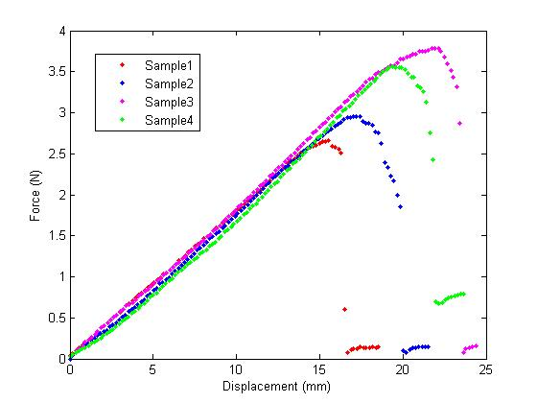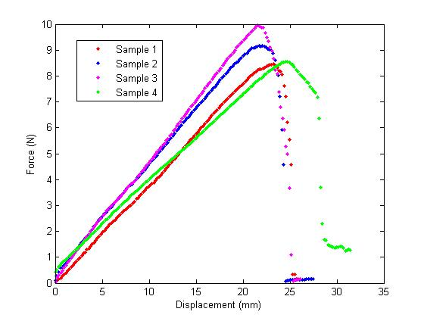

Figure 1. Force-displacement curves of 4 Confor Polyurethane Foam samples with 0.5cm width
Figure 2. Force-displacement curves of 4 Confor Polyurethane foam samples with 1cm width

- A one-tailed t-test assuming unequal variances is used to compare the failure displacements of the 1-cm wide chicken skin and the 0.5-cm wide chicken skin. A p-value of 0.320 was found, indicating that the 1-cm wide chicken skin is not significantly greater than that of the 0.5-cm wide chicken skin.

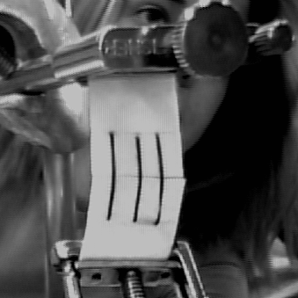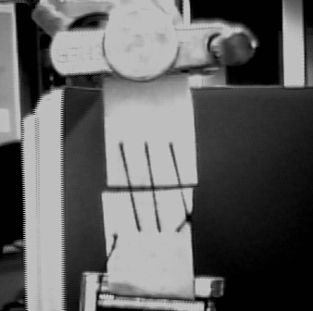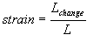

Figure 3.Undeformed 3-suture felt sample taken with a camera having a 640x480 pixel resolution.
Figure 4. Deformed 3-suture felt sample, taken with a camera having a 640x480 pixel resolution
Figure 5. Strain(mm/mm)= Total Elongation(mm)/Original Length(mm)

Conversion Factor (pixels/cm)
Picture 1 | 50.68
Picture 2 | 50.68
Picture 3 | 49.76
Picture 4 | 50.68
Picture 5 | 50.68
AVG | 50.496
SD | 0.411436508
Figure 6. Conversion factor found using a ruler oriented exactly as the samples are oriented in relation to the camera. Calculation of a 95% confidence interval yields a value of the mean ±3.2%

