**Diseased and Normal Cardiac Muscle Comparison Using Electrophoresis**

**Vivian Shaw**

**4/25/07**

**Background**

In experiment 1 (Muscle Protein Detection Using Electrophoresis), it was determined that there is no significant difference between myosin concentrations in cardiac and skeletal muscle (p value between the two samples = 0.081 > 0.05). This proposed experiment use the same methods used in this previous test. However, expanding upon the results found in this experiment, this proposal will test the differences in myosin concentration in cardiac muscle of people without heart problems, such as the samples used in experiment 1, and the cardiac muscle of persons with dilated cardiomyopathy. The comparison of these two samples will be done using the same band used in experiment 1, the 17,000 amu myosin light chain band.1

According to the Merck Manuals Online Medical Library, “Dilated (congestive) cardiomyopathy is a group of heart muscle disorders in which the ventricles enlarge but are not able to pump enough blood for the body's needs, resulting in heart failure”.2 As myosin and actin are responsible for the pumping action of the heart, the decrease in pumping power is expected to relate to a loss of myosin and actin in the diseased muscle.3

**Hypothesis/Objectives and Aims**

*Hypothesis:* Myosin, a common protein in muscle tissue, will be more abundant in the cardiac muscles of cardiac muscle without any major problems than in the cardiac muscle of a person with dilated cardiomyopathy.

*Objectives and Aims*:

* Gain knowledge of electrophoresis, an experimental technique used to separate proteins on the basis of molecular weight or electrical charge.
* To isolate, identify, and quantify protein in mammalian muscle using electrophoresis
  + To determine the effects upon the concentration of certain proteins in cardiac muscle of dilated cardiomyopathy

**Equipment**

*Lab Equipment*

BioRad Mini Protean II & III Cell Electrophoresis System

Power Supply (BioRad PowerPac Basic & 300)

Heating Block

*Supplies*

4-15% ReadyGel Polyacrylamide Gel

SDS buffer, undiluted

Loading Buffer

1.5 mL microfuge tubes with DTT

1.5 mL microfuge tubes

Cardiac muscle specimen of a person without any heart problems

SDS – Page Molecular Weight Standards

Coomassie Blue Stain

Destain Solution

Plastic Container

Pippettes and tips

Scalpel

Scissors

*Newly Purchased Equipment*

Cardiac muscle specimen of a person with Dilated Cardiomyopathy

**Proposed Methods & Analysis**

* Prepare samples of both cardiac muscle of a person without any heart problems and cardiac muscle of a person having dilated cardiomyopathy in microfuge tubes as outlined in the lab manual. This should take about 20 minutes.
* Practice loading samples in lanes 1 (dilated cardiomyopathy) and 10 (normal) of the gel with 10 µL of sample.
* Load lanes 3, 5, and 7 with 10 µL of the dilated cardiomyopathy cardiac sample and lanes 4, 6, and 8 with 10 µL of the normal cardiac sample. Load lane 2 with 10 µL of standard.
* Run the gel at 110 V until the blue line of dye is just about to run off the gel into the solution for about 1 ½ - 2 hours. Stain the gel with Coomassie Blue for 30 minutes.
* Drain the dye and add destaining solution and a wadded paper towel. Let the gel sit for 45 minutes. Repeat with new solution and a fresh paper towel, and let the gel sit for another 45 minutes.
* Drain most of the solution and take a digital photo of the gel.
* Using MATLAB image analysis software, select areas of interest around the 17,000 amu myosin light chain protein band, and record the cumulative positive pixel value. Repeat three times per band.
* Create a graph of the relationship between distance traveled on the gel and molecular weight using the standard. Using this relationship, calculate the molecular weight of the sample proteins.
* Find a conversion factor between concentration and pixel value of a band using the standard. Using this conversion factor, calculate the concentration of the 17,000 amu myosin protein.
* Conduct an unpaired t-test comparing the mean concentration of 17,000 amu myosin protein in each sample band for the dilated cardiomyopathic cardiac muscle and the typical cardiac muscle, and analyze the one-tail p value.

**Potential Pitfalls & Alternative Methods/Analysis**

One possible pitfall could occur during preparation of the muscle samples. During this step, the cell is lysed and the proteins are denatured so that they will be trapped in the polyacrylamide gel at different points based on their size. However, if the muscle sample is not digested well, the proteins will not come out of the cell and the gel will not have good results. To avoid this problem, experimenters should allow a little extra time for the mixing of the sample with DTT and the sample’s time on the heat block.

Minimal uncertainty in this experiment could be related to the analytical procedures which determine the molecular weights of each band. The curve fit used to extrapolate a relationship between distance along the gel traveled and molecular weight of the band could have a R-squared value below .95 or may not be a very good representation of that relationship. One method to reduce this error could be the use of a reference point to find the distance in pixels traveled along the gel when using MATLAB (ex. Finding the y value of the gel at the northwest corner of each band).

Additionally, quantitative analysis of the pixel color intensity could add a significant amount of error. Small changes in the position of the region of interest could result in very different calculated values for intensity, as the threshold value against which the significant bands are measured is accounted for by the top and bottom lines of the selected region. To minimize this error, experimenters should always check the selected areas to make sure that they selected a region that does not include too much outside noise (significant values discovered outside of the band) and that the selected area includes the background around the band.

**Budget**

*Purchase:*  muscle from persons with dilated cardiomyopathy

*Cost*: $1400

*Supplier:* Science Care

*Specifications:* enough for 40 2x1 inch pieces

*Justification:* Is one of the main samples being tested

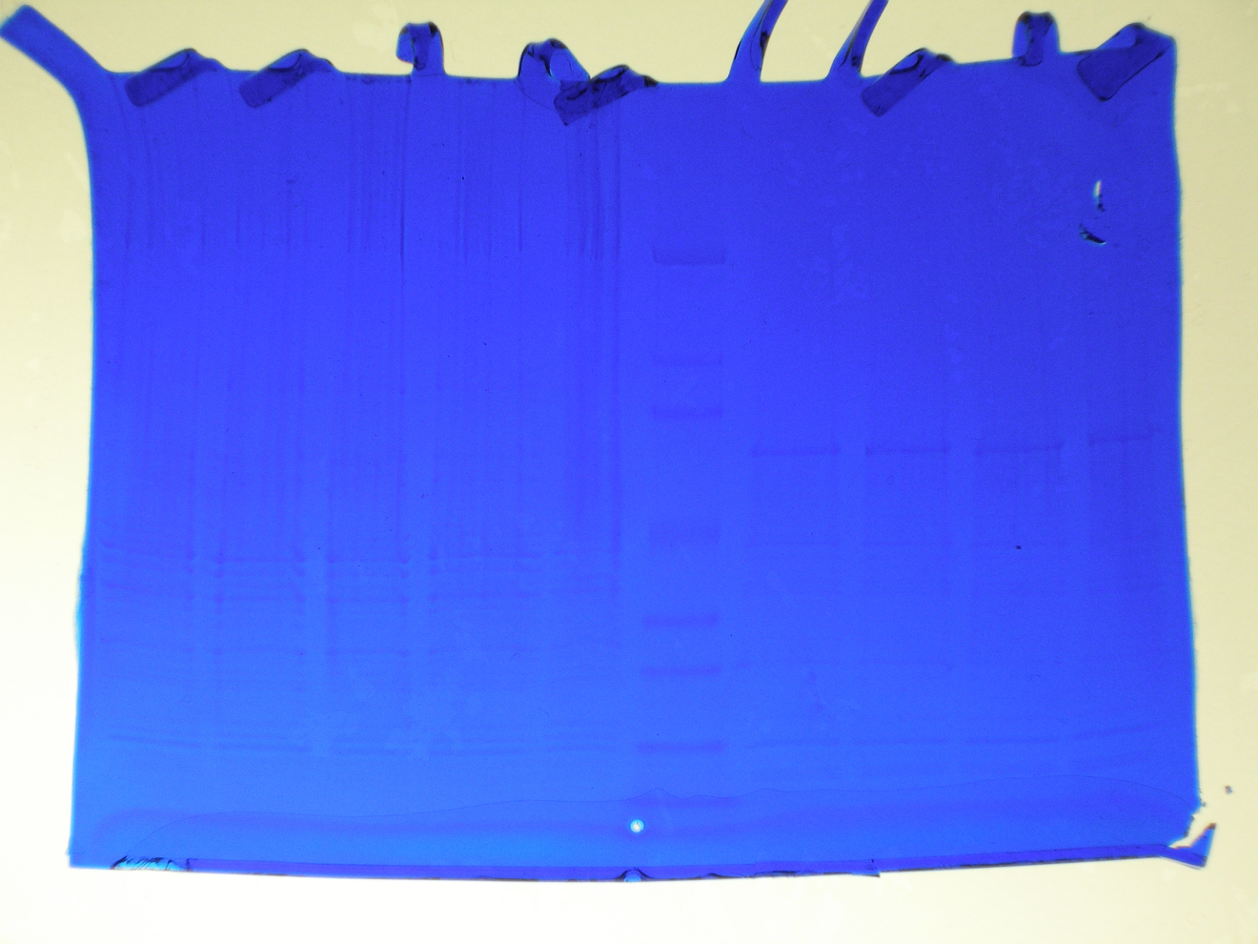**Appendix**

1

Myosin light chain protein band

**References**

2 Dilated Cardiomyopathy. (2003). In *Merck Manuals Online Medical Library* [Web]. Merck. Retrieved

April 24, 2007, from <http://www.merck.com/mmhe/sec03/ch026/ch026b.html>

3 Alberts, B, Johnson, A, Lewis, J, Raff, M, Roberts, K, & Walter, P (2002). *Molecular biology of the cell*.

New York: Garland Science.