Effects of Elastin Content on Material Properties of Arteries
Date Due: April 25, 2007
BE 210
Section 102
Piyali Sircar

BACKGROUND

Elastin is the dominant extracellular protein in tissues which need to withstand high stress and strain without compromising mechanical integrity or structure. Skin, arteries, lungs and diaphragm are some organs that depend on elasticity to function. However, under physiologically aberrant conditions (i.e. genetic mutations, acidosis, smoking) or aging elastin may a) not be present or b) not function optimally.¹ Patients with hypertension exhibit lower levels of elastin in their arteries, suggesting that mutations in the elastin gene cause hypertension⁴, which affected 50 million adults in the US in 2004.² Mutations or deletions of the elastin gene, account for three known clinical conditions, by dramatically lowering the functional capacity of organs and tissues with elastin content.⁴ In yet another study, subjects over the age of 50, displayed greatly reduced artery distensibility, suggesting that elastin content diminishes with age.⁹ Because elastin is an integral component of many tissues and is implicated in a variety of disorders when damaged or absent, it is important to study its effects on the material properties of the tissues it comprises. This experiment will simulate abnormal conditions where elastin is absent to quantify and compare its material properties to those of normal tissues.
In a previous study using chicken skin, no significant correlation was found between displacement rate and Young’s modulus (p value=0.46). This result is most likely attributed to the lack of a significant disparity between the two rates chosen, 25 mm/min and 75 mm/min.¹³ This lab is an extension of this previous study, which aims to investigate the effects of an intrinsic property on material properties. The elastin in arteries will be denatured to compare normal arteries, high in elastin content, to samples lacking elastin. Although there is a high degree of variability in elastin content of different arteries, they will used indiscriminately. Differences in elastin content will be normalized as best as possible in an even sample distribution. Matlab will be used to identify the points of ultimate stress and points of failure to calculate fracture energy which will be compared between the E+ and E- samples.
(Note: E+ will be used to denote tissue samples containing elastin where E- will denote tissue samples that have been treated with elastin with no functional elastin.)

HYPOTHESIS/OBJECTIVES

The objective of this experiment is to evaluate the effects of eliminating elastin on the material properties of arteries, normally high in elastin content (30-41% elastin by weight in canines).⁵ In order to denature elastin, tissues will be submerged in a 6.5 ug/mL solution of elastase for 40 minutes. It is hypothesized that the ultimate stress and fracture energy of tissues lacking elastin will be lower than those corresponding to normal tissue. This is because the greater the elasticity, the more the material will stretch prior to rupture and the greater the requisite energy to achieve rupture. It is important to note that while elastin is digested, collagen, a triple helix molecule responsible for tensile strength, will remain unaffected by elastase. Another reason behind this hypothesis is the strong correlation between low elastin content and human disorders suggesting poorer material properties. Other goals of this experiment include practicing dissection technique and the biological focus of learning fetal pig anatomy.

EQUIPMENT

Major Equipment

Instron 4444 Benchtop: The Instron will be used to apply equal and opposite loads to artery samples and provide a means to measure the force applied to the tissue. The machine’s head speed (displacement rate) may be adjusted to yield optimal results. See Manual for operation.¹⁴

Lab Equipment

Scalpel (with fresh supply of blades), Scissors, Forceps: These tools will be used to dissect the fetal pig and carefully extract as many identifiable arteries as possible (should be labeled with injected red latex). Instruments will also be used to cut arteries into equal lengths and make longitudinal incisions down the length of each artery in order to separate the rubber tubing from the artery walls. Forceps will be used to mount the specimen in the Instron.

Plastic rulers, Calipers: Rulers will be used to measure the lengths of artery segments to be tested as well as the consequent length and width of the artery walls after the longitudinal incision down the tube is made. Calipers will be used to measure the thickness of the arterial wall.

100 mL beaker: Tissue samples will incubate while they are digested by elastase in this beaker.

Supplies
Fetal Pigs (Quantity: 10) ¹²: Students will dissect fetal pigs to extract arteries to be used as samples in the second half of the experiment: tensile loading.¹²

Fetal Pig Dissection Manual (40) ¹²: Students will be asked to read this manual ahead of time and bring it to lab so they are prepared for the dissection and it takes place in a timely manner.¹²

Elastase ¹⁰: This protease will specifically target and digest elastin at an optimum pH of 8.5 and temperature of 37 degrees C, although its function is efficient enough for the purpose of this experiment at 25 degrees C and a pH of 8.0. The enzyme will be shipped as a lyphilized powder which should be stored in a solution of KCl or an alkaline buffer to resist changes in pH at a concentration of 0.1 M. The working concentration of elastase should be prepared before lab, diluted to a concentration of 6.5 ug/mL in Tris buffer. This concentration of elastase is suitable for treating ~100 mg of elastin in 40 minutes.¹⁰ (~385 mL of working concentration elastase, enough for 13 groups, can be prepared from the aliquot ordered.)

Tris Buffer ¹⁵: Elastase will be diluted to a concentration of 6.5 ug/mL in Tris buffer prior to use in the lab.

Confor Polyeurethene Foam: This will be cut into uniform rectangles and used as surrogates to familiarize students with the Instron machine and help them select an appropriate displacement rate for the opposite ends of the machine.
PROPOSED METHODS & ANALYSIS

- Instron Set-Up & Surrogate Tensile Testing (Estimated Time: 30 min)
  - Refer to the Lab Manual to calibrate the Instron Machine.
  - Use Confor Polyurethene Foam surrogates to familiarize yourself with the Instron machine and determine an appropriate displacement rate to be kept constant throughout the experiment. A suitable speed is one which stretches the artery at a reasonable rate while collecting a sufficient number of data points for accurate data analysis.

- Fetal Pig Dissection & Extraction of Arteries (2 hours)
  - Two groups will share a fetal pig. Each group is responsible for obtaining 20, 5 cm artery samples. See Pig Dissection manual for initial incisions to be made. Extract necessary organs.
  - Blood vessels injected with red latex are the arteries. Identify these and extract them carefully. To remove an artery use the forceps to hold the artery steady near the site of the cut, while using the scalpel to make the incision. (Major arteries to look for include the ascending & descending aortas and the proximal & distal cranial mesenteric arterties.
  - Extract as many arteries as possible. (One fetal pig will be shared between two groups).
See Figure 2 in Appendix for major arteries in pig.

- Sample Preparation (1 hour 15 min)
  - Cut as many 5 cm artery samples as possible, keeping samples derived from each artery, separate from one another. Each group should be able to obtain at least 20 samples from the total, combined length of arteries in fetal pig. Because the percent elastin content in different arteries ranges from 15.6 +/- 0.7% in the coronary artery to 41.1 +/- 2.1 % in the ascending aorta (data taken from canines), it is important to ensure an even sample distribution to minimize differences. In order to do this, distribute the samples derived from different arteries evenly between the 2 groups.
  - Make a longitudinal cut along the side of each artery, flattening the cylindrical artery into a rectangle. This separates the pre-injected latex from the artery.
  - Each group will have a total of at least ten samples: 5 for the control (E+) and 5 to be submerged in a solution of elastase. Submerge 5 samples in a beaker of 20 mL of 6.5 ug/mL of elastase for 40 minutes to completely denature the elastin protein in the arteries. To ensure that they do not dry out and to simulate moist, in vivo conditions, soak the remaining 5 control arteries in a beaker of distilled H₂O.

- Artery Tensile Testing (1.5 hours)
  - After selecting an appropriate displacement rate, carefully load each sample into the Instron as established in the Lab Manual. Measure each sample’s geometry (width, length and height) before continuing.
  - Operate the Instron as directed in the Manual, and observe sample for rupture anywhere on the tissue sample between the 2 clamps. If the sample slips out of the clamps, discard the trial.
  - Acquire load force and linear displacement data from the Instron.
  - Using Matlab, identify the region of elasticity, rupture/failure point, and point corresponding to ultimate stress and strain. Calculate and tabulate stiffness¹⁴, Young’s modulus (from the slope of the region of elasticity) and fracture energy (from the area under the curve, until the point corresponding to the rupture point). A strict, consistent criteria must be maintained for each point and region described above for accurate analysis. Some guidelines follow:
1. When defining the linear elastic region in Matlab, while it is important to select a large representative region it is also important to ensure that accuracy is maintained by minimizing fluctuations and excluding regions of sustained changes in slope.
2. The failure point should be defined as the final point before a dramatic decrease in stress.
See Figure 1 in Appendix for Stress-Strain curve constructed in Matlab.
Total Estimated Time in the Lab: ~6 hours
Protocol:
    - Set up and familiarize with the Instron Machine as specified in the Lab Manual.
    - Test as many wooden surrogates as needed. Collect force and displacement data for at least 5 samples using the Instron. Select an appropriate displacement rate.
    - Dissect the fetal pig and extract as many arteries (in red) as possible. Prepare artery tissue samples as specified, treating half of the samples in a 6.5 ug/mL elastase solution for 40 minutes.
    - Load tissue samples into the Instron. Measure the gage length of each tissue sample between the clamps prior to testing. Perform the tensile test and record observations during the test, noting where and how the rupture occurred.
    - Acquire force and displacement data for the arteries. Calculate stress and strain using these data and construct a stress vs. strain graph in Matlab.
    - Use this graph to identify the ultimate stress, ultimate strain the linear-elastic region and rupture point using defined, consistent criteria.
    - From these values calculate and tabulate stiffness, Young’s modulus and fracture energy.
    - Perform two-tailed t-tests assuming unequal variances to compare the Young’s moduli and fracture energies between the E+ and E- samples.

POTENTIAL PITFALLS & ALTERNATIVE METHODS/ANALYSIS
There are pitfalls associated with both the biological and mechanical aspects of this lab. Pitfall #1 will occur if elastase does not digest 100% of the elastin, failing to simulate abnormal conditions. Although elastase functions optimally at a temperature and pH of 37 degrees C and 8.5 respectively ¹⁰, for the purpose of this experiment the enzyme is efficient enough at 25 degrees C (approximately room temperature) and a pH of 8.0 (it will digest 1 mmol elastin/min). However, if these temperature and pH conditions are not maintained, the protease may fail to digest 100% of the elastin in the sample. If this occurs there will be no significant statistical difference in Young’s modulus or the fracture energies between E+ and E- conditions. (Note: there may be no correlation between elastin and the material properties.) A possible follow up experiment is to run a gel with E+ and E- samples to see whether elastin is present in one or both of the samples. Due to cost and time restraints, a positive control cannot be performed at the time of the experiment.
Another pitfall may arise from uneven thickness and consistency in arterial tissue. Literature indicates arteries are not homogeneous; their structures can be divided into three parts 1) tunica adventitia, 2) tunica media and 3) tunica intima, each with different components.⁷ Elastin is contained primarily in the tunica media; however, the percent elastin content varies over a wide range suggesting that the thickness and consistency of each artery will not be the same. Furthermore the thickness and consistency in the same artery may not necessarily be uniform throughout the sample. This means that load distribution in the tissue will not be uniform. The problem of variable thickness and consistency in chicken skin (Experiment #3) caused the samples to rupture off center in a nonlinear way. Ideally the skin would have torn mid sample in a linear manner, maintaining an even load distribution for the duration of the tensile test. Areas of increased thickness in arterial tissue will not experience the same load as thinner regions which will deform more rapidly and become sites of rupture. As a result the calculated stiffness will be less than the actual stiffness. The rupture point will occur earlier affecting both the point of ultimate stress and strain as well as Young’s modulus by yielding results lower than actual values. Although nothing can be done to eliminate or reduce this pitfall since it deals with biological systems, it is important to recognize that an uneven load distribution due to sample variation exists and will affect results in the aforementioned ways.
As in any experiment dealing with biological systems it is important to recognize that conditions simulated in the lab are not perfectly in vivo and pose restraints on what can be tested in the lab and how results may be interpreted. Because arteries pump blood they need to be able to expand along the axis of vessel diameter and not laterally, therefore elastin proteins may be aligned in such a way as to allow expansion and contraction in this direction only and not in the direction being tested. If so this would confer no significant difference in Young’s modulus or fracture energies in this experiment. No conclusions can be drawn from these results however it is worthy of mention and may be included in RESULTS.
To ensure that the sample slippage out of the Instron clamps does not occur during tensile loading (a pitfall experienced in Experiment #3), at least 5 mm of arterial tissue should be left as overhang on each end of the Instron. Finally, arteries must be highly distensible to circulate large volumes of blood throughout the body continuously. From this it is clear that the elastin content of arteries must be high; however, it is unclear exactly how much these arteries are capable of being extended elastically. In the unlikely event that the artery samples stretch beyond the allowable limits of the Instron machine, the protocol may be amended and a smaller sample length should be used.
BUDGET

Name of Product | Manufacturer/Seller | Price | Quantity | Justification
Fetal Pig 13+’’ Doubly Injected  W-PZ7K060.2 | Nebraska Scientific ¹² | $18.90 | 10 (1/2 groups) | Students will be responsible for extracting and preparing their own artery samples for tensile loading.
Dissection Guide to the Pig  W-PUB 1670 | Nebraska Scientific ¹² | $8.25 | 40 (1/group) | Will guide students through dissection process.
Tris Buffer 02152176.2 | MP ¹⁵ | $24.00 | 1 | Will be used to dilute elastase to a working concentration of 6.5 ug/mL of Tris buffer.
Elastase LS006365 | Worthington ¹⁰ | $180.00 | 1 (contains 25 mg, enough powder to prepare ~385 mL of 6.5 ug/mL solution) | Necessary to digest elastin present in artery samples.
Total Estimated Price: $723.20 (enough supplies for 20 groups)

REFERENCES
1 http://ttb.eng.wayne.edu/~grimm/BME5370/Lect5Out.html
2 http://www.wrongdiagnosis.com/h/hypertension/prevalence.htm
3 http://www.nlm.nih.gov/medlineplus/ency/article/001181.htm
4 http://www.pubmedcentral.nih.gov/articlerender.fcgi?artid=228487&tools=bot
5 http://circres.ahajournals.org/cgi/reprint/19/2/394.pdf
6 Alberts, Bruce. et. al. Molecular Biology of the Cell, 4th ed. New York: Garland Science. 2002.
7 http://www.sci.sdsu.edu/class/bio590/pictures/lect5/artery-vein.jpeg
8 http://www.picarena.com/index.php?fighter1=vein&fighter2=seam&action=fight
9 http://hyper.ahajournals.org/cgi/content/full/38/5/1185
10 http://www.worthington-biochem.com/ES/cat.html
11 http://wardsci.com/product.asp_Q_pn_E_IG0015993_A_Student+Classroom+Dissection+Set
12 http://www.nebraskascientific.com/catalog/plugins/items/browse.asp
13 Experiment #3: Tensile Testing of Chicken Skin.
14 Winkenstein, Beth. PhD. “Experiment #3.” BE 210 Spring 2007 Lab Manual.
15 http://www.mpbio.com/product_info.php/united_states/&products_id=152176

APPENDIX

Figure 1 Stress-Strain curve for Chicken Skin Surrogates in Experiment #3: Tensile Testing of Chicken Skin
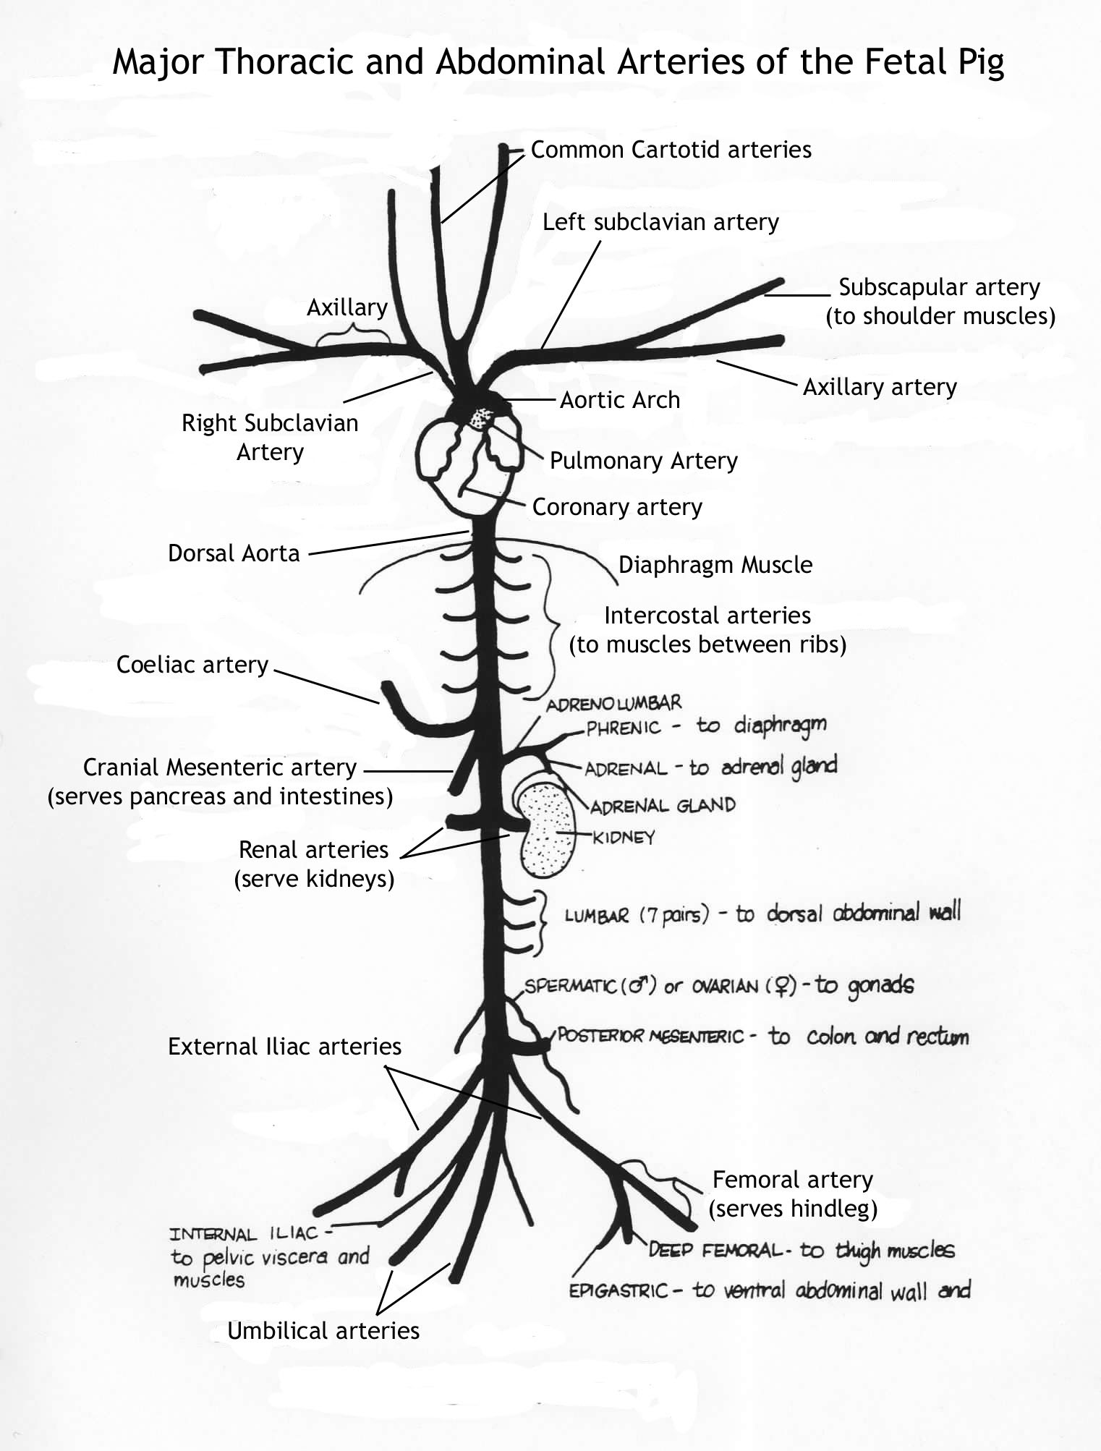

Figure 2 Diagram including all the major arteries in the circulatory system of a pig.

