WICS University
Gaby Moreno Cesar
Advisors: Norman I. Badler and Aline Normoyle
University of Pennsylvania

Abstract
Universities nationwide have clubs for women in computer science, commonly called WICS. Even though these clubs operate independently they still share very similar professional, academic, social, and outreach oriented goals. Despite the overlap, these clubs don’t have a centralized way of communicating with each other. They don’t have a way of sharing events, contacts, ideas, successes and failures, or even getting to know each other’s members.
The goal of the project is to bridge this gap between the WICS clubs by ideating, prototyping and testing interaction techniques that will allow clubs to share and learn from each other. We conduct user studies involving WICS board members from a small selection of clubs around the nation to understand how they run their respective clubs. These findings will inform the design and prototyping of a web application that will be built to facilitate their sharing of information.

Project Blog: thewicsproject.wordpress.com
Final Website: wics.meteor.com

INTRODUCTION
Universities nationwide have clubs for women in computer science, commonly called WICS. It has been shown by [FB02] that an active WICS club has the potential to be the driving force behind fostering a university’s community for women in computer science. Not only can it nurture relationships between its own members, but it can also impact connections with faculty, corporations, the university and even local schools. In this way, WICS clubs can both promote retention and spread awareness of computer science women.
Today, WICS clubs are formed by the proactive efforts of both students and faculty who identify a need for such a community. However, a central WICS organization does not exist therefore these efforts receive a limited source of guidance. So even though WICS clubs share very similar professional, academic, social and outreach oriented goals they mostly operate independently from each other. In addition, they don’t have a centralized way of communicating or of sharing events, contacts, ideas, successes, failures, or even getting to know each other’s members.
Our goal is to bridge this gap between the WICS clubs by ideating, prototyping and testing interaction techniques that will allow clubs to share and learn from each other. We conduct user studies involving WICS board members from a small selection of clubs around the nation to understand how they run their respective organizations. These finding will inform the design and implementation of a web application that will be built to facilitate their sharing of information.

We hope to make the following contributions:
- Increase interaction between clubs
- Promote successful practices and ideas
- Provide a resource for those wanting to start their own club
By doing so, we hope to ultimately give WICS clubs a tool to empower their goals of recruitment and retention of computer science women.

Design Goals
Our primary audience is those currently in a WICS club. We distinguish between board and general members. The goal is to enable a previously disjoint set of smart, passionate people with similar goals to meet, share and learn from each other by focusing on a few core principles which we outline in the next section.

Projects Proposed Features and Functionality

Identity
A typical WICS club already has a website, Facebook page, and/or a blog set up. This is similar to users of LinkedIn or Facebook who have personal portfolios and would like a community with whom to share them. One of our design goals is to enable clubs to create individualized profiles that will link to their sites if they have them as well as portray their members and key activities for others to get to know.

Reinforcement
We seek to provide reinforcement of successful practices by allowing members to interact with each other and view each other’s activities.

Feedback
Ultimately one of the strongest resources that we can provide WICS clubs is the support, experiences, and knowledge of each other. By having a focused, online community WICS members can draw from each other and grow from the ideas of passionate members with similar interests.

RELATED WORK
The gender gap in computer science is a well known problem. There are several gender-specific organizations that have been formed to try and bridge the gap by promoting retention and spreading awareness. WICS clubs form some of these initiatives. For the purposes of this project we address those causes which focus on community building for women in computer science because.

Women in CS Organizations
Several organizations do great work in spreading awareness and promoting retention of computer science women. A few of these focus on experiential activities such as conferences and forming local chapters. We mention them below.
The Anita Borg Institute organizes the annual Grace Hopper Celebration (GHC), the largest conference for women in computing. This event brings together women from all over the world for a few days which is typically enough to be a transformative experience for those that attend. At the core of its ideas is networking between the community of women and the formation of ties that will outlive the conference. While GHC targets all women (students, instructors, and professionals), we choose to focus on current students. Most current WICS groups, for example, do not know if other WICS members will be attending the conference unless they take the initiative to inquire on one of GHC’s social media forums. Even though many WICS groups attend Grace Hopper they cannot easily connect with each other. We think that the WICS application would enable this and help in the persistence of relationships and encouragement of collaborations beyond the span of the conference.
We briefly mention other organizations which focus on women and community building including the Association for Computing and Machinery Women in Computing (ACM-W) as well as the Society of Women Engineers (SWE). Both associations encourage local chapters but provide limited resources for them to interact.

WICS Clubs
There are a few very successful schools and WICS clubs that have been able to raise the percentage of women in their computer science major up to 40%, most notably Carnegie Mellon and Harvey Mudd College. Both have published papers on the subject. Carnegie Mellon WICS [FB02] is one of the few clubs which has tried to publish their successful activities and practices for other WICS clubs to use.
Harvey Mudd [AD10] on the other hand does not have a specific WICS club but demonstrates how awareness, ties to actual computer scientists, and real world experience can increase the percentage of women computer scientists.
Both Carnegie Mellon and Harvey Mudd have successful, replicable models of women programs which they have published and shared. Our goal is to promote these successful practices in a focused online community so that they spread more effectively, their adoptions increases, and increase their potential to grow from feedback given by the larger WICS community.

Information Sharing and Interactions
Finally, there are multiple online sites which are non gender specific but which have achieved great success in promoting information sharing, reinforcement and feedback amongst their members.
Facebook is successful at encouraging interactions amongst its members as well as giving them the change to form groups where like minded people can share and discuss similar interests.
Kickstarter has also done a good job of encouraging followings for specific projects as well as promoting the most successful ones.
Cowbird is a network of story tellers that is unique in the depth of interaction that it supports. It is very image based and allows for sorting by people, places, stories, and locations. We bring up Cowbird because it is still a small scale social network for a very specific kind of people which until now has done a good job of catering to their needs and encouraging expression and identity.

PROJECT PROPOSAL
As mentioned previously, we aim to build a small, focused community by way of a web application. There will be three phases to the project: user research, design, and implementation. Our goal is to engage WICS clubs from early on so as to progressively test the application from start to finish.

Anticipated Approach

User studies
We conduct focus groups of a select number of WICS clubs around the nation. The goal is to learn how they run their respective clubs so as better design the web application to their needs.

Design
The findings of the focus groups will inform the design phase. Here we conceptualize and mock-up the final look of the web application with consideration for core workflows and use cases.

Develop static front-end
Create the front-end of the application that will serve as a skeleton.

Develop interactions and visualizations
Implement main user interactions with the website such as forms, interactions between users, and any visualization such as the geographic map of clubs.

Database design
Design a database that will best store information for clubs, including their members and activities.

Backend functionality
Connect front-end with back-end so as to begin testing and filling either with sample data or real data from a few participatory clubs.

User testing
Involve a few participatory clubs throughout the development process for consistent feedback and testing of applications. Once the application’s main functionality is completed, the goal is to have one round of controlled contextual inquiry to identify usability and workflow trouble-points in the interface.

Final presentation
Present final demo of application as well as relevant results from user studies and testing.

Target Platforms
The application is built purely in JavaScript by using the Meteor.js open source platform. It works by running JavaScript inside a client web browser, a Node.js container on the Meteor server, MongoDB as the database, and the remaining HTML, CSS and static assets of the application.
In addition, Meteor is built using a smart packages system which interfaces with both the client and server so as to extend the Meteor environment in a variety of ways. Some are simply prepackaged client JavaScript libraries. This application in particular uses the following packages:
- Accounts-facebook – Facebook login
- Backbone – client-side URL routing
- Twitter Bootstrap – front-end toolkit
- jQuery – document traversal, event handling
- LESS – extends CSS
- Underscore – JS library providing support for functional programming

Evaluation Criteria
Evaluation will be based on user testing. Depending on time remaining after the implementation of the application, the user testing phase will include contextual inquiries involving a small number of WICS groups. A contextual inquiry is a one to one interaction between the user and an observer. During the contextual inquiries, we observe the user in action (via screen share) and collaborate to understand the user’s work to understand how they use the application and why. The observer will focus part of the discussion on the core interaction principles of identity, reinforcement and feedback to gage their effectiveness. The goal of the contextual inquiry will serve to determine the overall functionality, usability, and ultimate user satisfaction with the application.

RESEARCH TIMELINE
Project Milestone Report (Alpha Version)
- Background reading completed
- User research completed
- Database design and implementation complete
- Front end development in progress: clubs can create profiles

Project Final Deliverables
- User research report
- Fully functional web application

Project Future Tasks
- Event history visualizations
- Motivate creating from template

You will fill in the following sections as you make progress on your project, particularly for the alpha review and the final deliverable. In these sections, list pseudo-code, charts, images, examples, etc. to show what you’ve done over the course of the semester.

METHOD

Background Research
In order to better scope my project, I spent a significant portion of time interacting with other WiCS clubs, surveying their websites for overarching differences and similarities as well as studying other similar gender-related products.

Field Research at the Grace Hopper Conference
In early October, I had the chance to attend two WiCS-centered talks during the Grace Hopper Conference for Women in Computing. I specifically chose to go to them because I wanted to observe WICS members from different schools and geographic areas around the country interacting with each other. My belief and that of this project is that they can benefit, grow and be inspired by these interactions. My main goals in observing was to identify their overarching needs and concerns. The two talks are listed below.
- Student Organizations Supporting Women in Computing and Technology: Why and How?
- How You Can Make A Difference: Bootstrapping Efforts Toward Gender Imbalance
Based on my notes and observations of the attendees and presenters at these two talks, I compiled a list of their apparent needs, goals, and tasks organized according to the current state of their club:

Key Takeaways:
↓ A strong, well established club wants/needs to…
Open source good practices
Look for new event ideas
Bootstrap good event ideas
Meet other clubs
Meet other members
Deserve recognition
Needs encouragement
Look for advice
Look for role models
Build contact list
Recruit more members
↑ A less established club wants/needs to…

Survey of WiCS Clubs
There are WiCS clubs all over the U.S. and each has its own way of organizing events, structuring their leadership, and engaging members. I conducted a comparative analysis of 18 websites of a variety of WiCS clubs as a follow up to my findings from Grace Hopper. This is the list of schools:
Stanford University, UT Austin, University of Washington, Brown University, University of Pennsylvania, Columbia University, Tufts University, University of Oregon, UC Santa Barbara, UC Davis, North Carolina State University, University of Pittsburgh, Michigan Tech University, University of Arizona, Stony Brook University, Drexel University, Sonoma State University, UC Irvine, Michigan State University, Carnegie Mellon University, and Georgia Tech.

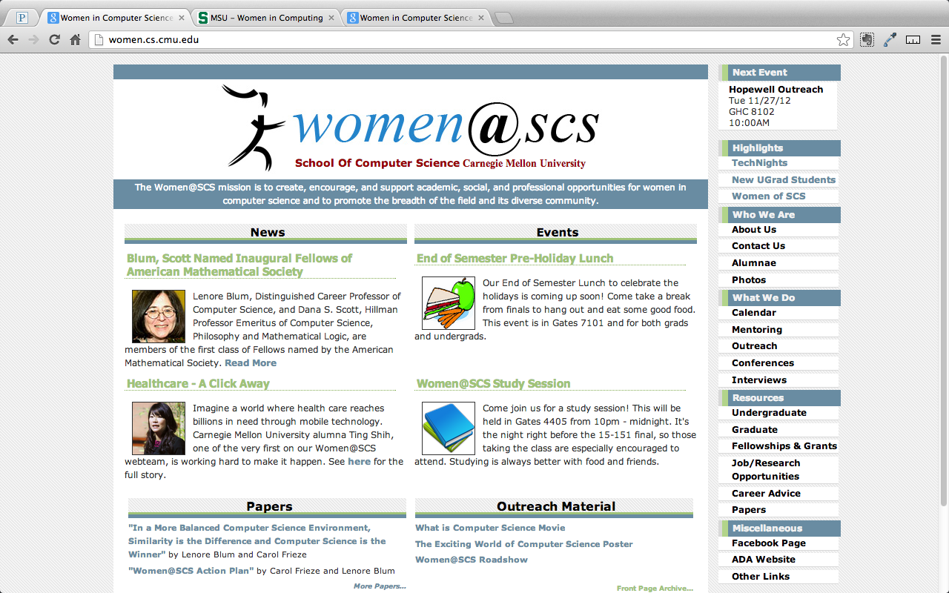
Carnegie Mellon Women Website

Relevant points of comparison included calendar, recent/featured events, corporate presence, faculty and staff involvement, sponsorship, board members page, blog, resources and links, as well as overall design.
My main takeaway - there is a huge emphasis placed on events in each of the WiCS websites that I studied. Because events are essential to the identity and success of a club, they will be a focal point in the scoping of this project.

Study of Gendered Design
An interesting point to note is that not one WiCS websites looked the same as the others. Each one had its own individual style. In order to round out my background research I decided to do a short comparison of current gender-related sites since I will be targeting women in my designs. A few examples sites are listed below.
- Pinterest – mainstream photo sharing network known for having a higher percentage of women users
- Girls Scouts, American Girl – targeting different age groups
- Deviant Art – art specific domain
- Google, Facebook – services target global users

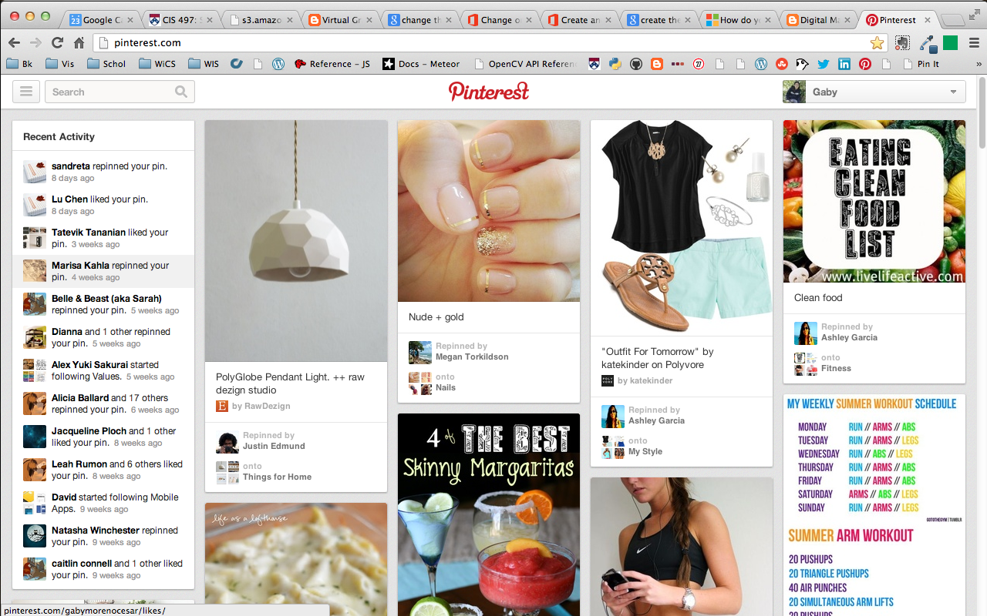
Pinterest – a content sharing device
My main takeaway - a social network made for women should connote some personality but remain for the most part subdued so as to not compete with content such as individual identities of users, events, and clubs on the site – Pinterest and Google being my main points of inspiration.

Design
Building upon the results from Grace Hopper, survey of WiCS websites, and study of gendered designs, I finalized the main design goals I would be targeting for my application, namely:
- Allow users to stay up to date of new activities
- Facilitate feedback on events
- Allow users to build upon successful ideas

Wireframes
Taking these requirements, I came up with a basic interaction framework that would support event viewing, sharing, and feedback which I laid out as wireframes and iterated upon throughout the design process.

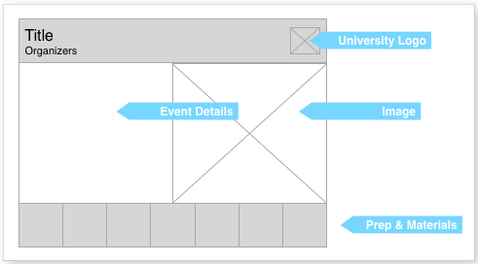
Sample event wireframe

Mockups
Mockups began the process of incorporating a visual look as well as iterating on the grid structure of the previous wireframes.

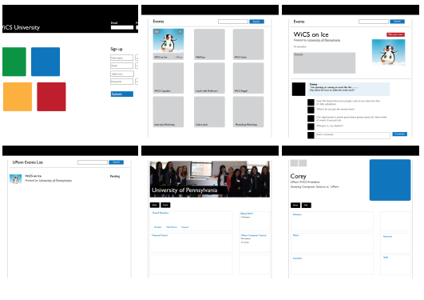
Mockups for login, main browsing page, event detail, user & club profiles

Paper prototypes
I conducted 5 separate paper prototype sessions which involved having a volunteer sit down and use their hands to navigate around the printed mockup components.
A typical session script:
- First reaction
What is your first reaction to the interface? What draws your attention? What do you feel compelled to do?
- Filter
How would you go about finding events if your club is on a low budget and has little time to plan?
- Search
How would you go about finding event ideas for a special occasion?
- View event detail
- Save
Asking these 5 simple questions allowed me to see that the basic UI features of browsing, filtering, and searching came very naturally to a user but not the save feature which is the component that encourages content reuse which is something that would have to be iterated upon.

Implementation
Implementation started as soon as mockups were done. Namely I started putting together the static assets for the application which included the foundational HTLM, LESS, and image files.
I then spent part of the semester building the WiCS application using Django, a Python web framework. About a third of the way, I pivoted, opting instead for Meteor.js, an open source platform allowing the developer to code an entire application in JavaScript and much better suited for both prototyping and development processes – my development time became significantly more productive when I started using Meteor.
Below, I outline the overall architecture and features of the WiCS application.

Events
Events are the core components of the WiCS application and became the main focus during development time. Overall, the goal was to experiment with and push how a user interacts with an event that has happened, will happen, and may happen, with the goal of encouraging reuse and collaboration between the creators of events.
An event’s schema in JavaScript object notation is as follows:
{
Owner: String,
Timestamp: Date object,
Title: String,
Date: Date object,
Description: String,
Cost: String,
Planning: String,
Mode: String,
Image_url: String,
School: String,
Comments: Array of Strings,
Likes: Array of user_ids,
Saves: Array of { user_id, event_id }
History: Array of {user_id, event_id}
}
- Browsing
A user encounters an event wall upon login which allows him to view events, their name, the people that created them, and their respective schools.

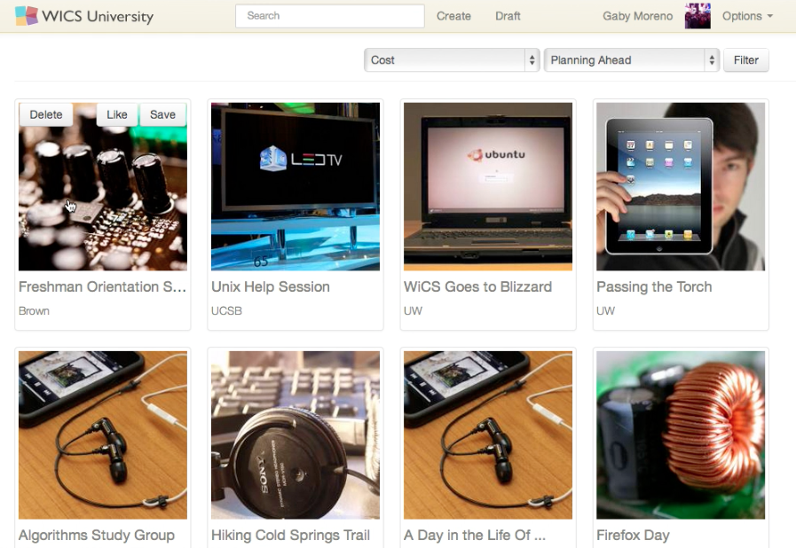
Home page – event gallery

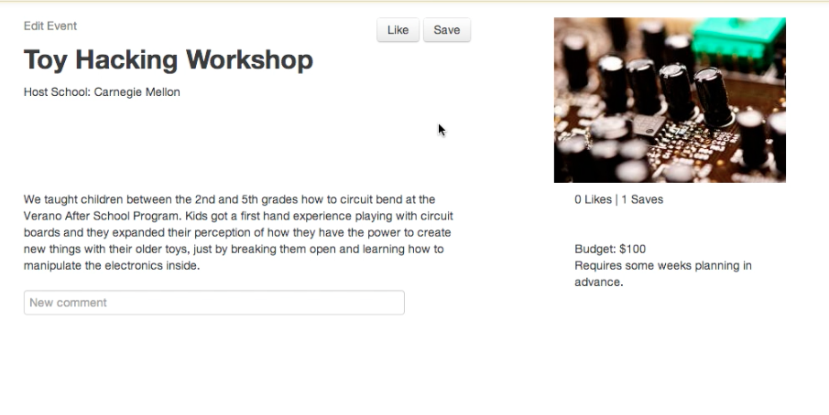
Event detail – Toy hacking workshop

- Search
A user can search for an event at any time by title or description. There are definitely some optimizations that could be done to the way search is done.
Currently, search is accomplished via the MongoDB query selectors which do a regex search of all event title and descriptions. It works for a small data set but will slow down as the number of events in the system increases.
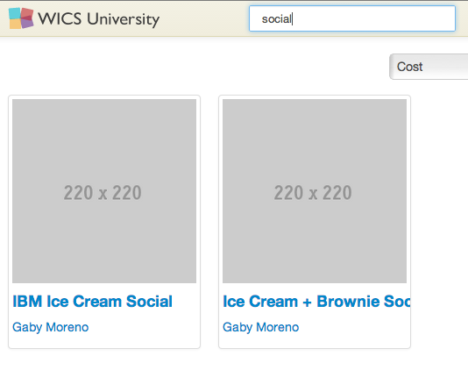
Searching for ’social’ turns up IBM and ice cream related events.

- Filtering
Filtering allows a user to focus in on events either by cost or by planning time.
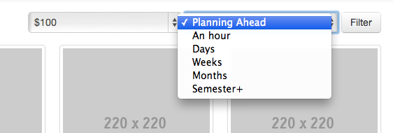
Filtering for $100 budget events that take about a week to plan.

- Create from scratch
The simplest use case for event creation is when a user decides to create an event from scratch.

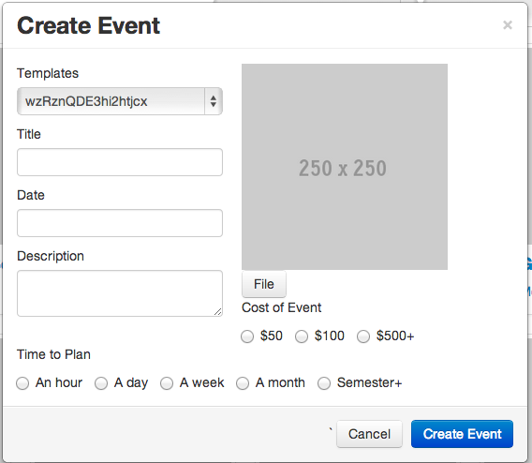
Creating an event dialog gives the option of either creating an event from scratch or creating one from a template.

- Create from template
The create event modal dialog gives users the choice of creating an event from a template. Templates come from events that the user has “saved” for later use. It allows for reuse.
This is implemented by automatically creating a copy of the event a user decides to save but with a different event id and an updated history so that it can be traced to the original event. More work will be done on this in the future.

- Draft
Sometimes when a user has an event idea but has not necessarily carried it out, he can draft an event instead and see if it gets any activity (likes, saves, comments). If the club ever actually hosts the event in real life then the owner of the event can choose to “publish” the event.
This is implemented by categorizing all events as ‘live’ or ‘draft’ events.

Users
A user is verified by logging in with his or her Facebook account. More options including email will be added in the future, but for now this is the best way of making sure a user exists as well as providing them with a basic starting profile in the system which other users may view.
A user’s schema is defined by Meteor.js and includes a profile parameter which may be populated with data from Facebook integration. During initial login, the application asks for permission to use the following fields:

Profile = _.pick(result.data,
“id”,
“name”,
“first_name”,
“last_name”,
“gender”,
“email”,
“education”,
“hometown”,
“location”,
“picture”,
“website”,
“work”
);

This profile information is extended by tracking a user’s interactions with events. Below is a list of the user’s available interactions:
- Like: like will show up in history of likes
- Save: will be added to history
- Comment: will be added to an event’s wall

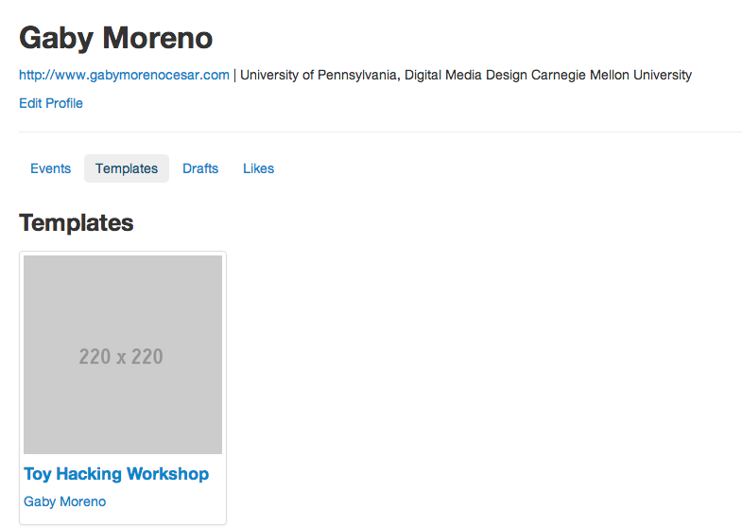
Basic user profile with history of events created, templates saved, drafts, and likes.

Smart Packages
Various smart packages were used in the development of the application and are explained below in further detail. The package system is one of the benefits of using Meteor. Much of the functionality of Meteor itself is implemented as packages which are JavaScript programs that can be injected into the client or server, extending the Meteor environment in a variety of ways.
- Backbone.js
Backbone.js is a model-view controller framework which provides client-side URL routing. This was used for passing search query parameters, as well as navigation to user and event detail pages.
routes = {
“”, “main”
“event/:id”, “event”
“user/:id”, “user”
}
- Underscore.js
Underscore.js is a utility belt library for JavaScript that provides support for functional programming and extends both the client and server environments. It was used for working with collections, Meteor’s way of storing data.
- Accounts-UI-Unstyled & Accounts-Facebook
Accounts-ui was initially used to add Facebook account capabilities as well as login controls to the screen. However, it has very little documentation and is not very flexible. Using the unstyled version of accounts-ui and manually setting up Facebook login ended up being a much easier way of integrating the look of the login controls into the current UI not to mention also asking for specific profile permissions.
- Twitter Bootstrap
Twitter Bootstrap is a front-end toolkit. It was used to set up the underlying grid structure of the visual layout as well as a starting point for branding common user interface components so it was also used in conjunction with LESS.
- LESS
LESS extends CSS with dynamic behavior such as variables, mixins, operations, and functions. The Bootstrap source which I heavily customized is written in LESS which allows for more compact style sheets and also helps reduce code duplication.
- jQuery
jQuery is a JavaScript library mainly used for facilitating document traversal, event handling and transitions in some cases.

RESULTS
See Method for images of application use cases. Video is also provided, showing the application in action.

CONCLUSIONS and FUTURE WORK
Building a full-blown social network from scratch is extremely time-consuming and required scoping down to the most essential use cases. There are a lot of common social network concerns that I could not address given the time that I had such as privacy, advanced user permissions, settings, and on-boarding. Creating full workflows for events in itself took up most of my development time and I was not able to dedicate as much time as I would have liked to user or even club profiles. That being said, I did complete my original design goals of enabling users to express identity, find reinforcement and feedback through the full, interactive event workflows I implemented.
I had previously only experience in creating one page JavaScript applications and learning to separate server and client side code was a challenge involving the understanding and integration of all the packages (libraries) outlined above.
I have listed the following as proposed next steps in the continued development of this project:
- Club profiles
- Event history visualizations
- Motivate creating from template (could potentially be done with the history visualizations mentioned above)
- Give user profiles more customization options
- Support more user-user interactions
APPENDIX
- Links
- LinkedIn: http://www.linkedin.com/
- Anita Borg Institute: http://anitaborg.org/
- Grace Hopper: anitaborg.org/initiatives/ghc
- ACM-W: women.acm.org
- Society of Women Engineers: ...swe.org
- Facebook: https://www.facebook.com
- Kickstarter: http://www.kickstarter.com/
- Cowbird: http://cowbird.com/
- Meteor.js: http://docs.meteor.com
- Smart Packages: docs.meteor.com/#smartpackages
- Node.js: http://nodejs.org/
- MongoDB: http://www.mongodb.org/
- Pinterest: http://pinterest.com/
- Girl Scouts: http://www.girlscouts.org/
- American Girl: americangirl.com
- Deviant Art: http://www.deviantart.com/
- Backbone.js: http://backbonejs.org/
- Underscore.js: http://underscorejs.org/
- Twitter Bootstrap: http://twitter.github.io/bootstrap/
- LESS: http://lesscss.org/
- jQuery: http://jquery.com/

- References
[FB02] | Frieze C., Blum L.: Building an Effective Computer Science Student Organization: The Carnegie Mellon Women@SCS Action Plan. Inroads SIGCSE Bulletin Women in Computing (June 2002), vol. 34, no.2, pp. 74-78.
[AD10] | Alvarado C., Dodds Z.: Women in CS: An Evaluation of Three Promising Practices. Proc. SIGCSE (2010).
[Mon12] | Monroy-Hernandez, Andres: Designing for Remixing: Supporting an Online Community of Amateur Creators. PhD Dissertation (Semptember 2012), MIT Media Lab, Cambridge, MA.
[Bre09] | Brennan, Karen. Scratch-Ed: An Online Community for Scratch Educators. Proc. CSCL (2009).
[MET] | Meteor: Documentation. Online,  http://docs.meteor.com.
[MDB] | The MongoDB 2.4 Manual. Online,  http://www.mongodb.org/.
[UND] | Underscore.js. Online,  http://underscorejs.org/.

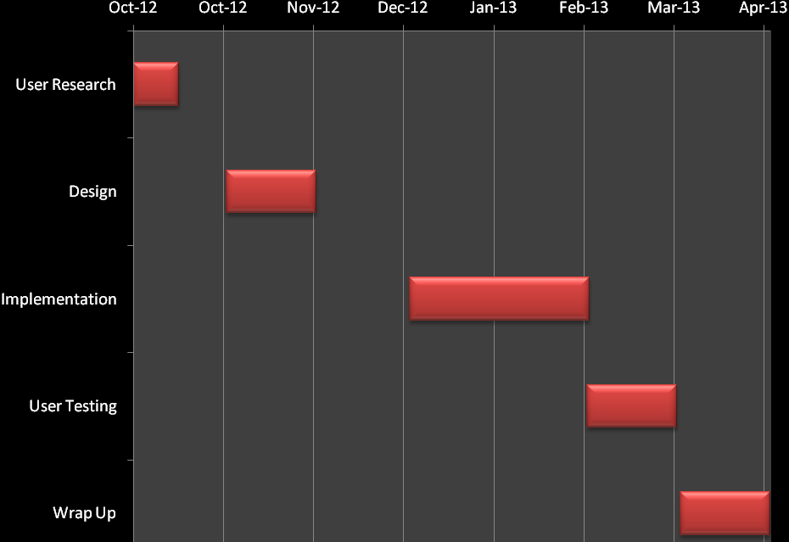
Figure 2: Tentative Project Timeline

