WICS: An Interactive Application for Women in Computer Science Groups
Gaby Moreno Cesar
Advisors: David Comberg (comberg@design.upenn.edu) | Rita Powell (rpowell@cis.upenn.edu)
University of Pennsylvania

Abstract
Universities nationwide have clubs for women in computer science, commonly called WICS. Even though these clubs operate independently they still share very similar professional, academic, social, and outreach oriented goals. Despite the overlap, these clubs don’t have a centralized way of communicating with each other. They don’t have a way of sharing events, contacts, ideas, successes and failures, or even getting to know each other’s members.
The goal of the project is to bridge this gap between the WICS clubs by ideating, prototyping and testing interaction techniques that will allow clubs to share and learn from each other. We conduct user studies involving WICS board members from a small selection of clubs around the nation to understand how they run their respective clubs. These findings will inform the design and prototyping of a web application that will be built to facilitate their sharing of information.

Project Wiki: https://fling.seas.upenn.edu/~gmoren/wiki/

INTRODUCTION
Universities nationwide have clubs for women in computer science, commonly called WICS. It has been shown by [FB02] that an active WICS club has the potential to be the driving force behind fostering a university’s community for women in computer science. Not only can it nurture relationships between its own members, but it can also impact connections with faculty, corporations, the university and even local schools. In this way, WICS clubs can both promote retention and spread awareness of computer science women.
Today, WICS clubs are formed by the proactive efforts of both students and faculty who identify a need for such a community. However, a central WICS organization does not exist therefore these efforts receive a limited source of guidance. So even though WICS clubs share very similar professional, academic, social and outreach oriented goals they mostly operate independently from each other. In addition, they don’t have a centralized way of communicating or of sharing events, contacts, ideas, successes, failures, or even getting to know each other’s members.
Our goal is to bridge this gap between the WICS clubs by ideating, prototyping and testing interaction techniques that will allow clubs to share and learn from each other. We conduct user studies involving WICS board members from a small selection of clubs around the nation to understand how they run their respective organizations. These finding will inform the design and implementation of a web application that will be built to facilitate their sharing of information.

We hope to make the following contributions:
- Increase interaction between clubs
- Promote successful practices and ideas
- Provide a resource for those wanting to start their own club
By doing so, we hope to ultimately give WICS clubs a tool to empower their goals of recruitment and retention of computer science women.

Design Goals
Our primary audience is those currently in a WICS club. We distinguish between board and general members. The goal is to enable a previously disjoint set of smart, passionate people with similar goals to meet, share and learn from each other by focusing on a few core principles which we outline in the next section.

Projects Proposed Features and Functionality

Identity
A typical WICS club already has a website, Facebook page, and/or a blog set up. This is similar to users of LinkedIn or Facebook who have personal portfolios and would like a community with whom to share them. One of our design goals is to enable clubs to create individualized profiles that will link to their sites if they have them as well as portray their members and key activities for others to get to know.

Reinforcement
We seek to provide reinforcement of successful practices by allowing members to interact with each other and view each other’s activities.

Feedback
Ultimately one of the strongest resources that we can provide WICS clubs is the support, experiences, and knowledge of each other. By having a focused, online community WICS members can draw from each other and grow from the ideas of passionate members with similar interests.

RELATED WORK
The gender gap in computer science is a well known problem. There are several gender-specific organizations that have been formed to try and bridge the gap by promoting retention and spreading awareness. WICS clubs form some of these initiatives. For the purposes of this project we address those causes which focus on community building for women in computer science because.

Women in CS Organizations
Several organizations do great work in spreading awareness and promoting retention of computer science women. A few of these focus on experiential activities such as conferences and forming local chapters. We mention them below.
The Anita Borg Institute organizes the annual Grace Hopper Celebration (GHC), the largest conference for women in computing. This event brings together women from all over the world for a few days which is typically enough to be a transformative experience for those that attend. At the core of its ideas is networking between the community of women and the formation of ties that will outlive the conference. While GHC targets all women (students, instructors, and professionals), we choose to focus on current students. Most current WICS groups, for example, do not know if other WICS members will be attending the conference unless they take the initiative to inquire on one of GHC’s social media forums. Even though many WICS groups attend Grace Hopper they cannot easily connect with each other. We think that the WICS application would enable this and help in the persistence of relationships and encouragement of collaborations beyond the span of the conference.
We briefly mention other organizations which focus on women and community building including the Association for Computing and Machinery Women in Computing (ACM-W) as well as the Society of Women Engineers (SWE). Both associations encourage local chapters but provide limited resources for them to interact.

WICS Clubs
There are a few very successful schools and WICS clubs that have been able to raise the percentage of women in their computer science major up to 40%, most notably Carnegie Mellon and Harvey Mudd College. Both have published papers on the subject. Carnegie Mellon WICS [FB02] is one of the few clubs which has tried to publish their successful activities and practices for other WICS clubs to use.
Harvey Mudd [AD10] on the other hand does not have a specific WICS club but demonstrates how awareness, ties to actual computer scientists, and real world experience can increase the percentage of women computer scientists.
Both Carnegie Mellon and Harvey Mudd have successful, replicable models of women programs which they have published and shared. Our goal is to promote these successful practices in a focused online community so that they spread more effectively, their adoptions increases, and increase their potential to grow from feedback given by the larger WICS community.

Information Sharing and Interactions
Finally, there are multiple online sites which are non gender specific but which have achieved great success in promoting information sharing, reinforcement and feedback amongst their members.
Facebook is successful at encouraging interactions amongst its members as well as giving them the change to form groups where like minded people can share and discuss similar interests.
Kickstarter has also done a good job of encouraging followings for specific projects as well as promoting the most successful ones.
Cowbird is a network of story tellers that is unique in the depth of interaction that it supports. It is very image based and allows for sorting by people, places, stories, and locations. We bring up Cowbird because it is still a small scale social network for a very specific kind of people which until now has done a good job of catering to their needs and encouraging expression and identity.

PROJECT PROPOSAL
As mentioned previously, we aim to build a small, focused community by way of a web application. There will be three phases to the project: user research, design, and implementation. Our goal is to engage WICS clubs from early on so as to progressively test the application from start to finish.

Anticipated Approach

User studies\
We conduct focus groups of a select number of WICS clubs around the nation. The goal is to learn how they run their respective clubs so as better design the web application to their needs.

Design
The findings of the focus groups will inform the design phase. Here we conceptualize and mock-up the final look of the web application with consideration for core workflows and use cases.

Develop static front-end
Use HTML/CSS to create the front-end of the application that will serve as a skeleton.

Develop interactions and visualizations
Use JavaScript to develop the main user interactions with the website such as forms, interactions between users, and any visualizations such as the geographic map of clubs.

Database design
Design a database in MySQL that will best store information for clubs, including their members and activities.

Backend functionality
Use PHP to connect front-end with back-end so as to begin testing and filling either with sample data or real data from a few participatory clubs.

User testing
Involve a few participatory clubs throughout the development process for consistent feedback and testing of applications. Once the application’s main functionality is completed, the goal is to have one round of controlled contextual inquiry to identify usability and workflow trouble-points in the interface.

Final presentation
Present final demo of application as well as relevant results from user studies and testing.

Target Platforms
- Aptana (web development editor)
- PHP/SQL (back-end & database)
- JavaScript (front-end interactions)
  - D3.js (visualizations)
  - jQuery
- HTML5/CSS3 (front-end design)

Evaluation Criteria
Evaluation will be based on user testing. Depending on time remaining after the implementation of the application, the user testing phase will include contextual inquiries involving a small number of WICS groups. A contextual inquiry is a one to one interaction between the user and an observer. During the contextual inquiries, we observe the user in action (via screen share) and collaborate to understand the user’s work to understand how they use the application and why. The observer will focus part of the discussion on the core interaction principles of identity, reinforcement and feedback to gage their effectiveness. The goal of the contextual inquiry will serve to determine the overall functionality, usability, and ultimate user satisfaction with the application.

RESEARCH TIMELINE
Project Milestone Report (Alpha Version)
- Background reading completed
- User research completed
- Database design and implementation complete
- Front end development in progress: clubs can create profiles

Project Final Deliverables
- User research report
- Fully functional web application
- Wiki page documentation

Project Future Tasks

You should insert a GANT CHART, see figure 2, to visualize your timeline of tasks. This timeline is very important for planning your time. Budget things the best you can and leave buffer space, especially at the end of the semester and before the alpha review, to account for tasks taking longer than expected. This is a 130 hour project, so we expect you to spend 10-12 hours per week over the course of the semester. You can use tables in word or import an excel image to easily add such a table to this document.

(remove line)

You will fill in the following sections as you make progress on your project, particularly for the alpha review and the final deliverable. In these sections, list pseudo-code, charts, images, examples, etc. to show what you’ve done over the course of the semester.

Method

RESULTS

CONCLUSIONS and FUTURE WORK
APPENDIX
- Optional Appendix

(remove line)

References
[FB02] | Frieze C., Blum L.: Building an Effective Computer Science Student Organization: The Carnegie Mellon Women@SCS Action Plan. Inroads SIGCSE Bulletin Women in Computing (June 2002), vol. 34, no.2, pp. 74-78.
[AD10] | Alvarado C., Dodds Z.: Women in CS: An Evaluation of Three Promising Practices. Proc. SIGCSE’10 (2010).

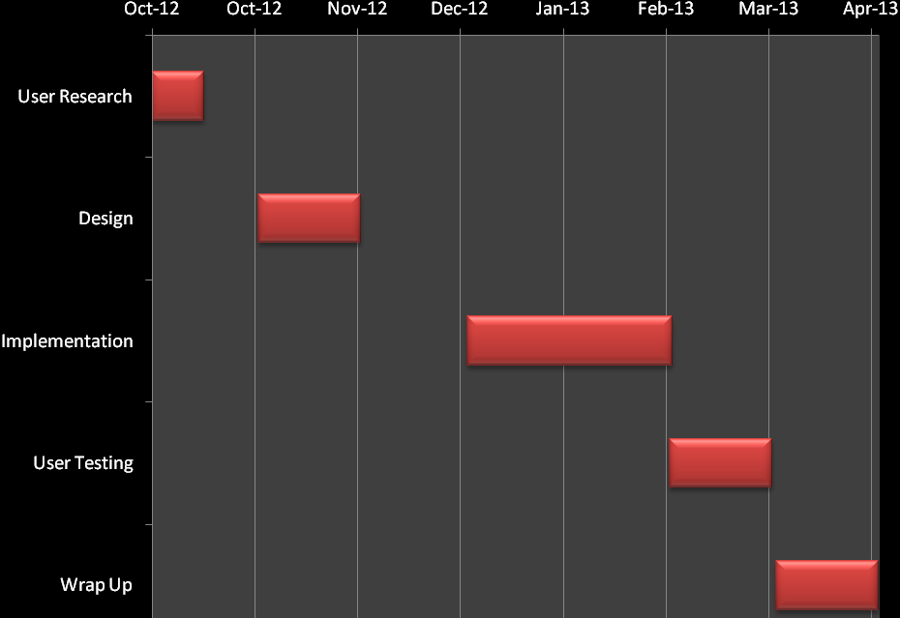
Figure 2: Tentative Project Timeline

