Real-Time Auralization in Cellular Automata Based Sound Propagation Frameworks
Michael Walczyk
Advisors: Norman Badler, Amy Calhoun
University of Pennsylvania

Abstract
Auralization, the process by which sound signals are simulated in a virtual acoustic space, is lacking in current cellular automata based sound propagation frameworks. A proper implementation of auralization would allow players to hear the sounds arriving at his or her avatar’s grid cell location. We investigate two different approaches to solving the problem of auralization. The first method involves constructing the degraded signal at the listener’s location through the Short Time Fourier Transform (STFT). The second method involves destructively altering the original sound signal in the frequency domain by gathering attenuation information from an impulse of non-zero amplitude sound packets.

Project Blog: http://mwalczykdmd.blogspot.com/

INTRODUCTION
In computational acoustics, auralization is the process of simulating sounds in a virtual acoustic space from computer-generated data. Given a short input signal (an impulse), we can generate a corresponding impulse response that represents the acoustic qualities of the environment. Through convolution with the impulse response, we can imbue dry (unprocessed) sound files with the characteristics of the virtual space.
Auralization can be applied to numerical acoustic simulations of real-world spaces, allowing builders to hear and analyze sounds within an architectural space prior to construction. In recent years, auralization has also become fundamental to the field of virtual environments and agent-based simulations where total immersion is desirable. Realistic sound propagation and audio reproduction augments the user’s sense of presence and therefore directly improves the quality of the system.
Current cellular automata based sound propagation frameworks generate sound packets at regular intervals. Each sound packet contains a band index indicating the frequency range of the packet, an amplitude value, and a spread value that denotes the “clarity” of the packet. At any particular time during simulation run time, zero or more of these packets can exist at a grid cell containing the user’s avatar. In order to hear what the avatar is hearing, these packets must be auralized. We propose two different solutions based on procedural audio synthesis and real-time audio manipulation capabilities. First, sounds can be constructed in real-time through the inverse Short Time Fourier Transform (iSTFT), a Fourier-related procedure used to determine localized frequency content of a sound signal. Second, by appropriately accounting for attenuation and degradation, we can alter the original sound source data and present the listener with acoustically accurate sounds.

Contributions.
This project makes the following contributions:
- An exploration of Unity’s procedural audio capabilities, including the newly introduced OnAudioFilterRead method (available in version 3.5 of Unity)
- Auralization of the propagated sound signals using constructive and deconstructive methodologies
- Frequency-specific attenuation and degradation properly accounted for in the final degraded signal

Design Goals
The target audiences for this project include Unity game developers and researchers in the field of virtual reality and agent-based simulations. An implementation of realistic auralization would provide real-time audio feedback for developers, users, and game testers. Equipped with acoustic perception, virtual agents in cellular automata based sound propagation frameworks can respond to aural stimuli. However, in the case of the user’s avatar, auralization allows one to hear what his or her avatar is hearing in the virtual acoustic space.

Projects Proposed Features and Functionality
- Real-time audio manipulation using custom audio implementations
- Plausible auralization of sound packets propagated through cellular automata based frameworks, accounting for appropriate environmental degradation of sound signals

RELATED WORK
Sound Field Simulations. In the past decade, many research groups have focused on reproducing realistic 3D sound fields. [YST04] offers one approach to the problem using a multi-channel system and the finite difference time domain method. The approach we will utilize offers a different auralization approach.
Computational Acoustics. Prior researchers in the field of acoustics have developed several notable methods for sound propagation in virtual environments, including the finite difference method, the finite element method, and geometric ray tracing [KV10]. The SPREAD model offers a novel approach to the sound propagation problem using pre-computed propagation values and finite sound packets.
Numerical Simulations. In recent efforts to reduce the computational costs of sound propagation, much research has gone into the field of numerical acoustic simulations. As shown in [RNL09], one such method decomposes 3D scenes into finite acoustic spaces in which numerical analysis can be efficiently performed, making the numerical approach to the sound propagation problem an ideal strategy for real-time, dynamic auralization.
Digital Audio Filters. As described in [RP07], there are several popular strategies for designing digital filters. The Wave Digital Principle defines several electrical filter components along with their digital counterparts. Filters can be placed in a digital signal processing chain to affect the outgoing audio signal (i.e. the signal that the listener will hear). In our project, we will be designing a series of custom filters to modify the original source signals to account for attenuation, degradation, and reflections.
Feature Extraction. Recently, advances in modal analysis and modal synthesis have made it possible to dynamically create audio content from the intrinsic material properties of scene geometry. [RYL10] describes a novel technique for extracting the salient features (i.e. an array of damped sinusoids) from an audio file, which can be utilized to facilitate real-time audio synthesis. This technique establishes a framework for synthesizing sounds that closely resembles the original real-world recording. Our project attempts to model this same behavior using the proposed constructive auralization technique.

METHOD OVERVIEW

Anticipated Approach
Given a database of approximately one hundred different sound files (incidental hits, vocal utterances, textures, etc.), our goal is to modify the original sound data of these sources in real-time to reflect the acoustic properties of the listener’s location in space.
Current cellular automata based frameworks propagate an attenuated sound packet sequence to the listener’s grid location. This sequence contains frequency band and amplitude information that can be used to facilitate the auralization procedure. We can compute the auralized signal through either of the two proposed methods (constructive or deconstructive synthesis). For constructive synthesis, we treat the collected sound packet data as a coarse subset of STFT data. We can subsequently use an inverse STFT to reconstruct a crude version of the original sound signal. For deconstructive synthesis, we instead propagate a new “probe” sound packet sequence. Upon arrival at the listener’s location, we use the attenuated data gathered from this impulse to degrade the original audio file. The resulting sound is sent to the sound card for playback.

Target Platforms
The primary software platform for this project implementation is Unity, a game engine and IDE for developers. Version 3.5 of Unity supports the creation of custom audio filters and procedural audio synthesis, making it an ideal platform for real-time rendering of audio data and sound simulation in virtual environments.


Evaluation Criteria
In real-time, we will be able to render and hear the sounds arriving at the user’s avatar’s location. Thus, we can compare the original audio file to the degraded signal outputted from our propagation model. This project will be evaluated based on previous models of sound propagation. Version 3.5 Unity introduces the possibility of procedural audio synthesis. This project takes advantage of these new features, which remain largely unexplored amongst the Unity developers’ community.

RESEARCH TIMELINE
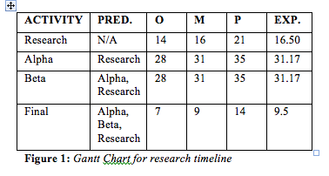
Project Background Research
- Completed all background reading (past SIGGRAPH papers, materials provided by Pengfei Huang, computational acoustics reference materials, etc.)
- Prepared brief presentation outlining background reading
Project Milestone Report (Alpha Version)
- Proposed software framework is functioning with simple base cases
- Begin collecting necessary data, images, sound samples, and diagrams
Project Milestone Report (Beta Version)
- Proposed software framework is functioning with the majority of test cases
- Collected all necessary data, images, sound samples, and diagrams
Project Final Deliverables
- Software implementation of the simulation model with auralization
- Demo of auralization implementation
- Documentation of relevant code, diagrams, results, case analyses, and conclusions

Method
As Unity’s procedural audio capabilities are still largely unexplored, a major contribution of this project was to experiment with different auralization methodologies within the context of cellular automata based frameworks. As mentioned prior, version 3.5 of Unity introduced support for native procedural audio synthesis via the OnAudioFilterRead method, which allows the user to collect and modify sound source data in real-time. The method header can be seen below:
void OnAudioFilterRead(float[] data, int channels);

The event parameter data denotes a buffer of 2048 floats ranging from [-1.0f;1.0f] representing the amplitude values of the audio data in the scene. OnAudioFilterRead updates approximately once every 20 milliseconds and runs on a separate thread than Unity’s main thread. By storing, modifying, or attenuating the information contained in this buffer, we can alter the final outputted sound. When sound sources are absent in the scene, the buffer data can be generated on the fly with simple synthesis techniques. As an initial proof of concept, we used OnAudioFilterRead to simulate additive synthesis (the summation of sine waves at various frequencies).
The nature of the information stored in the model’s sound packet representation necessitates the use of Short Time Fourier analysis. The Short Time Fourier Transform (STFT) facilitates detailed time-dependent frequency analysis of a signal. Figure 2 depicts a series of time domain signals and their corresponding STFT spectrums.
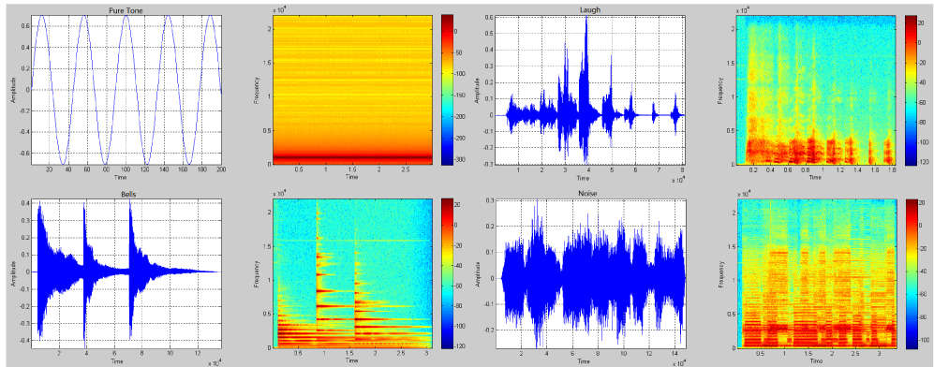
Figure 2: STFT analysis converts time domain signals into spectrum data (amplitude values at different frequency bands)
The STFT of a time domain signal can be calculated by windowing overlapping subsections of the original signal, performing a Fast Fourier Transform (FFT) on each subsection, and storing the result of each transformation in a two-dimensional array.
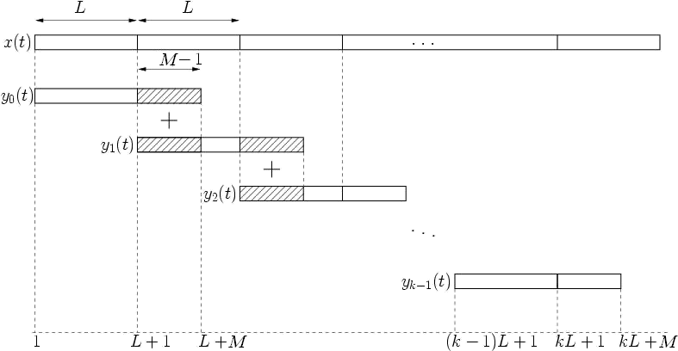
Figure 3: A block diagram of the Overlap-Add method with window size L and overlap distance (M-1). Each segment y_{n}(t) is a subsection of the original time domain signal, x(t). We can modify each y_{n}(t) in the frequency domain then reconstruct the degraded version of the audio signal by performing an iFFT on each y_{n}(t).
Conversely, the original sound signal can be reconstructed from the corresponding STFT data by accumulating a series of inverse Fast Fourier Transforms (iFFT) via the Overlap-Add method (Figure 3). All of the aforementioned procedures were implemented in Unity as part of the proposed framework.
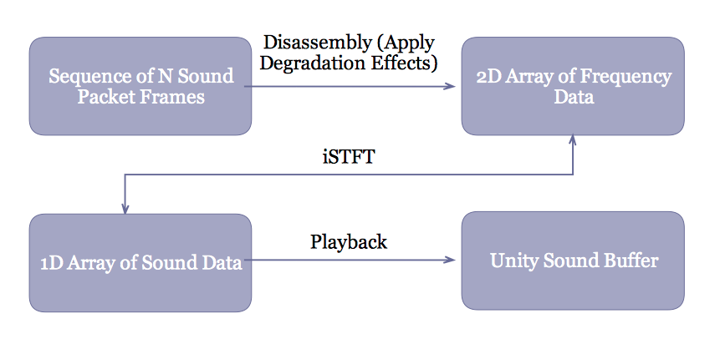
Figure 4: The pipeline of the constructive auralization method
With these signal-processing techniques, we explored two primary methods of auralization in Unity. The constructive method (Figure 4) directly utilizes the inverse STFT (iSTFT) to reconstruct the degraded sound signal at the listener’s location. Sound packets in the cellular based automata model each represent a specific frequency band and amplitude value. A series of these packets constitute a sound packet frame, which can be viewed as a windowed subsection of STFT data. Depending on the original sound signal’s length, a collection of these sound packet frames together coarsely represent the original audio file. As the packets propagate throughout the scene, the amplitude values are attenuated based on a variety of location specific properties until finally arriving at the listener’s location. Each time the Collect method is called at the listener’s location, we store the received sound packet frame in a buffer called framesToAuralize:
void Collect(int index, SoundPacketSequence s) {
//Add frame for auralization
if(frameCount < frameLimit) {
framesToAuralize.Add(f);
frameCount++;
}
else {
//Send to auralization procedure, then clear
aurScript.setFramesToAuralize(framesToAuralize);
framesToAuralize = new List<SoundPacketFrame>();
frameCount = 0;
}
}

Once we receive the entire sound packet sequence, the buffer is sent to the auralization script for disassembly. Since each sound packet frame only contains three frequency bands (low, medium, high), each amplitude value is duplicated a number of times to create a larger STFT dataset. The resulting two-dimensional array of data is then transformed back to the time domain via an iSTFT. This data is sent through OnAudioFilterRead and subsequently, the sound card, for playback.
//Construct a 2D array of floats from the received sound packet frames
float[,] bufferData = new float[framesToAuralize.Count, 99];
int row = 0;
int col = 0;
//Iterate through each of the sound packet frames
foreach (SoundPacketFrame frame in framesToAuralize) {
SoundPacket[] frames = frame.packets.ToArray();
//Get the three amp values stored in this frame
float low = frames[0].amplitude;
float mid = frames[1].amplitude;
float high = frames[2].amplitude;
//Create indices for filling this row of STFT data (each
band is copied 33 times)
int lowIndex = 0;
int midIndex = 33;
int highIndex = 66;
for(var i = 0; i < 33; i++) {
bufferData[row,i+lowIndex] = low;
bufferData[row,i+midIndex] = mid;
bufferData[row,i+highIndex] = high;
}
//Advance to the next row of STFT data
row++;
}
//Place the inverse STFT data back into Unity's sound buffer
data = iSTFT(bufferData);

The deconstructive method behaves similarly, but rather than propagating the sound packet sequence representing the original audio file, we instead create a new sequence (visualized in Figure 5) that contains a short impulse of approximately ten non-zero values (i.e. ten sound packet frames, each of which contains a single sound packet with a non-zero amplitude value). When this new sound packet sequence arrives at the listener’s location, we can use the attenuated amplitude values (due to environmental absorption and degradation) to calculate an attenuation ratio. This value is then used in conjunction with the STFT of the desired audio source to attenuate the sound in the frequency domain. Similar to the constructive technique, we then perform an iSTFT on the attenuated data and output this amplitude information to the sound card.
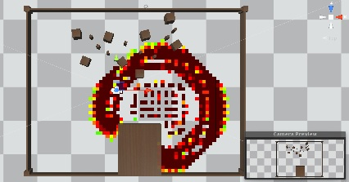
Figure 5: In the deconstructive auralization method, a short impulse of non-zero amplitude packets propagates across the scene

RESULTS
Upon conclusion, the deconstructive method of auralization yielded the most accurate results. A more precise mapping from the coarse dataset provided by the sound packet representation to the high number of frequency bands necessary for iSTFT reconstruction is necessary for the constructive method to become viable. Although noticeable distortion still exists in the final outputted signal from the deconstructive method, this project has shown that frequency domain calculations within the limitations of Unity’s procedural audio capabilities are possible. Through the deconstructive method of auralization, we were accurately able to attenuate the sound signal based on distance cues provided by the probe sound packet sequence.

CONCLUSIONS and FUTURE WORK
In this paper, we presented two techniques for solving the problem of auralization in cellular automata based sound propagation models using procedural audio synthesis in Unity. Both methodologies utilize Short Time Fourier analysis to obtain detailed time dependent frequency information. For the constructive method, we use the coarse dataset provided by the propagated sound packet sequence of the original audio source to reconstruct a degraded signal via an iSTFT. For the deconstructive method, we instead propagate an impulse sound packet sequence, which can later be used to guide the degradation of the original audio file in the frequency domain.
Continued exploration of modern digital signal processing techniques and Unity’s procedural audio capabilities certainly could yield higher accuracy results and more effective auralization methodologies. In particular, the following implementation improvements could be considered:
- Improve the quality of the STFT/iSTFT output (i.e. reduce the distortion and jitteriness that is currently present in the reconstructed audio data)
- For the constructive method, investigate a more accurate mapping from the coarse dataset provided by sound packet sequences to the frequency domain dataset necessary for accurate iSTFT output
- For the deconstructive method, investigate ways to apply different attenuation ratios to different frequency bands (higher frequencies, for example, should attenuate more than lower frequencies)
- Determine location specific absorption values (i.e. packets that travel close to geometric obstacles attenuate faster due to higher absorption rates)

References
[KV10] | KRISTIANSEN U. R., VIGGEN E. M.: Computational Methods in Acoustics. NTNU - Dept. of Electronics and Telecommunications (2010).
[RNL09] | RAGHUVANSHI N., NARAIN R., LIN M. C.: Efficient and Accurate Sound Propagation Using Adaptive Rectangular Decomposition. IEEE TVCG (2009).
[RP05] | RABENSTEIN S., PETRAUSCH R.: Simulation of Room Acoustics via Block-Based Physical Modeling with the Functional Transformation Method. Applications of Signal Processing to Audio and Acoustics, IEEE Workshop (Oct. 2005), 195-198.
[RP07] | RABENSTEIN S., PETRAUSCH R.: Block-Based Physical Modeling for Digital Sound Synthesis. Signal Processing Magazine, IEEE (2007), 42-54.
[RSM*10] | RAGHUVANSHI N., SNYDER J., MEHRA R., LIN M., GOVINDARAJU N.: Precomputed Wave Simulation for Real-Time Sound Propagation of Dynamic Sources in Complex Scenes. ACM Transactions on Graphics (TOG) (2010).
[YST04] | YOKOTA T., SAKAMOTO S., TACHIBANA H.: Sound Field Simulation Method by Combining Finite Difference Time Domain Calculation and Multi-Channel Reproduction Technique. Acous. Sci. & Tech. (2004).
[RYL12] | REN Z., YEH H., LIN M. C.: Example-Guided Physically Based Modal Sound Synthesis. ACM Trans. Graph. (2012)

Other Online Referenced Materials:
1. The Short-Time Fourier Transform and Its Inverse
2. Time-Frequency Analysis in Matlab
3. The Lomont FFT Implementation

