Augmenting SPREAD: Real-Time
Auralization in Unity3D
Michael Walczyk
Advisor: Norman Badler, Amy Calhoun
University of Pennsylvania

Abstract
Pengfei Huang, a PhD candidate at the University of Pennsylvania, has developed an agent-based sound perception model called SPREAD. This system models how sound packets travel through and interact with a virtual space. Agents can “hear” these sounds and react accordingly. Equipped with acoustic perception, these virtual agents can interact more realistically with the virtual environment. However, SPREAD currently lacks auralization, the process that simulates sound in a specific acoustic space. A proper implementation of auralization in the SPREAD model would allow players to hear the sounds arriving at his/her avatar’s current grid cell location.

Project Blog: http://mwalczykdmd.blogspot.com/

INTRODUCTION
In computational acoustics, auralization is the process of simulating sounds in a virtual acoustic space. Given a short input signal (an impulse), we can generate a corresponding impulse response that represents the acoustic qualities of the environment. Through convolution with the impulse response, we can imbue dry (unprocessed) sound files with the characteristics of the virtual space.
Auralization can be applied in acoustical simulations of real-world spaces, allowing builders to hear and analyze sounds within the space prior to actual construction. Auralization is also a fundamental concept in the field of virtual environments and agent-based simulations where total immersion is desirable. Realistic sound propagation and audio reproduction augments the user’s sense of presence and therefore directly improves the quality of the system.
The SPREAD model creates sound packets at regular intervals. At any given time during the simulation, zero or more of these packets may exist at a grid cell containing a user’s avatar. In order to hear what the avatar is hearing, these packets must be auralized. We propose a solution based on Unity3D’s procedural audio synthesis and real-time audio manipulation capabilities. Sounds can be modified in real-time by implementing Unity3D’s OnAudioFilterRead() method. By appropriately accounting for attenuation, degradation, and reflections, we can alter the original sound source data and present the listener with acoustically accurate sounds.

Contributions.
This project makes the following contributions:
- Real-time modification of sound data using Unity3D’s custom audio filters
- Auralization of sound buffers in the SPREAD model, accounting for attenuation, degradation, and reflections

Design Goals
The target audiences for this project include game developers and researchers in the field of virtual reality and agent-based simulations. An implementation of realistic auralization in the SPREAD simulation model would provide real-time audio feedback for developers and users. Equipped with acoustic perception provided by the current SPREAD implementation, virtual agents can respond to aural stimuli. However, in the case of a user’s avatar, auralization allows one to hear what their avatar is hearing in the virtual acoustic space.

Projects Proposed Features and Functionality
- Real-time audio manipulation using Unity3D and custom filters
- Realistic auralization of sound packets propagated through the agent-based SPREAD model, accounting for appropriate environmental degradation of sound signals

RELATED WORK
Sound Field Simulations. In the past decade, many research groups have focused on reproducing realistic 3D sound fields. [YST04] offers one approach to the problem using a multi-channel system and the finite difference time domain method. The approach we will utilize in SPREAD offers a different auralization approach.
Computational Acoustics. Prior researchers in the field of acoustics have developed several notable methods for sound propagation in virtual environments, including the finite difference method, the finite element method, and geometric ray tracing [KV10]. The SPREAD model offers a novel approach to the sound propagation problem using pre-computed propagation values and finite sound packets.
Numerical Simulations. In recent efforts to reduce the computational costs of sound propagation, much research has gone into the field of numerical acoustic simulations. As shown in [RNL09], one such method decomposes 3D scenes into finite acoustic spaces in which numerical analysis can be efficiently performed, making the numerical approach to the sound propagation problem an ideal strategy for real-time, dynamic auralization.
Digital Audio Filters. As described in [RP07], there are several popular strategies for designing digital filters. The Wave Digital Principle defines several electrical filter components along with their digital counterparts. Filters can be placed in a digital signal processing chain to affect the outgoing audio signal (i.e. the signal that the listener will hear). In our project, we will be designing a series of custom filters to modify the original source signals to account for attenuation, degradation, and reflections.

PROJECT PROPOSAL

Anticipated Approach
Given an array of approximately one hundred different WAV files (incidental hits, vocal utterances, textures, etc.), our goal is to modify the original sound data of these sources in real-time to reflect the acoustic properties at the listener’s location. These properties include attenuation, degradation, and reflections. We can compute the impulse response at the listener’s grid cell location as well as the desired attenuation, degradation, and reflection factors (based on the listener’s position and time) in parallel with the auralization process. We can then use Unity3D’s OnAudioFilterRead() method to store the original sound data in a float buffer. With the computed impulse response and desired attenuation, degradation, and reflection factors, we can then compute the auralized signal through convolution with the original dry signal. The resulting signal will be stored in a new buffer and sent to the sound card for playback.

Target Platforms
The primary software platform for this project implementation will be Unity3D, a game engine and IDE for developers. Unity3D supports the creation of custom audio filters that can be inserted in digital signal processing chains, making it an ideal platform for real-time rendering of audio data and sound simulation in virtual environments.

Evaluation Criteria
In real-time, we will be able to render and hear the sounds arriving at the user’s avatar’s location. Thus, we can compare the original signal to the modified signal resulting from our propagation model. This project will be evaluated based on previous models of sound propagation in Unity3D.

RESEARCH TIMELINE
See Figure 1 below for timeline estimates.
Project Background Research
- Completed all background reading (past SIGGRAPH papers, materials provided by Pengfei Huang, computational acoustics reference materials, etc.)
- Prepared brief presentation outlining background reading

Project Milestone Report (Alpha Version)
- Proposed software framework is functioning with simple base cases
- Begin collecting necessary data, images, sound samples, and diagrams

Project Milestone Report (Beta Version)
- Proposed software framework is functioning with the majority of test cases
- Collected all necessary data, images, sound samples, and diagrams

Project Final Deliverables
- Software implementation of the SPREAD simulation model with auralization
- Demo of auralization implementation
- Documentation of relevant code, diagrams, results, case analyses, and conclusions

Method

RESULTS

CONCLUSIONS and FUTURE WORK

References
[KV10] | KRISTIANSEN U. R., VIGGEN E. M.: Computational Methods in Acoustics. NTNU - Dept. of Electronics and Telecommunications (2010).
[RNL09] | RAGHUVANSHI N., NARAIN R., LIN M. C.: Efficient and Accurate Sound Propagation Using Adaptive Rectangular Decomposition. IEEE TVCG (2009).
[RP05] | RABENSTEIN S., PETRAUSCH R.: Simulation of Room Acoustics via Block-Based Physical Modeling with the Functional Transformation Method. Applications of Signal Processing to Audio and Acoustics, IEEE Workshop (Oct. 2005), 195-198.
[RP07] | RABENSTEIN S., PETRAUSCH R.: Block-Based Physical Modeling for Digital Sound Synthesis. Signal Processing Magazine, IEEE (2007), 42-54.
[RSM*10] | RAGHUVANSHI N., SNYDER J., MEHRA R., LIN M., GOVINDARAJU N.: Precomputed Wave Simulation for Real-Time Sound Propagation of Dynamic Sources in Complex Scenes. ACM Transactions on Graphics (TOG) (2010).
[YST04] | YOKOTA T., SAKAMOTO S., TACHIBANA H.: Sound Field Simulation Method by Combining Finite Difference Time Domain Calculation and Multi-Channel Reproduction Technique. Acous. Sci. & Tech. (2004).

ACTIVITY | PRED. | O | M | P | EXP.
Research | N/A | 14 | 16 | 21 | 16.50
Alpha | Research | 28 | 31 | 35 | 31.17
Beta | Alpha, Research | 28 | 31 | 35 | 31.17
Final | Alpha, Beta, Research | 7 | 9 | 14 | 9.5
Figure 1: Gantt Chart for research timeline

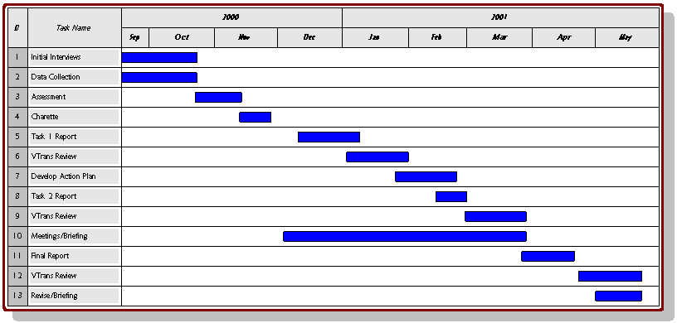
Figure 2: For publications with color tables and figures that span two columns like your gant chart or results will.

