**CIS 4480/5480 Recitation 1 - Processes, Valgrind and Style**

*Welcome back to recitation!!!* 😃

**Exercise 1: Processes and File Access**

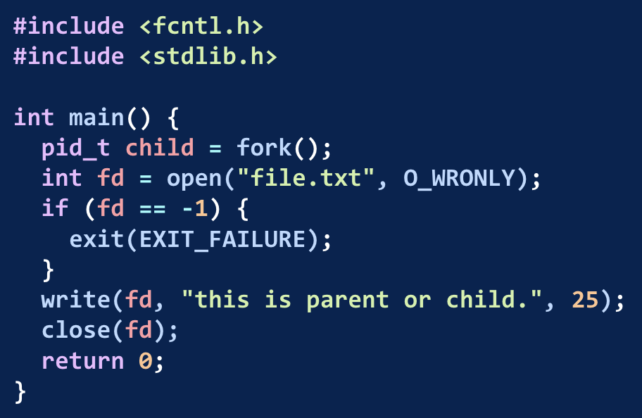

Questions to answer:

* Which processes have access to file.txt?

1. Parent
2. Child
3. Both
4. Neither

* If the parent closes the file, can the child still write to file.txt? **Explain your answer**.

**Exercise 2: The Process Family Tree**

Here are two diagrams, where each labeled box represents a process. P0 is the “original process” that forks P1. Arrows show the parent-child relationship. The order of processes spawning from first to last is: P0, P1, P2, P3.

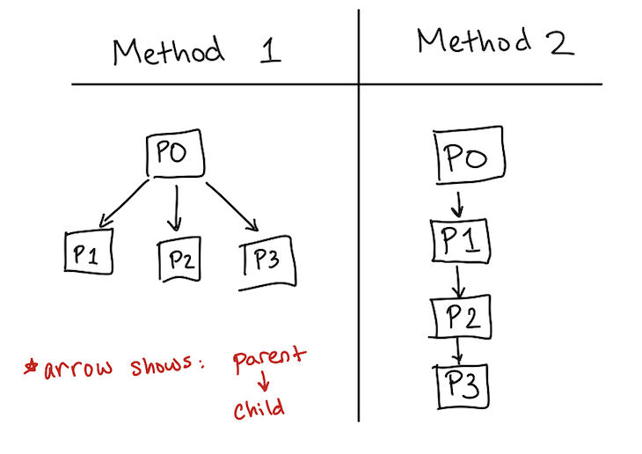

Questions to answer:

* Using either C code, psuedocode, or a written description, describe how you would fork 3 processes to achieve diagram 1 and diagram 2.

| Diagram 1 | Diagram 2 |
| --- | --- |
|  |  |

* Let’s say I have 3 independent tasks: T1, T2, and T3.
  + P1 will exec T1
  + P2 will exec T2
  + P3 will exec T3
  + P0 must wait until T1, T2, and T3 have finished.

Which diagram will result in the faster runtime? Explain your answer.

**Exercise 3: Waiting**

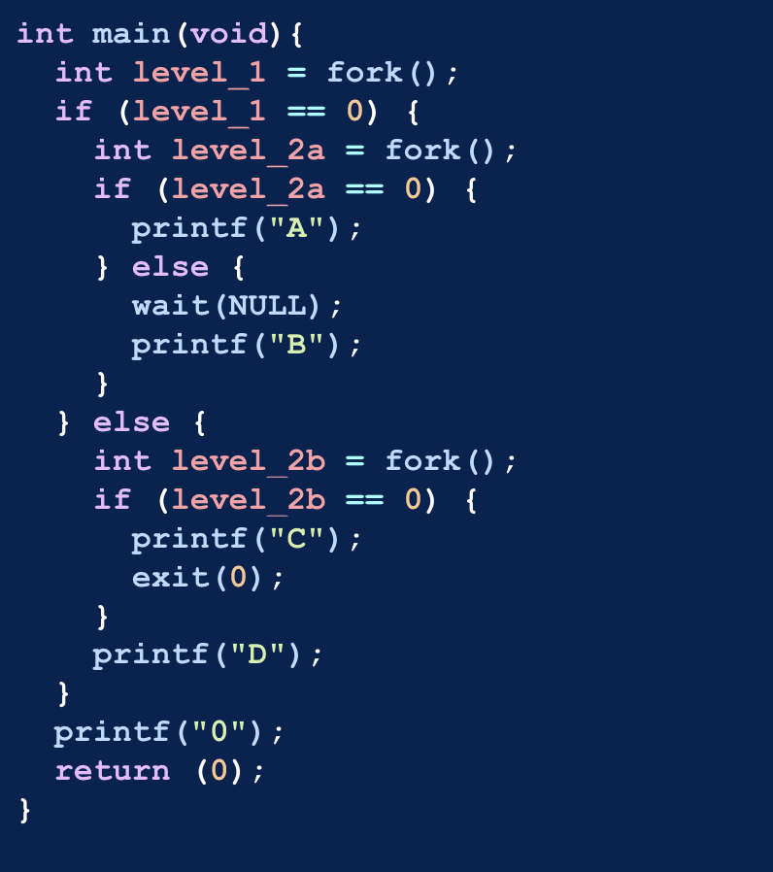

### Questions to Answer:

1. Draw a diagram of all processes and clearly indicate all parent-child relationships. You may model your diagram after the one shown in Exercise 2, if you would like.
2. Which of the following are possible outputs? Select all that apply:
   1. B0AC0D0
   2. D0CA0B0
   3. D0A0B0C
   4. CAD00B0
   5. ABCD000

**Exercise 4: Good Style😎**

Read through the style guide here: <https://www.seas.upenn.edu/~cis5480/25su/documents/style>

Questions to Answer:

* What style guides did you learn from reading the style guide and plan to use before turning in Penn-Shredder?
* Are there any style guidelines that are confusing, or that you think don’t actually contribute to good style? If so, explain what you find confusing, or what seems unhelpful.

**Exercise 5: Exit Questions**

From 1-5, answer the following:

How fast is the recitation pacing?

(not fast) 1 2 3 4 5 (fast)

How helpful is the recitation lecture portion?

(not helpful) 1 2 3 4 5 (helpful)

How fast is the recitation worksheet portion?

(not helpful) 1 2 3 4 5 (helpful)

Would you like to see more practice, or more content-review?

* Content review!
* Practice!
* There’s a good balance of both!

Any feedback?

Mark any topics you would like to see/practice next week

* Wait versus Waitpid
* Masks
* Handlers
* Pipes
* File descriptors
* Debugging (GDB or Valgrind)
* Other: ___________________________